Notification of Non-Substantial/Minor Amendments(s) for NHS Studies

This template must only be used to notify NHS/HSC R&D office(s) of amendments, which are NOT categorised as Substantial Amendments.
If you need to notify a Substantial Amendment to your study then you MUST use the appropriate Substantial Amendment form in IRAS.

Instructions for using this template
- For guidance on amendments refer to http://www.hra.nhs.uk/research-community/during-your-research-project/amendments/
- This template should be completed by the CI and optionally authorised by Sponsor, if required by sponsor guidelines.
- This form should be submitted according to the instructions provided for NHS/HSC R&D at http://www.hra.nhs.uk/research-community/during-your-research-project/amendments/which-review-bodies-need-to-approve-or-be-notified-of-which-types-of-amendments/ . If you do not submit your notification in accordance with these instructions then processing of your submission may be significantly delayed.

- Study Information

Full title of study: | Induction of labour for predicted macrosomia ‘The Big Baby Trial’
IRAS Project ID: | 229163
Sponsor Amendment Notification number: | Non-Substantial Amendment 04
Sponsor Amendment Notification date: | 06th July 2018
Details of Chief Investigator:
Name [first name and surname] | Professor Siobhan Quenby
Address: | University Hospitals Coventry and Warwickshire NHS Trust, Clifford Bridge Road, Coventry.
Postcode: | CV2 2DX
Contact telephone number: | 07873416716
Email address: | s.quenby@warwick.ac.uk
Details of Lead Sponsor:
Name: | University Hospitals Coventry and Warwickshire
Contact email address: | R&DSponsorship@uhcw.nhs.uk

Details of Lead Nation:

Name of lead nation  delete as appropriate | England
If England led is the study going through CSP?  delete as appropriate | N/A
Name of lead R&D office: | University Hospitals Coventry and Warwickshire NHS Trust

- Summary of amendment(s)
This template must only be used to notify NHS/HSC R&D office(s) of amendments, which are NOT categorised as Substantial Amendments.
If you need to notify a Substantial Amendment to your study then you MUST use the appropriate Substantial Amendment form in IRAS.

No. | Brief description of amendment  (please enter each separate amendment in a new row) | Amendment applies to  (delete/ list as appropriate) |  | List relevant supporting document(s), including version numbers  (please ensure all referenced supporting documents are submitted with this form) |  | R&D category of amendment  (category A, B, C)  For office use only
No. |  | Nation | Sites | Document | Version
1 | Addition of new site:  Ipswich Hospital NHS Trust | England | All sites or list affected sites | N/A
1 | Addition of new site:  Ipswich Hospital NHS Trust | Northern Ireland | All sites or list affected sites | N/A
1 | Addition of new site:  Ipswich Hospital NHS Trust | Scotland | All sites or list affected sites | N/A
1 | Addition of new site:  Ipswich Hospital NHS Trust | Wales | All sites or list affected sites | N/A
2 | Addition of new site:  Yeovil District Hospital NHS Foundation Trust |  |  | N/A
3 | Addition of new site:  Surrey & Sussex Healthcare NHS Trust |  |  | N/A
4 | Addition of new site:  East and North Hertfordshire NHS Trust |  |  | N/A
5 | Addition of new site:  Western Sussex Hospitals NHS Foundation Trust |  |  | N/A
6 | Addition of new site:  East Kent Hospitals University NHS Foundation Trust |  |  | N/A
7 | Addition of new site:  NHS Grampian |  |  | N/A
8 | Addition of new site:  South Tees Hospitals NHS Foundation Trust |  |  | N/A

- Declaration(s)

Declaration by Chief Investigator

- I confirm that the information in this form is accurate to the best of my knowledge and I take full responsibility for it.

- I consider that it would be reasonable for the proposed amendment(s) to be implemented.

Signature of Chief Investigator:

Print name: Siobhan Quenby

Date: 08/06/2018

Optional Declaration by the Sponsor’s Representative (as per Sponsor Guidelines)
The sponsor of an approved study is responsible for all amendments made during its conduct.
The person authorising the declaration should be authorised to do so. There is no requirement for a particular level of seniority; the sponsor’s rules on delegated authority should be adhered to.
- I confirm the sponsor’s support for the amendment(s) in this notification.
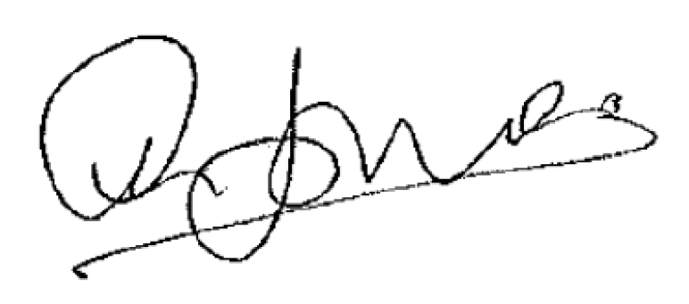

Signature of sponsor’s representative:

Print name: Ceri Jones

Post: Head of Research & Development

Organisation: University Hospitals Coventry & Warwickshire

Date: 11/06/2018

