Insert patient identification sticker here

Alternatively write the patient’s name, DoB and address or NHS number

Dear Dr [insert name],

Re: patient participation in ‘The Big Baby Trial’ - Induction of labour at 38 weeks in large for gestational age fetuses to reduce the risk of shoulder dystocia – HTA 16/77/02

I am writing to inform you that your patient has agreed to participate in the Big Baby trial. Big Baby is a multicentre prospective, individually randomised controlled trial for women ≥18 years, to determine whether induction of labour at 38+⁰ to 38+⁴ weeks gestation (intervention), in pregnancies with a large for gestational age fetuses (>90th centile), reduces the incidence of shoulder dystocia compared to expectant management (control). Your patient has:

Agreed to be randomised and was allocated to Arm A - Usual care
Agreed to be randomised and was allocated to Arm B - Induction of labour at 38+⁰ – 38+⁴
Declined to be randomised but agreed to participate in the prospective cohort study (data collection only)

Please find enclosed a copy of the Participant Information Sheet for this trial. Your patient has been given a copy of this, together with a copy of their completed Consent Form(s). Your patient is able to withdraw from all aspects of the study, and in such circumstances they would be asked to complete a Consent Withdrawal Form.

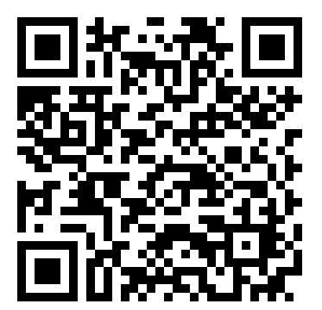
Further information and progress updates are available at http://warwick.ac.uk/bigbaby but if you have any questions please contact the Trial Office: email: BigBaby@warwick.ac.uk, telephone: 02476 968663 or write to: The Big Baby Trial Coordinator, Warwick Clinical Trials Unit, CSL, University Hospital Coventry and Warwickshire, Coventry, CV2 2DX.

Yours sincerely,

[Insert informant’s details]

Enclosures:
Big Baby Participant Information Sheet

