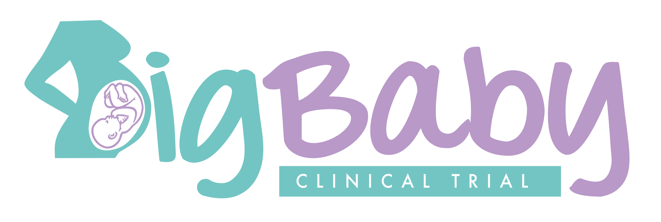  The big baby trial  Bigger babies can sometimes have a more difficult birth which may result in shoulder dystocia.  Shoulder dystocia happens when the baby’s head has been born but the baby’s shoulders becomes stuck – this happens in 1 in 150 births.  Erb’s Palsy can occur in around 1 in 10 cases of shoulder dystocia. It is caused by the stretching of the nerves in the baby’s neck - this may lead to a loss of movement in the baby’s arm, which can be temporary or permanent.  Management  We currently do not know the best way to care for women with bigger babies and we are doing a trial of early induction versus usual care to find out.  Early Induction  Would starting labour earlier, when babies are smaller, mean that shoulder dystocia is less likely to happen?  Results  The results of this trial will help women, obstetricians and midwives decide on the best way to deliver big babies.           | This maternity unit is taking part in the BIG BABY TRIAL  ────  This trial is for women whose baby appears bigger than expected for their dates  ────  If you would like information about the trial, ask your obstetrician, midwife, go to the trial website or contact us – we are very happy to answer any questions  Contact us  Email: BigBaby@warwick.ac.uk  Telephone: 02476 573341 / 02476 523858  Write to: The Big Baby Trial Coordinator, Warwick Clinical Trials Unit, University of Warwick, Coventry, CV4 7AL.
  
  Trial website - for further information go to the trial website at http://warwick.ac.uk/bigbaby or scan the QR code below.
  
  
  Big Baby_Poster V1.1 | 18 July 18 | IRAS: ID 229163

