
Big Baby Eligibility Guidance
Each week we have a lot of eligibility queries, we hope this document can help you to decide if the patient may
be eligible.
Inductions for LGA
Inductions for Other Reasons
Many obstetricians are recommending induction for LGA and there is confusion if these women should enter the trial.
One of the exclusion criteria is “caesarean section or induction indicated due to health conditions such as cardiac disease or hypertensive
disorders”.
If you discuss the trial with the participant before they see the
obstetrician, then you can offer them the trial. The obstetrician will then
need to sign the essential recruitment document to say they can take
part. If the participant is randomised and allocated to standard care and
the obstetrician recommends induction – we strongly recommend this is
done after 39⁺⁰ weeks gestation.
If there is a plan to induce the woman before 39⁺⁰ weeks gestation due to another health condition, then the woman cannot enter the RCT and
cohort study.
If there is a plan to induce the woman after and including 39⁺⁰ weeks gestation then the woman can enter the RCT and cohort study.
If you see the participant after the Obstetrician has reviewed the
participant and the obstetrician has made the following plans, please
follow the table.
The Cohort Study
Induction planned/booked ≥ 39+⁰ | Can enter the RCT & cohort
Induction booked (has a date) for <39⁺⁰ | Cannot enter RCT & cohort
C-section planned/booked for≥ 39+⁰ | Can enter the cohort
Induction planned/booked for≥ 39+⁰ but <40⁺⁰ | Please speak to the  obstetrician and ask if they  could induce as near to 40+⁰ as possible

The cohort study has exactly the same inclusion and exclusion criteria as the RCT. We are interested in outcomes for women where they have chosen their delivery option. I.e. the woman wanted early induction, expectant management or caesarean section. If the obstetrician has
booked for the woman to be induced before 39⁺⁰ weeks gestation these
women are not eligible for the cohort study.

Big Baby Eligibility Guidance | V2.0 | 09th August 2021

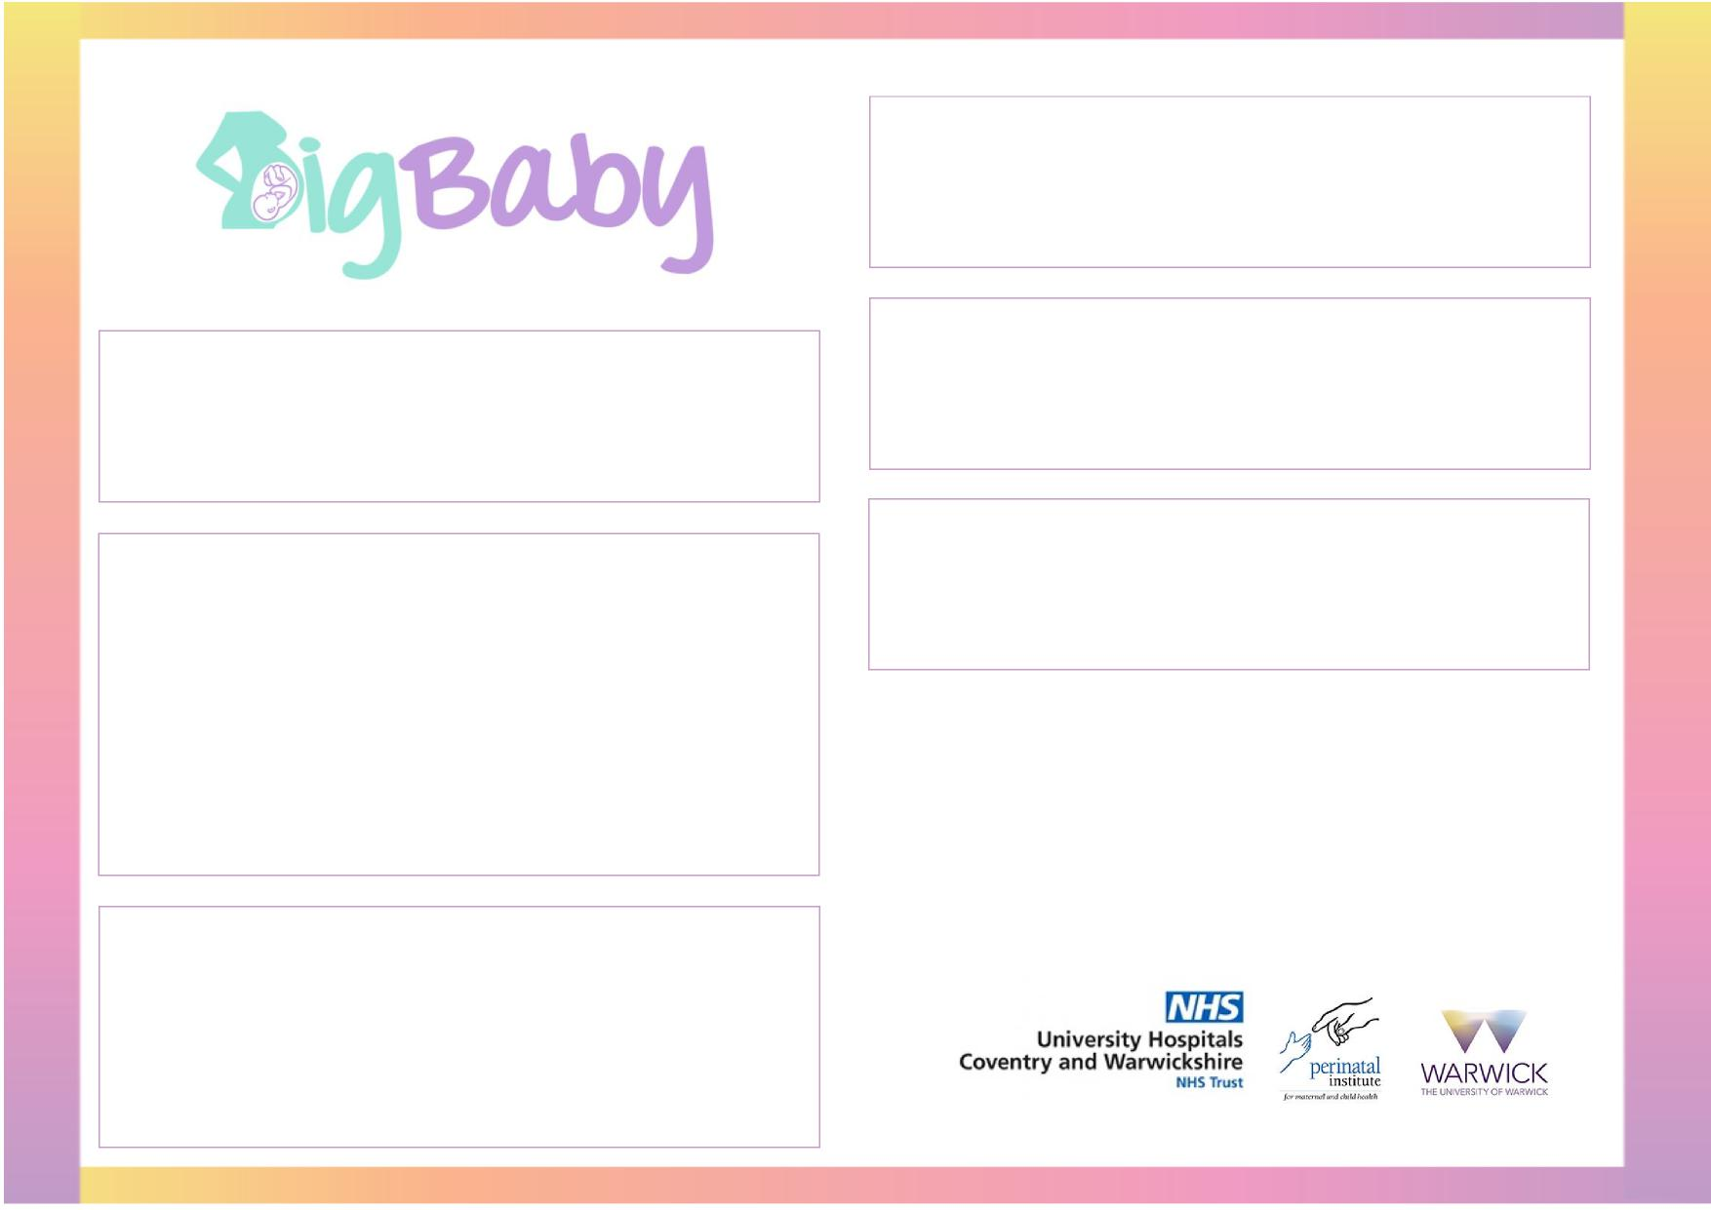
Method of induction
We do not specify which method of induction is used. Please follow your local hospital policy and document what was used in the case
report form.
IVF
Polyhydramnios
Women with an IVF pregnancy can be included in the RCT and
cohort, providing there is no plan to induce her before 39⁺⁰ and the
named obstetrician is happy for her to participate.
Women with polyhydramnios can be included in the RCT and cohort,
providing there is no plan to induce her before 39⁺⁰ and the named
obstetrician is happy for her to participate.
Previous Caesarean Section
Glucose tolerance test
Women with a previous caesarean section can be included in the RCT and cohort, providing the named obstetrician is happy for her to
participate.
If you have a participant who meets all the eligibility criteria, but a
glucose tolerance test / blood sugar monitoring has been arranged
the participant can still be included in the RCT and cohort study.
If the test finds the woman has GDM and has been randomised the
woman does not need to be withdrawn. Any event that happens
after randomisation is classified as an outcome and is recorded on
the case report form.
If you have any more eligibility queries, please contact the trial managers on
024 76 523858
Metformin for Polycystic Ovaries
If the woman is taking metformin for polycystic ovaries she can be included in the trial.
If the woman is taking metformin for diabetes she cannot be included in the trial.
_{g}
Big Baby Eligibility Guidance | V2.0| 09th August 2021

