What will happen in this trial?  Women will be randomly selected to either have their labour induced (started) at around 38 weeks (the intervention group) or to continue as normal (the usual care group).  As part of the trial, we will ask women about their health, the health of their baby and their experience of taking part in the trial.  If you would like more information about this trial, please contact us or the research midwife (see over the page), or ask your obstetrician or midwife. | Funding: This trial is funded by the National Institute for Health Research (NIHR), Health Technology Assessment Programme.  Sponsorship: The trial is sponsored by University Hospitals Coventry and Warwickshire NHS Trust.  Research team: Professor Siobhan Quenby from University Hospitals Coventry, Warwickshire NHS Trust and The University of Warwick and Professor Jason Gardosi from the Perinatal Institute are the chief investigators, working with the following organisations. |  | The Big Baby Trial  - This maternity unit is taking part in the Big Baby Trial.  - The aim of this trial is to find out if labour should be started a little earlier for women with babies who appear to be bigger than expected for their dates.  - We want to find out if doing this could prevent problems for women or babies during birth. This issue has been identified as an important unanswered question for the NHS.  - The results of this trial will help women, obstetricians and midwives decide on the best way to care for women with bigger babies.  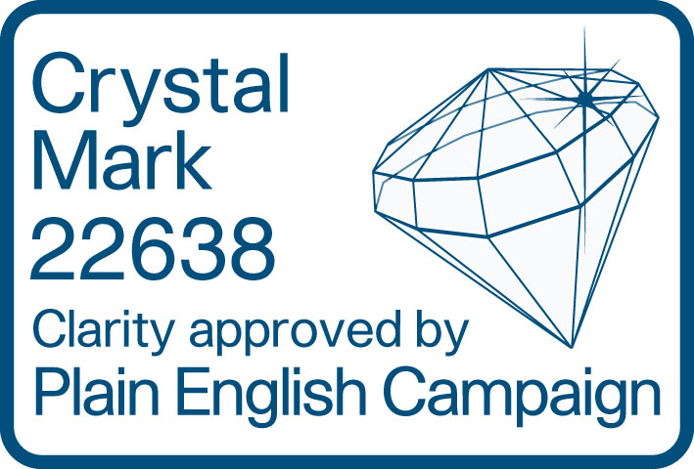  
   | 
  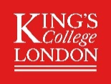 | 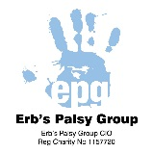
   |  | 
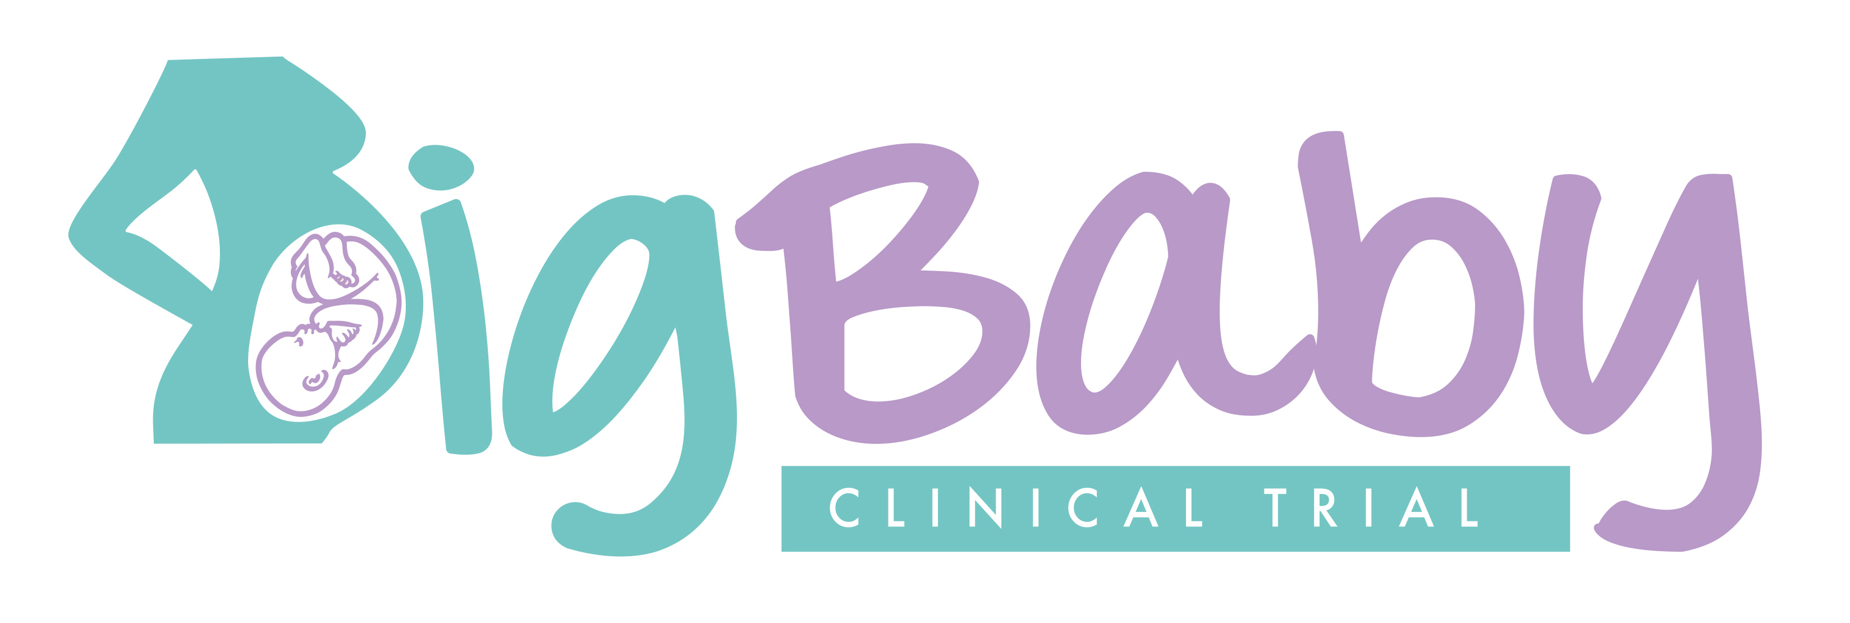
Big Baby leaflet V1.2 | 25 Sep 18 | IRAS: ID 229163
Why are we doing this trial?  Women whose babies appear bigger than expected for their dates may have a difficult birth which may result in shoulder dystocia.  ‘Shoulder dystocia’ is when the baby’s head has been born but one of the shoulders becomes stuck behind the woman’s pubic bone (one of the bones in the pelvis), delaying the birth of the baby’s body.  If this happens, the doctors and midwives need to use different ways to deliver the baby’s shoulders.  Stretching of the nerves in the baby’s neck can happen in babies with shoulder dystocia. This may cause loss of movement in the baby’s arm (Erb’s Palsy), which can be temporary or permanent.  We currently do not know the best way to care for women with bigger babies. It may be that starting the labour earlier, when babies are smaller, means that shoulder dystocia is less likely to happen.  However, starting labour early may also have risks for women and babies.  The aim of this trial is to answer these questions. | “We are proud to support the ‘Big Baby Trial’. We currently have over 2,400 families registered as members of our organisation which illustrates how many families are affected by this condition.  We are looking forward to the trial and hope it will help prevent or at least minimise the effect of Erb’s Palsy on children, mums and families.”  Karen Hillyer, Chairperson of the Erb’s Palsy Group  Who has reviewed this trial?  To protect patients, this trial was reviewed and approved by South West - Exeter Research Ethics Committee (REC) on 19/03/18 [18/SW/0039].  The REC are an independent group of people who review all research carried out in the NHS to protect your safety, rights, well-being and dignity. | Questions about the trial  If you have any questions about the Big Baby Trial, the following people will be happy to answer them.  Your obstetrician or midwife  Contact us  The Big Baby Trial Research Midwife [number xxxxxxx]  You can also contact the Big Baby Trial Management Team (see below)  Email: BigBaby@warwick.ac.uk  Phone: 02476 573341 or  02476 523858  Write to: The Big Baby Trial Warwick Clinical Trials Unit Warwick Medical School Gibbert Hill Campus University of Warwick Coventry, CV4 7AL  Trial website: http://warwick.ac.uk/bigbaby  

