Database Entry Guidelines


The ‘Big Baby Trial’ – Induction of labour at 38 weeks in large for gestational age fetuses to reduce the risk of shoulder dystocia

Version: | 2.0
Effective date: | 01 July 2022
Authors: | Name: Sara Wood  Job Title: Trial Manager

Revision Chronology: | Effective Date: | Reason for change: | Name of person approving change:
V1.2 | 11 February 2020 | Updated CRF version and system upgrade
V1.0 | 22 October 2018 | Updated CRF version, and clarification of some data entry points | Jaclyn Brown
V1.1 | 21 November 2018 | Corrected URL
V1.1.1 | 19 March 2020 | Updated CRF pages

General Guidelines

What needs entering and when?

Data | Instructions
Screening log | Screening logs need to be completed and if possible emailed every month as an Excel spreadsheet to uhc-tr.bigbaby@nhs.net
Participant Contact Details | Please enter the participant contact details in to the Big Baby database. This is a secure location and the contact details are only visible to staff at your site with access to the database, and staff within the Big baby Trial Management Team at Warwick Clinical Trials Unit (WCTU). As described in the Participant Information Sheet, these data are only used if we need to contact the participant, e.g. to send the the two or six month follow-up questionnaires. These data are stored in a separate area of the database to the trial data and do not form part of the analysis datasets. Please also ensure that the email address is available for women who are willing to participate in future follow-up studies. These study invitations will be via email.
Eligibility Forms (CRF pages 2-3) | Once the woman has been recruited into the trial these forms will need to be entered into the Big Baby database by site staff.  The Eligibility section of the CRF still needs to be completed on paper. This is to make sure that we have a signature from a Doctor on the delegation log confirming that the woman is eligible to join the trial  Please send scanned copies of these forms for central monitoring to uhc-tr.bigbaby@nhs.net.
Recruitment (CRF page 4) | Recruitment is now online.  https://CTU.warwick.ac.uk/bigbaby  Log into the Big baby database and complete the Recruitment section  The woman’s trial number will be provided at this time, she will be randomised at this time. You will receive an email with the trial number and the randomisation arm.  If for any reason you are unable to access the Big Baby database to recruit a woman into the trial, you can telephone the recruitment officer at WCTU who can recruit a woman for you over the telephone:  Please telephone 02476 150402. This service is only available Monday to Friday 9:00 to 17:00  Update the screening log with the woman’s Study Number
Baseline Questionnaire | Please Provide the woman with a paper copy of the Baseline Questionnaire, please try and ensure that this is completed before the woman has been told her randomisation group to avoid biasing the answers she gives. Scan and email the completed questionnaire to  uhc-tr.bigbaby@nhs.net  The questionnaire can be entered by WCTU staff. If you wish to enter this questionnaire yourselves it does not need to be scanned to WCTU
CRF | Please enter CRF data as and when the data become available. We would request that delivery and outcome data are entered within 2 weeks of the baby being delivered if possible.
Delivery Notes | Please scan over the redacted delivery notes for head to full body delivery only, ensuring that the Trial Number is on each page of the notes to:  uhc-tr.bigbaby@nhs.net  Please add the Shoulder Dystocia pro-former is one has been completed.  If the participant had a c-section, please scan the delivery notes indicating that a c-section took place.
CRF | Unscheduled hospitalisation– please complete each unscheduled visit form this at least once per woman/baby. The forms are in the Unscheduled Data Entry area. These forms repeat so if there is more than one hospitalisation for a specific form, please create and complete more forms.  If the woman/baby has not had a hospital visit in the timeframe, please complete the form to confirm that there was no hospital visit.
CRF | End of Trial Form- Please ensure that the End of Trial form is complete at your 30 day check or if the woman and or baby have withdrew.  Please enter as the data becomes available.
CRF | Notification of Death Form is only required if the woman and or baby died. Please enter if the data become available and scan a copy of the corresponding SAE to  uhc-tr.bigbaby@nhs.net
SAE forms | Please complete one form per known SAE that happened between randomisation and 30 days post initial discharge following delivery. Please complete paper forms and scan them to WCTU. They will be entered into the database by WCTU.  to uhc-tr.bigbaby@nhs.net
Two and Six Month Follow-Up | WCTU will contact you when the two and six month follow-up questionnaires are due to be sent out, to see if questionnaire A or B should be sent. Questionnaire A is for when mother and baby are doing well and living together. Questionnaire B is for when mother is not living with baby. WCTU will send out the questionnaires, receive them back and enter them into the database.

What is not needed at WCTU
Data | Instructions
Informed Consent  RCT/Cohort | Copies of these need to be given to the participant, and need to be filed in the woman’s medical notes and the Investigator Site File, but no copies are needed at Warwick Clinical trials Unit (WCTU)
Essential Recruitment Documentation | This is source data which needs to be available at site for potential audits. We do not need to receive this document at WCTU

Accessing the Big Baby database
To access the database type in https://CTU.warwick.ac.uk/bigbaby to Microsoft Explorer (version 11 or above) or in Google Chrome.
You will see the following screen:
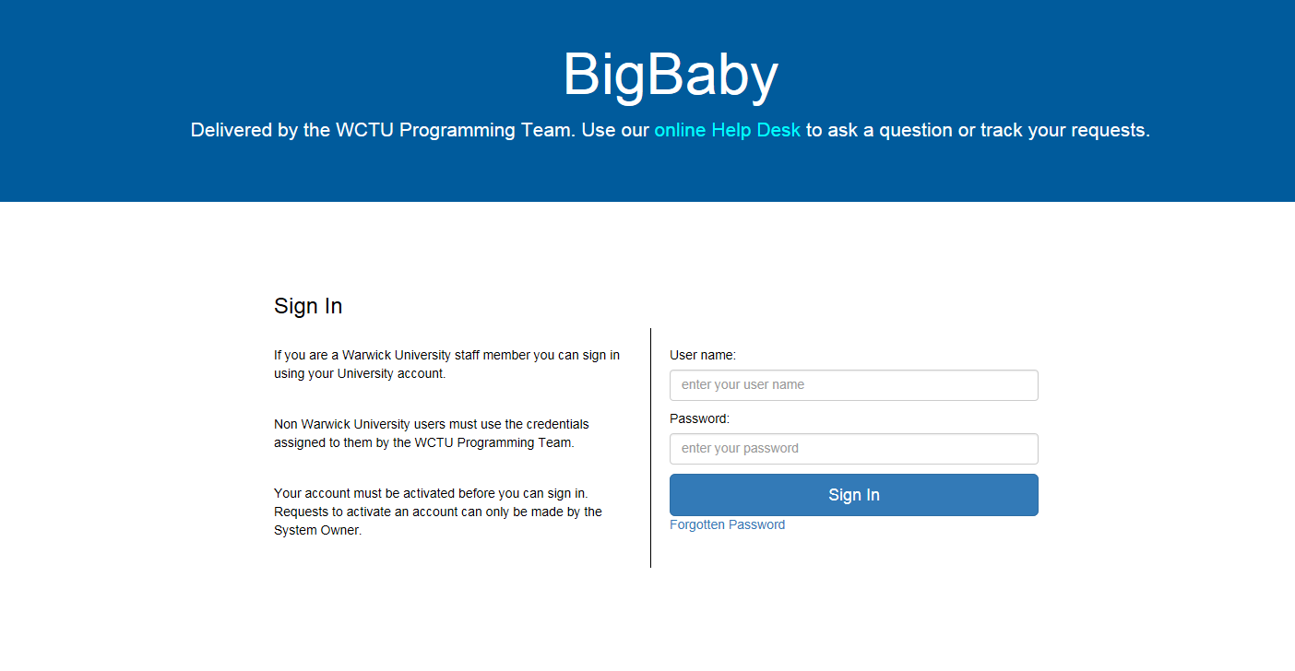
Please do not share your login details with anyone else, or use anyone else’s details. All entry and updates to this system have a complete audit trail, recording the name of the person doing the entry/editing and the date and time this was done.
Enter your Username and Password and press the ‘Sign In’ button, or press the ‘enter’ key.
If you are unable to log in please contact the Big baby Team on 02476 523858 or bigbaby@warwick.ac.uk. We will be available Mon-Fri 08:00 to 16:00 (excluding bank holidays)
If you have forgotten your password click on the ‘Forgotten Password’ link under the ‘Sign In button and follow the instructions there.
The database cannot be accessed from a wireless connection or from your home address unless you are accessing the database via your hospital’s Virtual Private Network (VPN).
Make sure you are in the correct database (training or live database) by checking the web address, and by checking your log-in on the top right hand side of the screen is your personal log-in and not the training login.
Use these instructions in conjunction with the Big Baby CRF Completion Guidelines V5.0 15 March 2022.

Navigation
Once logged in you will see the following screen:
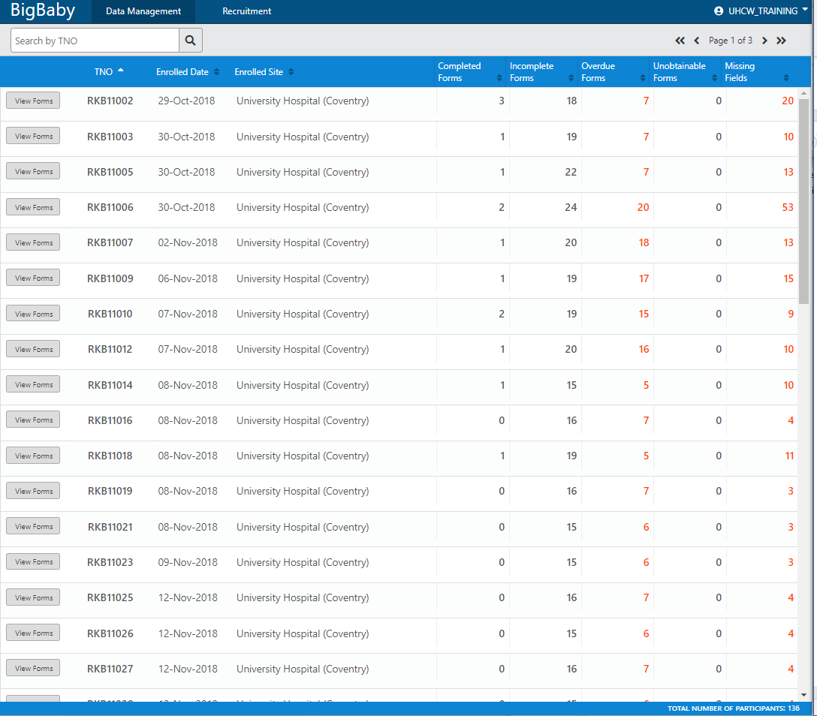

To recruit a woman into the trial Click on the ‘Recruitment’ tab.
To enter data on a woman who is already recruited click you need to be in the ‘Data Management’ tab. You can select participants from the list or search for participants in the Search by TNO space.

General Information for all screens:
Moving to the next field | You can move to the next field with the mouse, or by pressing the ‘TAB’ key on your keyboard
Data format | In the grey box at the side of each field there is an indication of the format in which the data are expected.
  Date | 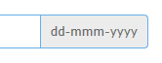
  Numbers | 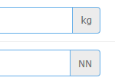
  Text | 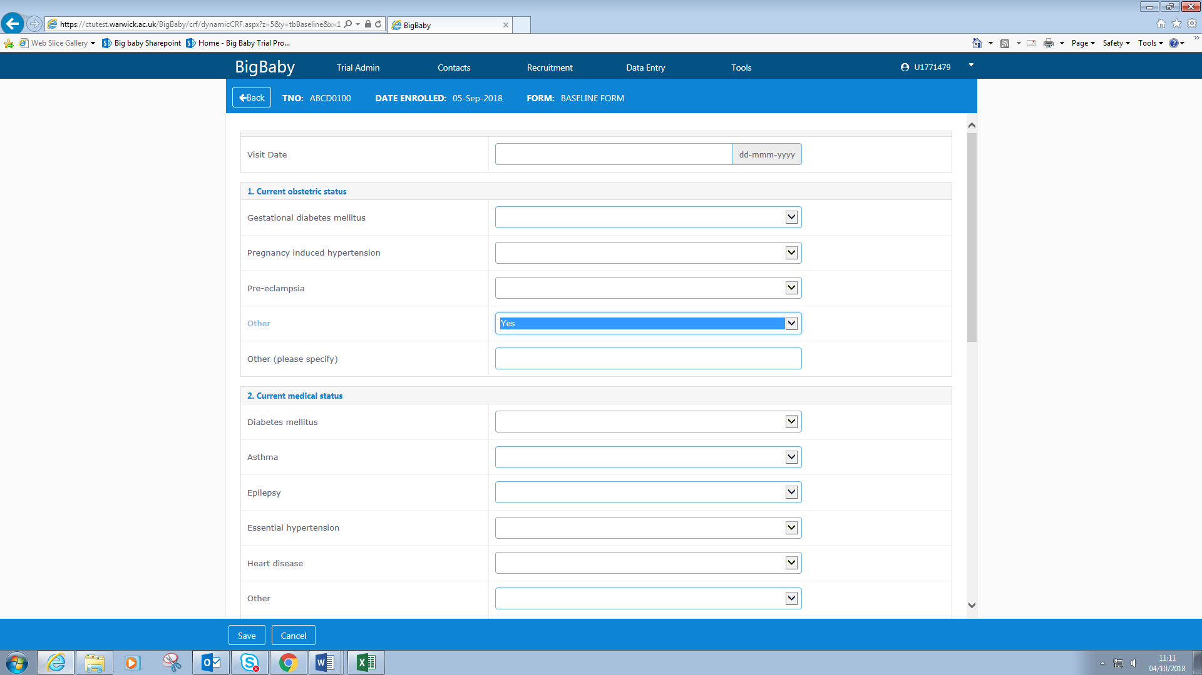
  Codelists | 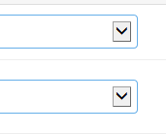
Dates | Dates must always be entered in full in the same format of dd-mmm-yyyy. E.g. to enter 1st January 2019 you must type in 01jan2019 for the entry to be saved. If the wrong format is used the entry will not be saved
Codelists | Fields with a codelist can be entered either by selecting the code from the drop-down menu with the mouse, or by typing the first letter of the code. Eg. Type ‘Y’ for ‘Yes’.
Multiple rows within a section | Some sections give you the opportunity to create one or more rows to enter data e.g.  - Previous pregnancies  - Selecting a ward during a hospitalisation  - Adding medications  - Adding adverse events  These sections will look like this:  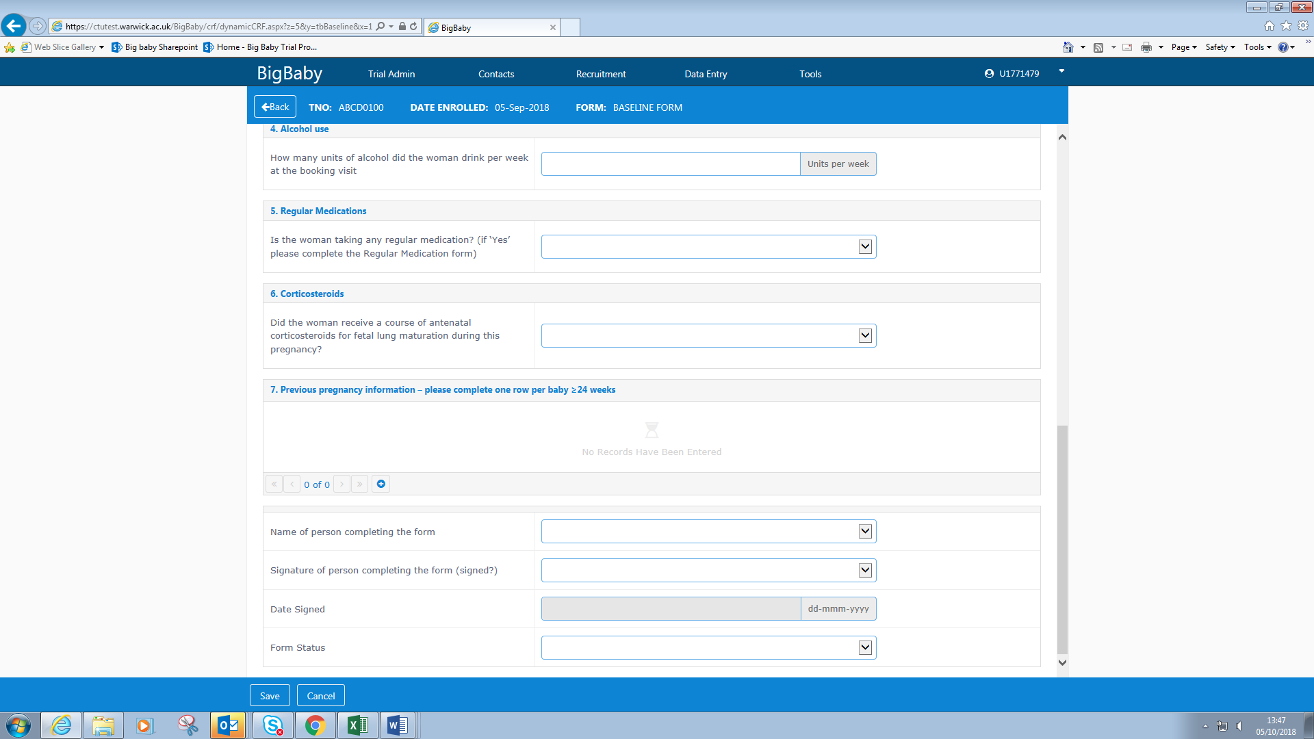  Click on the to create a new record. You can create as many records as you need.  This will create a form which expands to look like this:  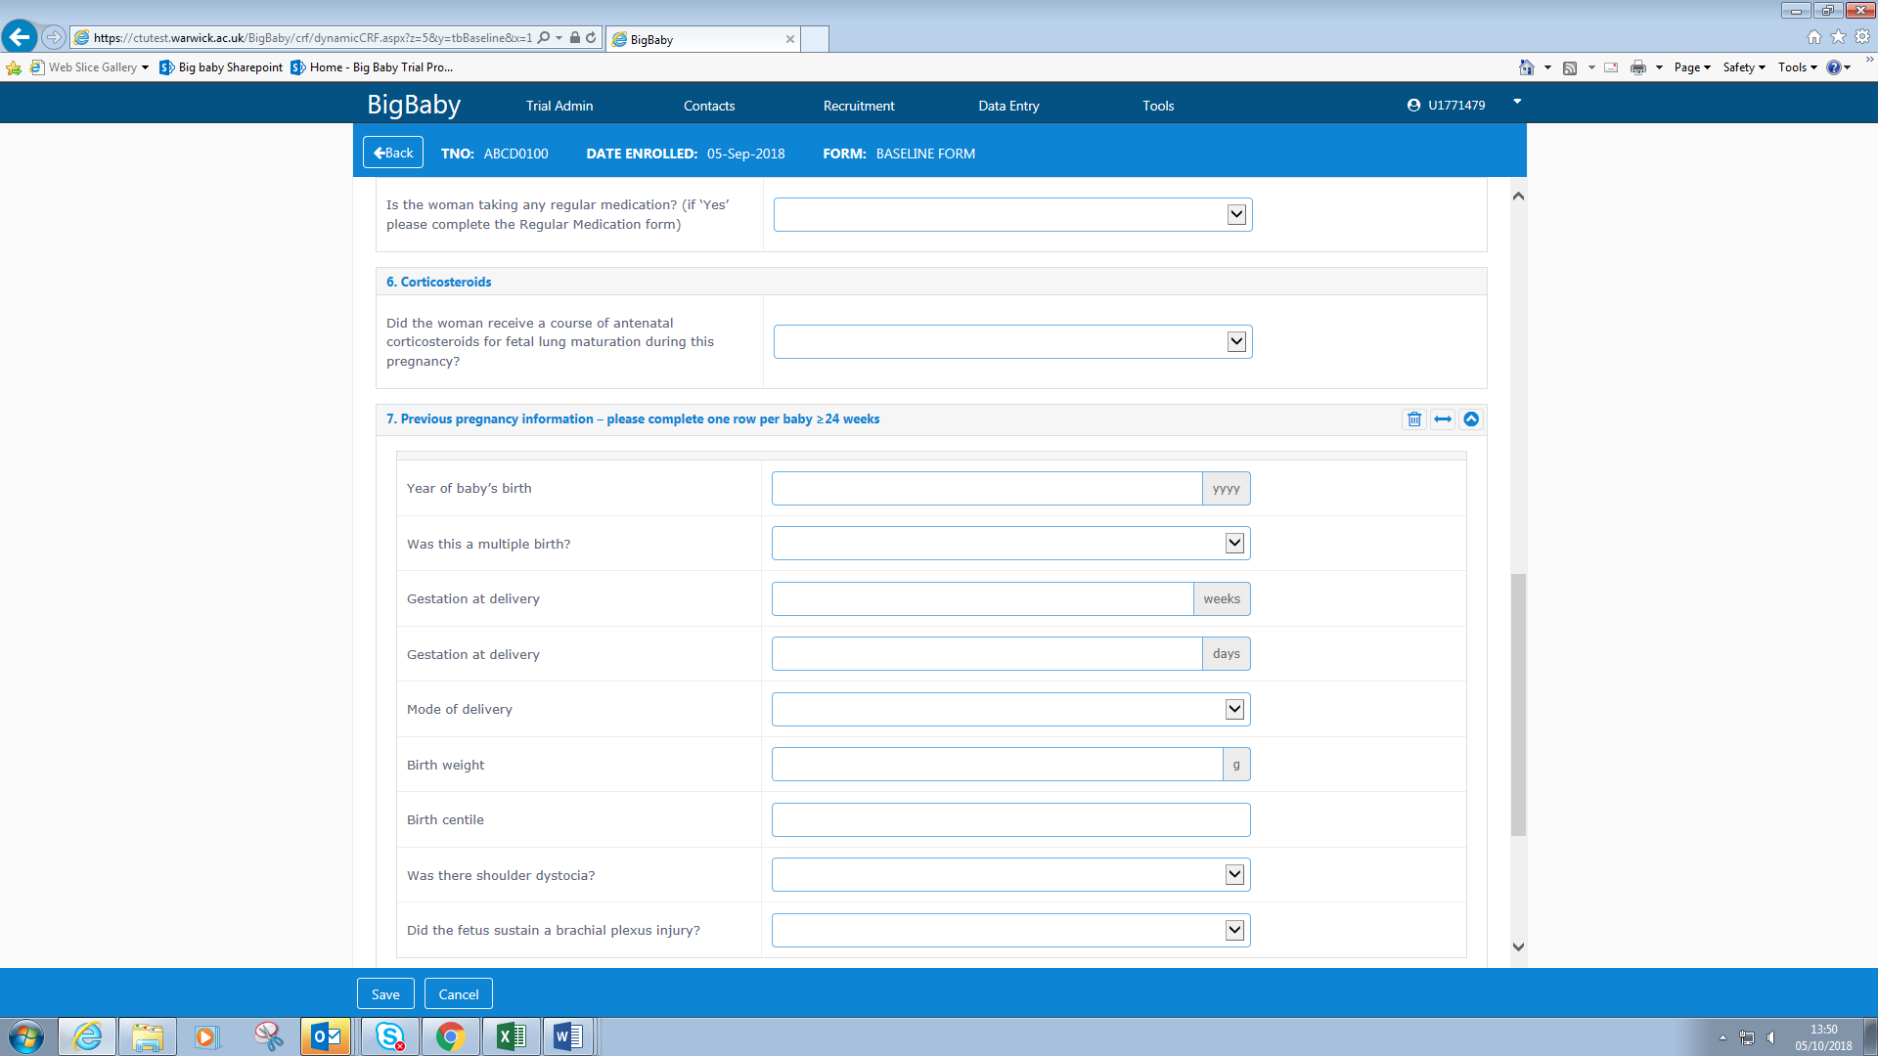  If you create a record in error, it can be deleted by clicking on  You can view all of the entered records by clicking 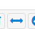  You can move between created records by clicking on these arrows  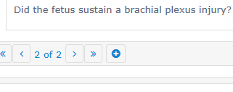
Additional Features | 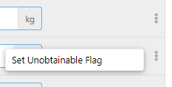  Clicking on the three dots in a vertical line will allow you to indicate if data are unobtainable on a specific field up to the point of saving the data. You can see that the flag is set as the blue line round the field indicating that the field is enterable disappears. You can remove the unobtainable flag be clicking on the three dots and selecting ‘remove unobtainable flag’  After the data have been saved, clicking on these dots will allow you to leave a comment on the field.  Once you have saved the form initially, you will not be able to mark the field as unobtainable, but you will be able to add a comment to this field.
Form Status | There is a ‘Form Status’ at the end of each section. One of the codes needs to be selected from the codelist before the data can be saved.  Please select:  - Clean - If you think that all the data are present and that there are no errors in the data  - Clean with unobtainable missing data - If there are missing data and you know that the data are unobtainable, but all the other data are clean.  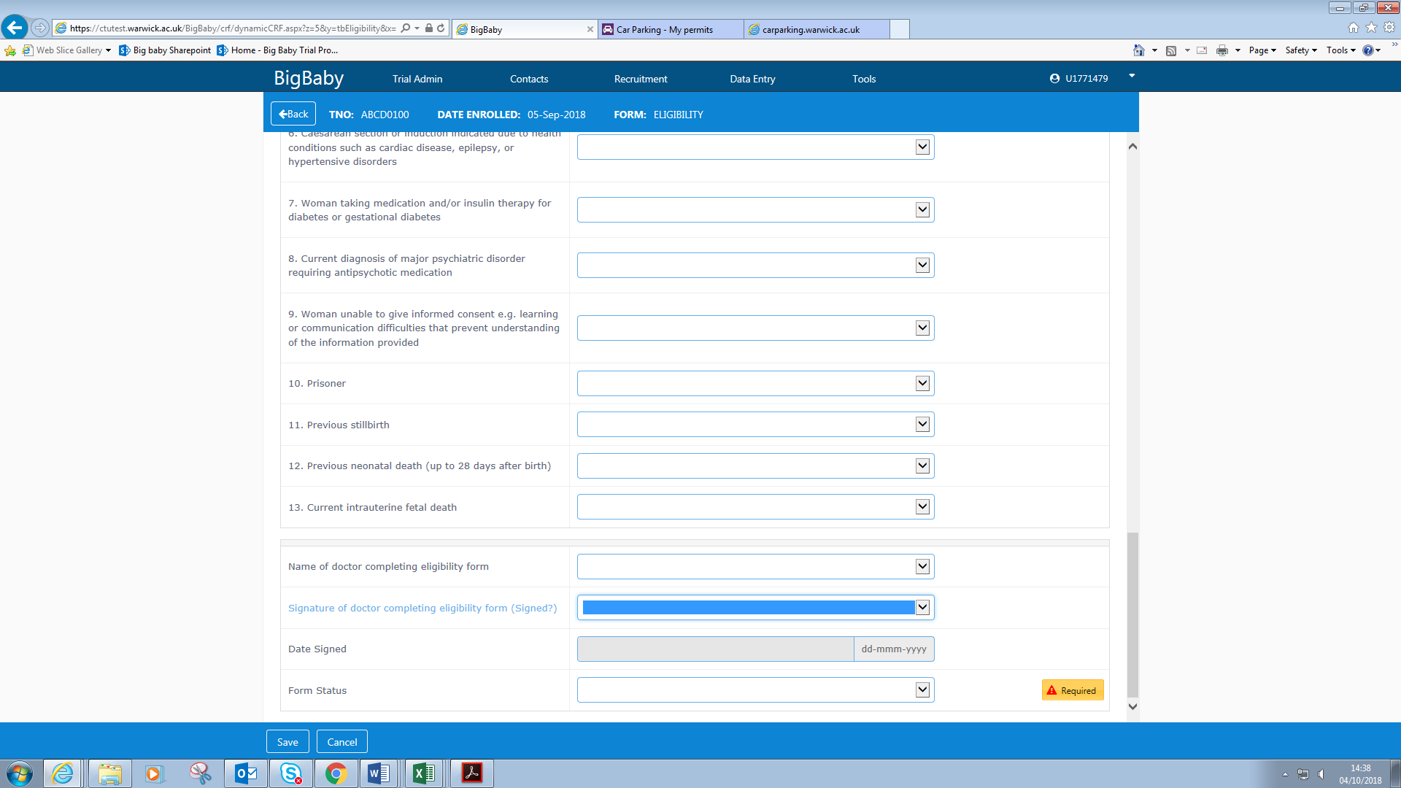  - Data query - If you think there are errors in the data, or there are missing data which you intend to complete at a later date.
Incorrect format used | If data are entered using the incorrect format, e.g. letters in a number field, the following error message will appear when you try to save the data at the end of the section. This means you cannot write UNK or NA in a number field.  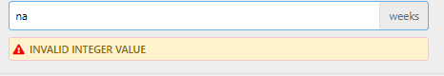
Required data | If a required data field has no data in it, an error message will appear when you try to save the section. The section cannot be saved until data are entered in the field.  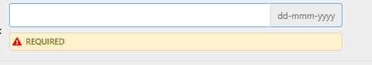
Saving | You can save the data you have entered at any time by pressing the ‘Save’ button at the top right hand side of the screen.  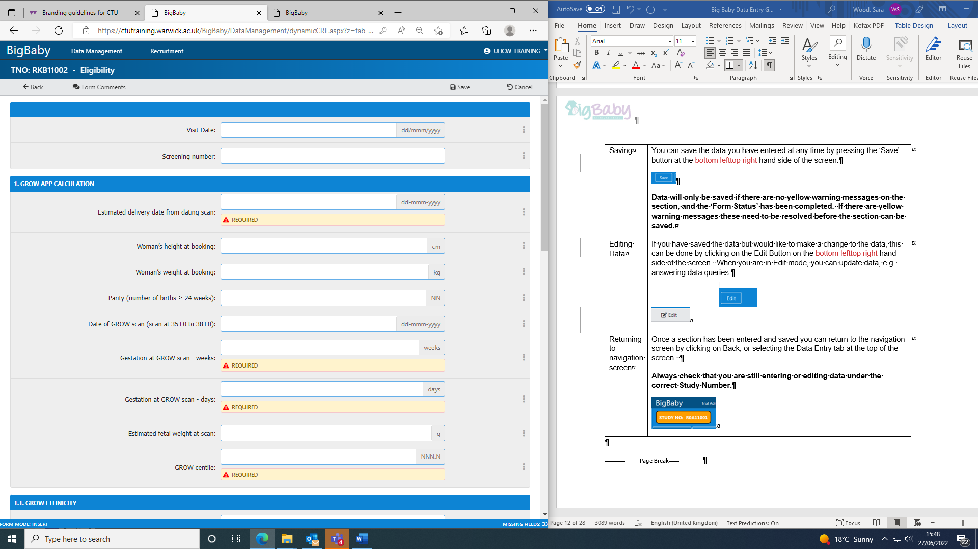  Data will only be saved if there are no yellow warning messages on the section, and the ‘Form Status’ has been completed. If there are yellow warning messages these need to be resolved before the section can be saved.
Editing Data | If you have saved the data but would like to make a change to the data, this can be done by clicking on the Edit Button on the top right hand side of the screen. When you are in Edit mode, you can update data, e.g. answering data queries.  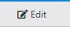
Returning to navigation screen | Once a section has been entered and saved you can return to the navigation screen by clicking on Back at the top left hand side of the screen.  Always check that you are still entering or editing data under the correct Study Number.

Recruitment
To recruit a new woman into the trial, , select the ‘Recruitment’ tab in the top bar of the database screen. Once ‘Recruitment has been selected, you will see:

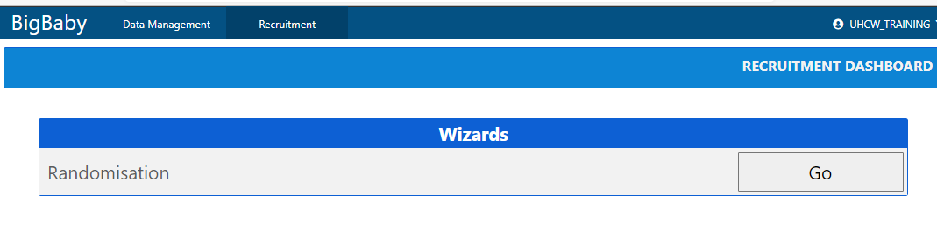

Randomisation

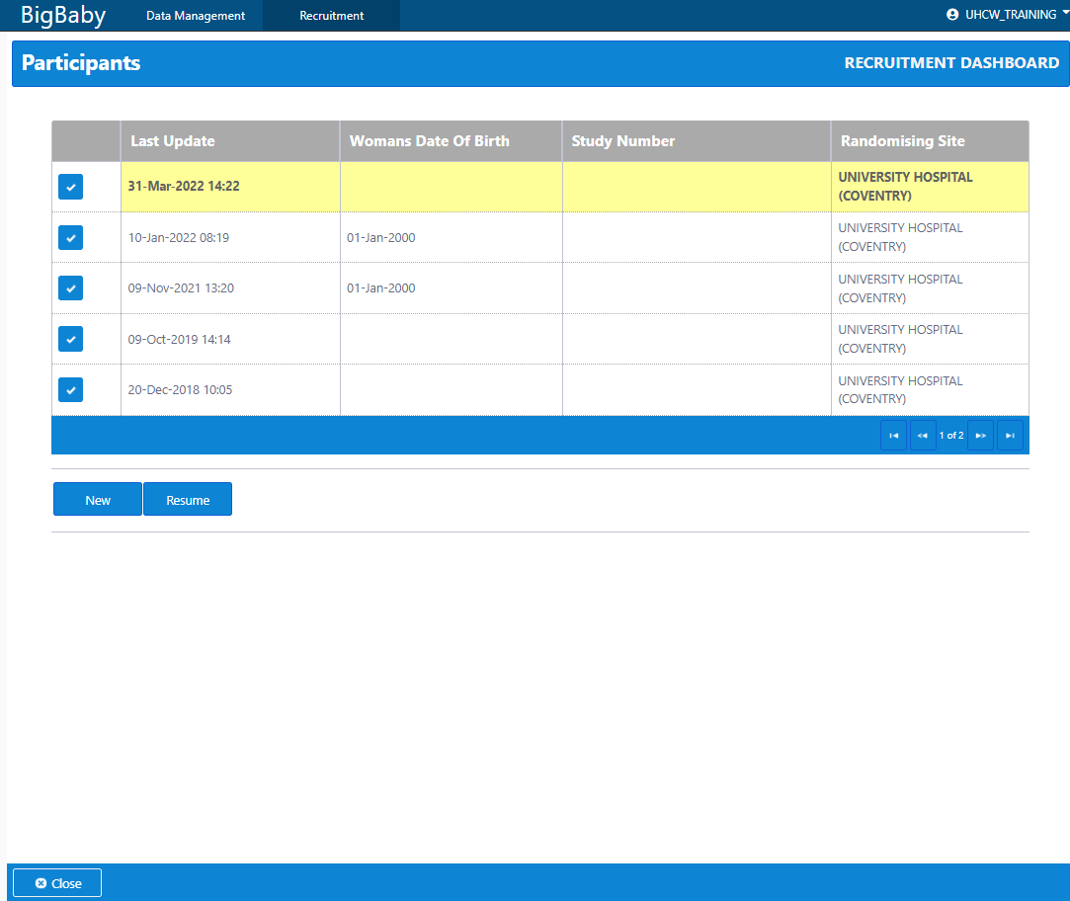
The table gives you a list of women where you have started but not completed the randomisation process.
The ‘New’ button is to be used to randomise a new woman, the ‘Resume’ button is to resume randomising a woman that was started earlier. If you use ‘Resume’ button you need to highlight the relevant line in the table to select the woman to continue randomising.
To randomise a new woman click on the ‘New’ button.
You will see a set of instructions on randomising the woman. Click on the ‘Next’ button at the bottom right hand side of the screen to move to the next screen.
At any stage during the randomisation process, the ‘Previous’ button will take you to the previous page, and the ‘Cancel’ button will stop the randomisation of this particular woman, and put the record into the ‘Resume’ table described earlier. The data for the randomisation will be saved, but can be overwritten.

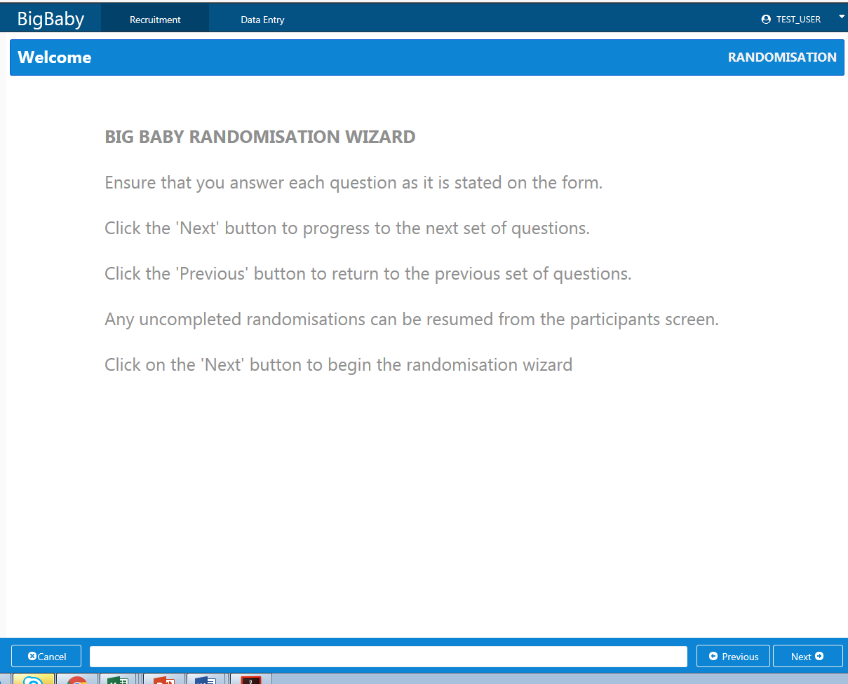
Click on the ‘Next’ button at the bottom right hand side of the screen to move to the next screen.
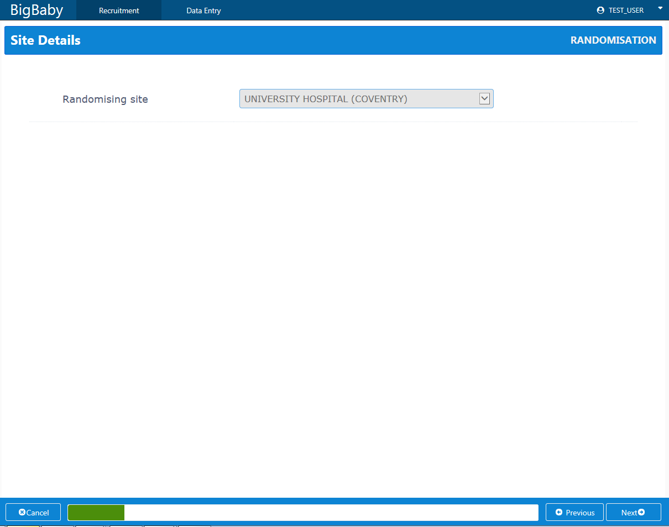
Your site name will appear as the randomising site, or if you are working over multiple sites, select the relevant site. If the site you need is not present, contact WCTU immediately on 02476 523858.
Click on the ‘Next’ button.
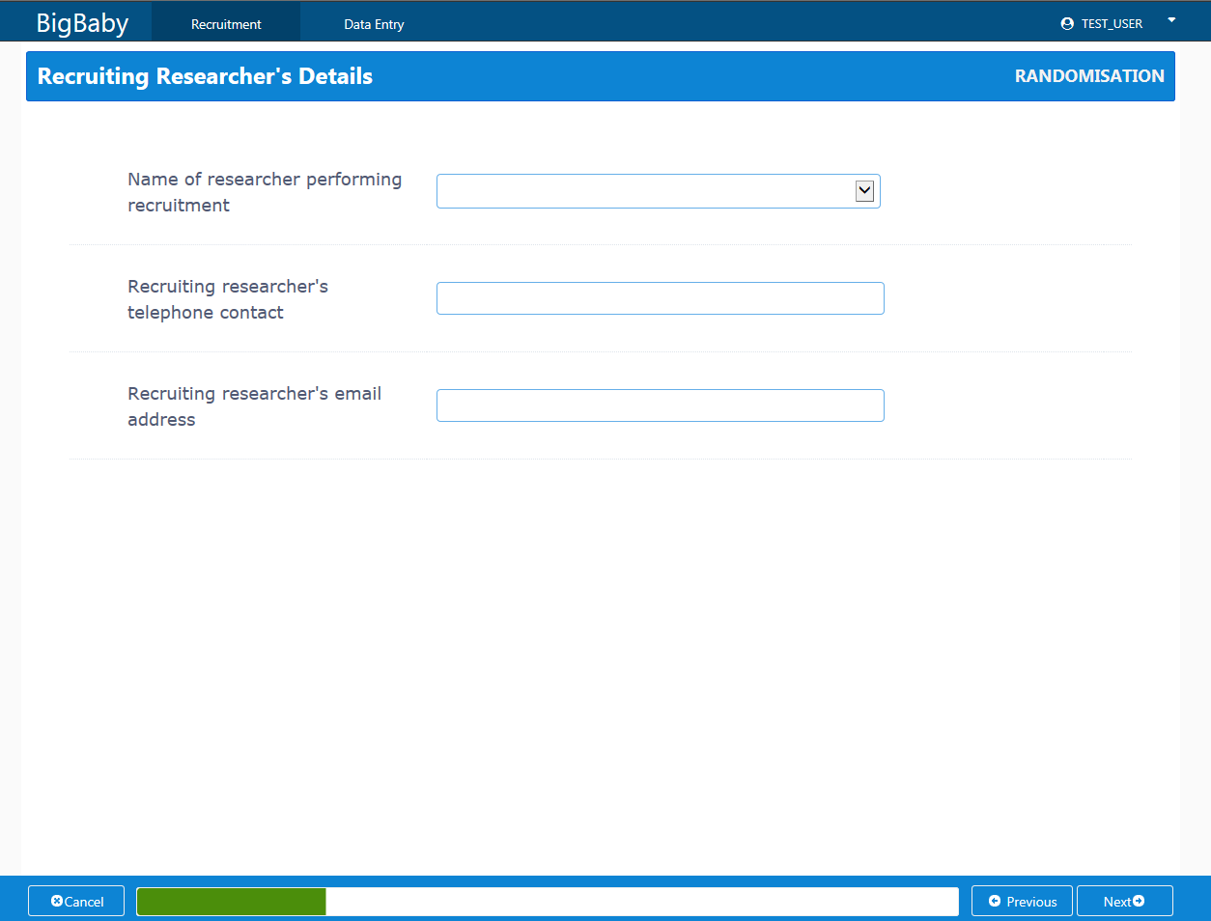
Complete the data requested in the next screens, clicking on the Next button to move to the next screen
Please note that most of these fields need to be completed to be able to randomise the woman. If ‘No’ is answered for any of the questions on this form, the woman cannot be randomised.

Once all of the data have been completed, you will see a confirmation screen for you to review the data. If anything is incorrect, go back to the incorrect data item using the ‘Previous’ key
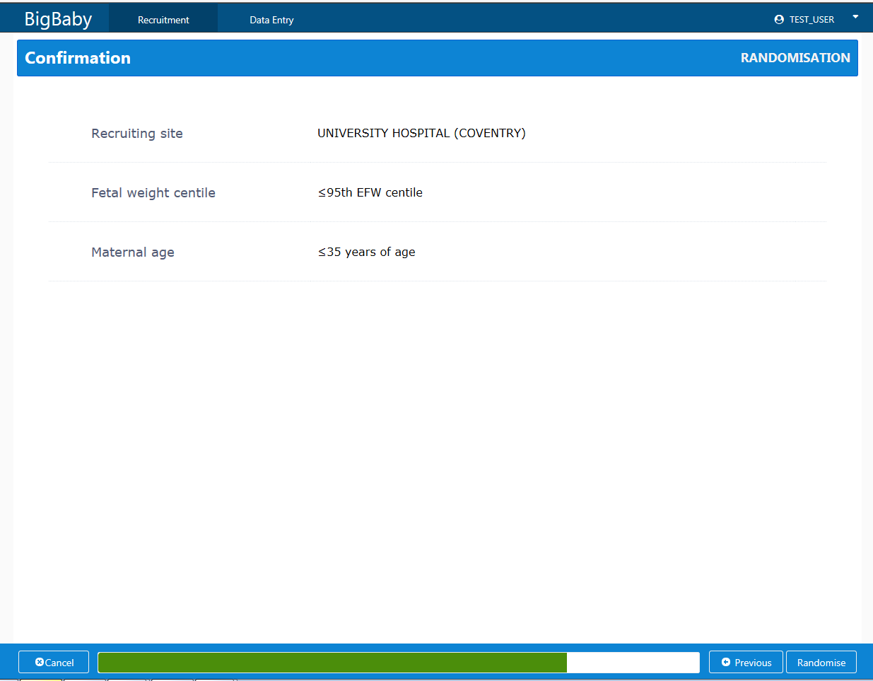
If the data appear to be correct, click on the ‘Randomise’ button at the bottom Right hand side of the screen. If the data are incorrect, press the Previous button until the required screen is reached, correct the error, and return to confirmation screen with he Next button.
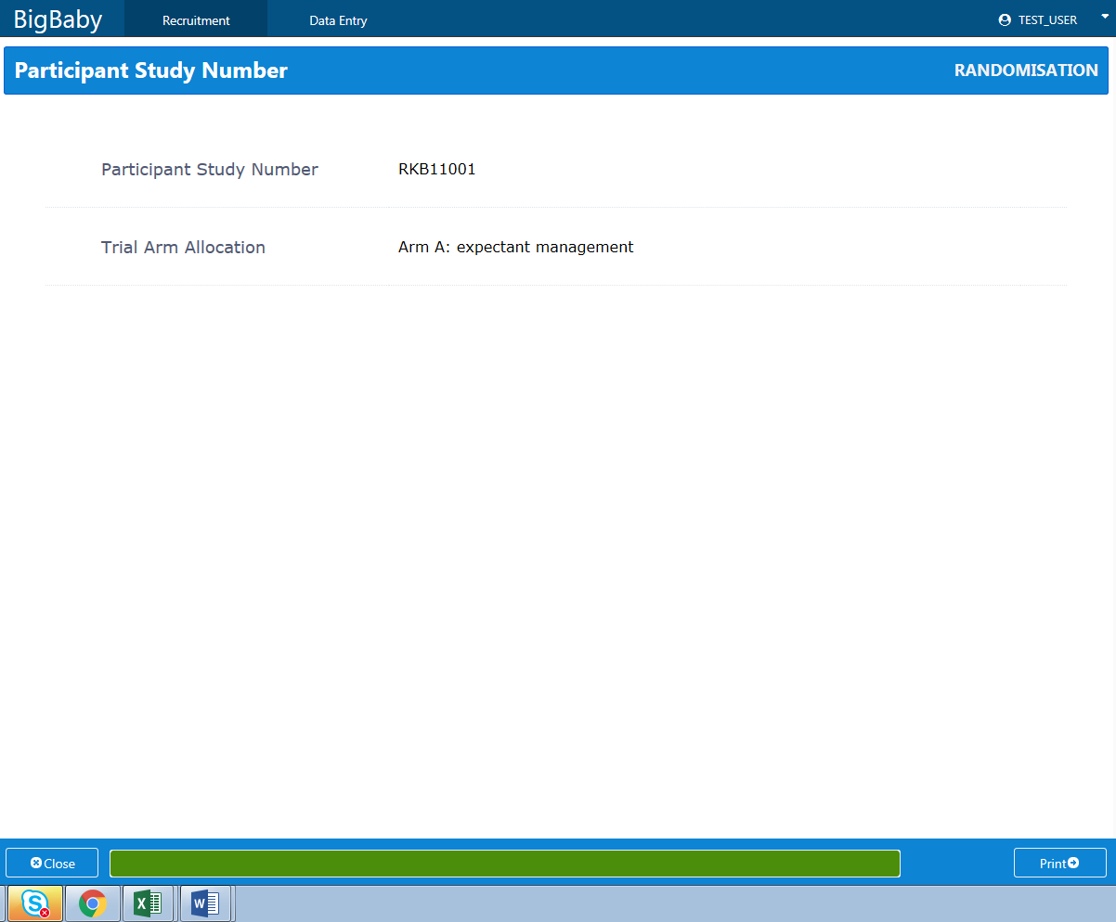

Your Randomised patient has now been allocated a Study Number and a Randomisation Arm. You can print this for your files by pressing the ‘Print’ button in the bottom left hand side of the screen.
Please make a note of your woman’s Study Number. You will need this to select the correct forms for Data Entry, and to link to the screening number in the screening log
This woman is now randomised and the data are saved. To recruit another woman into the trial or to enter data on this woman, select either the Recruitment tab or the Data Entry tab at the top of the screen.
Clicking on the ‘Close’ button will log you out of the Big Baby database.

Data entry
Click on the Data Management tab and select Participant Manager.
For specific CRF completion issues, please refer to the CRF Completion Guidelines, or contact the Trial Management Team.
Select the Participant’s trial number by either scrolling down the list to the correct number, or by typing in the number you wish to use in the top left hand corner in the Search by TNO box.
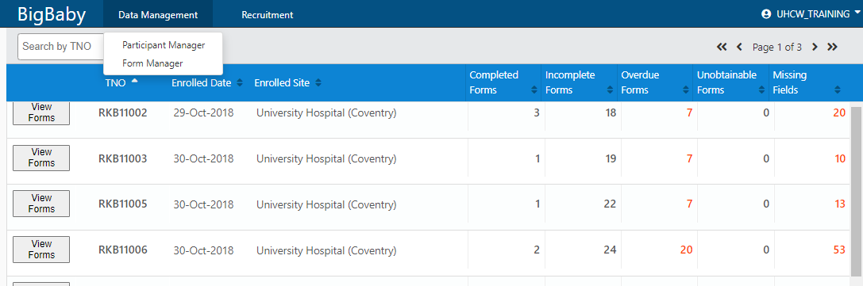
The forms for the selected woman will become visible if you click on the View Forms button for the participant.
None of these data in this document are for real participants.

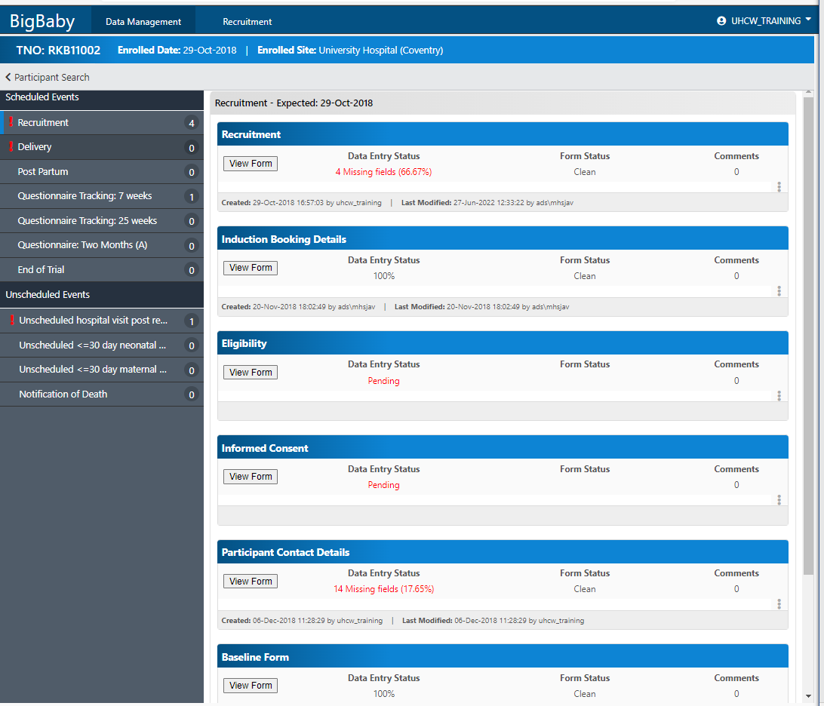
To view the recruitment data click on the ‘View Form’ button in the recruitment row of the table.
The panel to the left hand side of the screen lists all of the scheduled and unscheduled events of the Case Report Form. In the screenshot above, the Recruitment event is highlighted by a blue bar at the left hand side of the name. This indicates that the Recruitment forms are being displayed in the right hand panel. Also notice that there is a red exclamation mark next to the Recruitment event name, this means that data entry is outstanding for some forms in the section.
You can see that data entry for the Eligibility and Informed Consent forms is pending/outstanding.

Looking at the recruitment form, you can see that RKB11002 was recruited (created) on 29 October 2018, and her data has been edited as the ‘Last Modified’ date is different to the ‘Created’ date. You can also see that there are 4 fields with missing data on this form.
There are no comments on this form. If you would like to add a comment at a form level click on the three vertical dots at the end of the row, this will enable you to add a form level comment. Only the person who created the comment can edit or delete it.
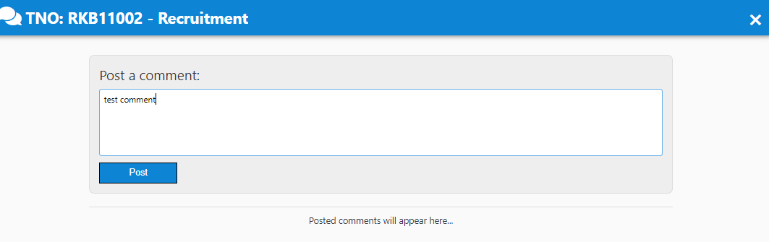
Click Post
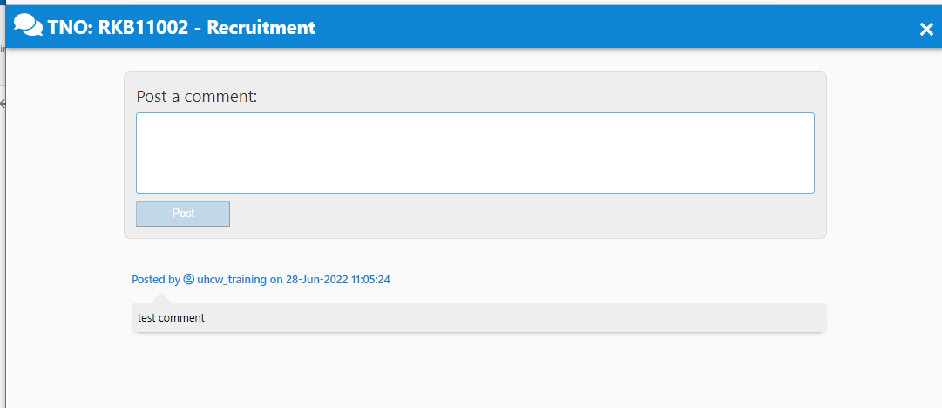
The comment is now indicated, as under the comments field, one comment is visible.
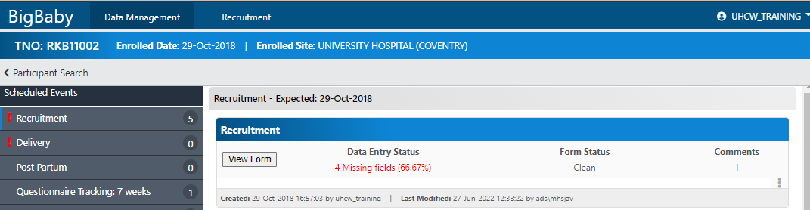

Select the form you would like to enter/edit by clicking on the ‘View Form’ button under the form name you wish to complete.

If you open the eligibility form it will look like this.
Always check to make sure that you are in the correct woman’s form

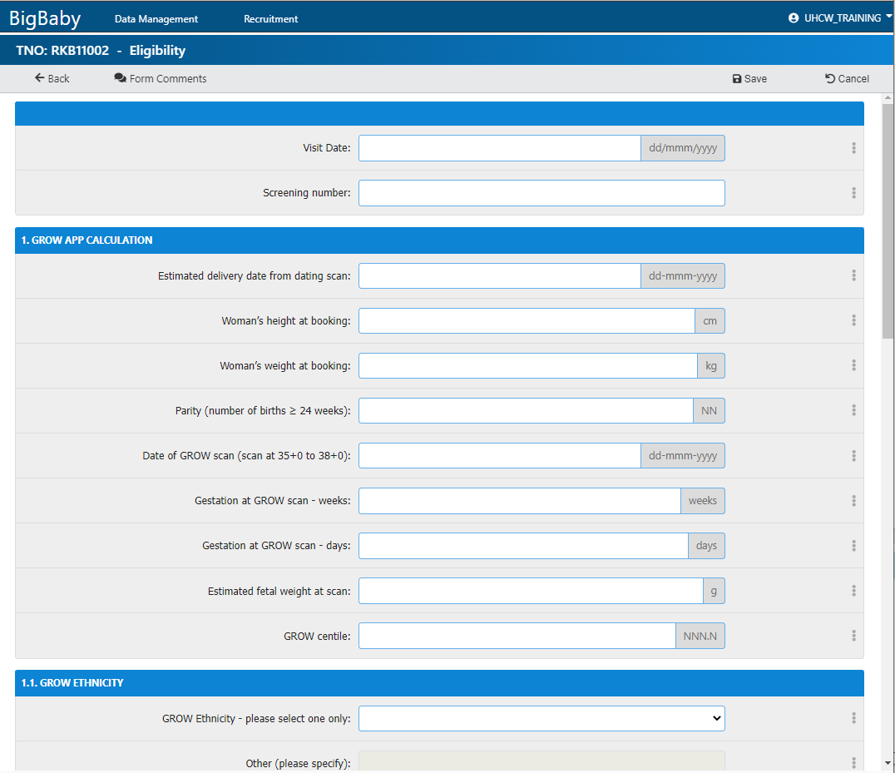

Enter the data from the woman’s notes.

Once you have completed the form you can press the ‘Save’ button.

Clicking ‘Cancel’ or ‘Back’ before you click the save button will mean that no data are saved.

Unscheduled Events
These are events that may happen more than once for the woman in the trial, or may not even happen at all.
The following forms need to be completed at least once for each participant in the RCT trial, or in the Cohort group and planning to have an elective caesarean, but may need to be completed more than once:
Unscheduled hospital visit post randomisation prior to delivery
Unscheduled <=30 day neonatal readmission/neonatal death
Unscheduled <=30 day maternal readmission
For any group, if the woman or baby dies, please complete the Notification of Death form.

Data Editing
If data have been entered and saved, but you wish to add more data to a form, or you wish to edit data already entered, click on the ‘View Form’ button for the form you would like to edit.
E.g. on the Eligibility form for RKB11002
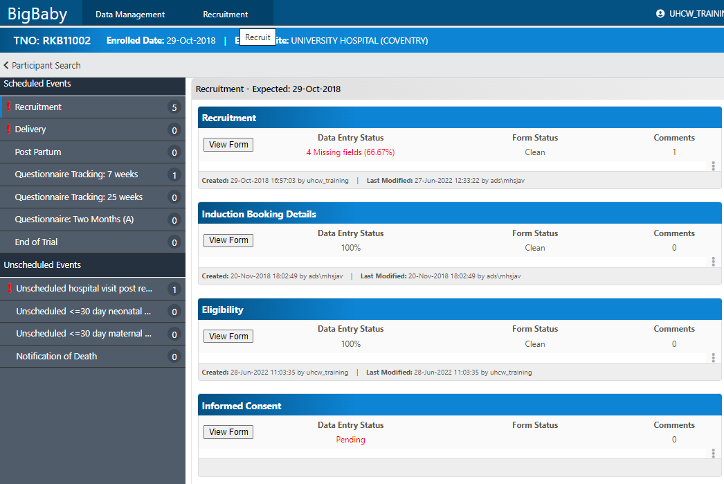

You will then see the following screen
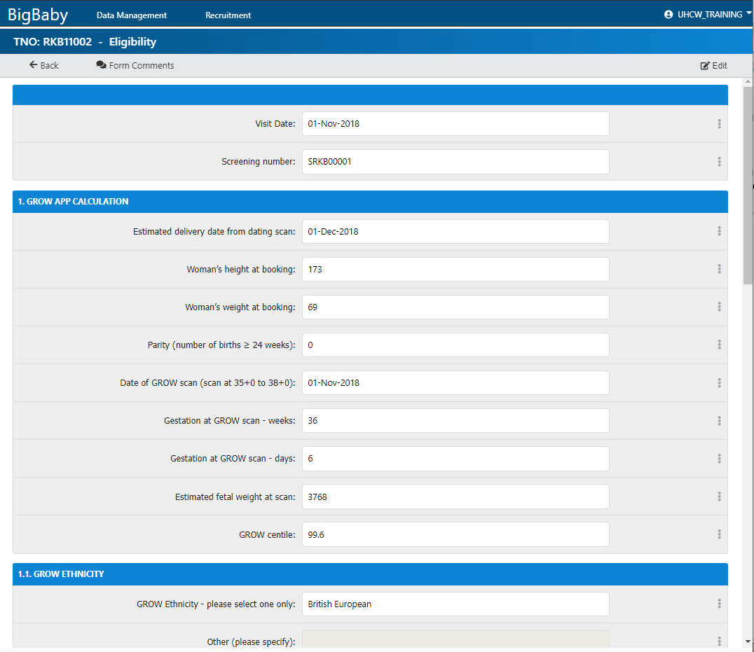
You can view these data, but you will not be able to change them until you click on the ‘Edit’ button on the top right hand side of the screen.

Clicking on ‘Edit’ makes the screen enterable.
Make the required change and click on ‘Save’ in the top right hand side of the screen.
You will then get a message:
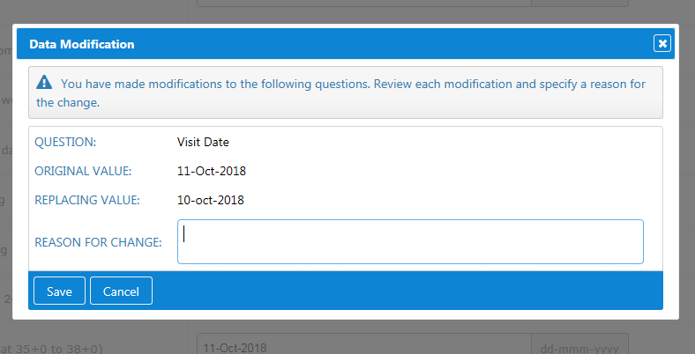
Type the reason why you changed the data, and save this reason.

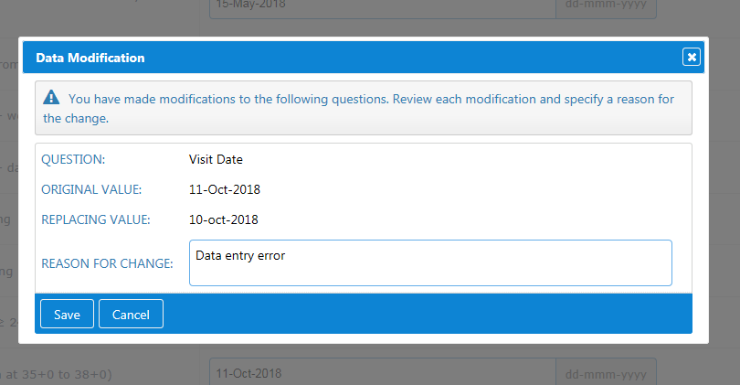

When you go back to the entry screen you can see that the ‘Date modified’ column has been updated to show the last date and time the section was modified.

Form Manager
This can be used to see the status of tasks.
Go to the Data Management tab and select ‘Form Manager’

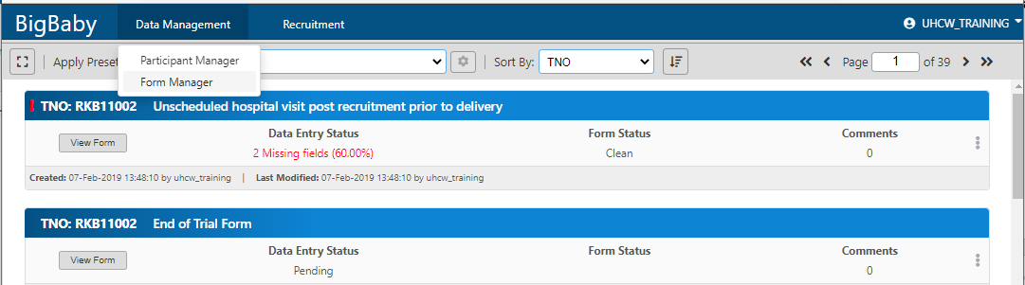
You can see filters that you can set by clicking on the expand button.
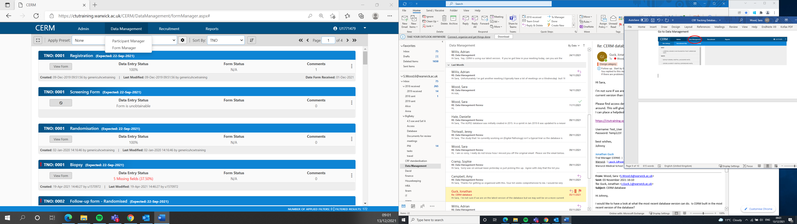
The view will then look like this
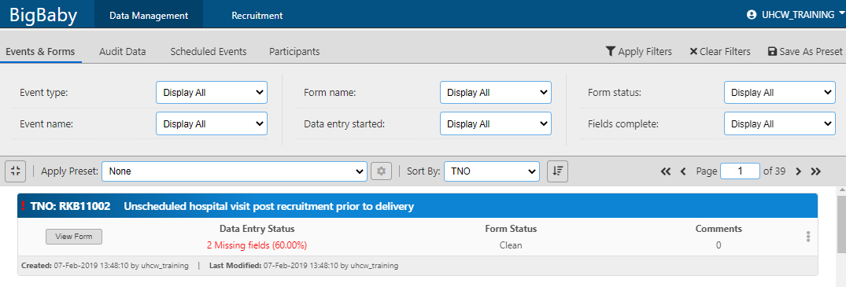
You can run filters that have already been created by going to the Apply Preset field, and choosing a report that WCTU or you have already created.

Here we have chosen the report ‘Forms not yet entered’.
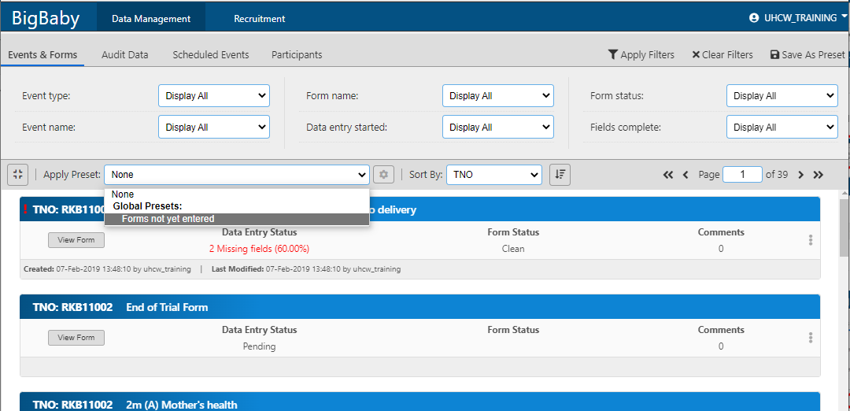
When you chose the report it will automatically run and show all of the forms that have not yet been entered.

You can set your own reports by amending the filters in Events and forms, Audit data, Scheduled Events and Participants. Please see examples at the end of this document if you are interested.

Entering difficult data
Please complete all data fields where possible. Missing, inaccurate or inconsistent data will probably result in you receiving a query form us at a later date,
Partial dates:
If the full date is not known, e.g. the start date of a medication taken for many years, please use the convention of entering ‘15’ for an unknown day, and ‘Jun’ for an unknown month.
For unknown times, e.g. the time the woman left the delivery ward. Please enter the best estimate.
If data are unknown and you do not think you will be able to access the data, please save the form status as ‘Clean with unobtainable missing data’, and mark the data item as unobtainable, using the three dots at the end of the field.
If you enter data into the wrong Study Number, please let the Trial Management Team know and we will have the data deleted for you.
Please make use of the Comment features, either whole form comments, or comments on individual fields to stop us from raising data queries.

Filters
You can create filters to look for outstanding forms, forms due in the future or missing data

Go to Data Management/Form Manager and expand the filters by pressing the expand button

For an example of how to set up filters.
If you would like to see which forms are due in today (this only works for scheduled forms as you should have pre-defined when each form was expected, e.g. 2 weeks after recruitment):
Choose Scheduled events and click on Today for Expected End Date.
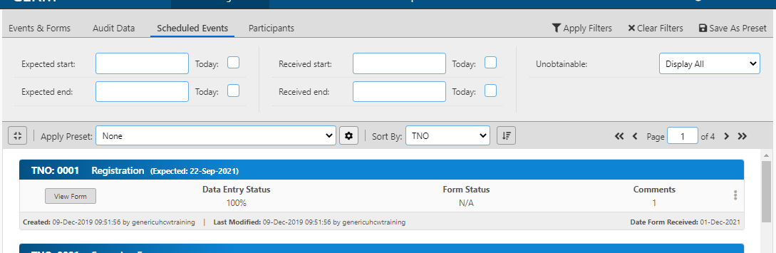

This will show all of the forms that are due up to and including today. If you click on Today, rather than choosing a date, then when you save the filter, it will always be the current day. Click Apply Filter to run the selection.
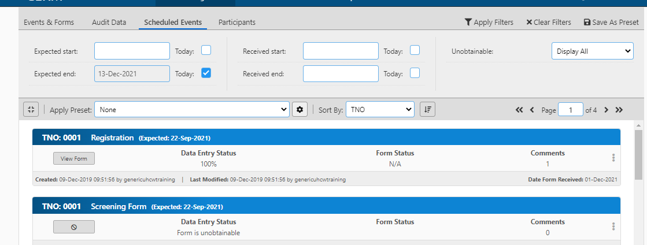

If you wanted only to see the forms that will be due in the next week, amend the Expected Start Date and Expected End Date. You can change the dates to give the time period required. If you save the filter the dates used will also be saved. If you save the filter using ‘Today’ then the ‘Today’ date will always move to the current date. Again click Apply Filters to run the selection. N.B. if you select a specific date, and save this report. It will save the data. If you select ‘Today’ next time you run the report it will run for the current day

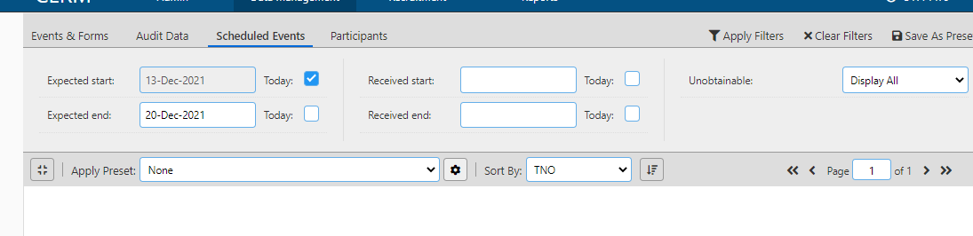

To see forms that are due but have not been entered:
Go to the Events and Forms tab, and for ‘Data Entry Started’ select ‘No’ and Apply Filter

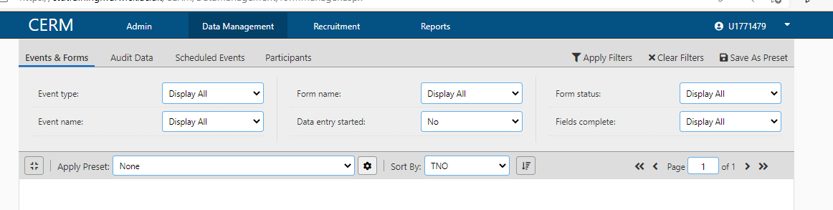
The forms then displayed would be anything between the dates selected in the Scheduled Events tab where data have not been entered.
To see all outstanding forms in Scheduled Events tab, leave the ‘Expected Start’ blank, select ‘Today’ for ‘Expected Stop’, then go to Events & Forms tab and select ‘Data Entry Started’ as ‘No’

Creating and Saving Filters
You can create and save a filter
Fore example if you wish to see all End of Trial forms where data entry has started but there are missing fields, you could go to the Events and Forms tab and select Form name as End of Trial, with Data Entry Started is ‘Yes’ and Fields Complete is ‘No’. Apply this filter.
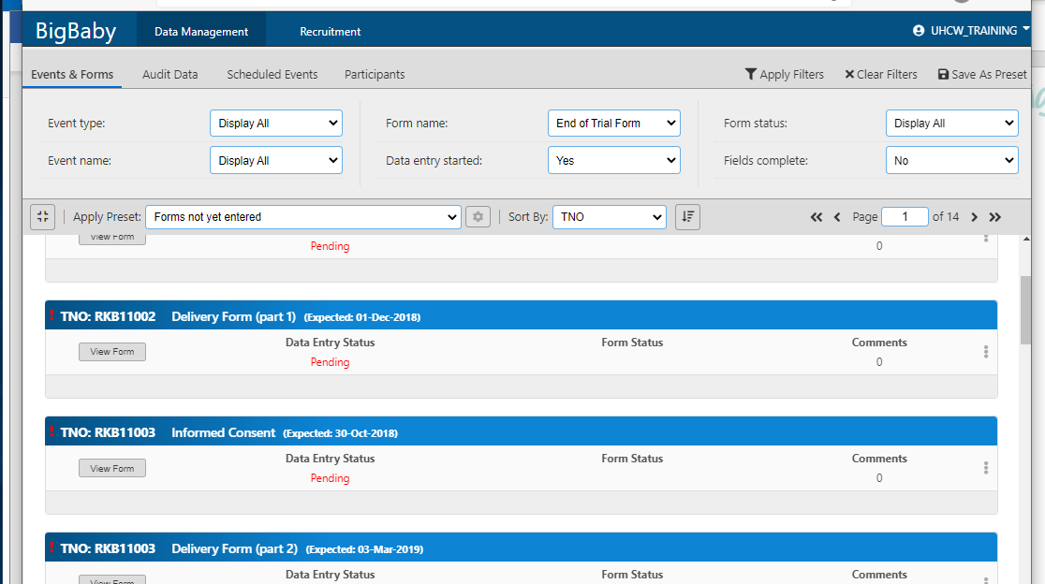
To save as a pre-set, check that all filters are set correctly, Apply Filters then save as pre-set. This will then be available as a standard report:
Give the report the name that you wish to use, in this case it is named Missing End of Trial Data then save it.
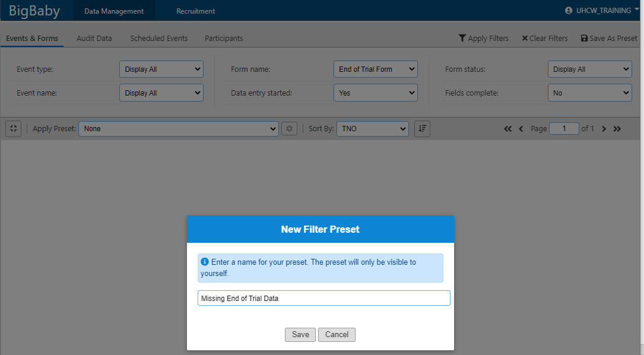

This will then appear in the Apply Preset field for you
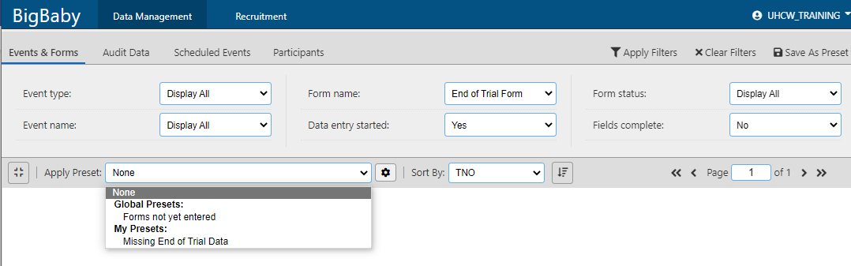

To delete a preset report the you can click on the cog then delete the form that is no longer required
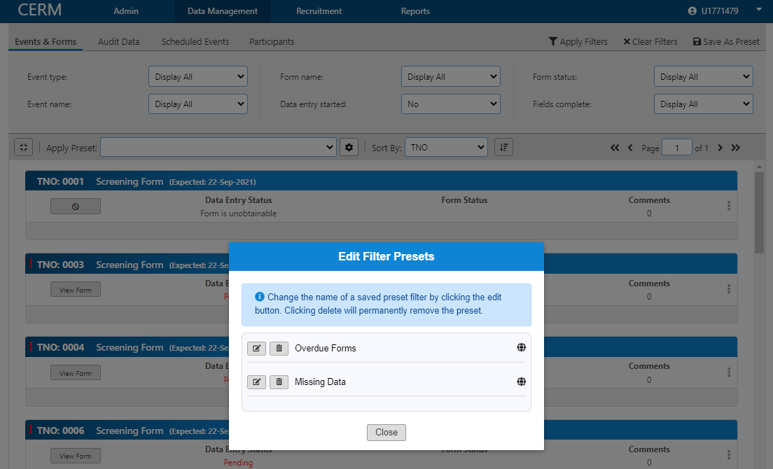

To see what is due in the next month you can set a report with the Expected start date as ‘Today’ and the Expected end date as the date one month on ( actual date needs to be entered) ***this will need to be updated on an ongoing basis as the Expected end date will always be saved as the date entered in and will not change with time***

