If there is a plan to induce the woman before 39⁺⁰ weeks gestation due to another health condition, then the woman cannot enter the trial.
If there is a plan to induce the woman after and including 39⁺⁰ weeks gestation, then the woman can enter the trial.
.
If you have any more eligibility queries, please contact the trial managers on
024 76 523858

Big Baby Eligibility Guidance
Each week we have a lot of eligibility queries, we hope this document can help you to decide if the patient may
be eligible.
Inductions for LGA
Inductions for Other Reasons
Many obstetricians are recommending induction for LGA and there is confusion if these women should enter the trial.
One of the exclusion criteria is “caesarean section or induction indicated due to health conditions such as cardiac disease or hypertensive
disorders”.
If you discuss the trial with the participant before they see the
obstetrician, then you can offer them the trial. The obstetrician will then
need to sign the essential recruitment document to say they can take
part. If the participant is randomised and allocated to standard care and
the obstetrician recommends induction – we strongly recommend this is
done after 39⁺⁰ weeks gestation.
If you see the participant after the Obstetrician has reviewed the
participant and the obstetrician has made the following plans, please
follow the table.
Contact us
Induction planned/booked ≥ 39+⁰ | Can enter BigBaby
Induction booked (has a date) for <39⁺⁰ | Cannot enter BigBaby
C-section booked for≥ 39+⁰ | Cannot enter BigBaby
Induction planned/booked <39⁺⁰ | Speak to obstetrician and ask if they could induce as near to 40+⁰ as possible then  Can enter BigBaby  C

Big Baby Eligibility Guidance | V4.0 | 01 March 2022

Previous Caesarean Section
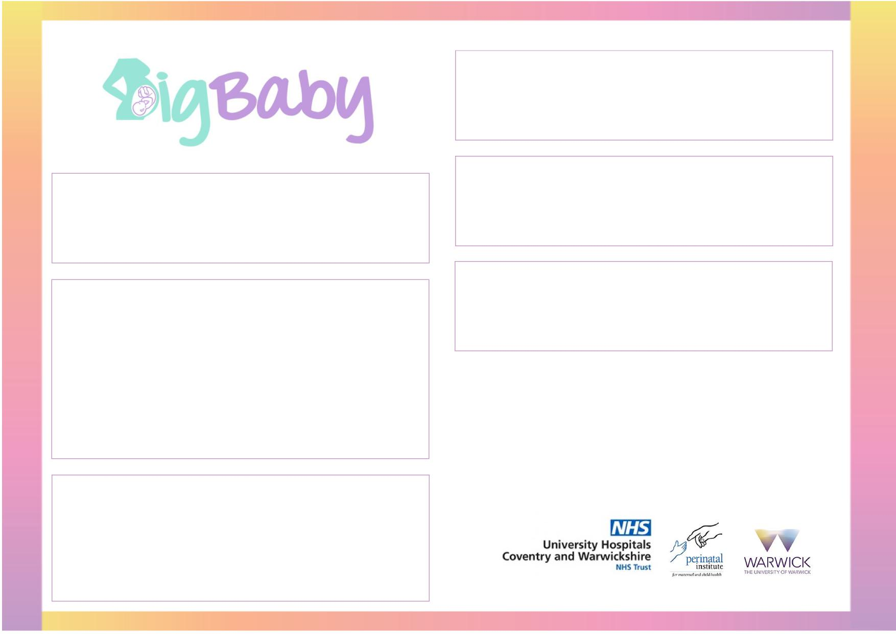
Method of induction
We do not specify which method of induction is used. Please follow your local hospital policy and document what was used in the case
report form.
IVF
Polyhydramnios
Women with an IVF pregnancy can be included in the trial, providing there is no plan to induce her before 39⁺⁰ and the
named obstetrician is happy for her to participate.
Women with polyhydramnios can be included in the trial,
providing there is no plan to induce her before 39⁺⁰ and the named
obstetrician is happy for her to participate.
Glucose tolerance test
Women with a previous caesarean section can be included in the trial, providing the named obstetrician is happy for her to
participate.
If you have a participant who meets all the eligibility criteria, but a
glucose tolerance test / blood sugar monitoring has been arranged
the participant can still be included in trial.
If the test finds the woman has GDM and has been randomised the
woman does not need to be withdrawn. Any event that happens
after randomisation is classified as an outcome and is recorded on
the case report form.
If you have any more eligibility queries, please contact the trial managers on
024 76 523858
Metformin for Polycystic Ovaries
If the woman is taking metformin for polycystic ovaries she can be included in the trial.
If the woman is taking metformin for diabetes she cannot be included in the trial.
_{g}
Big Baby Eligibility Guidance | V4.0| 01 March 2022

