Out-of-Hospital Cardiac Arrest Outcomes (OHCAO)

Data Sharing Request: Guidance and Application Form
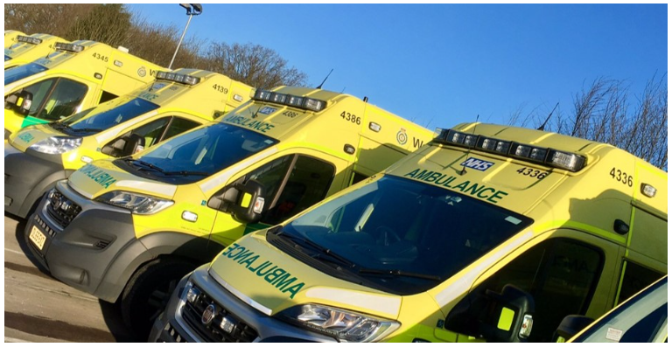
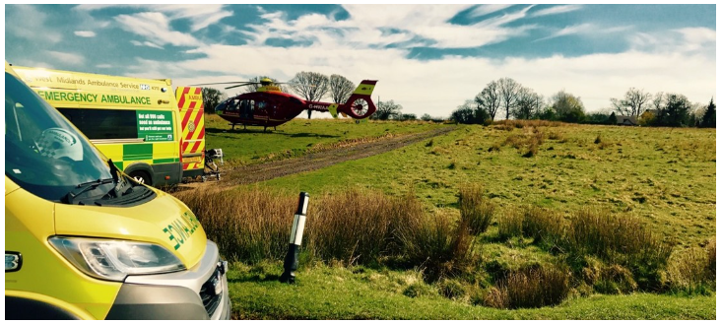

Guidance to applicants:
The OHCAO project supports the principle of data sharing to maximise the potential of stored data in accordance with international best practice guidelines [^{1,2}]. For the purpose of this policy “research data” are defined as factual records (numerical scores, textual records, images and sounds) used as primary sources for scientific research, and that are commonly accepted in the scientific community as necessary to validate research findings. A research data set constitutes a systematic, partial representation of the subject being investigated [¹].

The information that you provide in this data sharing request application form will be used to inform our application review process, including due diligence and ultimately any future data sharing agreement. We therefore strongly recommend that you contact the OHCAO team to discuss your potential data requirements beforehand.
We can be contacted by email at OHCAO@warwick.ac.uk.
Not all enquiries progress to the application stage, since it may be that your application can be met through existing published data, or you may need to discuss your proposal with the OHCAO team.
Some important elements of an application that often require further discussion include:
- whether OHCAO holds the data requested
- the purpose for accessing data
- the benefits accessing the data could yield for health and social care, patients and the public, in the UK and globally
If you are ready to make a formal application, we require you to complete all sections of this form and provide all relevant supporting information and enclosures where applicable.
The application will be referred back to you if more information is required in any of these areas.
Each application is subject to thorough assessment and review. The steps of this review are outlined in the flow map in annex 1. This includes submission to our Data Use Committee who will assess the application on:
- Scientific merit – the project must relate to cardiac arrest epidemiology, treatment or outcome
- Feasibility
- Methodological expertise within the team
- Justification for access to data
- Any overlap with other ongoing research
- Funding arrangements
- Ethical approvals
Note - The Data Use Committee is constituted by representatives from ambulance services (The National Ambulance Service Medical Directors [NASMeD]), the project team (Chief Investigator, study statistician), funders and lay representatives.
The Data Use Committee may request amendments or further information before their approval is given.
Once the application is approved by the Data Use Committee, there will then be further review by our Steering Committee. Once final approval is given by the Steering Committee, the contractual terms will be drafted. Subject to a successful data sharing request application, a Data Sharing Agreement (DSA) will be set up between the relevant parties; the OHCAO study manager will liaise with you to initiate this.
The DSA will need to be fully executed before the data is shared. See Annex 1. OHCAO Data Sharing Application Process: Flow Chart.
The DSA will stipulate that 1) the data recipient must obtain prior written approval from the individual ambulance service trust Principal Investigator(s) if they are identifying any individual NHS trusts in any publications; 2) the OHCAO project team will be offered the opportunity for a team member to fulfil authorship eligibility as per International Committee of Medical Journal Editors (ICMJE) guidelines [³] and co-author any resultant manuscripts, 3) external researchers require approval from the OHCAO project team for any papers presenting data from the OHCAO database prior to being submitted for publication.

All use, storage and handling of the data must comply with the UK General Data Protection Regulation (UK GDPR) and Data Protection Act 1998 (as amended). The DSA will stipulate processes, including destruction of data at the end of the study. It is the responsibility of the applicant to ensure adequate security levels are in place for data storage. Further studies will need to re-apply to the OHCAO project for approval.

Anonymisation
All datasets provided by OHCAO will be in an anonymised format. There are sections of this form that contain questions seeking confirmation that risk of data being re-identified through other sources accessible by the applicant will be mitigated in both the dataset and dissemination of outputs.

Note – Requests for Personal Identifiable Data (PID) will only be considered if there is a sound scientific reason. In addition to ethical approval, evidence of application to and approval by the Confidentiality Advisory Group (CAG) will also be required.

About this application
This application is…
☐ A new application
☐ An amendment to an existing application
☐ An extension of an existing approval

Application Form
Safe People
Who is going to be accessing the data?
Safe people should have the right motivations for accessing research data and understand the legal and ethical considerations when using data that may be sensitive or confidential. Safe people should also have sufficient skills, knowledge, and experience to work with the data in accordance with the required standards. Researchers may need to undergo specific training or accreditation before accessing certain data or research environments and demonstrate that they can be trusted to use the data in an appropriate manner.
The purpose of this section is to:
- identify details of people who will be accessing the data and the people who are responsible for completing the application
- identify any individual or organisation that intends to access the data requested
- confirm that those listed all have the necessary accreditation and/or expertise to work with the data effectively.
Training
We require assurance of appropriate Information Governance awareness and training in advance of considering a data sharing request application form. Currently we require you to confirm you have read:
- The National Data Guardian (NDG) Standards for Healthcare Data
- The Data Security Standard Overall Guide – (DSP) Toolkit
- National Data Guardian for Healthcare (CDG) Review: Review of Data Security, Consent and Opt-Out assets
And undertaken appropriate training, such as:
- Data Security and Awareness Level 1 Training (organised by eLearning for healthcare)
- MRC Regulatory Support Centre: Research, GDPR & Confidentiality (we will accept a certificate of completion)
Information Governance (IG) awareness and training must be current. Any IG training must be updated every three years, and where your training certificate expires within the time period of your study, you will be required to renew your training, as a condition of having the application approved.
Please note, this is not an exhaustive list, so if you have undertaken other relevant Information Governance training that covers comparable areas, please provide details in your application.

Please identify the Lead Applicant and Co-Applicants. These should include anyone who will access the data. This includes those from the applicant organisation and any third-party organisation(s) who will access the data for the purposes of this request. If more space is required, Annex 3 can be used.
1. Lead Applicant
1a. Full name
1b. Job title
1c. Organisation (with which employment contract is held under which requesting the data for)
1d. Email address
1e. Role with the data requested
1f. Will this person access the data requested? Yes ☐ No ☐
1g. Has this person undertaken professional training or education on the topic of information Governance?
(See Information Governance)
Please provide details of the most recent relevant training attended or planned.

Please attach CVs for the lead applicant.
CVs should include as a minimum:
- details of most relevant publications
- relevant outputs
- relevant training (to include Information Governance training).

2. Co-Applicant
2a. Full name
2b. Job title
2c. Organisation (with which employment contract is held under which requesting the data for)
2d. Email address
2e. Role with the data requested
2f. Will this person access the data requested? Yes ☐ No ☐
2g. Has this person undertaken professional training or education on the topic of information Governance?
(See Information Governance)
Please provide details of the most recent relevant training attended or planned.

Please attach CVs for all the applicants listed.
CVs should include, as a minimum:
- details of most relevant publications
- relevant outputs
- relevant training (to include Information Governance training).
If you wish to add further individuals, please use Annex 3: Additional co-applicants

Safe Project
What is the purpose of accessing the data?
Safe projects are those that have a valid research purpose with a defined public benefit and are approved by data owners. For access to data to be granted, researchers need to demonstrate that their proposal is an appropriate, lawful and ethical use of the data and that it is intended to deliver clear public benefits. The purpose of this section is to ensure that:
- the research purpose has a defined public benefit: this can be new knowledge, new treatments, improved pathways of care, new techniques of training staff, etc
- how the data requested will be used to achieve the project objectives is clearly explained
- the project rationale can be understood by lay reviewers.
3. Project details
3a. Title of project (300-character limit)

3b. Provide a lay summary of the project (300-word limit)
The lay summary should be in plain English, stating the project aims, scientific rationale, project duration and public health impact

3c. What is the anticipated start date of the project? (DD/MM/YYYY)

3d. What is the anticipated end date of the project? (DD/MM/YYYY)
3e. What are the project aims, objectives and rationale? (300-word limit)
Please describe:
- the overall aims of the project
- the specific objectives of the project
- any hypotheses that you wish to test
- details of any peer-review of the project prior to this application submission.

3f. How will the data requested be used to achieve the project objectives?
Please provide full details of your research methodology and statistical analysis. This must include justification of sample size, statistical methods and analyses proposed, additional data sources such as linked data, and any plans for collaborative work.
Please include:
- specific method(s) of analysis you plan to use (such as regression)
- sample size and justification for this
- as far as possible, the outcome or dependent variable(s)
- the starting-point for any modelling processes – acknowledging that the model may evolve
- how any potential selection/causal bias will be addressed (e.g. by including a control group with information on how this control group will be created)
- methodology references, if a non-standard methodology is proposed
- information about any contribution to the field of research methodology that you believe may result from your research
- an explanation of how your methodological approach will answer the research question(s) set out in the project when employing methods not covered by any of the above (e.g. correlation or basic descriptive analysis only will be used, noting that such analysis might be more applicable for exploratory research).
A separate Statistical Analysis Plan (SAP) can be provided as a supporting document if preferred.

3g. How will the project benefit the public and what is the anticipated impact?
3h. What patient and public involvement and engagement (PPIE) strategies have been used in the study. If not being used a brief explanation of why they are not planned? (300-word limit)
Please include:
- how you have incorporated public and patients’ views when designing your research questions and this project (this could be direct interaction or based on published surveys and research work, e.g. by Understanding Patient Data and UseMyData)
- your plans for sharing the results and disseminating the findings in an accessible way to the general public.

3i. In considering your proposal, do you believe it could disadvantage any group or individual? Explain what steps you have taken to avoid this.
Please explain if you believe you could disadvantage any group or individual in considering your proposal, such as by bias or non-inclusivity and explain what steps you have taken to avoid this.
Funder information
A funder is the organisation or body providing the financial resource to make the project possible, and may be different to the organisation detailed in the Safe People section.
4. Does your project have a funder? Yes ☐ No ☐
If Yes, please provide name:
If No, please provide details of how you intend to fund the study

5. Sponsor Information
The sponsor takes primary responsibility for ensuring that the design of the project meets appropriate standards and that arrangements are in place to ensure appropriate conduct and reporting.
5a. Associated applicant Please confirm the name of the applicant linked to this sponsor organisation. This information will be used to form the legal documents, such as the Data Sharing Agreement or any other contracts required.
5b. Organisation name Please provide legal name to appear on legal documents
5c. Registered address
5d. City
5e. Postcode
5f. Country

6. Contracts person
Please provide a contact details for the lead person in your study’s sponsor organisation or to liaise with regarding contracts and data sharing agreement or any other legal documentation.
6a. Full name
6b. Contact email address
6c. Contact telephone

7. Safe Data
Researchers should have a clear legal basis for accessing the data and ensure they do not inadvertently learn something about the data subjects during their analysis. The dataset provided by OHCAO will be anonymous, and safe data is about ensuring that any risks of re-identification are minimised. Please provide assurance and confirmation that data subjects cannot be identified by your team by cross-referencing data sets from anywhere else.
Sensitive or confidential data should not be considered to be completely safe because of the residual risk to a data subject’s confidentiality, hence other limitations on access will need to be applied, even with a dataset that is anonymous in its standalone form.
The purpose of this section is to ensure that:
- there is a clear legal basis for requesters to access data
- the data requested is proportionate to the requirement of the project
- all data requested is necessary in order to achieve the public benefit declared
- data subjects cannot be identified by your team by cross-referencing data sets from anywhere else
- data is not requested that is not necessary to answer the research question
These are the information assets which your proposal seeks to access and use. You should consider this definition to be wide in scope and include any source of information which you propose to access and use.
7a. Do you anticipate any risk to individual privacy, such as identification, and if so, what steps have you made in your proposal to mitigate these?

7b. Data fields
Please indicate the data fields required and the justifications for each field.
Please review annex 2 – OHCAO variables.
Insert additional rows if required
Category | Field Name | Justification for this variable

7c. Inclusion and exclusion criteria (including data parameters)
Please provide a description of the precise criteria which define the patients to be included and to be excluded from the data extract you are requesting
This should include the precise start and end dates (dd/mm/yy), and a justification for this.
Inclusion criteria:

Exclusion Criteria:

8. Ethical approvals
8a. Has the project received ethical approval? NHS REC ☐ University Ethics ☐ Other ☐ No ☐
8b. If ‘No’, from where do you plan to get ethics approval: NHS REC ☐ University Ethics ☐ Other ☐ No ethical approval planned ☐
8c. Please provide details of ethical approvals, including ethics approval reference number and the name of the body awarding ethics approval, if applicable. If ethical approval has not been sought yet, please provide the planned date of application and to which ethics body you are applying. If you are not seeking ethical approval, please provide a clear justification for why you are not doing this.
8d. Has the project received CAG approval to collect Personal Identifiable Data (PID)? Yes ☐ No ☐ N/A ☐
8e. Please provide details of CAG approval including reference number

9. Safe Settings
We need to ensure the data will only be accessed in a secure setting. Safe settings are analytics environments where researchers can access and analyse the requested datasets in a safe and ethical way. Safe settings encompass the physical environment and procedural arrangements such as the supervision and auditing regimes. For safe settings, the likelihood of both deliberate and accidental disclosure needs to be explicitly considered.
The purpose of this section is to ensure that:
- researchers access requested data in a secure and controlled setting that limits the unauthorised use of the data
- practical controls and appropriate restrictions are in place if researchers access data through a non-Trusted Research Environment (TRE). There may be requirements that data is held on restricted access servers, encrypted and only decrypted at the point of use
This section collects details on how the proposal aims to store and use data, and controls in place to minimise associated risks.
This section must include the details of all locations where processing will be undertaken.
Processing, in relation to information or data means obtaining, recording or holding the information or data or carrying out any operation or set of operations on the information or data, including:
- organisation, adaptation or alteration of the information or data
- retrieval, consultation or use of the information or data
- disclosure of the information or data by transmission, dissemination or otherwise making available
- alignment, combination, blocking, erasure or destruction of the information or data
Storage and processing
Please provide details of the organisation doing the processing and/or storage:
9a. Information Commissioners Office (ICO) registered name of organisation
9b. ICO registered number

9c. What type of security does this organisation have in place? E.g. Data security and protection toolkit, ISO 27001, SLSP.
Please provide a data flow map (as an annex)
This should clearly detail which data or subsets of the data are shared with which recipient organisations. This will help all project members to understand where all the data is flowing and to make sure at every stage of data transfer, all organisational and technical security measures are in place to protect that data in line with data security and protection legislation, thereby ensuring we recognise early on, the contracting requirements for a project. It will help us to comply with the transparency and accountability principles of the UK GDPR by being explicit about how the data is flowing.
The data flow map should contain:
- identification of the controller(s)
- identification of the processor(s) (usually an organisation or individual if not part of an organisation – don’t forget funders, collaborators and oversight committees)
- a clear direction of data flow/transfer between each entity
- data labelled as anonymised ( or pseudonymised, identifiable data, special category identifiable data if this is relevant)
- purpose of each transfer
- method of transfer
- security of each transfer.

10. Safe outputs
Safe outputs ensure that all research outputs cannot be used to identify data subjects. They typically include ‘descriptive statistics’ that have been sufficiently aggregated such that identification is near enough impossible, and modelled outputs, which are inherently non-confidential. The purpose of this section is to ensure that:
- controls are in place to minimise risks of identifying individuals through planned study outputs
- the researchers aim to openly publish their results to enable use, scrutiny and further research.
Please include any plans for dissemination and publication of the data and results arising from your proposal. The dataset provided by OHCAO will be anonymous, but once released will be subject to linking with other sources that may enable possible re-identification Please also specify any controls in place to minimise risks of re-identification associated with publication. Dissemination can take place in a variety of ways and through many mechanisms, including through electronic media, print media or word of mouth.
Outputs dissemination plans
10a. How will findings of this study be disseminated, to what audience and in what format?
As the public might not read scientific literature or attend conferences, please consider how the results or findings will be disseminated to the wider public and how these fit with the public benefit of the proposal. Please indicate if you plan to publish your findings in an open access journal.
Please include any milestones for outputs dissemination.
10b. What steps will be taken to ensure that individuals cannot be identified in any dissemination? Please describe what disclosure control policy will be applied. (300-word limit)
Please describe the steps you will take to ensure the confidentiality of the data when disseminating or publishing your findings. This may include the application of disclosure control procedures, aggregation of data or other approaches.
10c. Archiving
Please state the date until which you will retain the data and indicate the reason for this date
10d. What method of destruction will be used when this period has expired?
10e. What evidence will be provided that destruction has occurred and when?

Checklist for submission:
Evidence of training for all team members listed ☐
CVs for all team members listed ☐
Evidence of ethical approval (or pending) ☐
Dataflow diagram ☐

Please send your completed application form to OHCAO@warwick.ac.uk. Once submitted, we will email you to acknowledge receipt. The OHCAO team will then review your application and respond.

Annex 1: OHCAO Data Sharing Application Process: Flow Chart
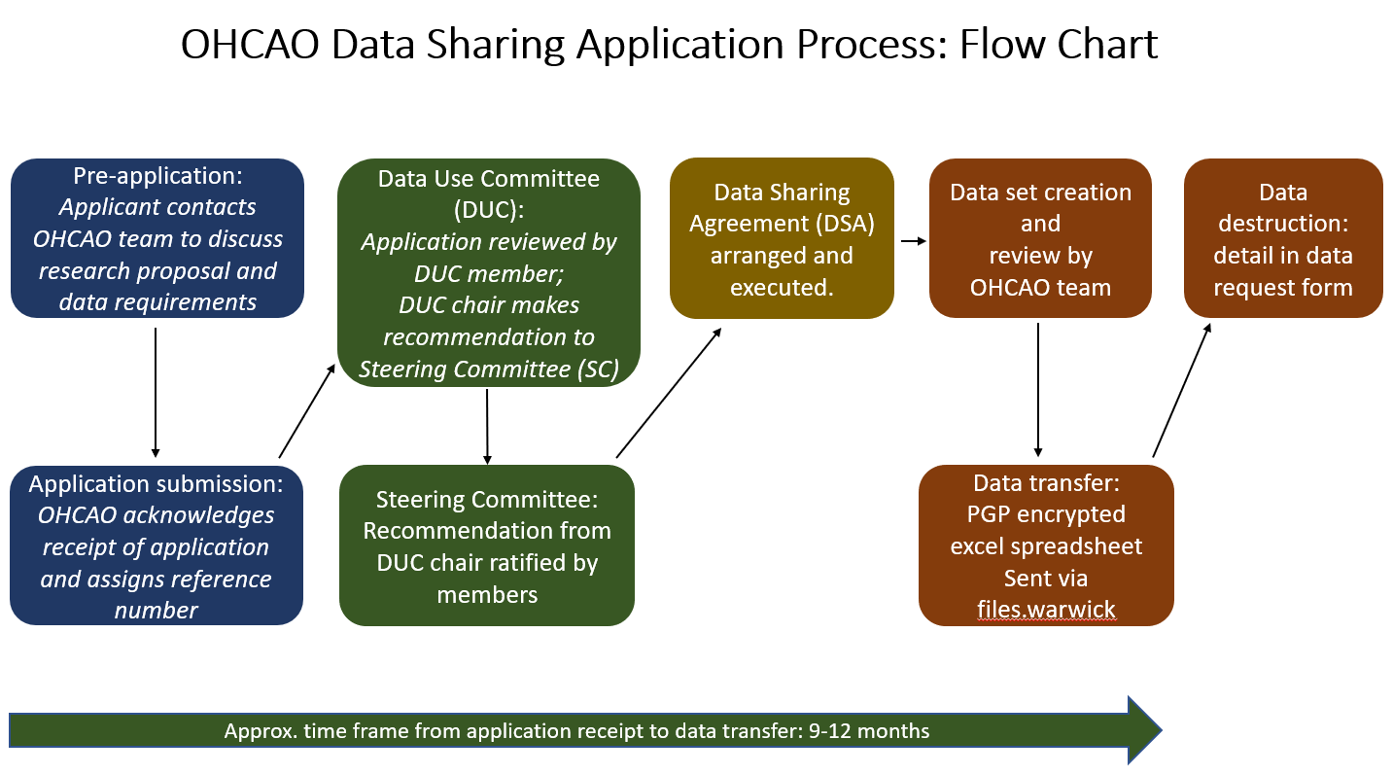

Annex 2: OHCAO Variables
OHCAO data set variables |  | required
Category | Field Name
Patient data | 1. Patient's age
Patient data | 2. Age unit
Patient data | 3. Patient's sex
Event Data | 4. Date of EMS call
Event Data | 5. Time of EMS call
Event Data | 6. Computer Aided Dispatch classification
Event Data | 7. Location of EMS occurrence
Event Data | 8. Utstein arrest location
Event Data | 9. Occurrence witnessed by
Pre-EMS First Aids | 10. Any treatment before EMS arrived
Pre-EMS First Aids | 11. Bystander commenced CPR
Pre-EMS First Aids | 12. Public Access Defibrillator available
Pre-EMS First Aids | 13. Public Access Defibrillator used by public
Primary Assessments | 14. Was a ROSC noted on arrival of EMS staff
Primary Assessments | 15. Initial aetiology of cardiac arrest
Primary Assessments | 16. Initial cardiac arrest rhythm
Primary Assessments | 17. Do Not Attempt Resuscitation order in place
Interventions | 18. EMS chest compressions
Interventions | 19. Consistent ventilations given by EMS
Interventions | 20. Attempted defibrillation of the patient
Interventions | 21. Total number of shocks
Drug Interventions | 22. Intravenous access
Drug Interventions | 23. Intraosseous access
Drug Interventions | 24. Adrenaline administered
Drug Interventions | 25. Amiodarone administered
Drug Interventions | 26. Saline bolus administered
Airway Management | 27. Oral pharyngeal airway used
Airway Management | 28. Nasal pharyngeal airway used
Airway Management | 29. Supraglottic airway used
Airway Management | 30. Endotracheal airway used
Outcome | 31. ROSC at any time
Outcome | 32. ROSC at hospital handover
Outcome | 33. Death confirmed by EMS
Outcome | 34. Receiving hospital code/name
Outcome | 35. Survival to discharge
Outcome | 36. 30-day survival
Outcome | 37. Date discharged
Process | 38. Time EMS mobile
Process | 39. Time EMS vehicle stops
Process | 40. Time of ROSC
Additional Variables | 41. Total number of out-of-hospital cardiac arrest patients

OHCAO data set variables |  | required
Category | Field Name
Personal Identifiable Data (PID) | 1. Patient's first name
Personal Identifiable Data (PID) | 2. Patients surname
Personal Identifiable Data (PID) | 3. Patient's Date of birth
Personal Identifiable Data (PID) | 4. Patient's NHS Number

Note – Variables considered to be Personal Identifiable Data (PID) can only be requested if the applicant has received approval from the Confidentiality Advisory Group (CAG).

Annex 3: Additional individuals
Full name
Job title
Organisation (with which employment contract is held)
Email address
Role
Will this person access the data requested?

Has this person undertaken professional training or education on the topic of information Governance?
(See Information Governance)
Please provide details of the most recent relevant training attended or planned.

Please attach CVs for the applicants identified. CVs should include as a minimum:
- Details of most relevant publications
- Relevant outputs
- Relevant training (to include Information Governance training)

Annex 4: References
References:
1. OECD Principles and Guidelines for Access to Research Data from Public Funding
http://www.oecd.org/science/sci-tech/38500813.pdf
2. Medical Research Council Data Sharing Population and Patient studies
http://www.mrc.ac.uk/research/policies-and-resources-for-mrc-researchers/data-sharing/data-sharing-population-and-patient-studies/
3. International Committee of Medical Journal Editors
http://www.icmje.org/recommendations/browse/roles-and-responsibilities/defining-the-role-of-authors-and-contributors.html

