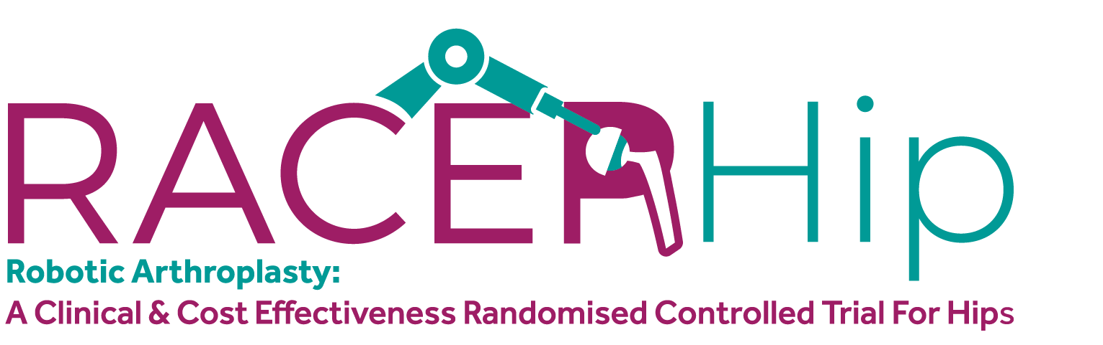

RACER-Hip Participant Information Sheet
Chief investigators: Mr Peter Wall and Professor Edward Davis
Hospital site: <<HOSPITAL SITE NAME>>
Principal investigator: <<PRINCIPAL INVESTIGATOR NAME>>
You are being invited to participate in a research trial. This information sheet will provide you with more information on the research so you can decide whether to participate. You have been invited because you have decided to undergo a total hip replacement and your surgeon also thinks this is the best treatment for you.
This study aims to compare robotic assisted total hip replacement with conventional total hip replacement for people with osteoarthritis of the hip. We plan to recruit 378 participants from hospitals across the UK.

Do I have to take part?
No, there is no obligation to take part. If you chose to participate and then change your mind, you are free to withdraw at any time. If you chose not to participate or change your mind, the care you receive will not be affected in any way.

Trial introduction
The research study compares a robotic assisted total hip replacement to a conventional total hip replacement for people with osteoarthritis of the hip.
Osteoarthritis of the hip is a painful condition, when it becomes severe it can be treated with a total hip replacement. This is a very common and successful operation at reducing pain and disability for people with osteoarthritis of the hip. However, some people continue to experience pain and problems with their hip, even after having the operation.
Total hip replacements have been performed for many years by orthopaedic surgeons, who use their experience and expertise to replace the hip with a standard set of instruments. The surgeons are very familiar with these instruments and have learned how to use them to get the best results. This is the most common way of performing a total hip replacement.
In more recent years, some surgeons have started using a robotic arm to help them perform the total hip replacement operation. The robotic arm is held and controlled by the surgeon throughout the procedure. The robot arm is meant to help move the instruments into the correct position by sensing the position of the leg more accurately.

Total hip replacement with standard instruments
Your surgeon will use their usual instruments to perform the total hip replacement and will be able to make whatever adjustments they think are necessary to get the best results. All your care will be to the same standard that anyone else would get in the hospital you are being treated in.

Total hip replacement using the robotic arm
Your surgeon will perform the total hip replacement with the aid of a robotic system called MAKO and made by a company called Stryker. This is the most widely used robotic system for total hip replacements and has been used many times and we are confident it is safe. It has a CE mark, which shows that the manufacturer has checked the product meets health and safety requirements and is an indicator of compliance with legislation and is licenced for use in the UK.
To use the robotic system, the surgeon inserts three pins in the pelvis bone, through small incisions which are approximately 5mm in length. The pins are used to tell the computer where the bones are. The surgeon then completes the operation but uses a robot to guide the preparation of the bone. They can make any adjustments they feel necessary and remain in control of the robot throughout. The robot will also help them to insert the new hip.

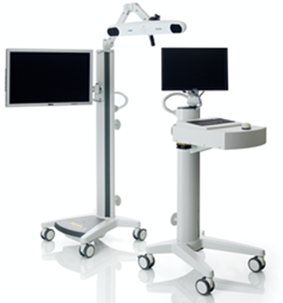
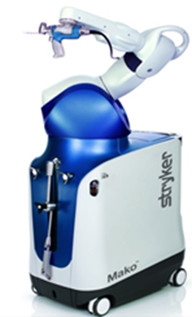
Picture 1 – The robotic hip surgery equipment
Robotic Arm
Camera system
Computer

What would taking part involve for me?
This research study is a randomised controlled trial. This means that the treatment you receive will be chosen at random by a computer, like tossing a coin to decide. You have an equal chance of receiving the conventional hip replacement or the robotic assisted hip replacement and your clinical team will not be able to influence this decision. To ensure that the comparison between the two treatments is fair, we will not tell you which operation you have had until the end of the study.
The people in the robotic assisted total hip replacement group require up to three small additional incisions on the pelvis to help the robotic arm sense where the bones are, as described above. To ensure that the operations look as similar as possible, the people receiving the total hip replacement with standard instruments will also have up to three small additional incisions around the pelvis bone. This is to ensure that people in the study don’t know which group they are in. These incisions are very low risk and will not affect your recovery. The incisions will have no medical benefit if you do not receive the robotic assisted total hip replacement.

Before your operation
If you decide to take part, you will be asked to sign a consent form to confirm this. The consent process can also be completed remotely over the phone or video link and witnessed by a member of staff independent of the trial. In both cases you will be given the opportunity to ask questions and have these answered before agreeing to participate. You should only sign the consent form or verbally agree to the study if you are happy to participate. Participation in the study will have no impact on the scheduling of your operation. Once you have signed the consent form, we will ask you to complete a short questionnaire to tell us about how your hip is currently affecting your life. It should take about 15 minutes to complete.

CT scan and x-rays
Before the operation in a separate visit, your surgeon will organise a CT scan of your hip and some simple x-rays of your pelvis and lower back. This will be performed on all trial participants, regardless of whether you have the robotic surgery or not. Everyone’s bones are slightly different, so the scans formulate a plan to best fit the new hip joint to your bones. Because you will receive these extra scans if you participate in the trial, we will send you a £20 shopping voucher to reimburse you for travel expenses to attend these scans.

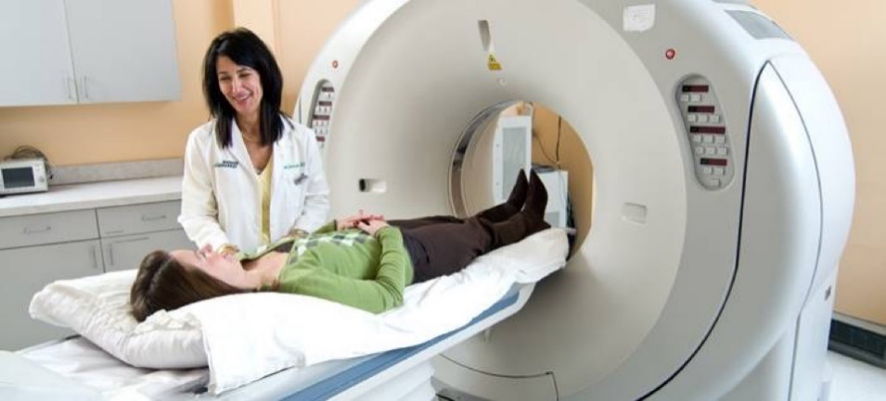
Picture 2: a CT scanner
To plan the operation, the images of your hip from the CT scan will need to be sent outside of the European Union, to the robotic system manufacturer (Stryker, USA). These images will contain at least two pieces of information which could identify you (for example, your name or date of birth) but these will only be seen by Stryker employees to plan your operation and will not be shared with any other party. This information will be managed through a secure portal and covered by individual agreements and information governance approvals between your NHS hospital and Stryker. This scan and some of the x-rays would not normally be needed for people who have a standard hip replacement but is needed for people who have robotic assisted total hip replacement.
Because of the additional imaging involved in this study, you will have a slightly higher dose of radiation to your body than if you did not take part in the study. The risk from this radiation to your health is however very low.

Day of the operation
When you arrive at the hospital for your operation, a member of staff will check with you whether you are still happy to take part.

During the operation
You may or may not see the robotic equipment in theatre; equipment may be wheeled in or out of the theatre so this will not indicate which treatment you are getting. A representative of the company (Stryker) and possibly another surgeon may be in theatre during the procedure to provide technical advice. This is a normal and necessary part of delivering the surgery safely.

After the operation
On the day after the operation and subsequent two days, a member of staff will come and ask you about the pain in your hip. If you leave hospital before the third day, we will give you a form to fill in at home or we will call you to ask you these questions.
The research team will review your medical notes after you’ve been discharged from hospital to find out how many painkillers or other treatments you received. We will work out how much blood you have lost using routine blood tests and we will take details about the operation and any other relevant treatments you received before or after the hip replacement.
When you leave hospital, you will be provided with a discharge booklet containing advice and exercises. If your clinical team think that you need to see a physiotherapist, they will organise this. If not, they will provide you with the exercise booklet to guide you through recovery.
You will receive a short questionnaire 6 weeks after the operation and further questionnaires at three, six and 12 months after the operation. Three months after your operation you will be invited for a further CT scan of your hip. After this scan, you will receive a £20 shopping voucher to reimburse you for travel to the scans. We will also send you questionnaires two years, five years, and 10 years after the operation. These questionnaires are very important to understand how you are doing.
You will continue to have routine follow up visits at the hospital which would normally happen if you weren’t in the trial. If one of these coincide with a due date for your questionnaires, we may ask you to complete the questionnaires in clinic instead. If you agree, we can send you a reminder that the questionnaire is due, based on the contact details you provide, such as your address, email and phone number. With your permission, we will also ask for contact details of your next of kin, in case we lose touch with you from the contact details you provide. A researcher may also contact you by phone to help you complete the questionnaires. We will contact the hospital that enrolled you to the study prior to the five and 10 year follow up questionnaires to check the information originally provided by you, such as your contact information and that you are well enough to complete these questionnaires.
We will request access to routine NHS data records (National Joint Registry, NHS Hospital Episode Statistics, or the Scottish Arthroplasty Project) at five and 10 years after your operation to find out how many participants had further hip operations or complications.

What are the possible disadvantages and risks to taking part?
There are general risks with any operation. After a hip replacement, it is normal to get some pain, swelling, bruising and some drowsiness or sickness from painkillers. Risks of having a hip replacement include continued or worsened pain, infection, wound problems. There is also a risk of the hip replacement dislocating or causing a discrepancy in the length of your legs. In some cases, there is a need for further surgery including redoing the hip replacement. Other risks include blood clots in the leg or lung, death, or injury to structures around the hip such as nerves or blood vessels.
The additional risk to taking part in the study is small. The pins in the bone used for the robot could rarely cause a fracture of the bone or an infection, but this is thought to be rare (less than one in every 1,000 cases). The additional radiation dose from the CT scans and X-Rays in the study is also very low risk, equivalent to around 4 years and seven months of natural background radiation. The risk associated with these examinations has been calculated as around 0.05% over your lifetime. For comparison the natural risk is 50% over a person’s lifetime.

What are the possible benefits to taking part?
There are no specific benefits to taking part in the trial. By participating, you will help us to decide which is the best treatment for people having hip replacements in the future and which is most cost-effective for the NHS.

What would happen if I chose to withdraw from the study?
You can stop being part of the study at any time, without giving a reason, but we will keep information about you that we already have. Your decision to withdraw from the study will not affect your medical care.

What if new information becomes available?
Sometimes during a trial, new information becomes available about the treatments being studied. If this happens, someone will discuss this with you and ask if you are happy to continue in the study. If you do continue in the study, you may be asked to sign an updated consent form. If you chose to withdraw, you can discuss your continued care with your doctor and you will still be provided with treatment.

What happens when the research study ends and with the results of the study?
You will be in the study for two years, although we will also send you additional questionnaires at 5 and 10 years after your operation. If you are still having problems with your hip after the study, your GP can refer you back to the hospital to continue your care.
We will publish the results in medical journal and present them at medical conferences. We will write our reports in a way that no-one can work out that you took part in the study. We will send you a summary of the results and inform you which treatment you received approximately three years after your operation.

Will the information I provide be kept confidential?
This study is co-sponsored by the University of Warwick and University Hospitals Coventry and Warwickshire. The University of Warwick will act as the data controller, meaning they will be responsible for looking after your data and will be using it to complete the study.
We will need to use information from, you, from your medical records and NHS data records (National Joint Registry, NHS Hospital Episode Statistics, or the Scottish Arthroplasty Project) for this research project. This information will include your name, initials, NHS or CHI number, contact details, date of birth, ethnic background, and health information. People will use this information to do the research or to check your records to make sure that the research is being done properly.
People who do not need to know who you are will not be able to see your name or contact details, your data will have a trial ID number instead. We will keep all information about you safe and secure, in accordance with the Data Protection Act (2018).
Once we have finished the study, we will keep some of the data so we can check the results. We will keep your data for a minimum of 10 years after the study has finished.
Your rights to access, change or move your information are limited, as we need to manage your information in specific ways for the research to be reliable and accurate. To safeguard your rights, we ensure that we minimise the amount of personally identifiable information we use. This data may also be used for future research, including impact activities following review and approval by an independent Research Ethics Committee and subject to your consent at the outset of this research project.
If you agree to participate and with your consent to do so, your GP will be notified that you are taking part. If we are not able to keep in touch with you, we may contact your GP in the future to collect your health records, so we know if you have had any problems related to the operation.
In very specific circumstances, such as if the research team are concerned about your safety or the safety of another individual, we may need to disclose confidential information to your GP. If the circumstances allow, we will ask for your permission or inform you in advance of informing your GP.
For further information, see the University research privacy notice here: www.warwick.ac.uk/researchprivacynotice or email gdpr@warwick.ac.uk.

Who should I contact if I wish to make a complaint or something goes wrong?
If something goes wrong and you are harmed during the research due to someone’s negligence, then you may have grounds for legal actions for compensation against University Hospitals Coventry and Warwickshire or University of Warwick. Any complaint about the way you have been dealt with during the study or any possible harm you might have suffered will be addressed. Please address your complaint to the person below, who is entirely independent of this study:
Head of Research and Development
Research and Development Department
4th Floor Rotunda
University Hospitals Coventry and Warwickshire
Coventry, CV2 2DX
Tel: 02476 966195
Email: R&D@uhcw.nhs.uk
Or the University of Warwick team using the details below :
Deputy Director/Head of Research Governance :
Research and Impact Services
University House
University of Warwick
Coventry, CV4 8UW
Tel : 02476 522746
Email : researchgovernance@warwick.ac.uk
If you wish to raise a complaint on how we have handled your personal data, you can contact the Data Protection Officer who will investigate the matter: DPO@warwick.ac.uk. If you believe we are processing your personal data in a way that is not lawful you can contact the Information Commissioner’s Office (ICO).
For independent advice contact the Independent Advice Service/PALS service (Patient Advice Liaison Service) on <<LOCAL PALS/SCOTTISH EQUIVALENT PHONE AND EMAIL>> or follow the NHS complaints procedure.

Who has reviewed the study?
This study has been reviewed and approved by the <<XXX>> NHS Research Ethics Committee (REC). It has also been reviewed by many experts in the field on the funding board and trial oversight committees.

Who is organising and paying for the study?
This research is organised jointly by University Hospitals Coventry and Warwickshire and University of Warwick. It is funded by the National Institute for Health Research (NIHR) Health Technology Assessment (HTA) Programme (Reference NIHR 131407).
Stryker, the manufacturers of the robotic system, have agreed to meet the additional costs of robotic surgery for the study. They will not be involved in the organisation, analysis, or interpretation of the study findings.

Contacts for further information
Site contact information:
<<LOCAL RESEARCH TEAM CONTACT DETAILS>>
Trial contact information:
Email: racer-hip@warwick.ac.uk
Website: www.warwick.ac.uk/racer-hip

