BASELINE CHARACTERISTICS
Type of consent |  | Patient ☐  Emergency consent ☐
Patient ethnicity |  | White  - British  - Irish  - Any other White background  Mixed  - White and Black Caribbean  - White and Black African  - White and Asian  - Any other Mixed background  Asian  - Indian  - Pakistani  - Bangladeshi  - Any other Asian background  Black / African / Caribbean / Black British  - African  - Caribbean  - Any other Black / African / Caribbean / Black British background.  Any other ethnic group.  - Chinese  - Any other  Ethnicity not given ☐
Date and time of hospital admission |  | :  DD/MON/YYYY HH/MM
Date of first symptoms |  | DD/MON/YYYY
COVID status |  | Suspected ☐  confirmed ☐
Comorbidities |  | None |  |  | ☐
 |  | End stage renal failure requiring renal replacement therapy |  |  | ☐
 |  | Congestive cardiac failure |  |  | ☐
 |  | Chronic lung disease |  |  | ☐
 |  | Coronary heart disease |  |  | ☐
 |  | Dementia |  |  | ☐
 |  | Diabetes requiring medication |  |  | ☐
 |  | Hypertension |  |  | ☐
 |  | Uncontrolled or active malignancy |  |  | ☐
 |  | Morbid obesity (BMI >35) |  |  | ☐
Pre-admission function (Clinical Frailty Scale) |  | CFS1 | Very Fit |  | ☐
 |  | CFS2 | Well |  | ☐
 |  | CFS3 | Managing Well |  | ☐
 |  | CFS4 | Vulnerable |  | ☐
 |  | CFS5 | Mildly Frail |  | ☐
 |  | CFS6 | Moderately Frail |  | ☐
 |  | CFS7 | Severely Frail |  | ☐
 |  | CFS8 | Very Severely Frail |  | ☐
 |  | CFS9 | Terminally Ill |  | ☐
Core body temperature at hospital admission |  | . ºC
Heart rate |  | bpm
Blood Pressure |  | / mm Hg
Respiratory rate |  | Breaths per minute
CURB-65 | Is the patient confused?  No ☐  Yes ☐  N/A patient sedated ☐ |  |  | Urea?  - mmol/L
FiO₂
SpO₂ |  | %
PaO₂ |  | - kPa  ☐ Not available
PaCO₂ |  | - kPa  ☐ Not available
Form completed by: |  | Name:
Date form completed: |  | DD/MON/YYYY

Completion Guidelines for CRF 3: Baseline Form
This CRF should be completed after a patient has been randomised into the RECOVERY-Respiratory Support trial.

Dates: | Please use the following formats for dates: 06-Jun-1956.
Times: | Please record all times in the 24-hour format.

Definitions:

Hospital admission: time of arrival at Emergency Department.
Date of first symptoms: patient reported
The following should be recorded as close to time of randomisation:
- Heart rate,
- respiratory rate,
- blood pressure,
- Curb 65,
- FiO₂
- SpO₂
- PaO₂,*
- PaCO₂ *

*Conversion of mmHg to kPa = mmHg × 0.13332

Clinical Frailty Scale (https://www.bgs.org.uk/sites/default/files/content/attachment/2018-07-05/rockwood_cfs.pdf):

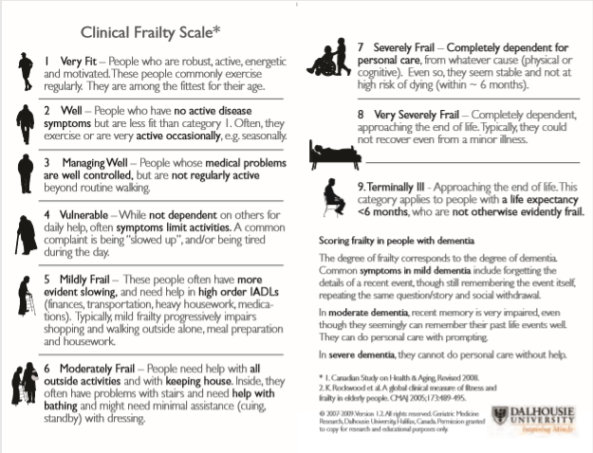

The person completing this CRF must have read the appropriate training slide set via the RECOVERY-Respiratory Support website and completed the online confirmation of training form.

