TNO: | 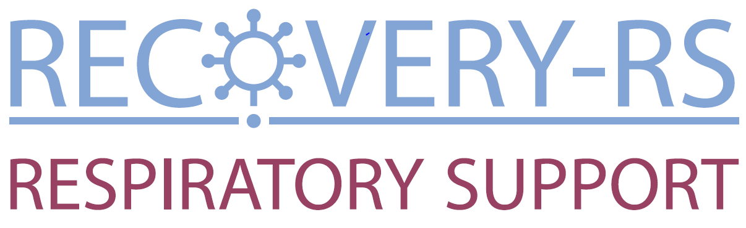  Protocol Non-compliance
PROTOCOL NON-COMPLIANCES
Any protocol non-compliances to report? |  |  |  |  | Yes ☐ No ☐
EVENT DETAILS:
(Include full details of the non-compliance i.e. exact nature of the event, how and when you became aware,
what investigations were undertaken, the implications of the findings, how this event has impacted (or had the potential
to impact) either patient safety and/or scientific quality/data credibility, the root cause of the finding)
Date of event:
 |  | DD/MMM/YYYY
CORRECTIVE ACTIONS:
(Give details of what immediate corrective action(s) were taken to rectify the situation and minimise the impact of the finding. Consider person responsible, who will be involved, stipulate timelines, consider impact on other areas, additional approvals needed)

RECOVERY Respiratory Care Trial CRF06 Version 1.0 03-Apr-2020

TNO: | Protocol Non-compliance

PREVENTATIVE ACTIONS:
(Give details of what actions will be/have been implemented to ensure the event does not happen again. Ensure actions relate to root cause. Consider if Quality Assurance procedures require updating, person responsible, who will be involved. Stipulate timelines, ensure actions are measurable)
FORM COMPLETED BY:
Name (please print): |  | Date completed:
Signature:
 |  | DD/MMM/YYYY

WCTU USE ONLY
ASSESSMENT OF REPORT:
Date CTU study team aware of event
Flagged to CI? |  |  |  |  |  |  |  |  |  |  |  |  |  |  |  |  |  |  |  |  |  |  |  |  |  |  |  |  |  |  |  |  |  |  |  |  |  |  | No ☐
 | Yes ☐ Date:
Reviewed by the TMG? |  |  |  |  |  |  |  |  |  |  |  |  |  |  |  |  |  |  |  |  |  |  |  |  |  |  |  |  |  |  |  |  |  |  |  |  |  |  | No ☐
 | Yes ☐ Date:
COMMENTS:
(Give details of justification for the outcome decision, further recommendations)
OUTCOME [select one only):
Not a Deviation/Violation ☐ ⇨Append relevant communications, file in TMF
Deviation ☐ ⇨Append relevant communications, file in TMF
⇨Date reported to other bodies*:
Violation ☐ ⇨Append relevant communications
⇨Date forwarded to sponsor’s office:
⇨Date reported to other bodies*:
Serious Breach ☐ ⇨Append relevant communications
RECOVERY Respiratory Care Trial CRF06 Version 1.0 03-Apr-2020

TNO: | Protocol Non-compliance

*Provide details of other bodies notified (e.g. PI at relevant site, DMC, TSC):

>Date breach confirmed (Day 0):
>Date forwarded to MHRA:
>Date forwarded to REC:
>Date forwarded to sponsor’s office:
>Date referred to DMC/TSC:
>Date reported to funder:
>Date reported to other bodies*:

RECOVERY-Respiratory Support CRF6 Version 1.0 03-Apr-2020

If deemed necessary by the TMG, has information been forwarded to other study sites for their information?
Yes ☐ Date | No ☐

Resolution date:

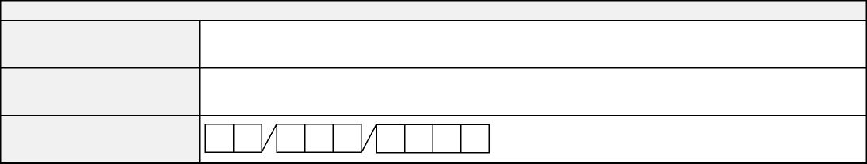
FORM COMPLETED BY:
Name (please print):
Signature:
Date completed:

