

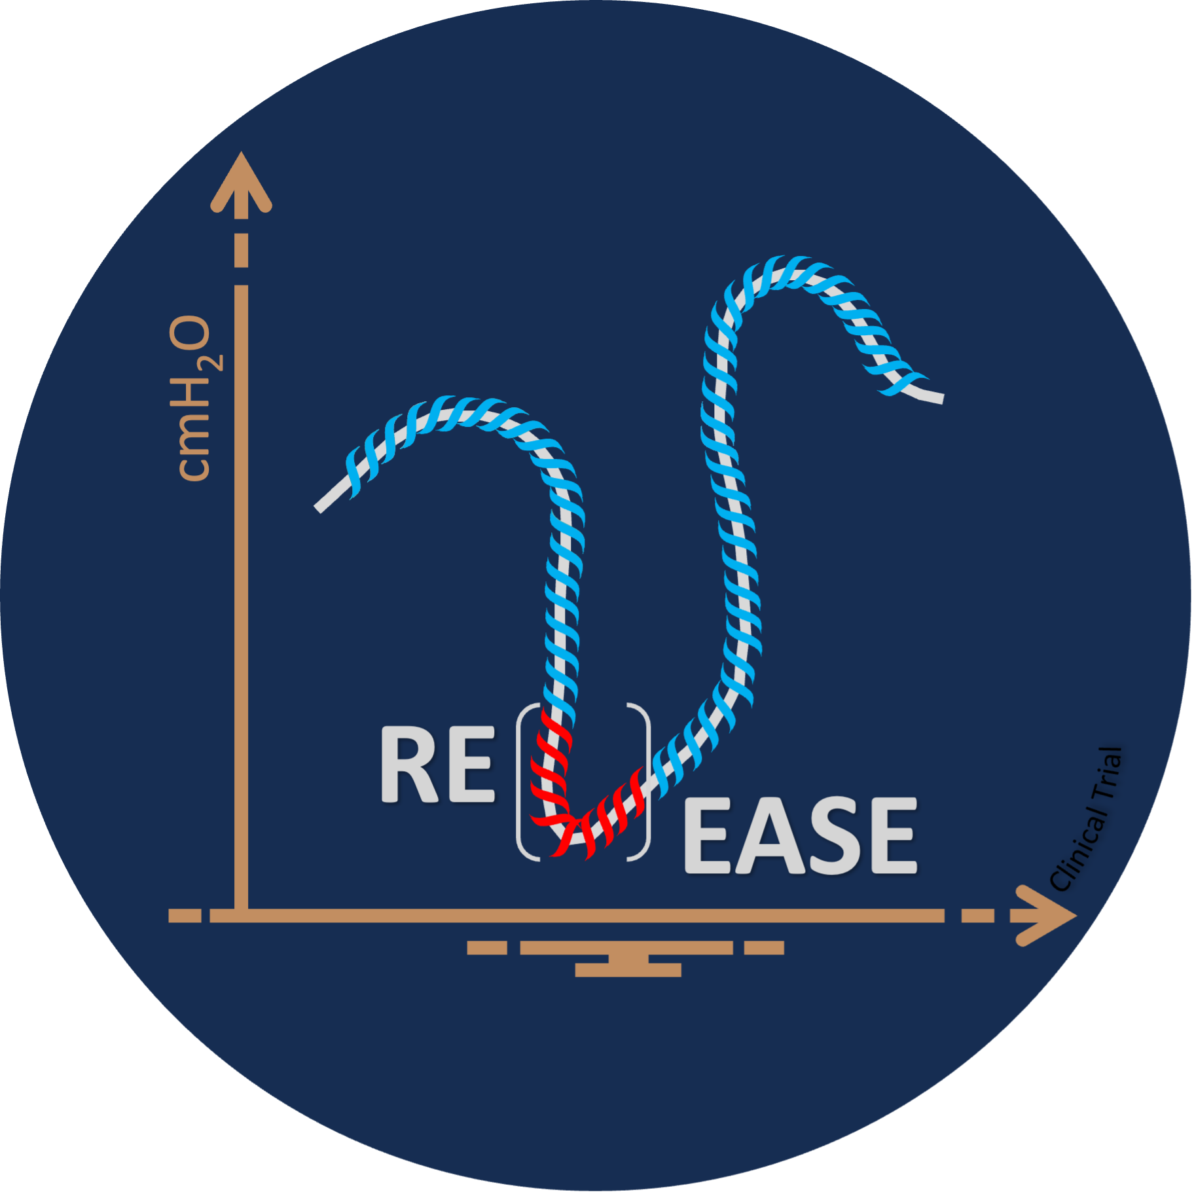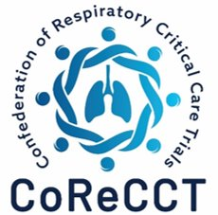

Airway Pressure Release Ventilation (APRV) vs conventional ventilation for patients with moderate to severe acute hypoxemic respiratory failure:
The RELEASE Trial

Chief Investigator: Luigi Camporota
Co-chief Investigator: Danny McAuley

- We are inviting you to carry on taking part in a study called RELEASE.
- You do not have to continue to take part if you do not want to. If you decide to continue to take part, you can change your mind at any time by telling the healthcare professionals looking after you. This will not affect any other care that you receive.
- You have recently been unwell and required a moderate or high amount of oxygen. At the time, the healthcare professionals looking after you felt that you were too unwell to make decisions about taking part in the study, so the study was discussed with your relative/ friend or an independent doctor. As you are now getting better, it is now possible to discuss the study with you.
- The RELEASE trial is looking to see if Airway Pressure Release Ventilation (APRV) which is a way of using the breathing machine helps patients with diseased lungs to heal faster and spend less time on a ventilator compared to the usual way breathing support is given in critical care.
- You are now in the follow-up stage of the study. This means that you are no longer ventilated (on a breathing machine). However, we would like to continue to collect information about you to see how well you recover.
- In this study we will use information from you, your GP, your medical records and some national healthcare databases. We will only use information that we need for the study. We will let very few people know your name or contact details, and only if they really need it for this study.
- Everyone involved in this study will keep your data safe and secure. We will also follow all privacy rules. At the end of the study, we will save some of the data in case we need to check it and for future research. We will make sure no-one can work out who you are from the reports we write.

Please read this information which provides an overview of the study to help you decide if you wish to continue to take part. One of the hospital research team will go through this with you and answer any questions you have. Please talk to others about the study if you wish and please feel free to ask any questions.

There is separate data information which describes how we will use data collected about you and can be accessed on the study website https://warwick.ac.uk/release-trial/public/, via the QR code at the end of this leaflet or a member of staff can print a copy for you.

Why am I being asked to take part in this research?
You have been in hospital with a condition called respiratory failure. This means you need extra oxygen to keep the oxygen levels in your blood at a safe level. There are several reasons why people have this condition. One of the most common reasons is a chest infection.
Your doctors will have given treatment for whatever condition was causing your respiratory failure. Despite this treatment, we know that some patients with respiratory failure will unfortunately get worse and may need to go on a ventilator (breathing machine) on a critical care unit (CCU). Going on a ventilator can be life-saving, but ventilators can cause damage to diseased lungs and make chest infections more likely.
The usual way a ventilator is used aims to protect lungs from damage until they are healed. However, damage can still occur, and lungs take time to recover. Airway Pressure Release Ventilation (APRV) is a way of using the breathing machine that we think causes less damage. It moves gas into the lungs gently over a longer time.

We are doing this study to find out if setting the breathing machine to deliver breaths using APRV helps patients with diseased lungs to heal faster and spend less time on a ventilator compared to the usual way breathing support is given in critical care. We also want to know if APRV saves more lives, improves patient’s quality of life, and saves the NHS money by helping people leave CCU sooner.

Do I have to take part?
No.
It is entirely up to you to decide. If you do not want to take part that’s OK. Your decision will not affect the quality of care you receive.

What will I need to do if I take part?
You were previously assigned by chance to one of two groups:
- APRV: The breathing machine will be set to the APRV mode. APRV moves gas into the lungs gently over a longer time. APRV is available on all ventilators that are used within the NHS.
- Usual care: The breathing machine will be set as usual by the critical care team.

Your friend or relative, the research team, or the medical care team did not get to choose which group you were in. This was be decided by a computer at random. This type of study is called a randomised controlled study and provides the best way for researchers and healthcare professionals to know if a treatment works.
You are now in the follow-up stage of the study. This means that you are no longer on a breathing machine. However, we would like to continue to collect information about you to see how well you recover. If you are happy to carry on taking part, we will ask you to sign a consent form. We will give you a copy of this information sheet and the signed consent form to keep.
We are collecting information about everyone in both groups to see how well and how quickly they recover. The information that we collect will include your age, sex, ethnicity and your medical information. We describe how we will use your data in the data information sheet.
We will also ask you to complete a questionnaire about your recovery in about 2-months and 6-months time. They will each take approximately five to ten minutes to complete. If needed, someone can complete them on your behalf. We may send you the questionnaires via text, email or post, or collect your answers to the questionnaire via telephone. We may share your name, email address, and phone number with a third-party company in order to send you the questionnaires by text message or email. We will also get in touch by text message, email or telephone if we have any queries about your questionnaire or if we have any updates related to the study.
Please take what time you need to decide whether or not to take part. You may wish to talk to family members.

Optional blood and urine sampling
All patients participating in the trial have the opportunity to provide blood and urine samples for future research. If consent was provided by your relative / friend or an independent doctor, samples would have been taken on three days whilst you were ventilated. The amount of blood taken on these days for research is small (20 ml each time or approximately 4 teaspoons). 5ml of urine would also have been taken on these days.
Blood and urine samples will be sent and stored at Queen’s University Belfast. Storage of these samples will enable us to undertake more research if new knowledge or technology becomes available. We do not know for sure what these future studies will be, but they may involve genetic analysis, sharing samples with collaborators abroad or research in collaboration with partners such as commercial companies. If this happens, the samples shared would be anonymous and external investigators or organisations would not be able to identify you.
Anonymised data collected as part of the study may also be used to understand the sample analyses. You can indicate on the consent form if you agree to let us retain samples for future use. All projects involving your blood and urine will be reviewed by an external committee of experts, which will safeguard the ethical use of them.
You can change your mind any time in the future and request for your samples to be destroyed without giving any reason by contacting the hospital research team. However, if they have already been used for research, it will not be possible to withdraw any data or findings from work completed using your samples.

What are the benefits of taking part?
As this is a study, you may or may not benefit from taking part. However, the findings of the research will help us to continually improve the treatments and care provided to patients with a similar condition now and in the future.

There is no payment for taking part in this study. However, to thank you for your time in completing the follow-up questionnaires at two-months and six-months, we will give you a small monetary gift voucher alongside each questionnaire.

The University of Warwick is currently leading several studies looking at how we treat patients with respiratory failure. This group of studies is called the ‘Confederation of Respiratory Critical Care Trials’ or ‘CoReCCT’. If you are taking part in other studies within CoReCCT, you will not need to complete questionnaires for each study. You will only be asked to complete the questionnaires once and will receive one voucher with each questionnaire.

What are the disadvantages or risks of taking part?

At this time, there are no important disadvantages or risks to taking part.

What if I change my mind?
You can change your mind about taking part at any time just by telling the research team. Even if you decide that you no longer wish to complete the follow-up questionnaires, you can still make a valuable contribution by letting us continue to collect information about you from healthcare records. This will not require anything from you, but if you are happy for us to do this it is important to make sure the study results are valid.

Will my taking part in this study be kept confidential?
In this research trial we will use information from your medical records, and healthcare databases such as NHS England. We will only use information that we need for the trial.

Everyone involved in this trial will keep your data safe and secure. We will also follow all privacy rules. At the end of the trial we will save some of the data in case we need to check it and for future research. We will make sure no-one can work out who you are from the reports we write.

For details on how data is used and kept safe, visit https://warwick.ac.uk/release-trial/public or scan the QR code at the end of this leaflet. If you prefer a printed copy please ask a member of staff.

What if there is a problem?
If you have any concern about any element of this trial, you can contact the researchers at your hospital: [insert PI contact details]
You can also seek advice from: [insert local Patient Advice and Liaison Service details or relevant local contact]
If you remain unhappy and wish to complain formally, you can do this by contacting the person below, who is a senior University of Warwick official and is independent of this study:
Head of Research
Governance Research & Impact Services
University House
University of Warwick
Coventry
CV4 8UW
Tel: 02476 575733
Email: researchgovernance@warwick.ac.uk

The University of Warwick will provide indemnity for this trial. If you are harmed due to someone’s negligence, you may have grounds for legal action which you may have to pay for. NHS bodies may also be liable if you are harmed as a result of negligence whilst taking part in a clinical trial. Non-negligent harm by NHS staff is not covered by the NHS indemnity scheme, and therefore compensation may not be paid in these circumstances.

Who is organising and funding the research?
This study is being sponsored and carried out by Warwick University, in partnership with NHS hospitals across the United Kingdom. The study is being coordinated by the Warwick Clinical Trials Unit. The study is funded by the National Institute for Health Research, Health Technology Assessment (NIHR154501). The views expressed are those of the author(s) and not necessarily those of the NIHR or the Department of Health and Social Care.

Who has reviewed this study?
People with personal experience of having respiratory failure and other members of the public have helped design and set-up this study.

Research in the NHS that involves patients is reviewed by an independent group of people called a Research Ethics Committee (REC). This committee is there to protect your interests. This study has been reviewed and been approved by Wales REC 2.

Contact for further information:
If you have any questions about the study, either now or in the future, you may contact your local hospital research team at <<local research contact details>>
You may also wish to seek the advice of an independent contact who has knowledge of the study but is not directly involved with the study
<<independent contact details>>

Alternatively, please contact the RELEASE trial manager at Warwick University:
Email: RELEASE@warwick.ac.uk

An online version both this information leaflet and the data information leaflet can be found on the study website, or by scanning the QR code below:
https://warwick.ac.uk/release-trial/public/



Thank you for taking the time to read this information and for considering taking part in this study.

