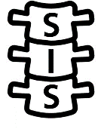

Young Person’s Patient Information Sheet (<16 years)

SIS: Randomised controlled trial of the clinical and cost-effectiveness of cervical spine immobilisation following blunt trauma

You are being given this information because you recently had a bad injury and may have damaged your spine. So, the ambulance service staff who treated you needed to take you to hospital for further tests.

To prevent further damage to your spine when taking you to hospital, ambulances often use something called “spinal immobilisation”. This involves using devices and strategies to stabilise your spinal column after spinal injury. There are two types of spinal immobilisation which we will explain later in this patient information sheet.

The ambulance staff who were looking after you decided you could take part in this research trial, as it’s a trial to find out which is the best spinal immobilisation method. It wasn’t possible to discuss the trial with you or your parents/guardian before because you were injured and need to be taken to hospital quickly.

Now that you are better, we’d like to ask whether or not you’d like to continue in the trial. It is important that you understand what the trial is about, why it is being done and what it will involve for you.

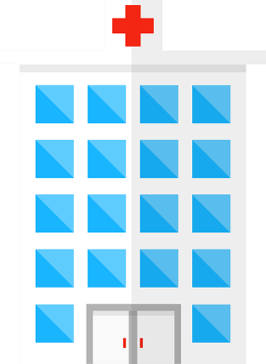
Please read this leaflet and think about it carefully. You can talk to your family, doctor or nurse about it if you want.
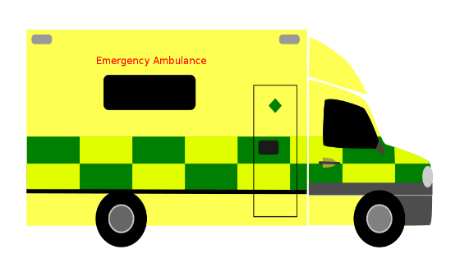
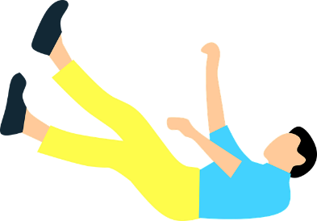

Why are we doing this research?
A research trial is a way that doctors will use to try to find out answers to questions, so we can help people get better.

This research trial is being done to find out which is the best “spinal immobilisation” method to use to prevent further damage to the spine when taking patients who may have damaged their spine to the hospital.

There are two types of spinal immobilisation.

- One is called “triple spinal immobilisation”. This is where paramedics place the patient on a rigid board or mattress and strap across their forehead using tape supported by blocks and/or hard neck collar. This reduces movement to prevent more damage to the spine when taking the patient to hospital.
- The other option allows the patient to move a bit, so they feel more comfortable, this is called “movement minimisation”.

Both methods are used in the UK. But we don’t know much about the effect of movement minimisation, so we are doing this trial to find out.

What will happen to me if I take part?
You have already been taken to hospital using one of the types of spinal immobilisation. The type that was used was decided by chance, a bit like tossing a coin, but we use a computer to decide this instead. This means that half of the people taking part in this trial were taken to hospital using triple spinal immobilisation and the other half using movement minimisation. This is the fairest way to see which works best.

We will collect some information from your hospital notes and a national database called the Trauma Audit and Research Network (TARN) for the trial. This will include information that could identify you

If you are happy to continue in the trial, you and/or your parent/guardian will be asked to sign a form

Research staff at the hospital you were taken to or at Imperial College London will ask you or your parents some questions about your recovery and to complete questionnaires during your hospital stay, when you are discharged from hospital and 30 and 180 days after your injury to see how you are doing.

Do I have to take part?
No, it is up to you if you want to take part. You can change your mind at any time.

You or your parents don’t have to complete the questionnaires. However, we will collect information about your health from hospital records and a national database. If you don’t want us to let us know. But we will keep information we have collected about you up to this point including information which would identify you. Again, if you do not want us to do this tell us or a member of the research team and we will stop.

Will taking part help me?
The trial may not help you at the moment, but it will help paramedics and doctors to know which method of spinal immobilisation to use for patients who suffer an injury in the future.

What if something goes wrong?
If there is a problem, you can talk to your parents/guardians, doctors, and nurses at any time.

What if I don’t want to take part anymore?
Just tell your parents/guardians and doctors and nurses carrying out the trial that you don’t want take part anymore. You don’t have to give any reason. It is your choice. But we will continue to collect information about you from medical notes and national databases unless you tell us you don’t want to. However, we will keep information we have collected about you up to this point unless you tell us you don’t want us to.

You can find the contact details for the doctors and nurses carrying out the trial at the bottom of this information sheet.

What will happen at the end of the trial?
The results of the trial will be written up so that people can read about it, but they won’t know that you were in the trial.

We will put our results on our trial website so your parents/guardians can read about the results of the trial.

If you or your parents/guardians agree we will share your information with other researchers to help with their research, but they won’t be given anything that might identify youtrial.

What if new information becomes available?
Currently there is no other research in this area which is why we are doing this trial. But sometimes, in the time it takes to do a trial, new information comes up. If this happens, the researchers conducting the trial will review this and decide whether the trial should be continued.

What will you do with my information?
We will use information from your medical records and national databases for this trial.

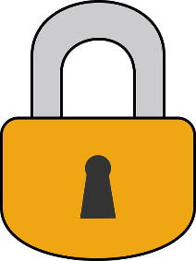
How will you look after my information?
We will keep your information private. Only people who need know will be able about to see your information and will keep information about you safe and secure.

How long will you keep my information for?

The University of Warwick and ambulance services and hospitals taking part in the trial will keep information about you for at least 10 years the trial has finished so that we can check the results. We will delete your name and contact details when we don’t need them anymore.

Where can I find more information about how we are using your information?
If you would like to find out more information about how we are using your information, you or your parents/guardians can contact the doctors and nurses carrying out the trial. Their contact details are at the end of this participant information sheet. They will give you information about who you can contact to find out more.

Who is organising and funding this trial?

There is a team of doctors and scientists lead by Professor Mark Wilson who are running this trial. Professor Mark Wilson works at Imperial College London. A team at University of Warwick Clinical Trials Unit is helping Mark to run the trial too. The National Institute for Health Research are the people funding the trial.

Who has reviewed and checked this trial?
Before any research goes ahead, it is checked by a group of people called a Research Ethics Committee. They make sure it is fair.

A different group of people (including members of the public) also checked the information sheets for the trial, like this one that you’re reading.

What should I do if I have any more questions?
You can speak to your parents/guardians, the doctors and nurses carrying out the trial or the Warwick trial team.
How do I contact the trial team for more information?

Hospital research team
Name:

Contact details:
University of Warwick trial team
Website: www.warwick.ac.uk/SIS
Email: SIS@warwick.ac.uk
Address: SIS Trial Manager, Warwick Clinical Trials Unit, Warwick Medical School,
University of Warwick, Coventry. CV4 7AL

