Sugar or Salt (SOS) trial:  Comparing two current  treatments for patients  with a brain injury | [Local hospital logo to be  inserted]
 | 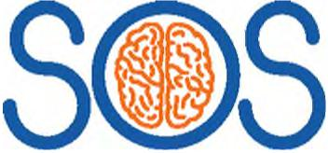

Invitation to take part in a research study
- We are approaching you because your relative has been admitted to hospital with a brain injury, and we would like to ask for your permission for them to take part in a research study.
- Throughout this information sheet we use the term ‘relative’ but this information also applies to partners, close friends, or other relations (e.g. if you are a carer).
- Before you make a decision, it is important for you to understand why the research is being done and what it will involve.
- Please take time to read the following information carefully. Discuss it with friends and other family members if you wish.
- We ask you to consider your relative’s views and feelings, and to set aside your own, when making a decision.
- Your relative joining the study is entirely optional, and you do not have to provide consent if you do not wish to. If you do not want your relative to take part, this will not affect the care they receive from their doctors.
- Ask us if there is anything that is not clear or if you would like more information.
How to contact us
If you have any questions about this study, please talk to the doctors who organise it:
[PI contact details]
Tel: XXX

Contents

- Why is the study being conducted?
- What would taking part involve?
- What are the potential benefits of taking part? What are the possible disadvantages of taking part?
What if something goes wrong?
- What will happen if I change my mind?
What will happen to the results of the study?
- How have patients and the public been involved?
Who has reviewed the study?
- Who is organising and funding the study?
What information do you collect?

Important things that you need to know
- We want to find the best way to treat patients where the brain swells after a head injury.
- We are comparing two different drugs, which are mannitol and hypertonic saline.
- Both of these drugs are normally used to treat patients with a brain injury, but we do not know which is better for patients.
- You can request that your relative stops taking part in the study at any time.

Personal legal representative pre­enrolment information sheet v6.0 11th April 2022
IRAS ID: 260350

Why is the study being conducted?
Over one million people each year suffer injuries to their heads which are severe enough that they need to go to hospital.
With the most severe injuries the brain often swells. If this swelling is not treated then the pressure in the skull can get too high, which compresses the brain and causes further damage to the brain.
The main treatments for swelling of the brain involve:
- putting the patient into a coma using drugs (to rest the brain)
- giving drugs
(to reduce brain swelling)
- in some cases brain surgery
(to release the pressure).
If initial treatments do not work, two drugs are commonly used to treat brain swelling:
- A salty solution (hypertonic saline)
- A sugary solution (mannitol)
Usually doctors would give one of these drugs, or a combination of both, but doctors do not yet know which treatment works best.
Both drugs also have unwanted side-effects. For example, hypertonic saline may affect the balance of salts in the blood, and mannitol may cause damage to the kidneys.
When doctors do not know which treatment is best, it is common to undertake a research study, to make sure that future patients have the best possible outcome after a brain injury. These studies involve putting patients into two groups, where one group will receive one treatment (in this case hypertonic saline) and the other group will receive a different treatment (in this case mannitol). The results are then compared to see if one is better. To try to make sure the groups are the same to start with, each patient is randomly allocated (by chance) to one of the groups.
This study is being conducted to compare how effective hypertonic saline and mannitol are for reducing the pressure in the brain. It will also measure which drug is better at helping the patient to recover, and what the side effects of each treatment are.

2 | Sugar or Salt (SOS) Trial

Personal legal representative pre­enrolment information sheet v6.0 11th April 2022
IRAS ID: 260350

What would taking part involve?
In total, 638 patients will be involved in the study. Half of the patients will receive the salty solution (hypertonic saline), and half of patients will receive the sugary solution (mannitol). Both of these treatments are given by a drip into the vein and several doses may be needed.
If you agree for your relative to be included in this study, you will be asked to sign a written consent form. If your relative becomes able to give consent for themselves during the course of the study, we will give them information about the study and ask whether they would like to continue in the study.
The study is expected to take around four years to complete. When the study finishes we will contact you/your relative to ask whether you/they would like to receive a copy of the study results.
Which of the two treatments your relative receives will be decided by chance using a computer programme (there is a 50% chance they will receive mannitol, and a 50% chance they will receive hypertonic saline). Your relative will still receive all other treatments and monitoring as part of standard care.
The study team will keep in contact with you or your relative for 12 months to find out how well they are recovering over time. Researchers will also calculate how much each treatment costs and compare this to how beneficial they were.

The follow-up will be done in two ways:
- We will post a short questionnaire to you or your relative 3 months, 6 months and 12 months after their brain injury to find out how they are recovering. We will also send a gift voucher with each questionnaire as a thank you, but there is no obligation for you to complete or return the questionnaires. These questionnaires should take around 10-15 minutes to complete. If we do not receive a response to the questionnaire, a member of the research team may telephone you/your relative to collect the information over the phone.
- We will collect data on your relative’s health, and information about their hospital stay from NHS medical records and from other organisations (these are listed later in this leaflet on page 8) over the next 12 months.

Hyperosmolar therapy in traumatic brain injury | 3
Personal legal representative pre­enrolment information sheet v6.0 11th April 2022
IRAS ID: 260350

What are the possible benefits of taking part?
Doctors do not know which of the two treatments is better, and that is why we are conducting this research. We therefore cannot promise any direct benefits as a result of taking part in this study. However it is hoped that the research will provide benefit to future patients who have a severe brain injury, as it will help doctors to know which is the best treatment to give.
What are the possible disadvantages of taking part?
The risk of harm from taking part in the study is not considered to be any higher than the risks of standard clinical care, because we are testing two existing treatments rather than a new treatment.
Because the study involves completing
questionnaires, there is a risk that you or your relative may find it upsetting to answer some questions about their recovery. Our trained research staff can talk to you or your relative about any such feelings and can suggest professional services for further support if this would be helpful.
Being part of the study will require a modest time commitment to complete the questionnaires (around 10-15 minutes for each questionnaire). However the information we collect will be very helpful to help us know how best to treat patients in the future.
What if something goes wrong?
If you have a concern about any aspect of this study, you should ask to speak to the researchers who will do their best to answer your questions [PI contact number].
You can also seek advice from your local Patient Advice and Liaison Service (PALS). They can be contacted at [insert local PALS contact details]
If you remain unhappy and wish to complain formally, you can do this by contacting the person below, who is a senior University of Warwick official and is independent of this study:
Deputy Director/ Head of Research Governance
Research & Impact Services
University House
University of Warwick
Coventry
CV4 8UW
Tel: 024 76 522746
Email: researchgovernance@warwick.ac.uk
This study is covered by the NHS and University of Warwick’s insurance and indemnity cover. Any complaint about the way you or your relative has been dealt with during the study or any possible harm they may have suffered will be addressed.
In the event that something does go wrong and your relative is harmed during the research and this is due to someone’s negligence then you/your relative may have grounds for a legal action for compensation against the University of Warwick or the relevant NHS organisation but you may have to pay your legal costs. The normal NHS complaints mechanisms will still be available to you.

4 | Sugar or Salt (SOS) Trial

Personal legal representative pre­enrolment information sheet v6.0 11th April 2022
IRAS ID: 260350

Hyperosmolar therapy in traumatic brain injury 5
Personal legal representative pre­enrolment information sheet v6.0 11th April 2022
IRAS ID: 260350
You/your relative’s rights to access, change or move their information are limited, as we need to manage your relative’s information in specific ways in order for the research to be reliable and accurate. If you decide to withdraw your relative from this study, we will keep the information that has already been collected. To safeguard your/your relative’s rights, we will use the minimum personally-identifiable information possible.
The decision for your relative to take part in the research is entirely voluntary and you can change your mind at any time without having to give a reason.
If you do not want your relative to take part in the study, or you change your mind at a later stage, this will not affect the care they receive from the NHS.
If you decide that you want your relative to be withdrawn from the study, we will not send any questionnaires to be completed. However we will continue to collect information about your relative’s health from other sources (please see page 8) unless you specifically request that we do not. To withdraw from data collection, please contact the study team at sostrial@warwick.ac.uk or write to SOS Trial, Warwick Clinical Trials Unit, University of Warwick, Gibbet Hill Road, Coventry, CV4 7AL.
Our patient and public partners will help us ensure that the findings of the research are summarised clearly. We will share the findings of the research widely. Our plan includes sharing the results with patients, the public, doctors and nurses. We will do this through talks, social media, written reports and scientific publications. We will work closely with our colleagues in professional organisations to ensure that the findings of this study are included in NHS clinical guidelines.
It will not be possible to identify you or your relative in any publications which result from this research.
What will happen to the results of this study?
What will happen if I change my mind?


Personal legal representative pre­enrolment information sheet v6.0 11th April 2022
IRAS ID: 260350
Sugar or Salt (SOS) Trial
All research in the NHS is reviewed by an independent group of people, called a Research Ethics Committee, to protect patients’ safety, rights, wellbeing and dignity. This trial has been reviewed and given a favourable opinion by the East of England - Essex Research Ethics Committee. The trial has also been reviewed by the Medicines and Healthcare products Regulatory Agency (MHRA) and National Institute for Healthcare Research (NIHR) Health Technology Assessment Board.
We are working closely with Headway, a national charity which supports people who have suffered severe brain injuries. They have helped us ensure that the patient and carers perspectives remain central to how the research is designed, conducted, analysed and shared with others. Patient and public representatives have agreed to work closely with us as part of the research team.
How have patients and the public been involved in this study?
Who has reviewed this study?
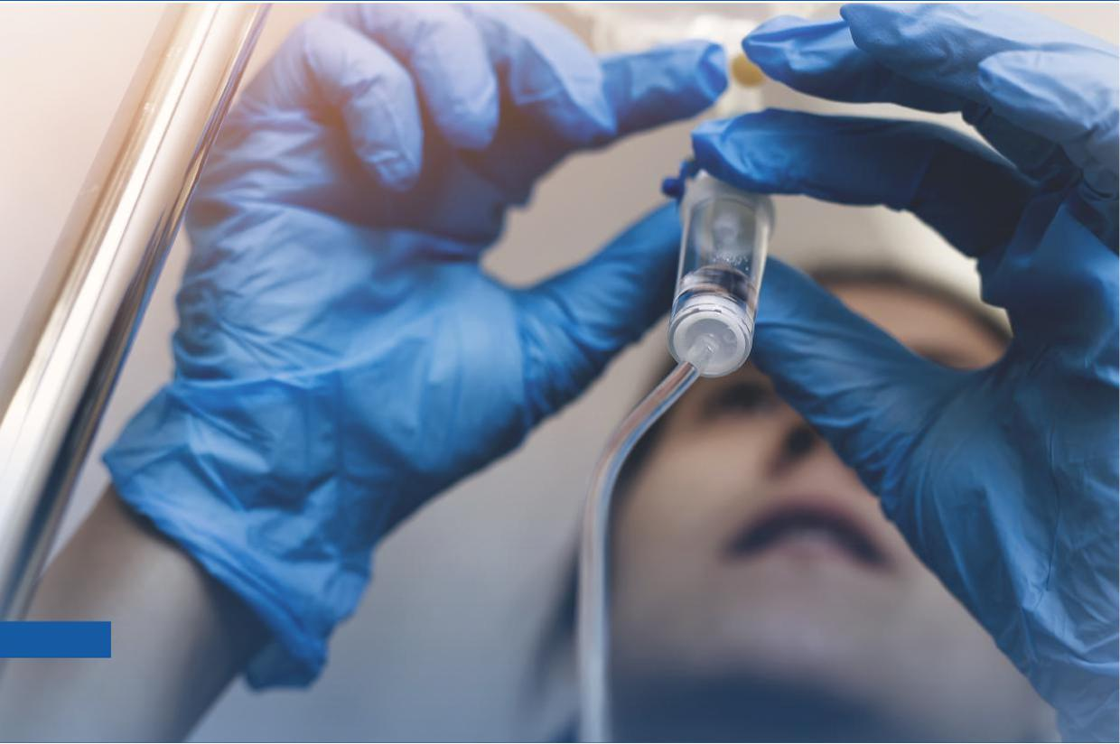
6

Who is organising and funding the research?
The study is organised by a group of doctors and scientists led by Professor Gavin Perkins, who works at University Hospitals Birmingham NHS Foundation Trust. The University of Warwick will coordinate the delivery of this study. University Hospitals Birmingham and the University of Warwick are cosponsors of the study.
This study is funded by the National Institute for Health Research (NIHR) Health Technology Assessment (HTA) Programme (Ref: 17/120/01).
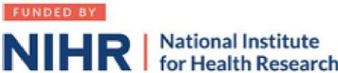
What information do you collect? Will my relative’s information be kept confidential?
The University of Warwick will act as the data controller for this study,and are responsible for looking after your/your relative’s information and using it properly. We will be using information provided by you/your relative as well as information from your relative’s medical records in order to undertake this study.
NHS hospital staff will collect information from you, your relative and their medical records for this research study in accordance with the University of Warwick’s instructions.
NHS hospital staff will use your relative’s name, NHS number and your/your relative’s contact details (address, telephone number, email address) to contact you/your relative about the research study, to make sure that relevant information about the study is recorded for your relative’s care, and to oversee the quality of the study. NHS hospital staff will pass these details to the University of Warwick, along with the information collected from you, your relative and their medical records.
By agreeing for your relative to take part in this study, their General Practitioner (GP) may be informed of their participation.

Hyperosmolar therapy in traumatic brain injury | 7
Personal legal representative pre­enrolment information sheet v6.0 11th April 2022
IRAS ID: 260350

The only people in the University of Warwick who will have access to information that identifies you/ your relative will be people who need to:
- audit the data collection process
- collect data from the organisations listed below
- contact you/your relative in order to:
- send follow-up questionnaires to be completed and contact you/them about any missing information on the questionnaires
- alert you/your relative that a questionnaire is on its way or has not been completed
- tell you/your relative about the results at the end of the study
Text messages to alert you/your relative that a questionnaire is on its way or has not been completed will be sent using a third party text messaging service called Esendex. We will share your/your relatives phone number with Esendex but no information that would identify you by name. Your/your relatives phone number will only be used to contact you about this study. Further information on Esendex’s privacy policy can be found here: https://www.esendex.co.uk/information-security-statement/
The University of Warwick will collect information about your relative for this research study from the following sources:
- their General Practitioner (GP)
- people involved in your relative’s care and rehabilitation
- NHS Digital
- Patient Episode Database for Wales (if your relative resides in, or is treated in, Wales)
- Information Services Division Scotland, part of NHS National Services Scotland (if your relative resides in, or is treated in, Scotland)
- Health and Social Care Northern Ireland (if your relative resides in, or is treated in, Northern Ireland)
- Intensive Care National Audit and Research Centre (ICNARC)
This information will include their name, date of birth, NHS number, address, and health information, which is regarded as a special category of information. This health information will include clinical information about diagnoses, treatments given and current health status, administrative information such as dates and methods of admission and discharge, and geographical information such as where they are treated and the area where they live. We will use this information to follow-up on how you relative recovers, and to find out the costs of treatment during their hospital stay and after discharge.
The University of Warwick, and the hospital where your relative is being treated, will keep information about your relative for a minimum of 10 years after the study has finished.
Individuals from the University of Warwick and regulatory organisations may look at your relative’s medical and research records in order to check the accuracy of the research study. Individuals from NHS Digital and ICNARC may look at research records for audit purposes.
The people who analyse the information will not be able to identify your relative and will not be able to find out their name, NHS number or contact details.
You can find out more about how we use your/your relative’s information here: https://warwick.ac.uk/services/ idc/dataprotection/privacynotices/ researchprivacynotice
When agreeing to take part in a research study, the information about your relative’s health and care may be provided to researchers running other research studies at the University of Warwick and in other organisations. These organisations may be universities, NHS organisations or companies involved in health and care research in this country or abroad. Your relative’s information will only be used by organisations and researchers to conduct research in accordance with the UK Policy Framework for Health and Social Care Research. This information will not identify your relative and will not be combined with other information in a way that could identify them. The information will only be used for the purpose of health and care research, and cannot be used to contact your relative or to affect their care. It will not be used to make decisions about future services available to your relative, such as insurance.
Thank you for taking the time to read this information leaflet.

8 | Sugar or Salt (SOS) Trial
Personal legal representative pre­enrolment information sheet v6.0 11th April 2022 IRAS ID: 260350

