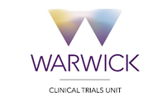
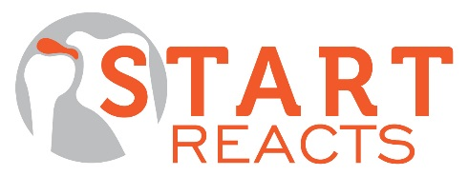

Study Summary Sheet Sub-acromial spacer for Tears Affecting Rotator cuff Tendons: A Randomised, Efficient, Adaptive Clinical Trial in Surgery

Study details | Short title: START  Chief Investigator: Mr Andrew Metcalfe  Lead Site: University Hospitals Coventry and Warwickshire  Trial Management Centre: Warwick Clinical Trials Unit  Funder: NIHR Efficacy and Mechanism Evaluation (EME) Programme
Study Overview | START is a participant and assessor blinded, multi-centre RCT comparing arthroscopic debridement with the InSpace balloon to arthroscopic debridement alone for people with an irreparable rotator cuff tear.  This pivotal new trial will be an adaptive design, its sample size will vary according to the outcomes of an interim analysis. This is proposed to be the first trial in a new programme of research aimed at improving the assessment of new surgical procedures.  The primary outcome will be the Constant score, which will be recorded at baseline, 3, 6 and 12 months. A per-patient payment will be made for the follow-up appointments and we will provide necessary equipment for the measurements.
Sample size | Max. 221 participants over a 2 year period
Approx. No. of sites | 21 NHS Sites
Information for sites | Sites should note:  - The participant and all staff outside of theatre will be blinded to the allocation.  - A standard rehabilitation and home exercise programme will be used for all participants.  - Randomisation will be performed in theatre once the diagnosis has been confirmed, using a simple online system available 24-hours a day.  - The InSpace balloon will be inserted at the end of the operation, in the intervention group. This is a short procedure taking only a few minutes and will not add significantly to theatre time.  - Surgeon training events will be provided and an OrthoSpace representative will be present to provide technical support at every case.  - Half of the balloons will be provided at no cost.  - Excess treatment costs have been approved for the primary centre. If there are any ETCs at your site (sites already using the balloon will make a saving) we have pre- prepared resources to help you manage these.
Eligibility criteria | Inclusion criteria:  - Irreparable rotator cuff tear  - Intrusive symptoms that warrant surgery  - Non-operative management has been unsuccessful  Exclusion criteria:  - Advanced gleno-humeral OA  - Subscapularis deficiency (except 1cm upper border tear)  - Interposition grafting or tendon transfers are indicated  - Unrelated symptomatic ipsilateral shoulder pathology  - Pseudoparalysis  - Previous proximal humerus fracture that influences shoulder function  - Neurological/muscular condition  - Previous entry into study (ie other shoulder)  - Unfit for surgery  - Unable to complete trial procedures  - Age under 18 and unable to consent to the trial
Study Design | Screening and recruitment in shoulder clinics  Enrolment  In theatre n= 212 (Maximum)  Arthroscopic debridement +/- biceps tenotomy  WITH InSpace device  N = 106 (Maximum)  Arthroscopic debridement +/- biceps tenotomy  WITHOUT InSpace device  N = 106 (Maximum)  Intervention  3, 6, 12 months (PROMs at 24 months)  Constant Score, strength, range of pain-free movement  Oxford Shoulder Score, WORC, EQ5D, Health Economics  Adverse events  MRI sub-study, scans at 6 weeks and 6 months  Follow up  Randomisation
Optional MRI sub-study | 56 participants will have a research MRI scans taken at 6 weeks and 6 months post-operatively. A light Theraband will be used to give some deltoid activation during the scan. The scans will be paid for, but your site does not have to take part in the sub-study to recruit to the main trial.
Contact Details | For any queries, contact our trial co-ordinating team on START@warwick.ac.uk tel: 02476 968 626

