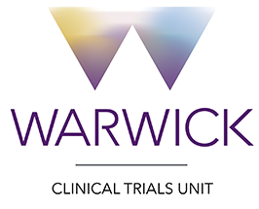
Note to File
Date: 11 December 2017

Study title: STRESS-L: Study into the Reversal of Septic Shock with Landiolol (Beta Blockade)

Subject: Screening documentation

All patients screened for this trial will be recorded on an Excel ‘Participant Screening Log’. Although a paper version has been provided in the ISF, the electronic version of the screening log is preferred, and should be emailed to WCTU (Stress-L@warwick.ac.uk) at least monthly so that CONSORT data may be collated. At the end of the study the electronic screening logs may be printed off and filed in section 10.1 of the ISF.

Name | Nafisa Boota
Signature | 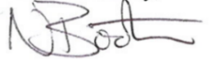
Job Role | Trial Coordinator
Date | 26/Mar/2018

