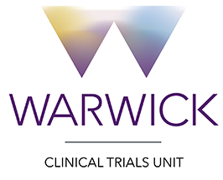
Note to File
Date: 11 December 2017

Study title: STRESS-L: Study into the Reversal of Septic Shock with Landiolol (Beta Blockade)

Subject: Version Log/Trial History Log

Please refer to section 2.3 for the Version Log/Trial History Log.

Name | Nafisa Boota
Signature | 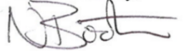
Job Role | Trial Coordinator
Date | 11/12/2017

