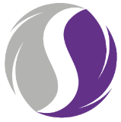
Welcome to the SWEET RCT newsletter!
June has brought rain, sunshine & lots of activity on the SWEET study!
As always, thank you all for your hard work!

The WCTU team have been busy opening sites, we now have 26 sites on board!
In other news, our team should be expanding shortly, however in the meantime we appreciate your patience in our response time to emails. If anything is time sensitive, please do mark as urgent & we will prioritise it.
  - ISSUE 3 – JUNE 2024
SWEET@warwick.ac.uk
  - newsletter

SWEET

Inclusion Reminder:

Where possible, we need to ensure all eligible women can take part in SWEET if they are interested.

There are lots of accessibility tools in video conferencing apps (teams, zoom etc) that can be utilised to assist patients with impairments/disabilities. You can find guidance on these here: https://rnid.org.uk/information-and-support/technology-and-products/video-conferencing-accessibility-meetings/
We also have loan tablets for HT&Me patients to help with accessibility and digital inclusion.

Upcoming Events:
Site Drop-In Session
09 July 2024 12:00
These recurring drop-ins will be used to provide study updates, address queries & share your experiences!
July’s session will cover initial consultations, difficult conversations & inclusion.

TEAMS Meeting ID:
314 957 200 738

Passcode: Qb7zrG


Letters of Access:
In order for our academic colleagues to undertake their HT&Me Consultations
fidelity checks & process evaluation research,
we will need to arrange letters of Access for open SWEET sites.

We will be in touch shortly to arrange these.
Recruitment Update (as of 27/06/2024)

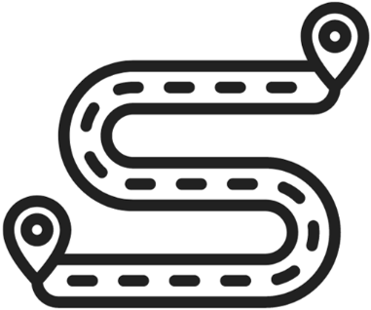
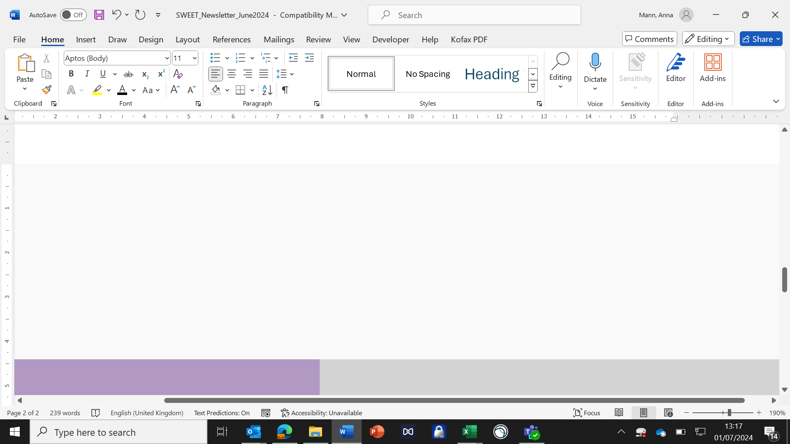
Screening Pathways:
We require patients from all breast cancer treatment pathways to successfully analyse the efficacy of the HT&Me intervention.
We ask you please screen from a variety of sources in order to capture both patients treated with Chemotherapy and/or Radiotherapy.
*Please note Chemotherapy patients must have completed their treatment before being approached for SWEET.
Substantial Amendment 1
SA01 received full REC & HRA approvals on 20th June 2024.
The amendment was shared with R&D departments 21st June 2024.

Please find below a summary of the updated and new documents:
Updated Documents | Version
Protocol | 4.0 08Apr2024
Protocol Summary | 2.0 08Apr2024
Patient Information Sheet | 4.0 08Apr2024
Informed Consent Form | 4.0 03Apr2024
GP Letter Usual Care | 4.0 08Apr2024
GP Letter HTMe Arm | 4.0 08Apr2024
Initial Appt Conf Letter | 2.0 08Apr2024
Follow Up Appt Conf Letter | 2.0 08Apr2024
Follow Up Questionnaire | 3.0 08Apr2024
New Documents | Version
Recruitment Animation  (this can be found on our website) | 1.0 Feb2024
Baseline Questionnaire Cover Letter | 1.0 03Apr2024
Follow Up Questionnaire Cover Letter | 1.0 03Apr2024
Patient Facing Clinic Posters | 1.0 05Mar2024
Patient Facing Clinic Banners | 1.0 01Mar2024

Please do not implement this amendment until your R&D department has issued C&C or the review deadline has passed.

