

Supporting Women with adherencE to hormonE Therapy following breast cancer

Dear [INSERT PARTICIPANT NAME],

Thank you for taking part in the SWEET trial. Your involvement has been very important to us.

We are writing to let you know that you are now coming to the end of the study. If you have not done so yet, please remember to fill in and return the final follow up questionnaire. What you tell us on these questionnaires is really important. It allows us to understand if the support package is useful and if it should be offered on the NHS to other women with breast cancer.
Please complete the questionnaire whether you are still taking hormone therapy, or not. If you have not received it, please contact your local site on: [INSERT LOCAL CONTACT DETAILS HERE]
The end of the study does mean that your access to the ‘HT&Me’ support website will stop in the next two months or so. If there are website pages that you would like to keep, you can download these and save them on your phone, tablet or computer, or print them out. Here is the link to the ‘HT&Me’ website: https://htandme.co.uk
If you have set up reminders on HT&Me to take your hormone therapy or order prescriptions, you may wish to organise another way to remind yourself (for example you could set up a reminder on your phone).
If you have any questions or concerns about your hormone therapy, or breast cancer more generally, please contact your breast care team, your GP or visit Breast Cancer Now: https://breastcancernow.org
You can visit the SWEET study website at any time to find out more about how the study is going: https://www.sweetstudy.co.uk. Once the study has finished, we will share the results on this website. You will also be sent a summary of the results (if you opted in to receive this). We expect this to be in early 2028. There are over 1500 women taking part in the trial and we need to wait until they have all been followed up for 18 months and then it takes another six months to analyse all the data and write up the findings.

Thank you again for your help with this important study.

Professor Linda Sharp Professor Eila Watson Mrs Jan Rose Mrs Lesley Turner
Study Lead Study Lead Patient Lead Patient Lead
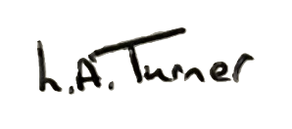
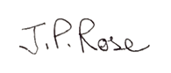
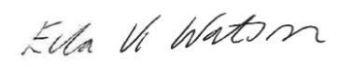

Insert QR Code
Insert QR Code
Insert QR Code

[HT&Me website] [Sweet Trial Website] [BCN website]

