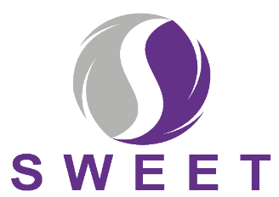

Dear {Participant Name}

Thank you for continuing to take part in the SWEET study. The study is investigating if a support package for women prescribed hormone therapy following initial treatment for breast cancer is useful or not.

Enclosed with this letter is your final 18 Month Follow Up Questionnaire; we are asking all women taking part in the study to complete this questionnaire.

Irrespective of whether:
- you are receiving the support package or not
- you are still taking your hormone therapy or not

This final questionnaire is really important.
It will help us understand how things have been with you over your time in the study. That will help us work out if the support package is helpful for women who have had breast cancer, and if it should be provided routinely through the NHS in the future. We would really like to hear from you whether you are receiving the support package or not and whether you are still taking your hormone therapy or not.

Please complete the questionnaire as soon as possible

It should take about 20-30 minutes of your time. Please return it to your local research team or directly to the SWEET trial office using the pre-paid envelope provided.

If you would like to know more about how the study is progressing, you can find updates here: https://sweetstudy.co.uk or on the QR code below

Thank you very much for your help with this important study.

Yours sincerely
[INSERT NAME & ROLE]


