

Dear {Participant Name}
Thank you for taking part in the SWEET study. This letter contains all the information you will need before your upcoming appointment with the SWEET study nurse/practitioner.
Your upcoming appointment with the SWEET study team is on:
Date:XX/XX/XXXX
Time:XX:XX to XX:XX

This appointment will be conducted:
- Face to Face/ By video conference/ By Telephone (please delete as applicable)
- Address/Video conference: (please insert appointment address or video conference link

If you need to change this appointment for any reason, please do not hesitate to contact us on:……………………………………….

Here is a link to a 6-minute video about hormone therapy. Please do try to watch this before your appointment with the SWEET study nurse/practitioner. You can type this link into google or your web browser, or scan the QR code using your smartphone camera to view the video.
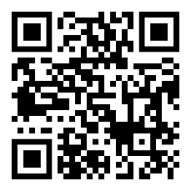

https://welcome.htandme.co.uk/

If you have any further questions, please do not hesitate to contact us on:……………………………

Yours sincerely
[INSERT NAME & ROLE]

