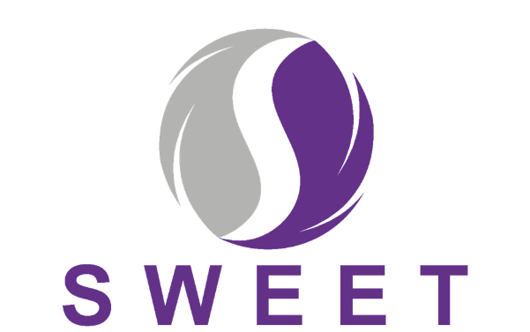

Participant Information Sheet
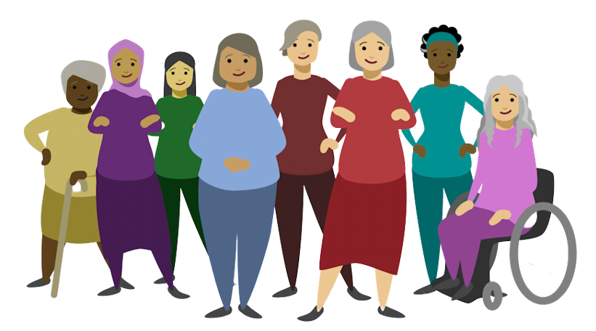
Title: Supporting Women with adhErence to hormonE Therapy following breast cancer

We are carrying out a research study for women who are taking hormone therapy after surgery for breast cancer, and we would like to invite you to take part. Joining the study is entirely up to you.
Before you decide we would like you to understand why the research is being done and what it would involve for you. One of our team can go through the information with you, to help you decide whether or not you would like to take part and answer any questions you may have.
Please take time to read the following information carefully. You may wish to speak to others before deciding whether to take part.
Part 1 tells you the purpose of this study and what will happen if you take part.
Part 2 gives you more detailed information about how the study will be carried out.


You may like to view our animation, which also provides information about the study using the QR code here.

PART 1:

What is the purpose of the study?
Many women are prescribed hormone therapy following diagnosis and hospital treatment for breast cancer. Hormone therapy significantly reduces the chances of breast cancer returning. Usually, women are recommended to take hormone therapy, in the form of a daily tablet, for several years. However, we know that some women either do not take this medication everyday as prescribed or sometimes stop taking it all together (known as “poor adherence”); this can increase their risk of breast cancer returning.
We have developed a support package (called HT&Me) which aims to encourage and support women to take their hormone therapy as prescribed and hopefully reduce the risk of breast cancer returning.
The purpose of the study is to investigate whether the HT&Me support package can improve hormone therapy adherence, and quality-of-life when compared to the standard NHS follow-up care offered in your hospital right now.

Why have I been invited?

You have been invited to take part in this study because you have been treated for a hormone sensitive breast cancer. Treatment for this includes taking hormone therapy (sometimes called endocrine therapy or hormone blocking therapy) every day to reduce the risk of your cancer coming back. This research study will offer 1460 women prescribed hormone therapy after breast cancer, across up to 80 UK NHS hospitals, the opportunity to take part.

This study is for all women prescribed hormone therapy after breast cancer surgery. Even if you do not have any problems or questions regarding your hormone therapy, we would still like you to take part.

Do I have to take part?
No. Taking part in this study is entirely voluntary and only if you provide permission (consent). Your routine NHS care will not be affected if you do not wish to take part. If you do not wish to take part, you do not have to give a reason why.
If you do decide to take part, you can change your mind at any time by letting your research team know. You do not have to give a reason for withdrawing from the study and your routine NHS care will not be affected if you do decide to withdraw. More information can be found in section 13.

What will happen to me if I take part?
If you decide to take part, we will ask you to complete and sign a consent form. If you are not attending the hospital for an appointment, we can do this over the phone. We will collect some details about you such as your date of birth, ethnic group, contact details (including name,
address, email address and telephone number), NHS number (or equivalent CHI/H&C number) and medical history (see SWEET Data handling Information Leaflet for full details). We will also ask you to complete a questionnaire booklet about hormone therapy, your quality-of-life, and the health services you have been accessing. This will take around 30 minutes in total.
Once this information is collected, you will then be randomly allocated into one of the following two groups by a process called randomisation. This is done by a computer so neither you, nor the research team choose which group you are randomised to. There is an equal chance of being selected for each group, like tossing a coin. We will tell you which group you have been randomised to.
- Group A: You will receive the HT&Me Support Package in addition to routine NHS care
- Group B: You will receive routine NHS care

If you are randomised to Group A you will receive access to the HT&Me Support Package which involves:
- An initial consultation of around 30 minutes with a HT&Me study nurse/practitioner (either based at your local hospital site, or via the charity Breast Cancer Now) to discuss hormone therapy, answer any questions you might have and introduce the HT&Me website. This appointment may be delivered in person, by video call or if required by telephone call. Appointments with a Breast Cancer Now nurse will always be completed over video call (or telephone). When you are sent your appointment for your initial consultation you will also be provided with a link to a short video about hormone therapy.
- Access to the HT&Me website for the duration of your time on the study (18 months), which contains short videos, information, tips & tools to support you to take your hormone therapy every day (e.g. you can set reminders to take your hormone therapy or order repeat prescriptions), get tips for managing any side-effects, and information about how to get further support, if you need it.
- After 12 weeks, you will have a follow up consultation with the HT&Me study nurse/practitioner (based at your site, or via Breast Cancer Now) to see how you are getting on with your hormone therapy and the HT&Me website. For a few women, we might record their consultations; this is simply to check what information they have been given and that the consultations are going as planned. We may also ask you to provide brief feedback of the appointments via text message.
- You will also be sent some messages by email or text throughout the study period, for example, to remind you about the importance of taking your hormone therapy and that the website may be a useful resource for you.
- You will also have your usual NHS care, including any follow-up for your breast cancer.

If you are randomised to Group B you will continue with your usual NHS care (including any follow-up for your breast cancer) and hormone therapy as prescribed. You will not receive any additional care.

For both groups, we will also follow up with you at 6 months, 12 months and 18 months, by questionnaire. This is really important for us to see how you are getting on with your hormone therapy, how often you are taking it and to complete some questionnaires about how you are in general. We would also like to ask you about your use of health services. As part of checking how you are getting on with taking your hormone therapy, we would also like to collect information about your prescriptions, including how often you request and collect breast cancer prescriptions and what other medications you are taking.

You may also be contacted for up to 15 years after you enter the study to see if you would be happy to tell us how you are, for the purpose of providing longer term information. As part of this follow-up, we may also want to collect information about any breast cancer treatment related prescriptions you are collecting or taking.

We may also ask you to take part in an interview (either by telephone or video call) with an experienced researcher to talk about your experience of being in the study and taking hormone therapy. It is your choice if you would like to take part in an interview; not everyone will be asked to take part, and this will only be with a small number of participants.

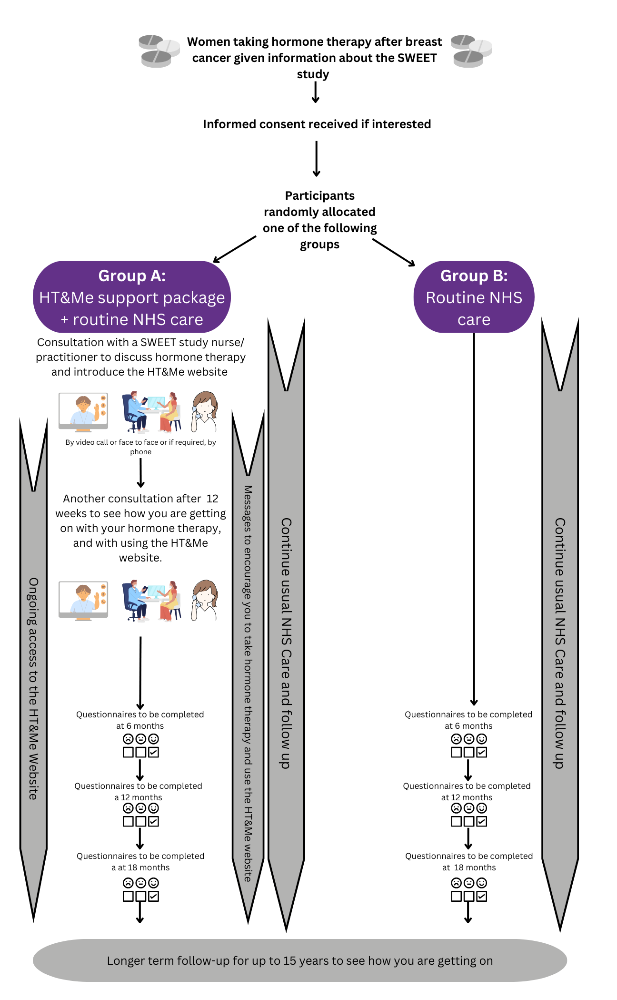
The image below summarises what is involved in taking part in the SWEET study:

What do I need to take part?
To be able to access the HT&Me website you will need to have access to a smart phone, tablet (e.g. iPad), or computer that can connect to the internet, and a working email address. If you are not sure whether you have the right type of device or internet access, please speak to your research team. We may be able to loan you a device (e.g. a tablet) with internet access if you do not have access to one.

What are the possible benefits of taking part?
We do not know whether the HT&Me support package will be effective in helping women to continue taking their hormone therapy as prescribed or in improving quality-of-life, however women in Group A, who receive the intervention will receive more information and support whilst taking their hormone therapy and they may find this helpful.
You may not directly benefit from taking part in this research, but your participation and completion of the follow up questionnaires will help guide support for women with breast cancer taking hormone therapy in the future.

What are the possible disadvantages and risks of taking part?
Although there is no physical risk to you from taking part in the study, we appreciate that being asked questions about your cancer may be upsetting. If you want to talk to someone at any time during the study, contact details of helpful organisations are provided at the end of this information sheet.

What happens when the research study stops?
Once the research study stops you will continue with any standard hospital treatment and follow-up. We will share the updates and results about the research in different ways (see section 14).

Who is organising and funding the research?
This research is managed by The Warwick Clinical Trials Unit (WCTU) at the University of Warwick (UoW). The Newcastle upon Tyne Hospitals NHS Foundation Trust (NuTH) is the sponsor for the study. The research team is based at Newcastle University, Oxford Brookes University, University College London, Imperial College London and Oxford University. This study is funded by The National Institute for Health Research (NIHR) (project reference NIHR200098). The NIHR would like you to know that any views expressed here are not necessarily those of the NIHR or the Department of Health and Social Care.

What if there is a problem?
If you have any concerns about any part of this study, you can talk to your hospital Site Study team who will do their best to answer your questions. If you remain unhappy and wish to complain formally, you can do this through the [NHS complaints procedure or insert equivalent for devolved nations].
If you prefer to raise your concerns with someone not involved in your care, you can contact the [Patient Advice and Liaison Service (PALS) or insert equivalent for devolved nations]. This service is confidential and can be contacted on Freephone: 0800 032 0202 [insert local PALS or insert equivalent for devolved nations]
Alternatively, if you wish to make a formal complaint you can contact the Patient Relations Department of the sponsor through any of the details below:
Telephone: 0191 223 1382 or 0191 223 1454
Email: nuth.patient.relations@nhs.net
Address: Patient Relations Department
The Newcastle upon Tyne Hospitals NHS Foundation Trust (NuTH)
The Freeman Hospital
Newcastle upon Tyne
NE7 7DN
This study is covered by NHS indemnity insurance. In the unlikely event that something does go wrong and you are harmed during the research, and this is due to someone's negligence then you may have grounds for a legal action for compensation against The Newcastle upon Tyne Hospitals NHS Foundation Trust but you may have to pay your legal costs. The normal NHS complaints mechanisms will still be available to you (if appropriate).

Part 2:

Contact details for further information

If you have any further questions, please contact your research team:

Principal Investigator:…………………………………………..Tel:..................................................

Research Nurse/ Trial Coordinator:……………………………………………………… Tel:…………………………………………

What if relevant new information becomes available?
Sometimes during a research study, new information becomes available. If so, a researcher will contact you to discuss your involvement in the study. If you decide to withdraw from the study, you should discuss your care with your doctor. If you continue in the study, you may be asked to sign an updated consent form if appropriate.

What will happen if I don’t want to carry on with the study?
If you decide that you do not want to carry on with the study, we will use the information that you have already given us to that point and will continue to collect data from your medical records or central NHS databases unless you don’t want us to.
If we are unable to contact you to complete the study follow-up (for example if you have changed address), we may try to continue collect this information remotely using your hospital or GP records unless you tell us you would like to withdraw from the study.
If you wish to withdraw consent at any time, please contact the Site study team.
In the unlikely event that during the study, you are no longer able to make the decision to continue in the trial (for example if you lost capacity to make decisions), you would be withdrawn from the study, but we would keep information about you that we already have.

What will happen to the results of the study?
Updates on study progress and results of the study will be posted on the Sweet Study website (https://www.sweetstudy.co.uk/).

At the end of the study, we will publish the findings in medical journals that are freely accessible and at relevant conferences. You will not be identified in any reports or publications. Once all participants have been followed up and the results have been analysed, we will make a copy of the study results available via an end of study information sheet and will add this to the study website. If you have asked for a copy of the results, this will be posted out to you by your hospital site.

Who has reviewed the study?
Any research that involves the NHS and patients is subject to review by an independent group of people called a Research Ethics Committee. This committee is there to protect your interests. This study has been reviewed and given favourable opinion by South Central - Hampshire B Research Ethics Committee (23/SC/0254). This study will be run in accordance with the UK Policy Framework for Health and Social Care Research. Women who have lived experience of breast cancer and hormone therapy have also reviewed this study, helped to design the HT&Me support package, and been involved in the study design.

What should I do if I have any questions after taking part in the study?
If you have questions about the study, please contact the hospital site study team at your hospital (i.e. the people who approached you about the study). If you would like more information, advice or support about living with breast cancer you could contact the following charities:
[For example, or insert equivalent for devolved nations]:
Breast Cancer Now (website: https://breastcancernow.org/)
Macmillan Cancer Support (website: https://www.macmillan.org.uk/)
Maggies Cancer Support Centres (website: http://www.maggies.org)
Should you be experiencing any difficult emotions or feelings and wish to speak to someone, please contact Mind for advice (website: https://www.mind.org.uk/).

Will my taking part be kept confidential?
In this research study we will use information from you, your medical records, your GP and central NHS Databases. We will only use information that we need for the research study. We will let very few people know your name or contact details, and only if they really need it for this study.
Everyone involved in this study will keep your data safe and secure. We will also follow all privacy rules. At the end of the study, we will save some of the data in case we need to check it AND for future research.
We will make sure no-one can work out who you are from the reports we write.
The SWEET Data handling Information Leaflet tells you more about this, you can request a physical copy of this and can also access via the link: insert link and document title
With your consent, some of your contact information will be shared with a text and email messaging service so that we can contact you as part of the trial. Personal identifiable data shared will only be used for this purpose and will be securely deleted when it is no longer needed.

Taking part in future research
If you choose to take part in the SWEET Study, your information may be used in future research, but only if approved by a Research Ethics Committee when needed. If you've agreed, we may contact you about other relevant studies—you will be provided with full details and can decide whether to participate. Sometimes, researchers ask to share study data to help answer important questions. These requests are carefully reviewed and only granted with proper ethical approvals. Any shared information will be anonymised so you can’t be identified. It will only be used for health research and won’t affect your care or things like insurance.

Thank you for taking the time to read this information sheet and consider taking part in this study.

https://www.sweetstudy.co.uk/

