

Dear {Participant Name}
Thank you for continuing to take part in the SWEET study – your help is really appreciated.
I am writing to let you know that the SWEET team has updated the participant information for the study. The only change is that the new information describes – more clearly - how the team securely stores your data and which organisations they will share it with.

If you would like to read the updated information, it is enclosed. You can also find it on the SWEET website which you access using the following link (https://www.sweetstudy.co.uk/) or the QR code below.

You can also read about how the study is progressing on the website.

If you have any questions, please do not hesitate to contact the SWEET Site study team on: ……………………………… (INSERT CONTACT DETAILS)

Yours sincerely
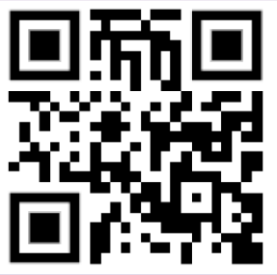

[INSERT NAME & ROLE]

