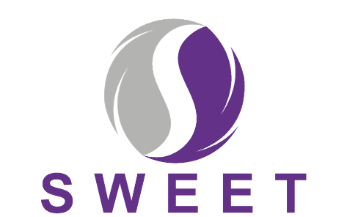
Supporting women with adherence to hormone therapy following breast cancer
Healthcare Professional Topic Guide

This is a guide of the broad topics that will be covered in the interview - the participant will be free to dictate the direction and content of the interview in relation to their views and experiences of the HT&Me support package. The actual questions will be phrased in a way that is clear and understandable to the participant. The early interviews and early stages of analyses may identify additional issues which may be useful to follow up in subsequent interviews. Therefore, the topic guide will be used flexibly and will evolve as the study progresses.

For SWEET Study practitioners delivering intervention:

- What was your involvement in the SWEET RCT?
- How have you found being part of the study?
- How did you find the training session? (e.g. content, format, length)
- Is there anything you felt should be added (or left out)?
- How confident did you feel about delivering the HT&Me intervention after the training?
- How did you find the study manual? Is there anything we need to change/add in the manual?
- How have you found delivering the initial appointment with women?
  - Which methods did you use? Face to face /video call/phone?
- Which did you prefer? Why was this? Which do you think women preferred?
  - How useful do you think women have found it?
  - What has worked well? What has worked less well?
  - What about the length of the appointment?
  - How did you feel introducing women to the website?
  - How did you feel about completing the checklist of what was covered during the appointment?
  - What about knowing that some appointments were being recorded – were you conscious of that? Did it change anything you said/did?
  - Did you have any concerns about delivering the intervention?
  - How do you think the ‘intervention’ would work as part of routine NHS care?
  - What do you think would need to be considered or changed to successfully make this part of routine NHS care?
  - Do you have any suggestions about how best this intervention could be delivered to people who may not speak English, or to people with additional support needs?
  - Any thoughts for improvements?

- How have you found delivering the follow-up appointment?
  - How useful do you think women found this?
  - What has worked well? What has worked less well?
  - What about the length of the appointment?
  - Do you think this is enough personal contact for women on this topic ie is the website / nudges sufficient to support them thereafter?

- Is there anything you have felt unconfident about during the study?
- How have you found completing the study paperwork?
- Have you had the opportunity to meet with other nurses / research teams from other sites? Did you find the meetings with the nurses / research teams in the other sites useful?
- Any additional thoughts regarding improvements to study processes / intervention content / anything else?
- Would you encourage colleagues to get involved in delivering this intervention and study?

For other HCPs at the site
- How have you found being involved with the SWEET RCT? What has your involvement been?
- Did you feel well informed about the RCT??
- Did you have all the information you needed? Did you know who to contact if you had any questions? Were you able to get answers if you had any questions?
- How did the study run in your hospital? Did the processes fit within usual working practices in the team? Who in the team was involved in running the study? Were there any problems or issues? Is there anything that we could improve in terms of the running of the study?
- What did you think when you first heard about the HT&Me intervention? What was the view of other people in the team?
- How does the HT&Me intervention fit in with your current working practices (i.e. existing and routine ways of caring for women with breast cancer)?
- Have you had any feed-back or queries from patients about the study? How did you deal with these?
- How do you think women felt about the randomisation process? Eg. being in the intervention arm being down to chance?
- Do you think the HT&Me intervention would be something that the team would use/adopt, if it was available beyond the RCT?

For PIs and senior staff with oversight
- How have you found being involved with the SWEET RCT? What has your involvement been?
- As a PI or senior member of staff with oversite of the study – how do you feel it has gone?
- Did you feel well informed about the study?
- What did you think when you first heard about the HT&Me study? What was the view of other people in the team?
- Do you feel that there was disruption to usual clinics due to the study?
- Were there any problems or issues? Is there anything that we could improve in terms of the running of the study?
- How does the HT&Me intervention fit in with your current model for management and FU of these patients?
- Did you have much contact with CIs / trials unit / other researchers? How did you find that? [Was it too much / too little]
- Any additional thoughts regarding improvements to study processes / intervention content / anything else?
- Do you think the HT&Me intervention would be something that the team would use/adopt, if it was available beyond the research?
- What would need to change for this to be rolled out as standard care at your site?

