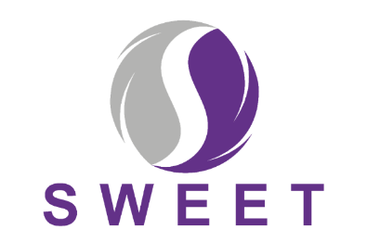
[To be printed on local NHS Trust headed paper]

Supporting women with adherence to hormone therapy following breast cancer
Dear [Patient Name]
We would like to tell you about some of the research taking place at [INSERT TRUST NAME]. You may have already spoken to a Consultant, Nurse or Research Nurse about this.
We would like to invite you to take part in the SWEET research study. It is up to you whether you choose to take part in this research study or not, but before you decide we would like you to understand why we are doing this research and what it would involve for you.
Many women like you are prescribed hormone therapy following diagnosis and treatment for breast cancer. Hormone therapy significantly reduces the chances of cancer returning. Usually women are recommended to take hormone therapy in the form of a daily tablet for several years. However, we know that some women either do not take this medication everyday as prescribed or stop taking it all together (known as “poor adherence”).
We have developed a support package (called HT&Me) designed to encourage and support women to take their hormone therapy as prescribed. We would like women like you to take part in our study which will test whether the support package can improve hormone therapy adherence, and quality-of-life when compared to the standard NHS follow-up care offered in your hospital right now.
The research is explained in more detail in the enclosed Participant Information Sheet.
You will be contacted by a member of the hospital team shortly who will answer any questions you have and ask if you are interested in taking part. If you have any questions in the meantime, please contact your local research study team. Details on how to do this are at the end of the Participant Information Sheet.

Thank you very much for considering taking part in this study.
[INSERT NAME & ROLE HERE]

