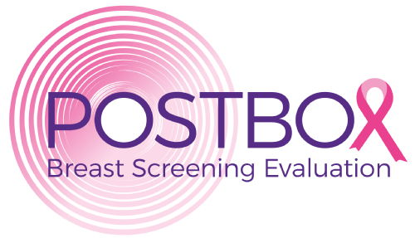

Patient Outcomes from Second film-readers and Test threshold relaxation in Breast screening:

Short Protocol for an observational retrospective cohort study (POSTBOx) 4th May 2020

Sian Taylor-Phillips¹ (S.Taylor-Phillips@warwick.ac.uk), David Jenkinson¹, Chris Stinton¹, Karoline Freeman¹, Alice Sitch², on behalf of the POSTBOx team.
- Division of Health Sciences, University of Warwick, Coventry, CV4 7AL, UK
- Institute of Applied Health Research, University of Birmingham, Birmingham, B15 2TT
(NOTE: part of the analysis of reader threshold detailed below is dependent on securing additional funding, ADAPT-Mammo funding application currently under review)
Introduction: Breast cancer screening technology has advanced significantly since the randomised controlled trials were conducted in the 1970s. Most randomised controlled trials and test accuracy studies examining advances have been too small to measure clinical outcomes, and have had to rely on extrapolation from intermediate outcomes such as number and type of cancer detected. We aim to evaluate the impact of two previous changes to the breast screening test on long term outcomes.
In this study we are opportunistically exploiting a natural experiment using two previous changes with large effect sizes and very large cohorts with long-term follow-up in a well populated database. We will measure the effect of the addition of a second film-reader, and changes to the test threshold on the balance of benefits and harm.
Objectives

- To measure the effect of a one or two film-reader breast cancer screening test on women’s intermediate and long term outcomes.

- To measure the effect of the breast screening test recall threshold on women’s intermediate and long term outcomes.

Data sources and linkage
Clinical and administrative information about breast screening appointments from the National Breast Screening System (NBSS) database at 80 English breast screening centres will be extracted and combined, then linked to the English Cancer Registry (for symptomatic cancers) and the Mortality and Births Information System (MBIS, for date of death), and Breast Screening Select (for details of atypical screening appointments).

Inclusion criteria
If data quality permits, we will include all routine breast cancer screening in England from the screening programme inception in 1988 to December 31st 2016. Women will be included if they have at least one mammogram as a result of population screening. There is a field used on the National Breast Screening System (NBSS) called ‘type of invitation’ which has a response of “call/recall”. This identifies which women are attending routine breast screening. Women who have only attended high/moderate risk screening or screening due to familial risk factors will be excluded, along with women who have not been screened between the ages of 47 and 73.

Cohort 1 will include only women’s final screening round (when she reaches the upper age limit of eligibility for screening).

Cohort 2 will include all appointments except the woman’s final appointment.

Interventions
There are two interventions (corresponding to the two objectives): whether two readers examine each woman’s mammograms (as opposed to only one), and the test threshold used by the readers.

Outcomes
- Overdiagnosis (at the population level) caused by addition of a second film-reader and decrease in recall threshold; i.e. the difference between the total number of cancers detected in the one and two film-reader groups at screening and presenting symptomatically
- Breast cancer mortality (if follow-on funding obtained)
- All-cause mortality (if follow-on funding obtained)
- False positive recalls at screening
- Number of cancers detected
  - Overall
  - Screen detected
  - Symptomatic detected (at 3, 13 and up to 30 years follow-up)
- Characteristics of cancer detected (grade, stage, size etc.)
  - Overall
  - Screen detected
  - Symptomatic detected (at 3, 13 and up to 30 years follow-up)
- Breast cancer free survival
- Breast Cancer treatment received (proxy for treatment associated morbidity, overall/screen detected/symptomatic detected, if follow-on funding obtained)

Follow-up times will be at 13 years (to match the Marmot review), 3 years (the screening interval), and a survival analysis approach incorporating the different follow up times.

Ethics and dissemination
The study has NHS ethical approvals (18/YH/0355) and Public Health England Office for Data Release Approvals (ODR1718_062). The study is registered on ClinicalTrials.gov (NCT04365114)

Funding statement
This project is funded by the National Institute for Health Research, as a fellowship for Sian Taylor-Phillips, (CDF-2016-09-018). The research team have applied for further funding to complete the analysis of recall threshold (NIHR HS&DR, ADAPT-Mammo, decision pending).

