
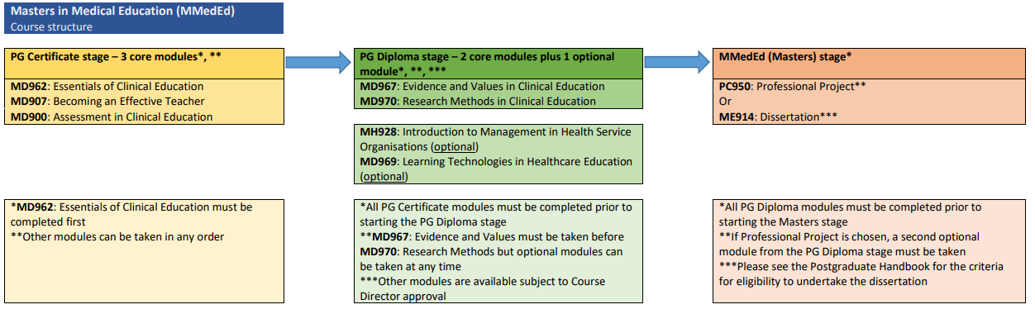
Year 3
Year 2
Year 1

