1.3: Fundamental Mathematical Concepts
- Calculate the following using the BIDMAS order of operations:
  - $\text{4}÷\text{5}+\text{6}×\text{2}$

  - $\frac{\left(\text{30}+\text{10}×\text{2}\right)}{\left(\text{6×4+1}\right)}$

  - $\text{4}+\text{2}×3^{2}$

  - $\text{7}+\text{3(}{\text{2}}^{\text{3}}-\text{4) }÷\text{ 2}$

- Convert the number 54,200,000 to standard form.

- Convert the number 3.75 x10⁻² from standard form to ordinary form.

- The following image shows the nutritional information from a box of pregnancy vitamins. Express the average amount of the following vitamins contained in each tablet in grams (g) in both standard form and ordinary form. (This is just to practice converting between orders of magnitude, in clinical practice use milligrams and micrograms for a reason! Note that when prescribing, µg is written in full as micrograms to reduce chance of drug errors).

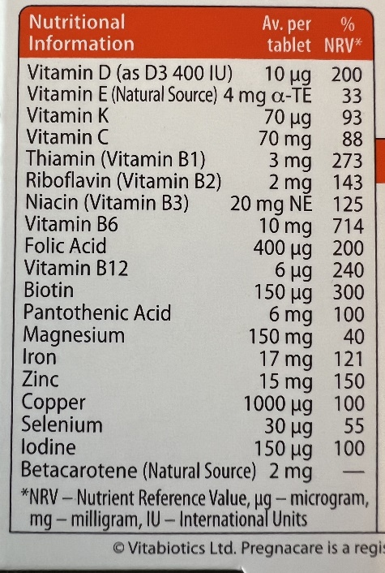

  - Vitamin D

  - Vitamin C

  - Folic acid

  - Iron

- Round the following numbers as follows:
  - 7.2369 to two decimal places

  - 5.9834 to three decimal places

  - 0.004506 to three significant figures

  - 98,347 to two significant figures

- Convert the following equations from exponential to logarithmic equations or vice versa.
  - 2⁶ = 64

  - 5⁴ = 625

  - Log₂(32) = 5

  - Log₄(64) = 3

- Solution A has a pH of 4 and solution B has a pH of 9.
  - Explain which solution has a higher concentration of hydrogen ions.

  - Which solution is acidic and which solution is basic?

- Fick’s Law describes the factors which affect the diffusion rate of gases across the alveolar-capillary membrane in the lungs. Fick’s Law is:
$$\text{Diffusion rate }=\frac{\left(\text{A}\right. ×\text{D}×\left.\text{∆P}\right)}{\text{T}}$$
Where,
- A – surface area available for diffusion
- D – diffusion coefficient of the gas, which is determined by molecular weight and solubility.
- ∆P – partial pressure difference of the gas across the membrane
- T – thickness of the membrane
Based on the above equation, describe the relationship between the rate of diffusion of a gas and:
  - Surface area

  - Membrane thickness

- Rearrange the following physiological equations:
  - $\text{Q}=\frac{∆\text{P}}{\text{R}}$ . Rearrange to make ∆P the subject.

  - $\text{V}=\text{IR}$. Rearrange to make I the subject.

  - Take it further to really test your understanding and apply these principles to an algebraic equation: $3x+5=20$. Rearrange to make $x$ the subject.

  - Apply your understanding to another algebraic equation: $y=4x+7$. Rearrange to make $x$ the subject.

- The graph below shows volume against pressure. The slope of the curve is compliance. Based on the axis of the graph, can you determine the physiological equation for compliance?
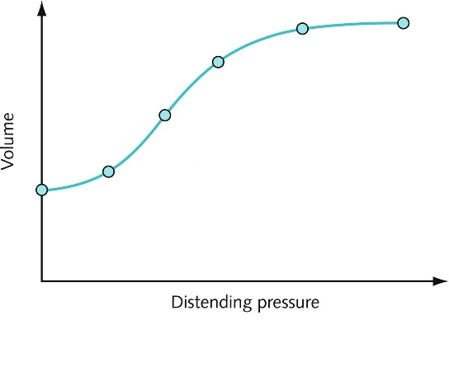
Image reference: Physiology, ventilation and gas exchange. Lawrence, Hannah, BSc, MBBS, MRCP, Crash Course Respiratory Medicine, 4, 27-41. Copyright © 2019 © 2019, Elsevier Limited. All rights reserved

