2.3: Atoms and Ions
- Complete the following table about subatomic particles using the following terms: positive, negative, neutral, 1 atomic mass unit, and negligible mass.
 | Charge | Mass
Protons
Neutrons
Electrons

- What is an isotope?

- Nitrogen-14 has 7 protons and 7 neutrons. What is its:
  - Atomic number

  - Atomic mass number?

- List FOUR elements which are important for physiological processes?

- What happens to the number of neutrons and protons in an atom during beta decay?

- Draw the electron configuration of the following atoms:

  - Helium (atomic number 2) b. Magnesium (atomic number 12)

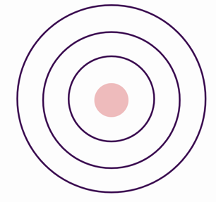

- What does the octet rule say about the stability of atoms based on their electron configuration?

- What is the definition of an ion?

- Based on the electron arrangement of magnesium you have drawn above, what will be the charge will a magnesium ion have and how is it written?

- What is the difference between a cation and an anion?

