Biological active matter in confinement.

Biological active matter is matter comprised of large numbers of active constituents, which consume energy to move or exert mechanical forces. Generally, the field of active matter focuses on understanding how the collective behaviours of internally driven components can give rise to various biological phenomena, while also aiming to produce biomimetic materials composed of active energy-consuming components. Motile micro-organisms, such as bacteria, self-propel in viscous media by applying a force mediated by a surrounding fluid. This not only causes the organisms’ motion but also generates a fluid velocity field around them. Many swimmers will create a substantial random or correlated motion of the fluid in which they are suspended. This leads to a phenomenon called active turbulence [1]. The emergence of this turbulent state depends on the geometric confinement of the active suspension. The objective of the proposed PhD research is to investigate the transition to active turbulence as a function of the geometric confinement and develop microfluidic geometry to control active fluxes in this system. The successful candidate will have to learn and apply a range of experimental and analytical skills, such as microfluidic design and microfabrication, optical video-microscopy and image processing, as well as microbiological and molecular biology methods for maintaining living cultures.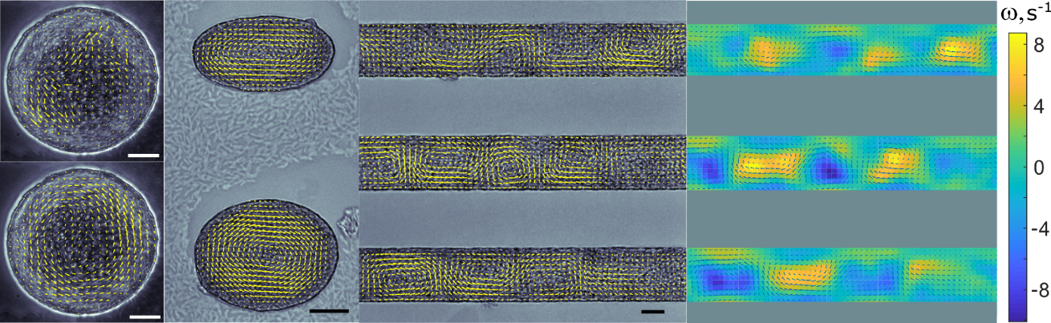
A
B
C
D
Figure 1. (A) Spiral flow field of bacterial suspension in confinement. (B) Averaged fields in the wells of elliptical shape represent a stable elongated vortex. (C) Averaged velocity field in a long rectangular groove is organized into a vortex lattice. (D) Vorticity field, ω = ∇ × V, calculated from panel C. Scale bar, 20 μm. [2]

References
[1] A. Doostmohammadi, T. N. Shendruk, K. Thijssen & J. M. Yeomans Onset of meso-scale turbulence in active nematics Nat. Commun., 8, 15326 (2017)
[2] V. Kantsler, E. Ontañón-McDonald, C. Kuey, M. J. Ghanshyam, M. C. Roffin, and Munehiro Asally* Pattern Engineering of Living Bacterial Colonies Using Meniscus-Driven Fluidic Channels ACS Synth. Biol. 9, 1277 (2020)

Supervisor: Vasily Kantsler
E-mail: v.kantsler@warwick.ac.uk

