Leaky magnetohydrodynamic waves of solar coronal structures
Supervisor: Professor Valery Nakariakov
Centre for Fusion, Space & Astrophysics, Department of Physics

Funded by the ERC AdG “A new look at the solar coronal heating problem” (ACDCSUN)

In the solar corona, magnetohydrodynamic (MHD) waves manifest as quasi-periodic perturbations of EUV, radio, and white-light emissions and are routinely detected with modern observational facilities. Among the various MHD wave modes, fast magnetoacoustic waves have attracted growing interest as agents capable of transferring energy across the magnetic field and thereby heating the bulk of the coronal plasma. We aim to advance our understanding of the solar coronal-heating problem in a transformative way by combining wave-based and reconnection-based approaches, considering plasma heating by fast magnetoacoustic waves excited by small-scale magnetic-reconnection events, such as nano- and picoflares.
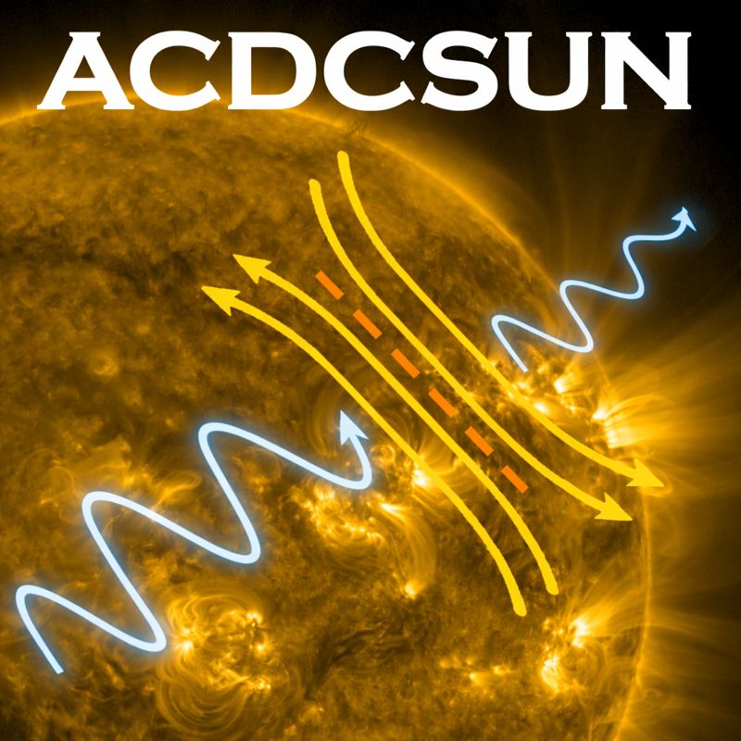
A four-year PhD studentship is available starting in October 2026. The research will involve modelling the excitation, dynamics, and dissipation of fast magnetoacoustic waves leaking from coronal plasma structures, forward modelling of the observational manifestations of this phenomenon, and the search for and analysis of the predicted observational signatures in data delivered by world-leading high-resolution spaceborne and ground-based instruments. The theoretical component of the project will include both analytical low-dimensional descriptions and full-scale numerical simulations.

The PhD project forms part of the European Research Council Advanced Grant “A New Look at the Solar Coronal Heating Problem” (ACDCSUN) and will include collaboration with other members of the project team, as well as with overseas colleagues.

This is an open-ended, ambitious project but with well-defined milestones and outcomes, suited for a strong and enthusiastic student.
Further reading: 2020ARA&A..58..441N, 2021MNRAS.505.3505K, 2025ApJ...994....6H
Contact: V.Nakariakov@warwick.ac.uk
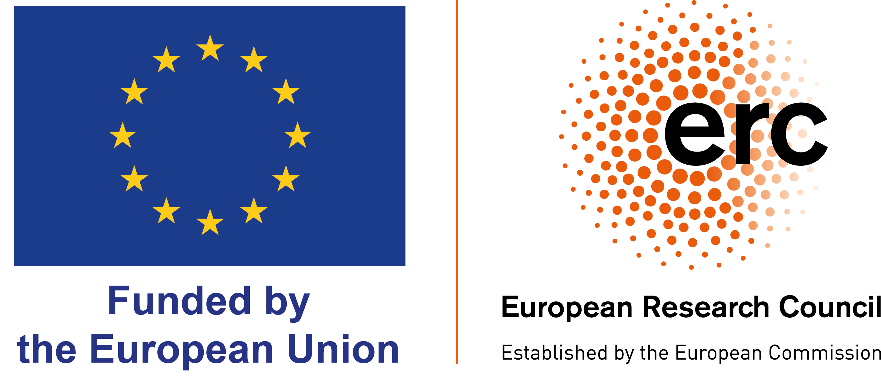
Web page: warwick.ac.uk/go/cfsa

