Decayless kink oscillations of solar coronal loops

Supervisor: Professor Valery Nakariakov
Centre for Fusion, Space & Astrophysics, Department of Physics

Funded by the ERC AdG “A new look at the solar coronal heating problem” (ACDCSUN)

Kink oscillations of plasma loops in coronal active regions are among the most intensively studied dynamic phenomena in solar physics. Particular interest is attracted by the stationary, or decayless, small-amplitude regime of these oscillations. The decayless regime of kink oscillations therefore provides previously unexplored information about the coronal energy balance and the enigmatic coronal-heating mechanism. Recent findings indicate that the energy supply counteracting the decay of kink oscillations, and hence responsible for the stationary regime, originates from quasi-steady motions in the lower layers of the solar atmosphere. The channels and efficiency of energy transfer from the lower to the outer atmospheric layers, and the interaction of quasi-steady flows with coronal plasma structures remain to be understood.
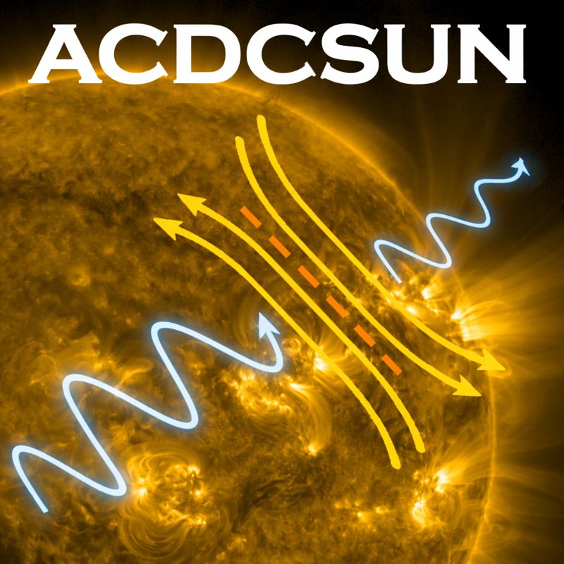
A four-year PhD studentship is available starting in October 2026. The research will involve modelling the decayless regime of kink oscillations, identification of observationally testable outcomes of the modelling, and their comparison with observables. The observational component of the research will utilise data delivered by world-leading high-resolution spaceborne and ground-based instruments. The theoretical component of the project will include both analytical low-dimensional descriptions and full-scale numerical simulations.

The PhD project forms part of the European Research Council Advanced Grant “A New Look at the Solar Coronal Heating Problem” (ACDCSUN) and will include collaboration with other members of the project team, as well as with overseas colleagues.

This is an open-ended, ambitious project but with well-defined milestones and outcomes, suited for a strong and enthusiastic student.
Further reading: 2020ARA&A..58..441N, 2024MNRAS.531.4611N, 2025ApJ...993L..35Z
Contact: V.Nakariakov@warwick.ac.uk
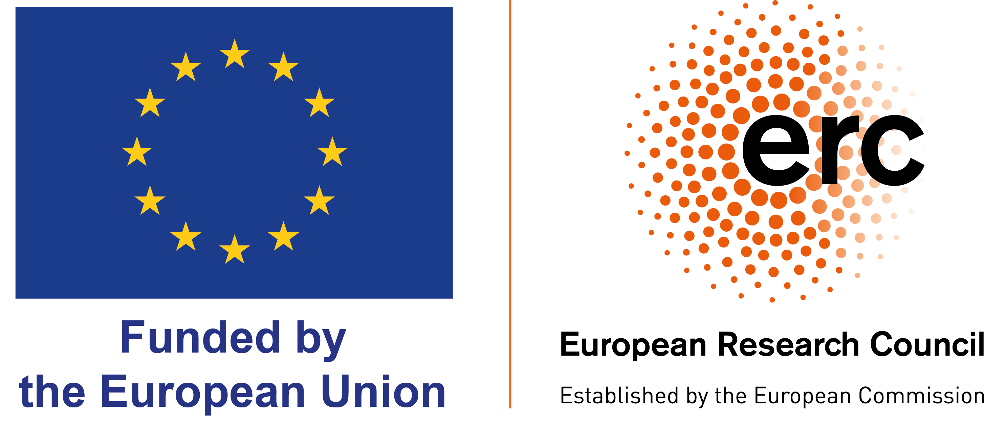
Web page: warwick.ac.uk/go/cfsa

