Title
Coined quantum walks in two, two+epsilon and three dimensions
Project Description
Quantum walks have demonstrated substantial potential in quantum computing applications, serving as practical tools for constructing quantum algorithms. Notably, quantum walks are computationally universal, as evidenced by Childs in his seminal paper (Childs, 2009). The enduring results show that quantum walks outperform their classical counterparts (Moore & Russell, 2001) further underscoring the promise of quantum technologies to revolutionize real-world applications in the near future. Despite ongoing advancements in quantum computing, designing algorithms with a quantum advantage remains a complex task. Therefore, a thorough understanding of the fundamental components of these algorithms, which can be formulated as quantum walks, is essential for future quantum scientists. The proposal outlined here will provide such an opportunity to train a student to become a fully quantum-enabled research worker.
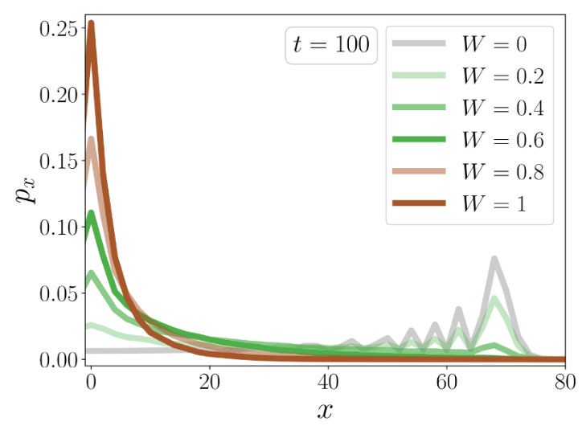
In short, this project aims to investigate the influence of disorder on the entanglement properties of quantum walks. A coined quantum walk is one where the direction of the walk is determined by a quantum coin. A Hadamard-coined quantum walk is then one where the walker states evolve entangled in time by repeated action of the Hadamard gate and the coin/spin-flip (Yao & Wald, 2023). Disorder may naturally arise as undesirable errors from faulty quantum operations, but it could also be harnessed as a tailored resource to enhance the computational performance of quantum algorithms. It is well-established that disordered quantum media can lead to wave localization (Römer, 2022; Römer & Schreiber, 2003), a phenomenon first identified by Anderson (Anderson, 1958). The impact of disorder on entanglement witnesses in quantum walks, however, has not been fully explored.
Figure 1 Walker distribution of a disordered CQW. Note how the localized peak at x=0 emerges for increasing disorder W while the travelling peak at x>60 diminishes. Taken from (Yao & Wald, 2023).
Given that quantum entanglement is a crucial computational resource, understanding the interplay between entanglement and localization is vital. Recent studies in one-dimensional systems have shown that localization is the dominant effect (Yao & Wald, 2023) (see Figure 1), but the possible dynamics in two-dimensional (2D) and three-dimensional (3D) systems remain less clear. This project intends to review the one-dimensional results and extend them to higher dimensions.
The project will involve both analytical and programming work, likely requiring equal levels of complexity. It will begin with the recalculation of standard one-dimensional coined quantum walk results, followed by an extension to two-dimensional, above two and then three-dimensional systems, predominantly through numerical methods. We also wish to point out that such quantum walks are now beginning to be used to define quantum analogues of active matter processes (Yamagishi et al., 2023). This is another very interesting development that supports the great interest in this topic of research.
The proposed studentship is well within the core expertise of the supervisor and also the quantum researcher in the theory group, as well as in the wider physics department. The topic falls within the subject area of Amos Chan and Animesh Datta and their groups, so that the student will be well embedded in an actively researched strategic area of the theory group. In addition, there is support and interest from colleagues in the Warwick Quantum faculty-level research centre (headed by Physics colleague Gavin Morley). Existing collaborations with colleagues in computer science (M Caro) and Engineering (H Sadeghi) for the planned QUANTOPIA joint-doctorate network, and also with EUTOPIA partners Mats Granath (U Gothenborg) and Andreas Honecker (CYU Cergy Paris) add an international dimension. Furthermore, haiqu, Inc., a quantum software start-up, has indicated its interest in the project.
We are fortunate to have received support from haiqu, Inc. at haiqu, Inc is a quantum software company focused on developing quantum middleware – the enabling and physics-informed software layers comprising compilation, noise mitigation, error correction, data loading and readout – and on optimizing quantum algorithms in real world industrial applications. Haiqu’s particular focus is on addressing near and mid-term hardware limitations through hardware-aware algorithm design. Through their ongoing collaborations with finance and engineering industries developing quantum applications the student will be exposed to current applied quantum research.
The student will be able to receive mentoring and practical advice on quantum walk simulations and their implementation on modern quantum architectures from experts at haiqu, Inc. Maciej Koch-Janusz and Maxence Grandadam, in collaboration with ETH Zurich are researching the use of quantum walks in quantum algorithms’ design at haiqu, Inc. It is planned that the student will visit them and also participate in a 3-month internship program at haiqu, Inc. during the PhD (via their EU-based offices). At the moment, no extended stay off-site is envisaged, and the mentoring from haiqu, Inc will at least initially be more at the level of once-per-month online meetings. This might change later depending on the progress of the project.
Anderson, P. W. (1958). Absence of Diffusion in Certain Random Lattices. Physical Review, 109(5), 1492–1505. https://doi.org/10.1103/PhysRev.109.1492
Childs, A. M. (2009). Universal Computation by Quantum Walk. Physical Review Letters, 102(18), 180501. https://doi.org/10.1103/PhysRevLett.102.180501
Moore, C., & Russell, A. (2001). Quantum Walks on the Hypercube. Lecture Notes in Computer Science (Including Subseries Lecture Notes in Artificial Intelligence and Lecture Notes in Bioinformatics), 2483, 164–178. https://doi.org/10.1007/3-540-45726-7_14
Römer, R. A. (2022). Numerical methods for localization. In Reference Module in Materials Science and Materials Engineering. Elsevier. https://doi.org/10.1016/B978-0-323-90800-9.00099-8
Römer, R. A., & Schreiber, M. (2003). Numerical investigations of scaling at the Anderson transition. In Anderson Localization and Its Ramifications (Vol. 630, Issue 1, pp. 3–19). http://arxiv.org/abs/cond-mat/0212569
Yamagishi, M., Hatano, N., & Obuse, H. (2023). Defining a quantum active particle using a non-unitary quantum walk. https://arxiv.org/abs/2305.15319v2
Yao, L. H., & Wald, S. (2023). Coined quantum walks on the line: Disorder, entanglement, and localization. Physical Review E, 108(2). https://doi.org/10.1103/PhysRevE.108.024139

