Emergency Procedure
*Insert Lab Location Details*

Location of Gas Isolation Points and Gas Detection/Monitoring Systems
For example:
The laboratory contains a compressed Nitrogen cylinder and a liquid Nitrogen both attached to the BET surface area analyser, and a gas detection/monitoring system.
*INSERT A ROOM PLAN WITH LOCATIONS OF DETECTION*
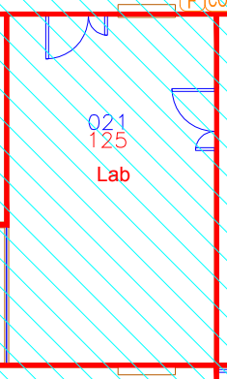
Emergency Response
For example:
Nitrogen (Liquid or gas)
The laboratory contains an emergency alarm. In the event of an alarm sounding, or if there is a suspected leak:
1.The laboratory must be evacuated.
2.Oxygen levels can be monitored from alarm control panels, which are situated outside each laboratory.
3.Only re-enter the affected area if the oxygen levels reach safe levels (>20%).
Hazard Specific First Aid Measures
For example:
Inhalation: In high concentrations may cause asphyxiation. Symptoms may include loss of mobility/consciousness. Victim may not be aware of asphyxiation. Call community safety team on 02476 522222 (mobile) for emergency responders and wait for help to arrive. Depending on the level of oxygen (e.g. below 14%) it is unsafe to enter a room to rescue an unconscious victim.
Eye contact: Rinse the eye with water immediately. Remove contact lenses, if present and easy to do. Continue rinsing. Flush thoroughly with water for at least 15 minutes. Get immediate medical assistance. If medical assistance is not immediately available, flush an additional 15 minutes.
Skin Contact: Contact with evaporating liquid may cause frostbite or freezing of skin. If clothing is saturated with the liquid and adhering to the skin then the area should be thawed with lukewarm water prior to removing the clothing.
Chemicals
General advice: A copy of Safety Data Sheet (SDS) and COSHH assessment of the hazardous chemicals (listed in the chemical inventory) in the laboratory are available in the H&S folder. Show these to the first aider or emergency responder (paramedic, fire service) in attendance.
*Consider entry routes to the body e.g. inhalation, skin contact, eye contact, ingestion.*
Spill and Leak Control Arrangements
For example:
Nitrogen (liquid and gas)
Evacuate area and provide adequate ventilation. Monitor oxygen levels via the gas detection panels. Beware that liquid nitrogen spillages can cause embrittlement of structural materials.
Chemicals
Wear suitable protective clothing. Avoid breathing vapours, mist or gas. Avoid formation of dust. Ensure adequate ventilation of the working area. Evacuate personnel to a safe area.
Prevent contamination of other chemicals nearby. If safe to do so, prevent further leakage or spillage. Do not let product enter drains.
Absorb spilled liquid products with chemical spill kit (if trained to do so). Refer to COSHH Assessment for spills in the H&S folder.
Emergency Contacts
Name | Role | Email | Telephone

