Standard Operating Procedure

Title | WarTPC High-Pressure Vessel
Author(s) | Xianguo Lu, Matthew Snape
Reviewer(s)
Date issued | 2022-11-18
Version number | 1.0
No. of pages | 2

- Purpose

  - This document defines the standard operating procedure of the WarTPC High-Pressure Vessel

- Scope

  - This SOP applies to activities involving the high-pressure vessel in P426. This pressure vessel has a volume of 195 Litres, with a maximum operating pressure of 10 barg,

- Responsibility

  - Xianguo Lu (PI)
    - Ensure that the staff/students are adequately trained to carry out the task by themselves
    - Ensure any incident, accident and near-miss is reported via the University’s reporting system
    - Ensure their staff/students understand the emergency procedures

  - Xianguo Lu, Matthew Snape (project members)
    - Must report incidents, accident, and near-misses via the University reporting system.
    - Must comply with these procedures and emergency procedures and University policies for health and safety at work
    - Lone Working should only be done only after ensuring other members of the group are aware that lone working will be taking place.

- Frequency

The vessel may:
- be opened or closed at irregular intervals. Ideally, other (i.e. project-irrelevant) users of the lab-space are not present during this intervention, as this work requires the movement of heavy parts and the use of long tools. The times for this intervention will be agreed with other users to that end.
- be open inside the laboratory in irregular intervals to allow insertion or removal of the detector. It is desirable to minimize the time the vessel is open, to ensure its cleanliness. Other users of the laboratory will be informed if the vessel is open for a short amount of time, and asked to not be present inside the lab-space during that period.
- be purged (i.e. evacuated by pumping it out) occasionally. This process may take hours up to days, and can possibly take place over the weekend, as it needs no supervision once started. As the pumps are noisy, periods of purging will be agreed on with other people using the lab-space and be timed in a manner to be as little as a nuisance as possible.
- be filled with a gas to a certain pressure. Filling will take place occasionally, usually after purging but not exclusively, and is expected to take at most hours. This will only be done with continuous supervision. Other users can be present in the lab-space during filling and they will be alerted to the activity going on, should they enter the lab.
- be vented to atmosphere. This action will occur after the vessel has been filled with a gas at any pressure and is necessary before opening the vessel or one of the vessel´s flanges. Venting will take about an hour and can – once it is started - be performed without supervision. Other lab-users may be present in the lab during the whole duration of the process.
- contain a gas with a pressure below or equal to atmospheric pressure (tolerance of 100 mBar). A sign on the vessel will make other users of the lab space aware that the vessel contains gas. This state may continue for days or weeks during a measurement campaign.
- contain a gas with a pressure above atmospheric pressure, up to 10 bar absolute. A sign will make other users of the lab-space aware that the vessel is at high pressure. Other users will be instructed to abstain from performing any action as opening the vessel, or opening any of the vessel´s flanges, or opening any part of the gas system until the vessel has been vented to atmosphere. This state may continue for days or weeks during a measurement campaign.

- Procedure

  - Vessel Door-Closing Procedures
    - Close the endcap hanging from the davit arm making sure the gaskets are in place. It can be helpful to have 2-3 bolts already in place to hold the gasket while closing the door. There is no metal-to-metal seal on the endcaps, so if you hear a clinking sound you must investigate.
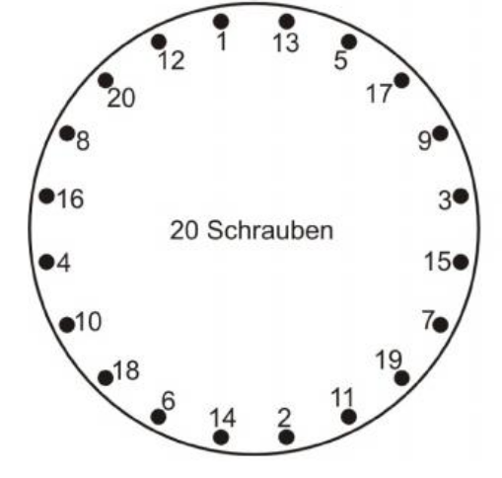
    - Tighten bolts according to the given sequence in the right figure (the sequence is also written on the vessel doors) in three passes: 200 Nm, 354 Nm, and finally 567 Nm. When First tightening the bolts, the date and time must be recorded.
    - Wait for 24 hours to retighten bolts to ensure a gastight connection after gasket has been compressed sufficiently. It may be useful to go round twice to ensure that all of the bolts are fully tightened.
Figure 1: The order is also inscribed on the vessel doors with permanent marker.

  - Vessel Filling Procedures
    - The Vessel should only be filled after the doors have been closed and sealed (as well as other gaskets/holes)
    - The Vessel should be filled slowly, and under close supervision. The gas will either come from the piped in gasses (i.e. Nitrogen or compressed air), or from a pressure cylinder of gas.
    - In the case that the Vessel is in the middle of it being filled but the people currently supervising the filling can no longer supervise, the gas supply should be halted, and the Vessel held at the pressure at the moment of halting.
    - If the vessel is pressurised with no one from the group in the lab, signage and other warning must be visible to let other people know about the pressure vessel.

  - Leak-Testing Procedures
    - Leak testing of the full system can be done by pressurizing the vessel to 8 bars using the compressed air line in the lab and monitoring the pressure over a period of time of 24 hrs. Many parts can be isolated using isolation valves and can be leak tested individually. The Leak test will be considered to be passed if the leak rate will correspond to less than 0.5 bar of pressure loss over a period of 24 hours.

  - Venting
    - In order for the vessel to be vented, the gas supply must first be cut off, either through the isolation valve or through the pressure regulator (ideally both). After this has been done, the venting valve may be opened, which will then slowly vent the contents of the vessel to the outside.

  - Inserting Components into Vessel
    - To insert components into the vessel, it must be first be brought down to atmospheric pressure (optional: and may at the same time be slowly filled with compressed air (not enough to maintain pressure) in order to minimise the amount of argon released directly into the room.
    - Components must slowly be removed and safely placed to once side until access is available to carefully insert the desired components in the intended place.
  - Applying High Voltage
    - Before any voltage can be applied to the internal components, the vessel must be grounded in case of any electrical discharges between the components and the vessel wall, and to prevent the build up of charge. Grounding the vessel should only be done with the aid of qualified person, and never done alone.
    - The internal components that require high voltage to be applied to the Cathode/Anode and the THGEM(S). Currently a maximum of 5kV can be applied to the THGEM(S) (limited by the tolerance of the cable), and the Cathode/Anode can be biased to a maximum of 15kV (limited by the power supply).
    - In order to bias the Cathode/Anode, the voltage must be increased slowly (ideally in steps) to minimise the chance of discharges. The THGEMS must also be biased in steps and done slowly, as discharges have the potential to damage the THGEM(S).
    - The THGEM(S) power supply should shut off the voltage automatically should the THGEM(S) trip to minimise the chance of damage to the THGEM(S).

  - Feeding Laser Light into vessel (this part of the project has not started; no relevant work will be carried out until an updated version of this SOP is submitted).

  - Emergency Procedures

    - Fire – If the fire alarm sounds whilst operating the vessel:
    - Leave via the nearest fire exit without sweeping the building
    - Go to their assembly point
    - Contact University Security on 02476 522222 or Hospital Security on 02476 962222 and wait until they arrive.
    - On arrival, inform Security if there is a confirmed fire
    - Ensure that firefighters are informed of pressurised gas
    - First Aid – If a first aider is required the individual should contact University Security on 02476 522222 (internal x22222) or Hospital Security at CSRL on 02476 962222 (internal x2222).
    - Leak – If there is a significant leak from the vessel, the gas supply must first be isolated by either the pressure regulator or isolation valve on the gas system, and then work must be stopped until the cause of the leak has been fixed.
    - Gas Release by safety valve – Should gas be released from the safety valve, the vessel must be isolated from the gas supply and then vented until the pressure is brought down to acceptable levels (=< 10bars), before operation can continue.

- History, or change control

“Draft” version of table during writing and reviewing of SOP as below,

Draft 1.0
Reviewed

then “Version” version of table as below on issue

Version 1.0

