15.46 at La Silla - Draft 4
Anwesha Sahu
Themes: astronomy, society, reflective, inspiration, travel
It’s 15.46 on Sunday, 21st September 2025, here on La Silla. I am sitting on my window ledge staring at the dusty burnt sienna Atacama mountains in the distance, perfectly complete with a sprinkling of snow on most peaks, leftover from winter. It’s the first day of spring here. It’s the last day of what feels like my pilgrimage. An astronomer’s pilgrimage.

I’ve been on the mountain for just under a week. The days and nights have melded into each other, and the past six days feel like one really long day as I have shifted my circadian rhythm to become that of an astronomer’s. Tonight is the final night of my 13 hour-long four-night observing duties. My body aches for deep sleep that lasts longer than five hours, and my limbs whisper desires for pause. But today, I can’t sleep. I want to witness the Milky Way arching over the Pacific after the gloaming. I want to photograph them with their satellite Magellanic Cloud galaxies. I want to hunt for the comet that someone told me about at lunch. I want to watch Orion rise over the snow-topped peaks. I want to be present, one more time, for every transient observation we perform with the New Technology Telescope (NTT).

—————————————————————————————————————————

I’m a radio astronomer with a keen interest in transients. Like every discipline, the most effective way to understand one’s specialty is to see how it fits into the bigger picture and with other closely related disciplines. This is where my interest in optical transients stems from. Transient astronomy is the branch that studies short-lived and often irregularly occurring astronomical events which undergo brightness changes rapidly - on the scale of human timescales of days to months. Classic examples of such events include supernovae, tidal disruption events, active galactic nuclei outflows, and cataclysmic variable stars’ outbursts. During the first year of my PhD, I joined the ePESSTO+ collaboration (astronomers as a species are known for their penchant for curious acronyms), short for (extended) advanced Public ESO Spectroscopic Survey of Transient Objects to better understand how transients are characterised. PESSTO’s aim is to connect the transient astronomy community from across the European Southern Observatory (ESO) member/collaborating countries, and the success of the program has allowed it to be extended twice. Over the last two years, I gained experience being with the support team for cleaning up the raw spectra of transients to derive useful science, and the target acquisition team who decide what targets the observers on site at La Silla will observe with the NTT. This year, it was my turn to be an observer for the ePESSTO+ collaboration and experience for myself, the ESO La Silla site in all its natural beauty and technological ingenuity - a desire I had held since my early days of falling in love with astronomy just under twenty years ago.

My journey as an observer at La Silla begins with two flights - one short hop from London Heathrow into Paris-Charles de Gaulle, and one drawn out fourteen hour flight from Paris to Arturo Merino Benitez International Airport Santiago, Chile. After a much-needed seven hour long sleep on the second flight, I awake to views of a dark sky above me outside, as the inflight map shows me that we are just about to enter Brazil’s mainland. The crescent moon’s soft silver glow on the Atlantic soon disappears as we make our way in, and I see layers of thick cloud with cumulonimbus patches flash like strobe-lights in the distance. Lightning and storms over the equator during changing seasons is not uncommon and I’m relieved that we are flying several thousand feet above the storms and to the right. Within a few hours, the skies have cleared and the first colours of twilight spill over the horizon and beneath me, I see the peaks of the Atacama desert and the Andes. I see frozen lakes (or perhaps salt plains?) dotted around burnt sienna peaks with slivers of ice racing down the valleys, reflecting a soft but deep crimson-orange. I see a jagged horizon get brighter and soon, only Venus remains in the sky. The peaks get closer as we make our descent into Santiago and I’m overwhelmed with joy and anticipation. I am so close to observing the heavens from a mountain top with behemoth telescopes, and it feels surreal. I get to live out my long-held desire, finally.

Once in Santiago, my colleague and I head to the ESO Guesthouse where we’ll stay the night to rest, and then take a flight up to La Serena before dawn the next day. The ESO Guesthouse has an ambience that is unmatched. It is a delightful colonial-style house converted into a guesthouse complete with a fountain and a luscious green garden. The Guesthouse staff look after each of the guests - every one of us an astronomer or a person with an astronomy-related career - with such care that for a moment, I genuinely feel like I’m at home and have not a single worry in the world. The dining area has food 24/7 and at mealtimes, every one gets served a three course meal. No academic ever thrived without proper nourishment and I feel like our hosts truly understood that! However, after being on the move for over 24 hours and fatigued from jet lag, I am unable to finish the portions served to me despite my best attempts. At dinner time, I meet around eight other researchers staying at the Guesthouse. We are from all over the world and our passion for astronomy unites us. There are people here from Italy, Germany, Sweden, The Netherlands, and the UK, who have lived across multiple continents over their careers. We share stories of fermenting beer and unique quirks that telescopes at the ESO sites have. Someone jokingly warns me not to point the NTT too low to observe a target as the mirrors have a genuine risk of falling off/loosening. Some of us are here to head over to La Silla Observatory, some for Paranal Observatory (site of the future ELT telescope and several other telescopes), others are returning from the Chajnantor Plateau where the ALMA radio array is, and some are here for meetings at the ESO headquarters at Vitacura, Santiago. I feel ready for my adventure.
—————————————————————————————————————————
La Silla Observatory, and the NTT

To get to ESO’s La Silla Observatory, home to the ESO 3.6 metre telescope and the New Technology Telescope amongst a plethora of other telescopes dotted across the site, the most common route is to fly from Santiago to La Serena – a picturesque city on the edge of the Atacama and on the Pacific, complete with a perfectly scenic coastline that combines jagged cliffs with sandy beaches. The approach into this airport can be tricky – as Ben and I learned following a 3 hr take-off delay and then being stuck in a holding pattern for nearly 20 minutes, due to visibility and runway conditions as the airport sits on a plateau between the mountains and the sea. Following this, it is a 2 hour drive to the observatory site, at an altitude of 2400m on the desert mountains of the Atacama.
We arrive on the site late afternoon on 16th September, and we have this night and the next night to give our bodies a headstart to adapting to the night shift. The La Silla Observatory site is a self-sufficient township (standing on the shoulders of deliveries, of course) with a 24/7 cafeteria, gym, lounge, cinema, residence rooms, offices, and more. Having such facilities at a location as remote as this goes to show how determination and a quest for knowledge can lead us humans to thrive in unity, even in desolation.
While Ben makes it to staying up till 6 am on the first night, I succumb to slumber by 2 am. I fare slightly better the following night and am up till 4 am non-stop, and a nap during the day gives me the energy my brain needs to focus on my training – this is my first optical observing run.
For a typical observing run, such as ours with ePESSTO+, the observer and telescope operator’s job begins a few hours before sunset, and ends just around sunrise. It’s almost spring equinox in Chile, and this means we must begin our telescope calibrations around 4.30 pm. Telescope calibration involves performing a series of procedures and well-defined observations to understand the telescope’s response to the sky and atmospheric conditions, so that response can be applied to the actual target observations. Each afternoon around this time, Ben and I arrive at the control room, and we decide which calibrations we need for that night. We use the online interface from ESO to upload our calibration requests to the execution sequence, and this is automatically updated on the telescope operator’s computer. Our telescope operator for the four nights we’re observing is Monica.
As the afternoon turns to dusk, Ben and I take turns heading to dinner, and Monica too. As a telescope operator, her role is to control the key operations and handling of the telescope and I am amazed at how proficiently and efficiently she’s able to monitor over four screens with controls, feeds and status updates, without flinching. My curiosity to know what she’s doing with each click and swipe on her screen, and how she manages her challenging role doing night shifts with such devotion, knows no bounds and I ask her. Monica is from Chile and has been working this role for 25 years - longer than I’ve been on the planet, and enjoys her job. She has just run a series of commands to perform a task for the NTT known as ‘image analysis’ and she explains what this entails to me with a delightful smile.
The NTT (New Technology Telescope) was built by ESO and inaugurated in 1989. At the time, it truly was one of a kind and was built with the newest engineering technology in the field of ground-based astronomical observatories. At a height of 18 metres with a primary mirror diameter of 3.58 metres, it boasts a flexible main mirror whose shape can be actively adjusted with the help of actuators in real time during observations, for the first time ever, to optimise image quality based on live sky/atmosphere conditions. This technology is called active optics, and the telescope uses a reference star with well studied optical properties to verify and retain the image quality between target observations. Active optics is now applied to all major modern optical telescopes - a technology that has its home in the NTT.
The NTT boasts another unique feature and that is the shape of its dome and enclosure. For starters, the classic spherical dome is nearly non-existent and quite small. Instead, the telescope is housed in an octagonal enclosure ventilated by a system of flaps that allow smooth air flow over the mirror to reduce atmospheric turbulence. The collective impact of these new technologies is sharper images. Performing quality control on the image generated by active optics is what Monica has just done, and that is called image analysis.
The NTT is capable of photometric observations and spectroscopy for science goals involving the study of topics such as star formation, galactic centre, protoplanetary systems, and more. I’m here to use the NTT for its workhorse instrument - EFOSC2. EFOSC2 is the ESO Faint Object Spectrograph and Camera (v.2). It is a multi-faceted instrument that can perform normal imaging, coronography (imaging the region around a star by blocking the light from the star), polarimetric imaging - which is useful to study the traces of magnetism in visible light - and spectroscopy (split light into its different components, like using a prism to form a rainbow from white light) with multiple submodes available for each task. For ePESSTO+, we intend to use its spectroscopic and normal imaging capabilities with various filters and grisms (similar to diffraction gratings; used for spectroscopy, dependent on the nature of the target and observing conditions). Over this night and the next three nights, we observe and classify approximately thirty targets with a combination of these observing modes and in doing so, we provide exciting new data for the collaboration. We have found some intriguing types of supernovae in galaxies several megaparsecs away, and obtained spectra for potential tidal disruption events. We’ve even collected spectra for active galactic nuclei (AGNs) in outburst upon special request, and imaged some transients in mesmerising spiral galaxies.
I feel humbled and feeble that I am able to observe and learn about these magnanimous physical phenomena that exist on scales my mind can barely fathom, from the comfort of my Earth, in a control room where I have a fuzzy blanket wrapped around me, while eating Doritos as a comfort 2 am snack. I can step out into the cold to wake myself up between lengthy target observation blocks and admire the Milky Way and be blown away by its glow. I can be amazed that I can see the fuzzy Magellanic Clouds and the crescent moon and still walk into the cafeteria for hot soup and croutons at 3 am, and have a memorable chat with other observers doing the same.
What a delight it is, to be an astronomer. What a privilege it is, to still have pristine dark skies. What a gift it is, to be human.

Follow my astronomy adventures on Instagram: @astro_anwesha
Photos and captions
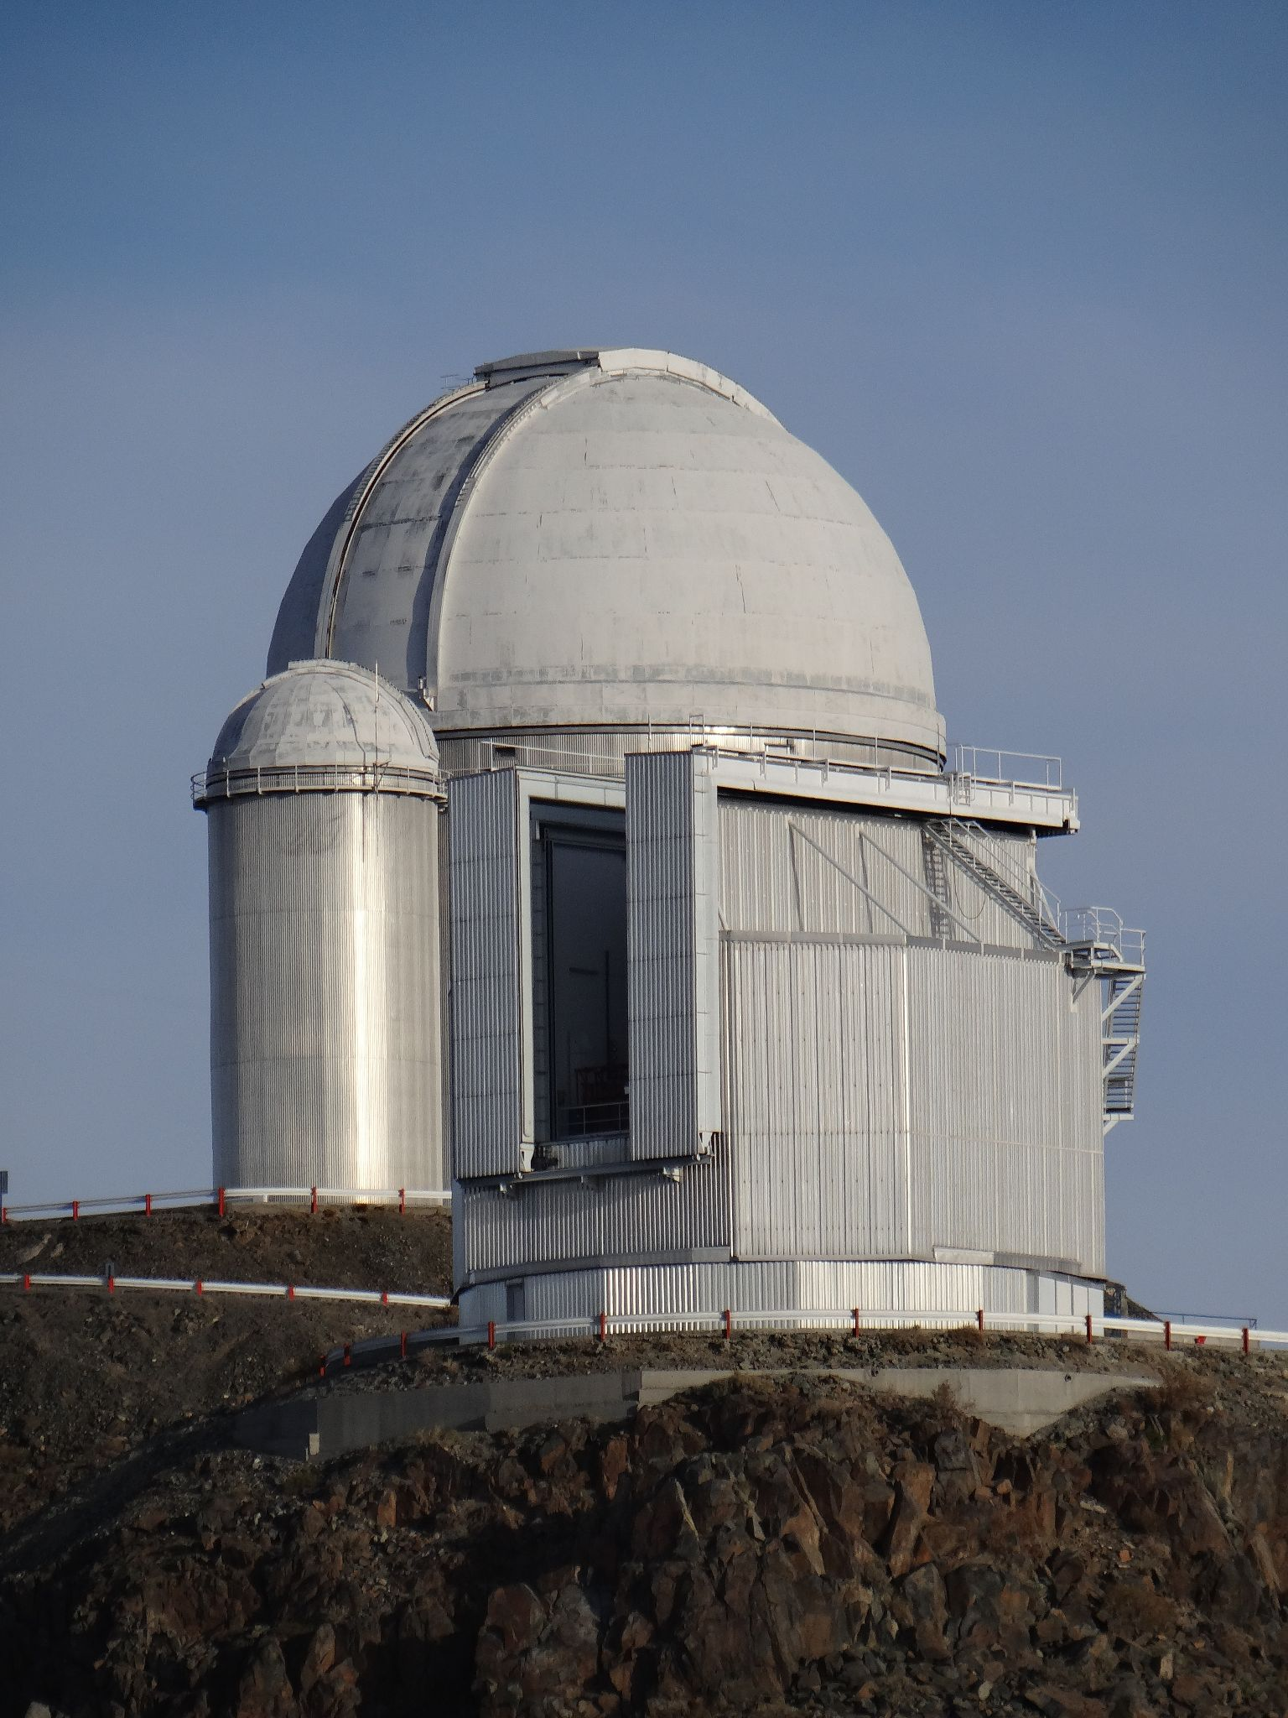
Figure 1: The NTT (box-like silver building with the open “dome” in front) and ESO 3.6 metre telescopes. The NTT has its dome open to perform sky flats. This is when the telescope observes the sky at dusk/dawn so its response to a uniform light source can be used for calibration. The ESO 3.6 metre telescope was not in operation this night due to fumigation - telescopes can get bugs when they’re in remote deserts!
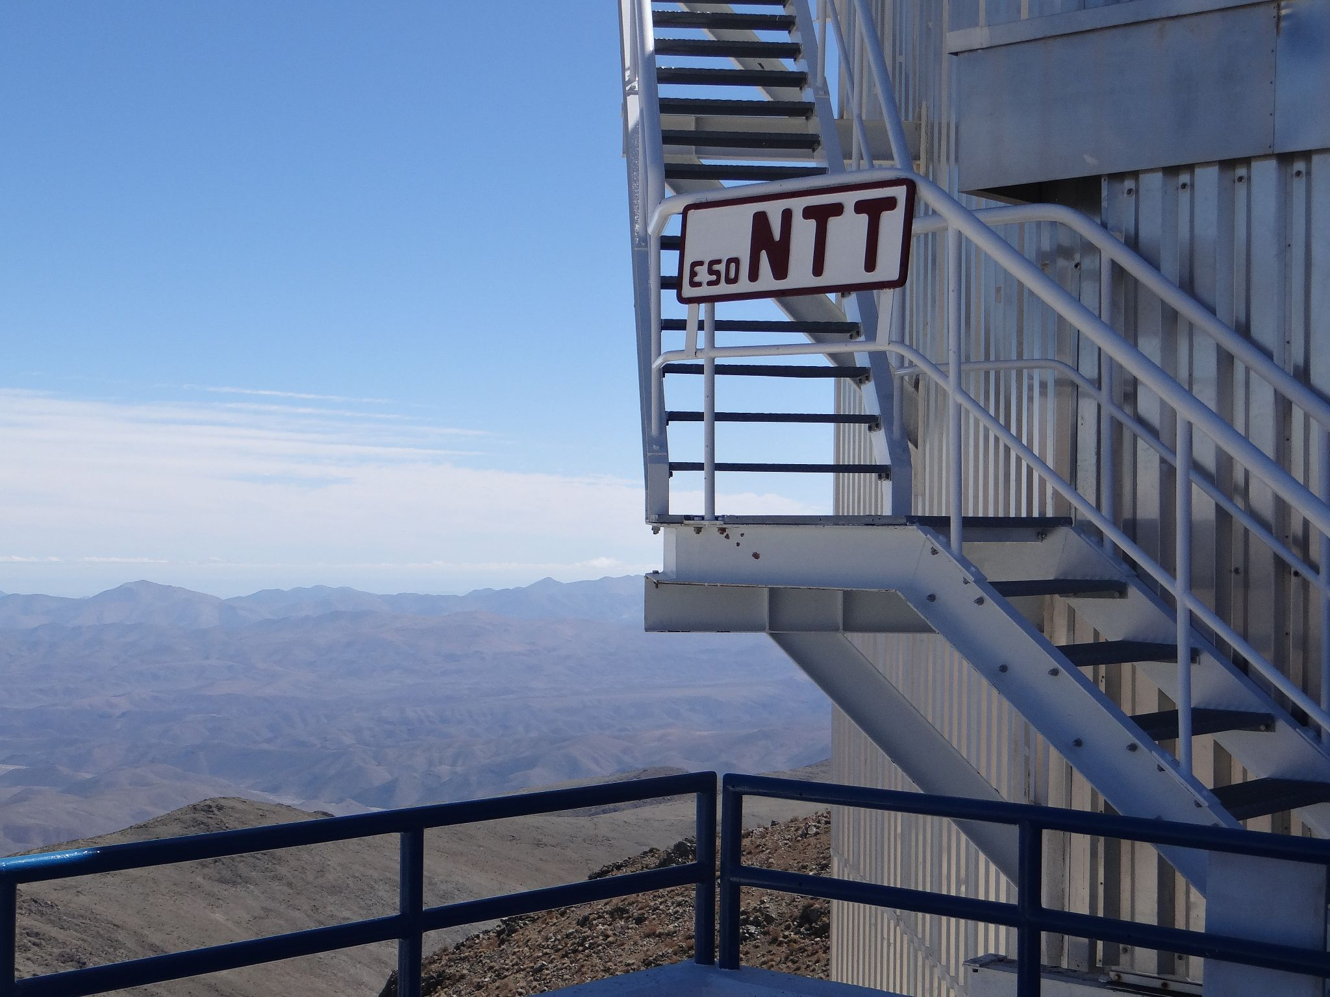
Figure 2: The entrance for ESO’s NTT
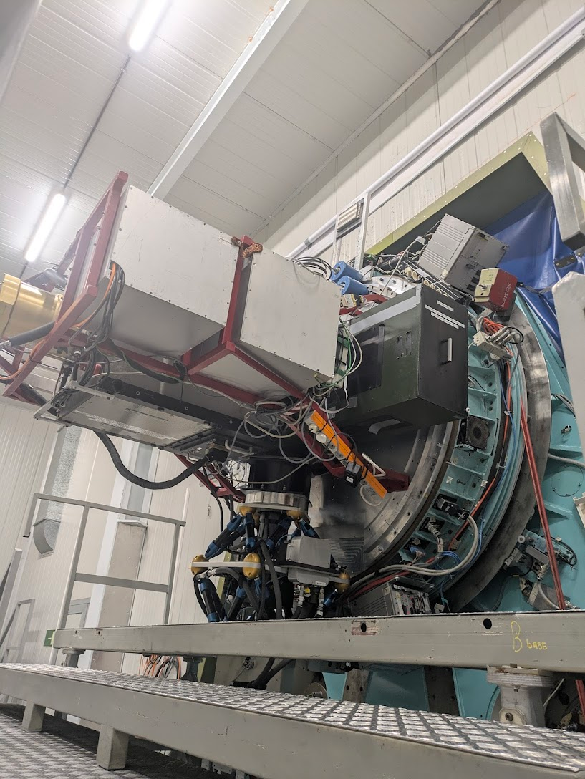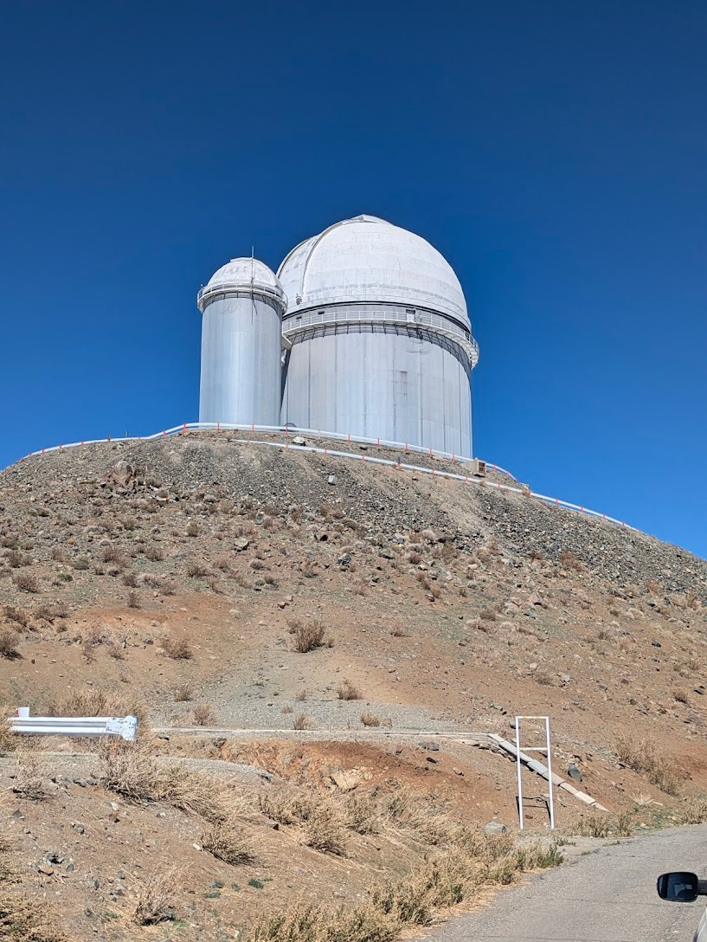
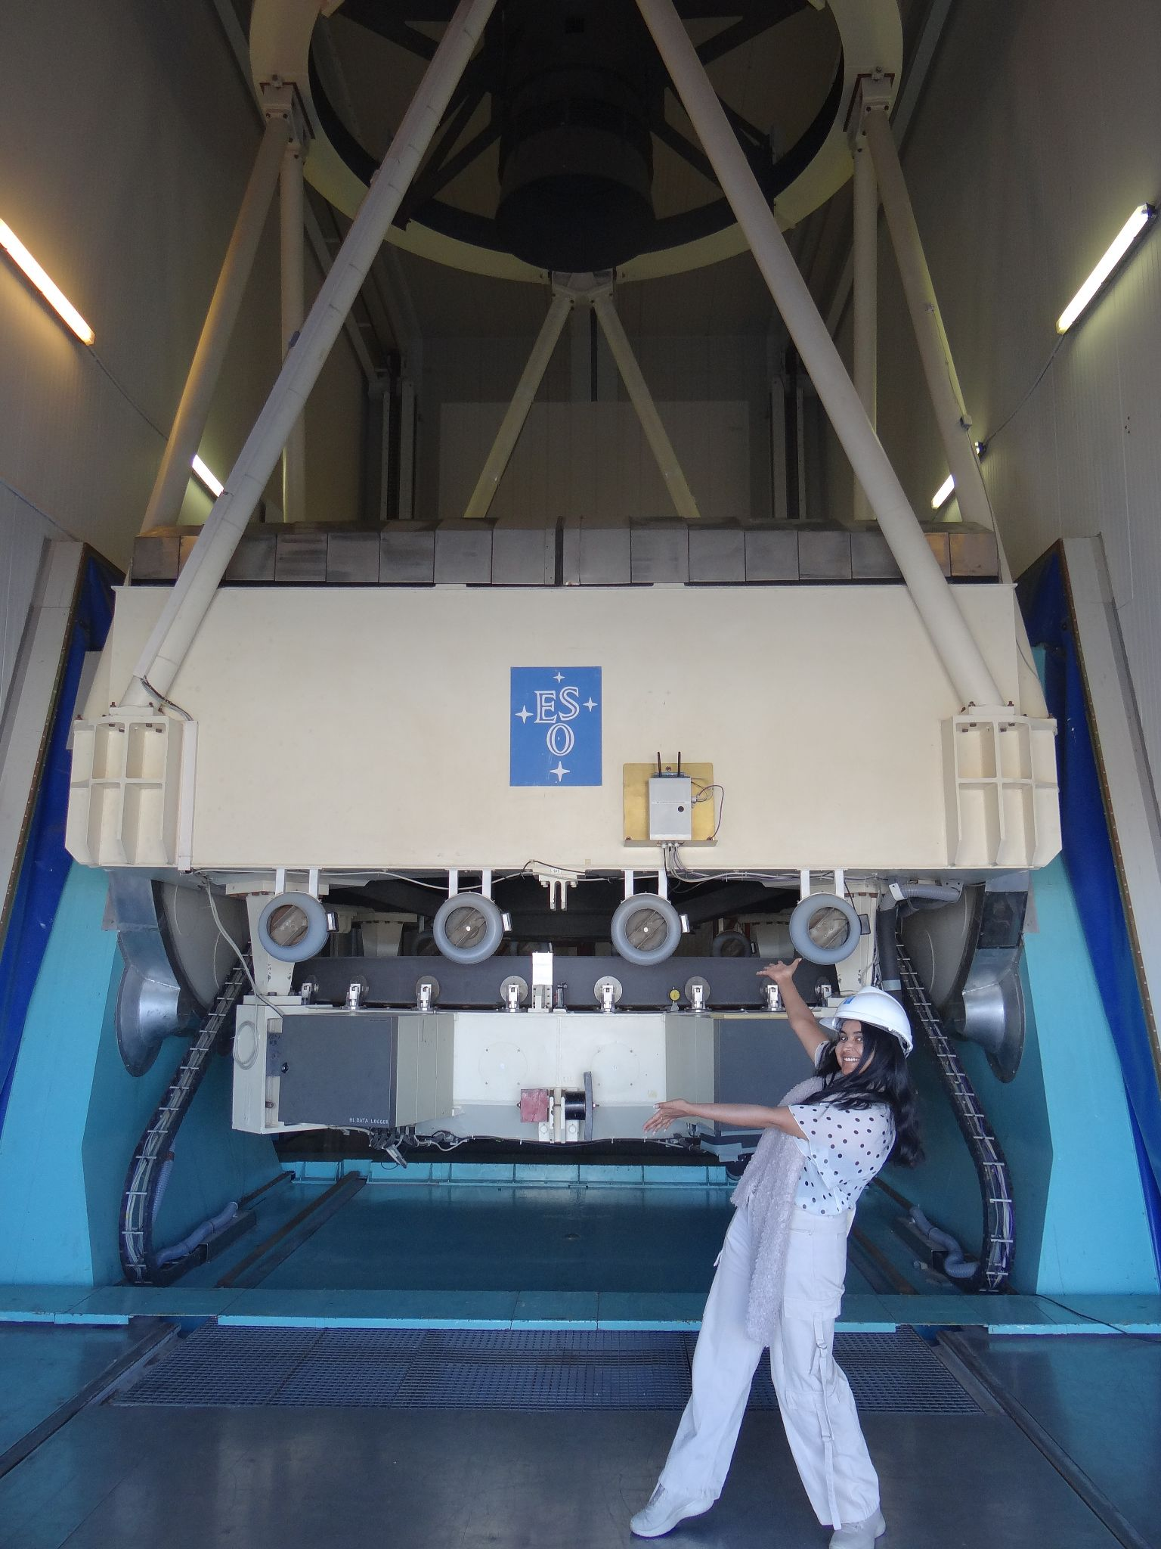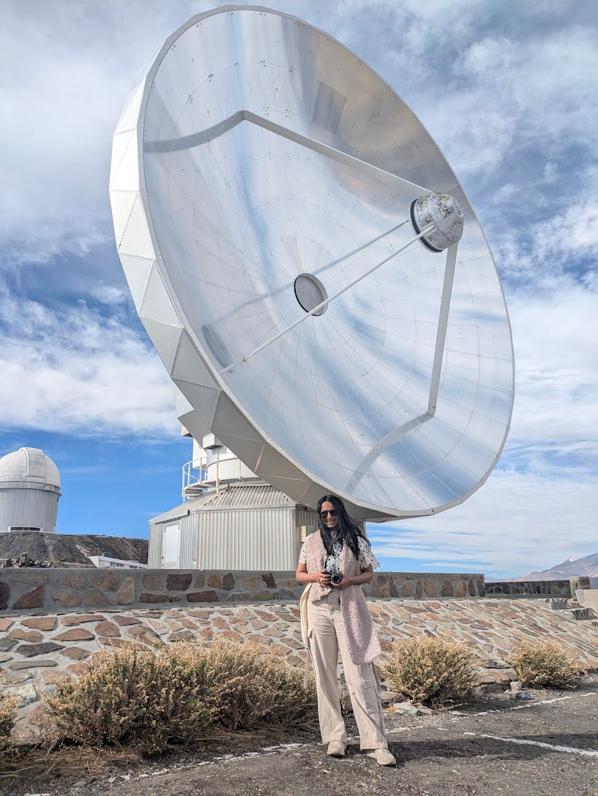
Figure 3
Clockwise from top left: a) The instruments docked on the NTT. EFOSC is the black cuboidal box. b) The ESO 3.6 metre telescope domes on the highest summit at La Silla, in all its glory. c) Standing with the NTT - me for scale. d) The Swedish ESO Sub-mm Telescope (SEST), now decommissioned. This is a radio telescope which also served as a prototype for the dishes of the Atacama Large Millimeter Array (ALMA).
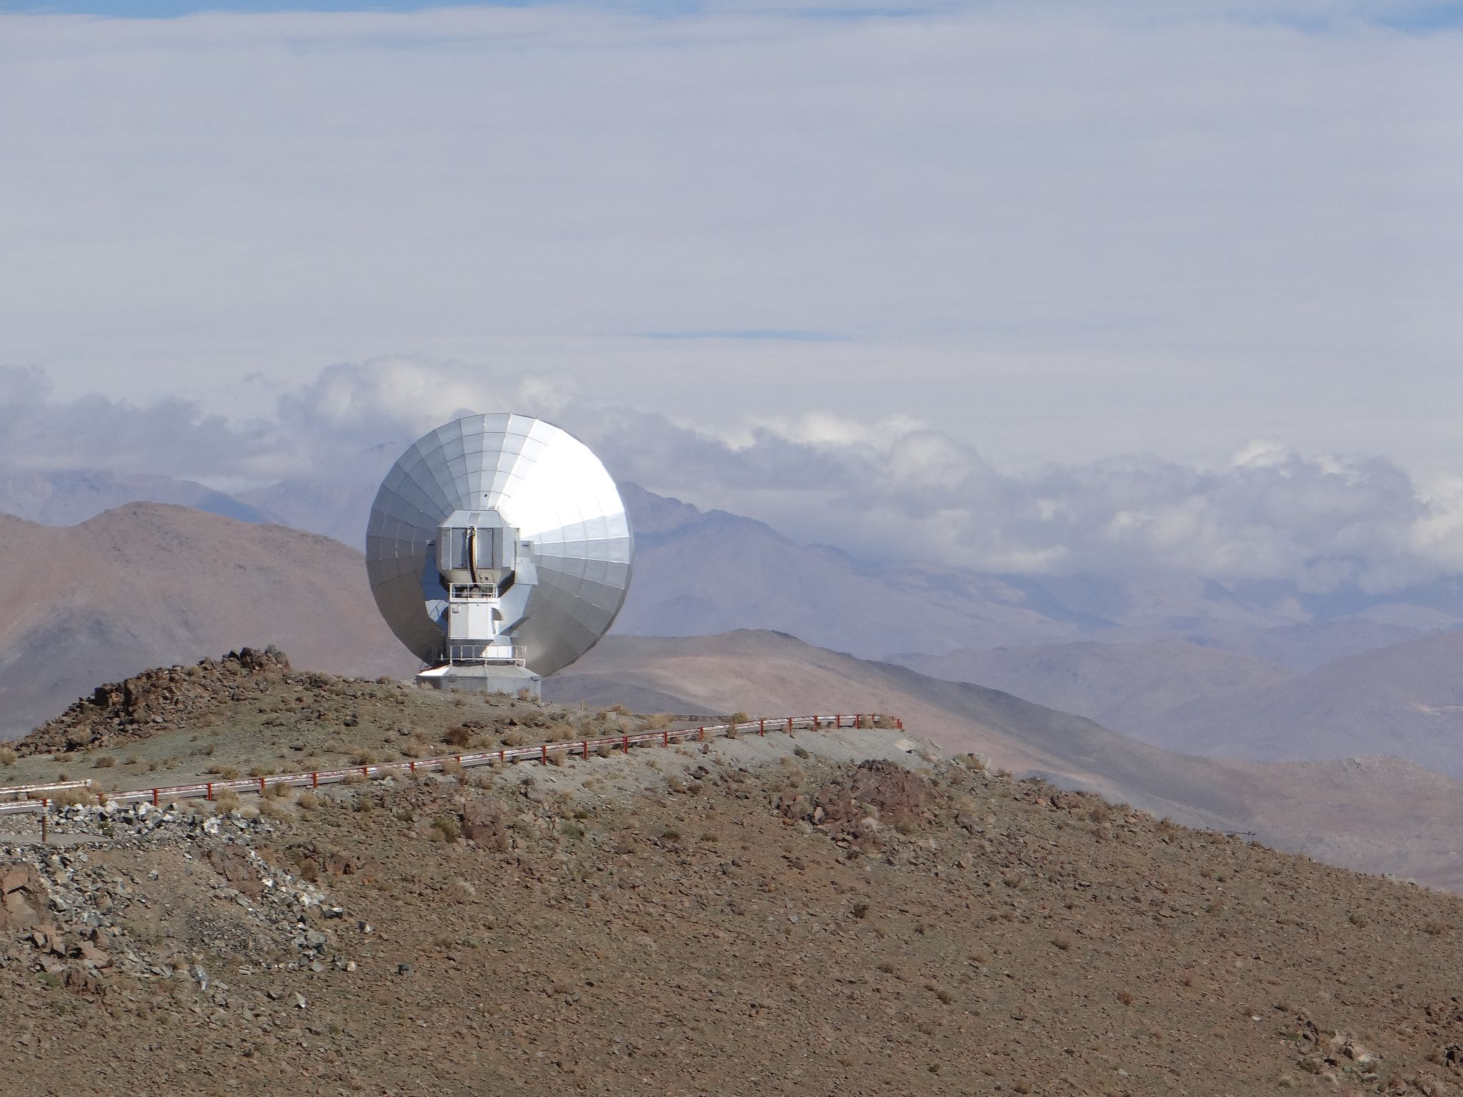
Figure 4: SEST, from a distance, with the mountains of the Atacama desert in the background.
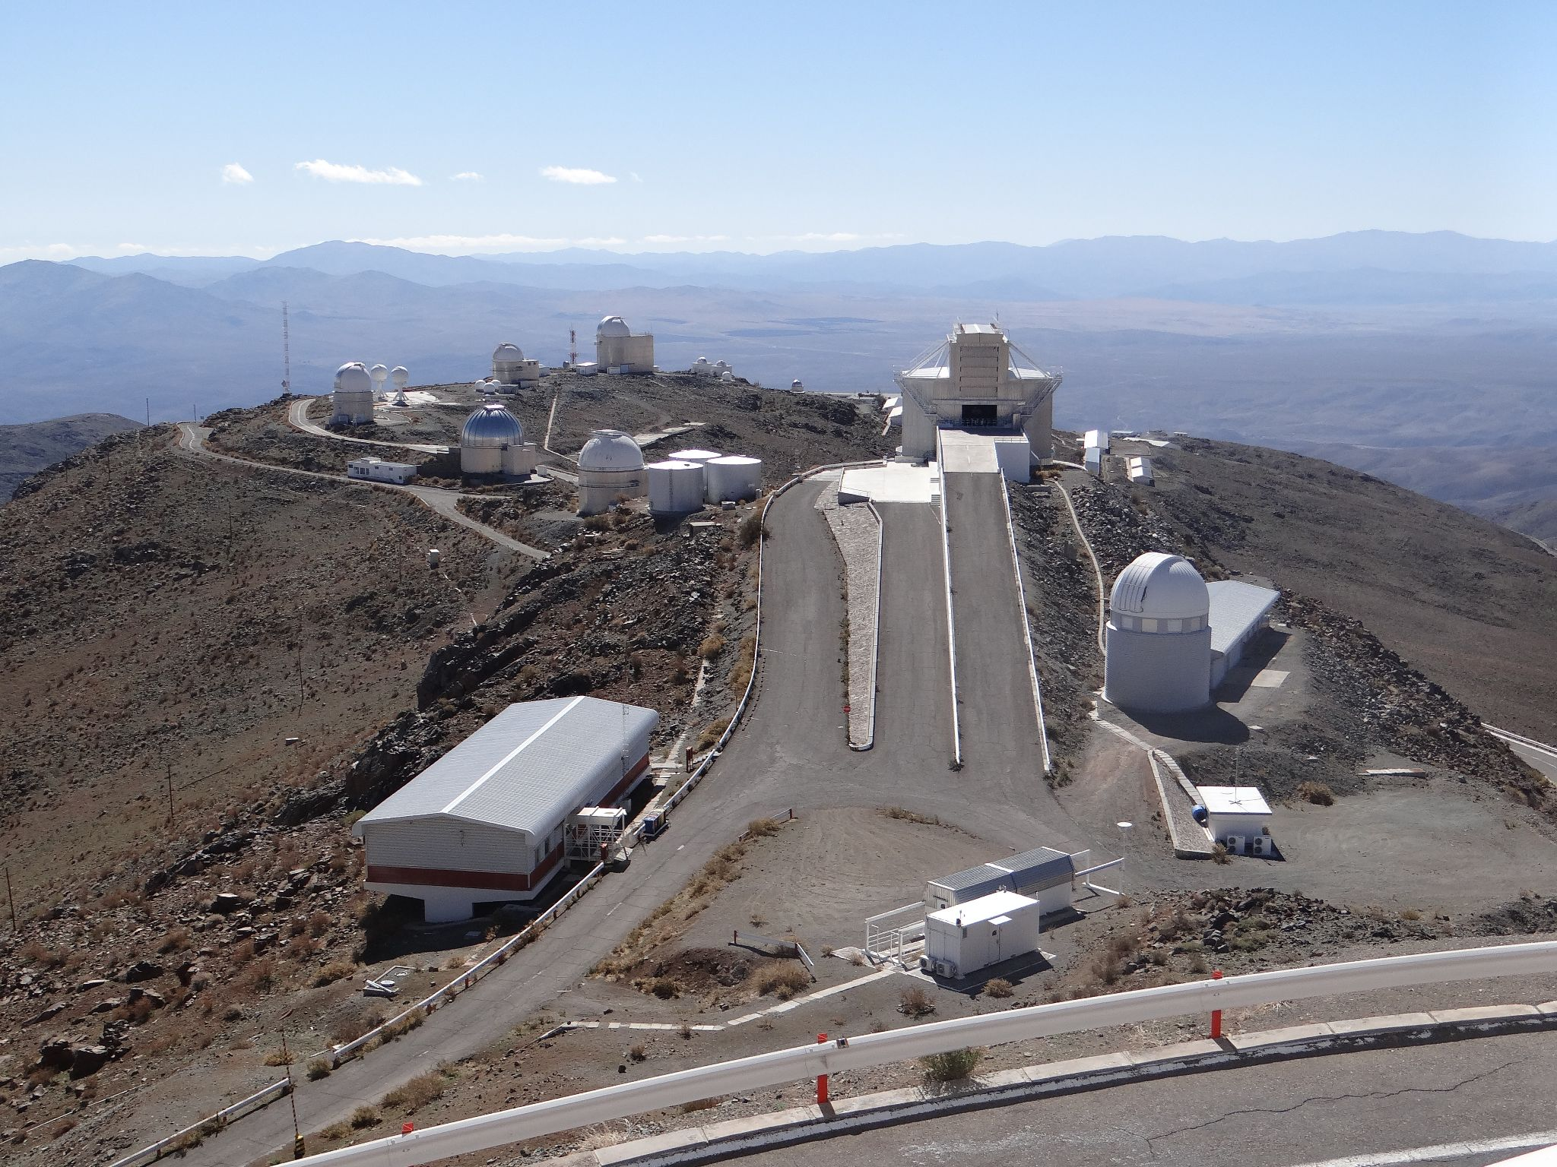
Figure 5: A birds-eye view of the ESO La Silla telescope site, as seen from the summit with the ESO 3.6m telescope. The NTT is the only non-circular dome shaped telescope clearly visible in this image.
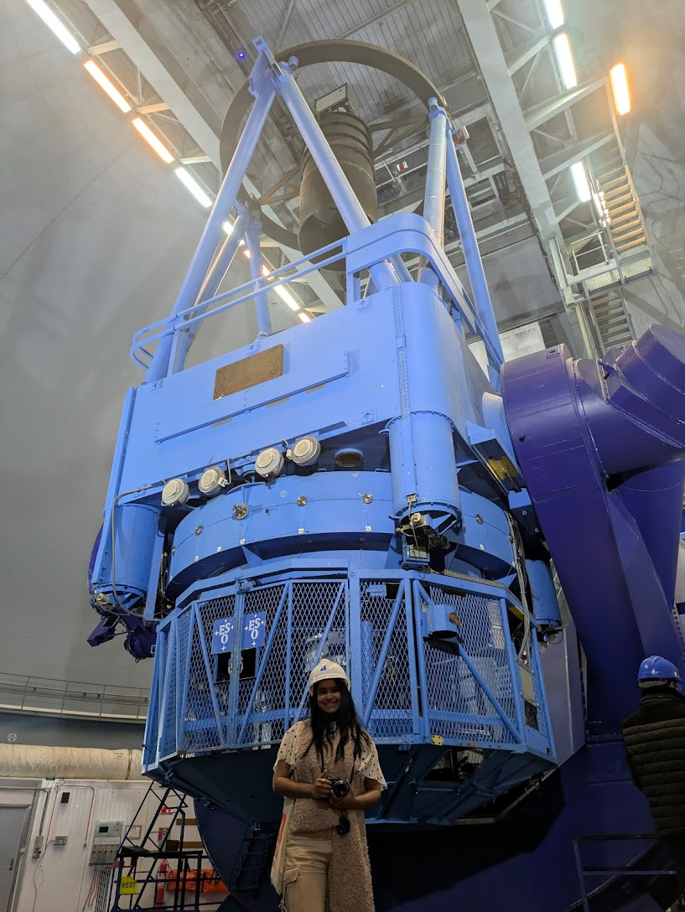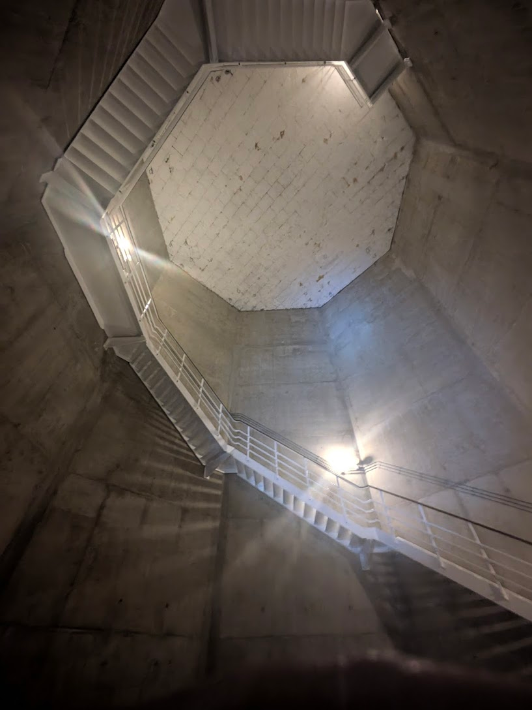
Figure 6: Left to right: a) Standing with the ESO 3.6 metre telescope. Me for scale. b) Seismic isolation chamber under the platform/levels which hold the telescope (see white roof in b). Chile and the Atacama are an immensely earthquake-prone zone. Having telescopes here means protecting them - they’re very expensive to re-build!

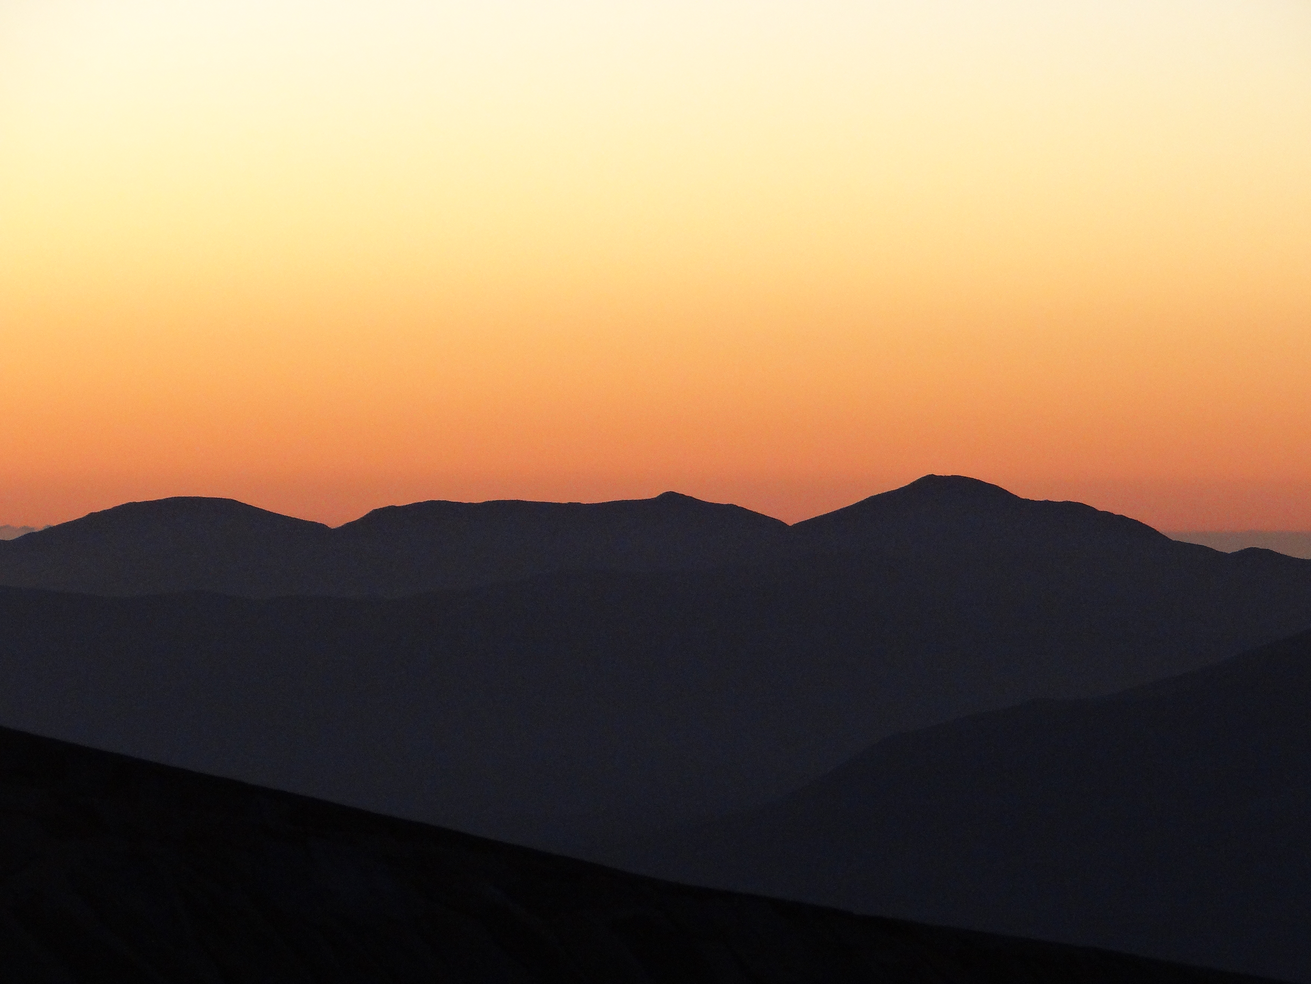
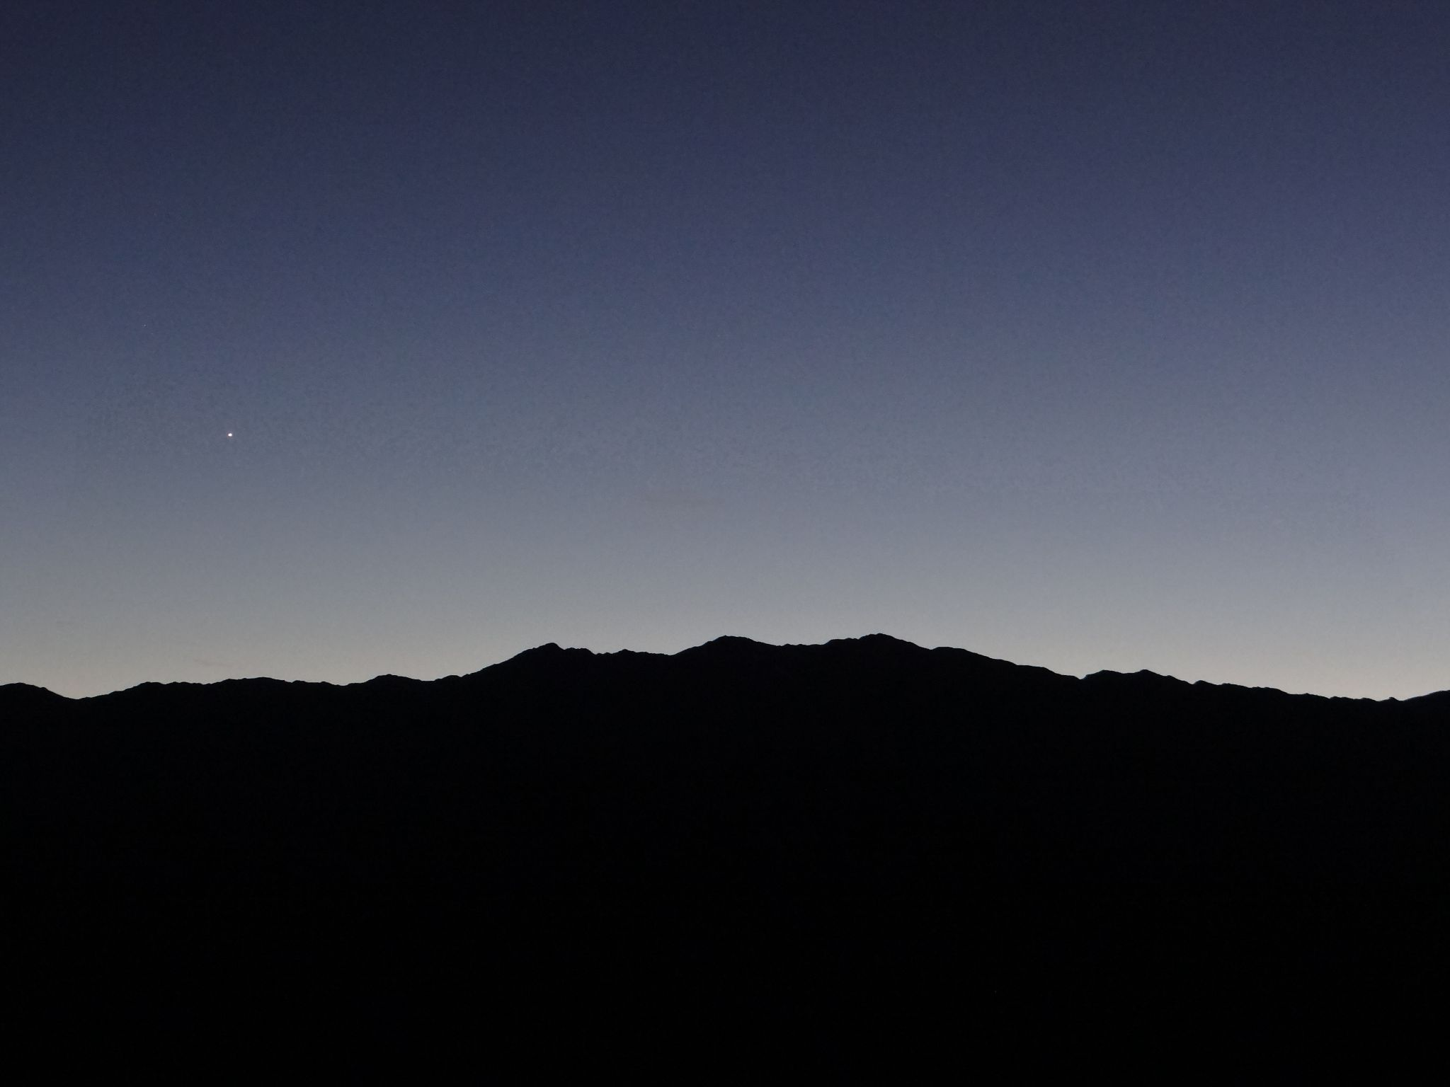
Figure 7: Sunsets and sunrises over the mountains coincided with when my shifts began and ended. This picture was taken prior to sunrise.

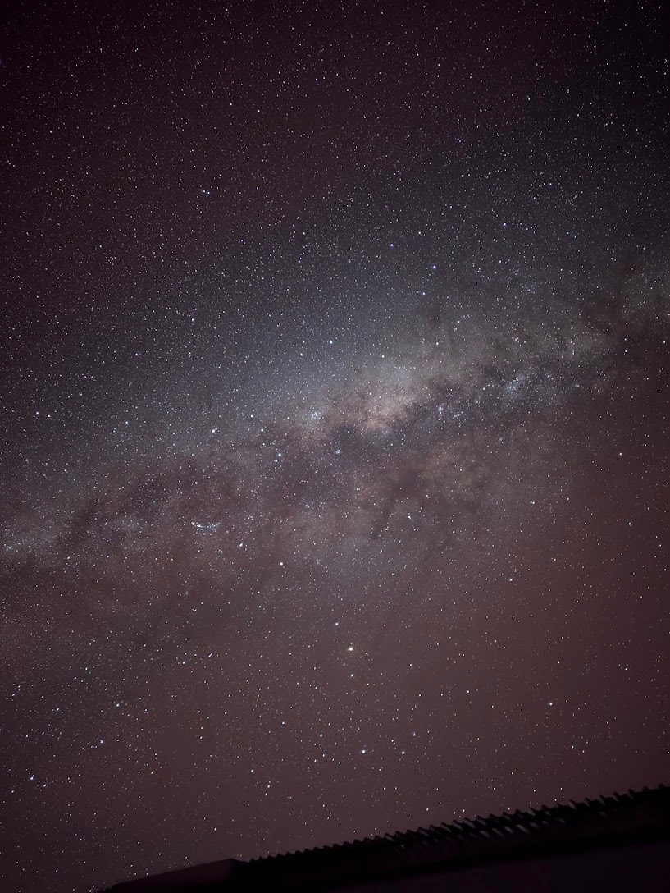

Figure 8: Long exposures of the night sky as seen from the observatory site.

Further reading:
NTT https://www.eso.org/public/teles-instr/lasilla/ntt/
EFOSC2 https://www.eso.org/sci/facilities/lasilla/instruments/efosc.html
ESO La Silla Observatory https://www.eso.org/sci/facilities/lasilla.html
SEST https://www.eso.org/public/unitedkingdom/teles-instr/lasilla/swedish/
Coronography https://www.britannica.com/science/coronagraph

Acknowledgments:
Everyone I met on this trip - if I’ve had a conversation with you, I express my gratitude for it. You made my trip merrier, and I learnt from you. Deanne, Danny for being the best PhD supervisors I could have asked for in making this observing opportunity a reality, and the ePESSTO+ collaboration members, specifically Joe Anderson and Cosimo Inserra. Ben Warwick for being a fun friend and colleague to work the grueling night shifts with. Monica and all the staff at ESO La Silla, and ESO for providing the funding for this trip, and to the Astrophysics PhD scholarship at the University of Warwick for enabling this PhD . Most importantly, my parents and Sam, for being my pillars and never not encouraging me to chase the stars.

