Space GCSE Booklet

Answers and additional diagrams on powerpoint

Credit to Ben Rogers for his work that has been adapted in the ‘What is an orbit?’ section.
Retrieval questions
Q1 | What is a light-year? | A unit of distance for astronomical scales. The distance light can travel in one earth year.
Q2 | What is a planet? | A non-luminous, spherical object that orbits a star. It must dominate its orbit.
Q3 | What is a moon? | A non-luminous object that orbits a planet.
Q4 | What is a galaxy? | A large collection of dust, gas and stars (each a possible planetary system of its own) held together by gravity.
Q5 | What is the name of our galaxy? | The Milky Way
Q6 | What is an orbit? | The elliptical path that one object in space takes around another object. It is caused by the gravitational attraction between the two objects.
Q7 | Name the 8 planets of our solar system in order (starting closest to the sun). | Mercury, Venus, Earth, Mars, Jupiter, Saturn, Uranus, Neptune
Q8 | What is found in the spaces between astronomical objects (such as planets, moons, asteroids)? | There is a small amount of dust but there’s no air (it’s a vacuum), so sound can’t travel, but there is still gravity due to all of the masses nearby.
Q9 | Name a natural satellite of the Earth. | The moon.
Q10 | What is an artificial satellite? | An object put into orbit around an astronomical object by humans e.g. the international space station around Earth, or the Pioneer probes around the Sun.
Q11 | Why is an object in orbit accelerating? | Because there is a central force acting on it, pointing towards the centre of the object. Because the velocity is changing.
Q12 | Why does the velocity of an orbiting object change but not the speed? | Because the orbiting object changes direction (hence the velocity must change), but its speed is constant.
Q13 | For a stable orbit, if the radius of the orbit decreases, what must happen to the speed? | The speed must increase.
Q14 | What force brings the dust and gas inside a nebula together to form a star? | Gravity.
Q15 | When the temperature within a protostar gets high enough, what process can begin? | Nuclear fusion (of Hydrogen into Helium)
Q16 | Why are main sequence stars in a state of equilibrium? | The force of gravity pulling the material inwards is balanced by an outwards force due to nuclear fusion.
Q17 | What will small stars eventually become? | Red Giants, then White dwarfs (with a planetary nebula), then black dwarfs
Q18 | What will large stars eventually become? | Red Supergiants, then a supernova leading to either a neutron star or a black hole.
Q19 | How are elements up to Iron in the periodic table formed? | Nuclear fusion in stars.
Q20 | How are elements beyond Iron in the periodic table formed? | By supernovae (the deaths of the largest stars).
Q21 | What three things are required to experience the Doppler effect? | A source of waves, an observer, and motion between the source and the observer.
Q22 | What is red shift? | The shift of waves to longer wavelengths (and smaller frequencies) as the source and observer move apart. Light shifts toward the red end of the spectrum.
Q23 | Why is light from distant galaxies red-shifted? | Because they are moving away from us (truly, the distance between us and them is increasing as the space between us expands).
Q24 | Why is red-shift evidence for the Big Bang Theory? | If all galaxies are moving apart, then they must have been closer together before. At some point they must have come from a single point (that was incredibly hot and dense) – The Big Bang.

Bitesize Assessment Q’s: https://www.bbc.co.uk/bitesize/guides/zth4xfr/revision/1

A note on the scale of the universe
The universe is big. Really big. And so our standard units of length (metres and kilometres) don’t really do astronomical distances justice as we end up with incomprehensibly large numbers. Instead, astronomers use the unit of a light-year. This, as the name suggests, is the distance that light can travel in one earth year (365.25days). The speed of light is c=3×10⁸m.s⁻¹, which means that light travels a distance of 3×10⁸m=300,000km every second. For a sense of scale, the circumference of the earth is 40,000km.
The diameter of our solar system is 0.001light-years, which means it takes light 0.001years to travel from one side to the other. This makes our solar system seem quite small when you notice that our next nearest star, Proxima Centauri, is 4.3light-years away (our nearest star is the sun). Space really is just that: lots of empty space.
The fact that light can never travel faster than 3×10⁸m.s⁻¹ means that when we see the light from a distant object, it was actually emitted from the object a long time ago (as it took the light so long to get here). So when we see light from Proxima Centauri, it has been travelling for 4.3years (and hence we’re actually seeing what Proxima Centauri looked like 4.3 years ago). The north star, one of the brightest stars in the sky, is over 300light-years away. So the light that we’ll see from it tonight was emitted long before even your grandparents were born. The furthest individual star that we’ve ever seen (which means we saw it in isolation from its galaxy) is about five billion light-years away.
Questions
- Why do astronomers use the units ‘light-years’ for distance?
- How many times around the earth does light travel in one second?
- How far is a light-year in km?
- How far is a light-year in m?
- How long, in hours, does it take light to travel from one side of the solar system to the other (give your answer to 2 significant figures)?
- How long, in seconds, does it take light to travel from one side of the solar system to the other (give your answer to 2 significant figures)?
- Why might a person say that looking at the stars is like looking into the past?
- How far does light travel in 5s?
- How far does light travel in 0.2s?

Objects in the universe
The universe as we see it comprises of billions upon billions of galaxies, each containing millions of stars and planets, as well as dwarf planets, asteroids, comets and nebulae. What are all of these objects? And which are bigger?
Note: We use the word luminous to describe objects that emit visible light. Some astronomical objects emit infrared radiation (black-body radiation) but not visible and they are categorised as non-luminous here.
Biggest    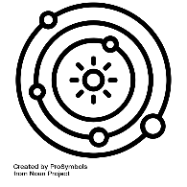  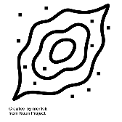  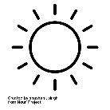          Smallest | Universe | The entirety of everything. The universe contains every object we know of.
 | Galaxy | A large collection of dust, gas and stars (each a possible planetary system of its own) held together by gravity that travel together through the universe. Our galaxy is the Milky Way.
 | Planetary system | The collection of objects that are attracted by gravity to a central star. We call our star system the solar system and it includes our star (the sun), the eight planets, five named dwarf planets, and the asteroid and Kuiper belts.
 | Nebula | A collection of gas and dust that will eventually form a star.
 | Star | The luminous (emits visible light) object at the centre of each star system. We call our star the sun.
 | Planet | The non-luminous (doesn’t emit visible light) objects that orbit a star. They are roughly spherical and dominate their orbit.
 | Moons | The non-luminous objects that orbit planets.
 | Dwarf Planet | The non-luminous objects that orbit a star that don’t fulfil all of the planetary criteria.
 | Asteroid | Generally lumps of rock and metal.
 | Comet | Generally lumps of ice and rock.
The order of the above table isn’t perfect. A moon will always be smaller than the planet that it orbits, but it might be bigger than some of the other planets in the same star system. Equally, some asteroids might be bigger than some moons.
Is there anything bigger than galaxies? Other than the universe itself, we do get galaxy clusters – groups of galaxies that travel together due to their gravitational attraction to one another.
Black holes
A black hole is an object that is so dense (so much matter has been squeezed into such a tiny space) that its gravitational pull is large enough that not even light can escape its clutches if the light gets within a certain distance of the black hole (the event horizon).
Small black holes may have existed since the very earliest moments in the Universe and there could be many of these throughout each galaxy.
Stellar black holes are formed when some of the largest stars reach the end of their lifetime.
Scientists have found proof that at the centre of each large galaxy is a supermassive black hole and these are believed to have formed around the same time as the galaxies they live within.
What makes a planet?
To be a planet, an object must fulfil three criteria:
- It must independently orbit a star (unlike moons, which orbit a star because they orbit a planet)
- It must have a large enough mass to make itself roughly spherical.
- It must dominate its orbit – this means it must be much larger than everything else that orbits the star along a similar path.
It is the last of these points that meant Pluto was no longer considered a planet but instead became considered a dwarf planet. Its path around the sun is shared with objects that aren’t significantly smaller than itself.
Questions
- What does luminous mean?
- Why is the earth non-luminous?
- Which is bigger, a galaxy or a planetary system? How do you know?
- What name do we give to our planetary system?
- What name do we give to our galaxy?
- What is the difference between a moon and a planet?
- Complete the following Venn diagram for all of the objects in the universe from the table above:
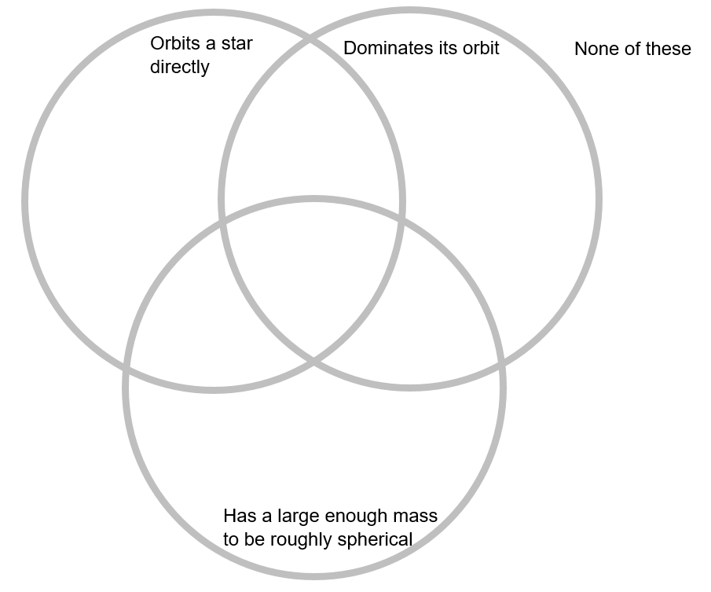
- Why is Pluto not considered to be a planet any longer?
- Can an asteroid be bigger than a moon?
- Are planets limited to having just one moon?

What is an orbit? Credit: Ben Rogers
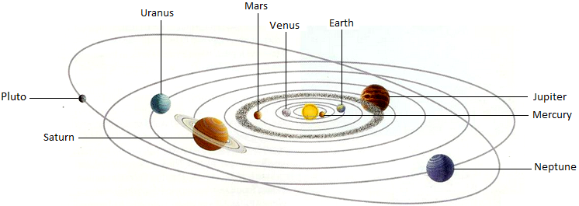
Until 1609, astronomers believed that the planets travelled in circular paths around the sun. It took a genius to calculate their actual paths, and Johannes Kepler discovered that planets actually travel in ellipses (an elongated circle). This was a problem for astronomers as nobody understood what force could make the planets travel in these elliptical paths. At first, Kepler thought it might be magnetism, but this is not correct. It turns out to be the gravitational pull of the sun, keeping all of the objects in the solar system travelling in these elliptical paths:

Note, to represent the real solar system:
- The orbits would need to be much larger.
- The planets would need to be much smaller.
- The ellipses would not be as stretched as this (that’s why it took a long time to realise the orbits were not circles). They are very close to being circular, but not quite.
- Pluto’s orbit should include other Kuiper belt objects that share its orbit.

We use the word orbit to describe this regular, repeating path that one object takes in space to move around another one. So, for instance, the moon orbits the earth (with an elliptical path) and the earth orbits the sun (with an elliptical path). Comets orbit the sun and tend to have exaggerated elliptical paths, so look less like circles. Whilst we might see them drawn as circles (as they are very close to being circular), we know that orbits are truly ellipses.
Examples and non-examples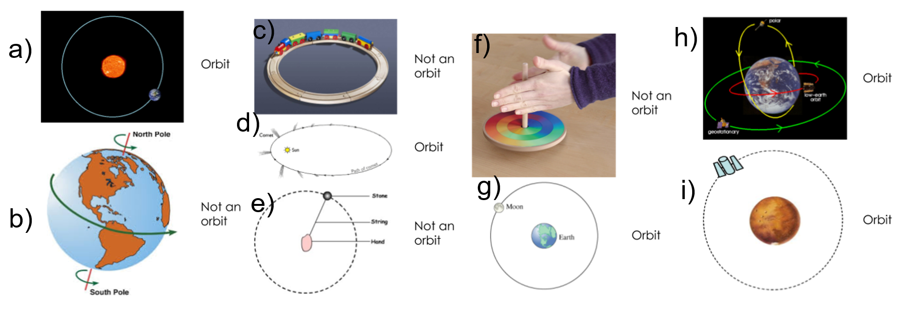
Orbits are maintained due to the force of gravity. The object that is orbiting is constantly being pulled by the object at the centre of its orbit (and, due to Newton’s third law, the orbiting object pulls back equally).
Questions
- What is an orbit?
- What shape do the paths of all objects have during an orbit?
- Why did astronomers struggle to notice that the paths of planets around the sun are ellipses?
- Why are orbits often drawn as circle?
- For each of the 4 ‘Not an orbit’ examples (b, c, e and f), explain why they are not an orbit.
- Draw a diagram to show the moons orbit around the earth at the same time as the earth’s orbit around the sun. You’ll need 3 labelled circles for the moon, earth and sun, and 2 labelled ellipses for the two different paths.
- What causes objects to stay in orbit?
- The earth pulls the moon in its orbit with a force of around 2×10²⁰N. With how much force does the moon pull the earth?
- The sun pulls the earth in its orbit with a force of around 4×10²²N. Use this number to explain why the gravitational moon does not significantly affect the earth’s orbit around the sun. Calculate the ratio of the moon’s pull on the earth to the sun’s pull on the earth.

Our solar system
Our solar system is the group of objects that orbit our star, the sun, due to its gravitational field. The objects that orbit the sun include eight planets, five named dwarf planets, the asteroid belt and the Kuiper belt. Moons also orbit the sun indirectly since every moon orbits a planet, with the planet orbiting the sun.
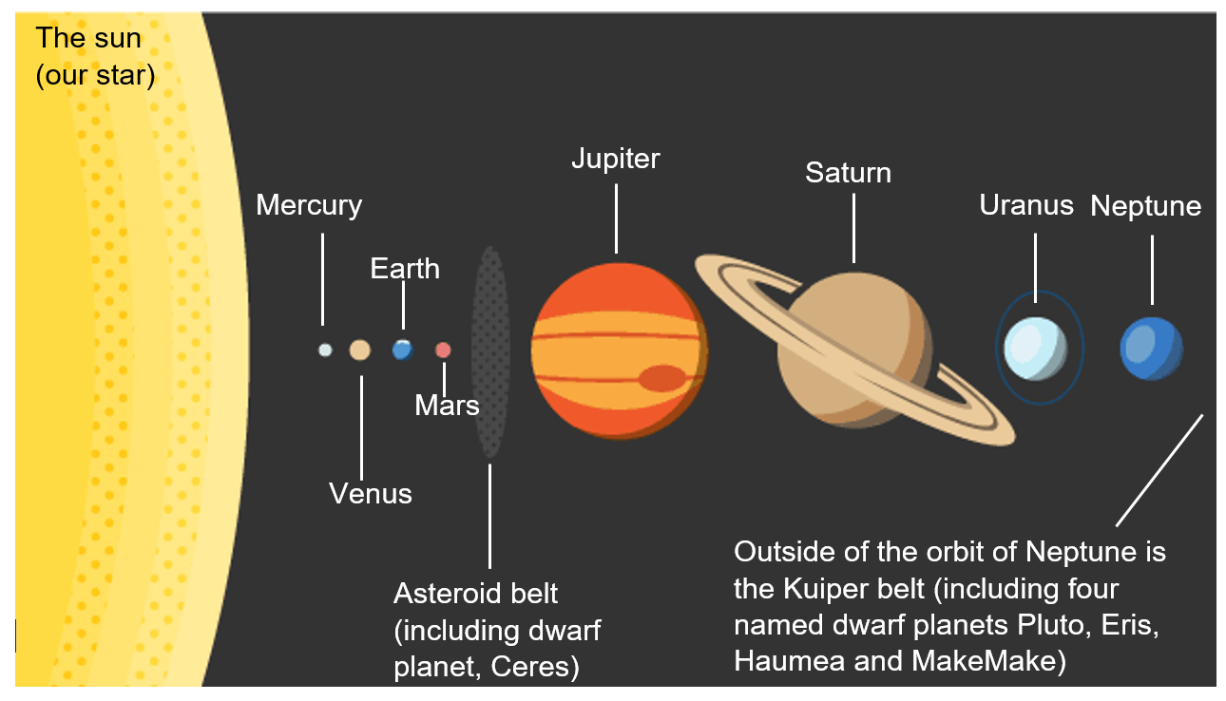
We often use mnemonics to remember the order of objects in our solar system, such as…. Insert your mnemonic here.
Beginning closest to the sun and moving outwards, we first encounter a group of four planets known as the inner planets (or the terrestrial planets). In order, these are Mercury, Venus, Earth and Mars. They are similar in composition, each being made of rock and metal, leading them to be quite dense. Earth is the largest of these four planets and takes 365.25 days to complete its orbit around the sun – this is how a year is defined: the time taken to complete an orbit.
The next object in the solar system is the asteroid belt. Asteroids are large lumps of rock and metal (much the same as the terrestrial planets) but are considerably smaller than planets. The asteroid belt is simply a large collection of asteroids all orbiting the sun at a similar distance away from it. Within the asteroid belt is the first of the named dwarf planets: Ceres. Dwarf planets are planet sized objects but ones that don’t have orbits that are free of other debris (asteroids).
Outside of the asteroid belt are the two gas giants: Jupiter and Saturn. These are the two largest planets in our solar system (Jupiter being the larger of the two). They are called gas giants as they are composed primarily of Hydrogen and Helium, which tend to be found as gases on Earth. It is so cold on these gas giant planets, though, that Hydrogen and Helium tend to be found in a liquid state there. These planets also have the largest masses in our solar system (with Jupiter having the larger mass).
The next two objects are the two outermost planets in our solar system: the ice giants. These are named Neptune and Uranus. They are composed predominantly of solid forms of water, ammonia and methane. On earth these substances are more naturally found as liquids (methane is gaseous on earth), and so the name “ice giants” indicates the temperatures on Neptune and Uranus are much lower than on Earth as these elements are found in a solid state there.
Outside of the orbit of Uranus and Neptune we have “trans-Neptunian objects” which includes the Kuiper belt: a further collection of smaller astronomical objects, similar to the asteroid belt. Within the Kuiper belt, there are four named dwarf planets: Pluto (which was previously incorrectly classified as a planet), Eris, Haumea and Makemake. Whilst the asteroids of the asteroid belt were mainly made of rock and metal (similar to the planets before them), the objects of the Kuiper belt are mainly made of the “ices” that make up Neptune and Venus: frozen water, frozen ammonia and frozen methane. Scientists are not yet in agreement about whether objects within the Kuiper belt are asteroids, comets or should be treated separately.
What’s amazing about our solar system is the amount of space that there is. In between one astronomical object and the next is nothing. A vacuum. When we consider the sizes of the planets compared to the size of their orbits, the planets seem tiny. Most pictures we see of the solar system don’t do the scale of the emptiness any justice. One team of individuals set out to make a true model of the solar system, starting with a marble to represent the Earth. In this case, if the earth is the size of a marble, the sun needs to be represented by an object that is over a metre in diameter, but even more astoundingly, it needs to be positioned 200m away from it. At this scale, Neptune is about the size of an apple but is over 5.5km from the sun.
Questions
- What are the four terrestrial planets called?
- What is a similarity between a dwarf planet and a planet?
- How long is a year on earth?
- What is the significance of a year in terms of the earth’s orbit?
- Which is the largest planet in our solar system?
- What are the ‘gas giants’ mainly composed of?
- Why is Hydrogen found on the ‘gas giants’ in a liquid state? What is the process called whereby a gas turns into a liquid?
- Which is the outermost planet in our solar system?
- What are the ‘ice giants’ mainly composed of?
- Why do we call Neptune and Uranus ‘ice giants’?
- List the eight planets from closest to the sun to furthest from the sun, including the location of the asteroid belt.
- The terrestrial planets are described as dense compared to the gas giants, what does this mean?
- Why do we only find dwarf planets in the asteroid and Kuiper belts?
- The earth has an average density of 5500kg/m³. If I take a 0.25m³ ‘average chunk’ of the earth, what is its mass?
- Jupiter has an average density of 1300 kg/m³. If I take a 0.25m³ ‘average chunk’ of Jupiter, what is its mass?
- Light travels at 3×10⁸m/s, whilst the sun is 1.49×10¹¹m away from the earth. How long does it take light that is emitted from the surface of the sun to reach earth?
- Neptune is 4.5billion km away from the sun.
  - Convert this into metres and into standard form.
  - How long does it take light to get from the sun to Neptune?
- Draw a labelled diagram of the eight planets, asteroid and Kuiper belts in orbit around the sun.
- Draw a labelled diagram of the nuclear model of the atom for ${}_{2}^{4}{He}$.
- What are the similarities and differences between the model of the solar system and the nuclear model of Helium?
- Why is it so difficult to create a scale model of the solar system?
Aside: comets vs asteroids vs meteoroids
The difference between asteroids and comets is one of composition: while asteroids are mainly composed of mineral and rock, comets are primarily composed of dust and ice. The ice within comets gives rise to the tail of a comet as the ice melts and boils. Their composition is partly due to where they are formed: asteroids formed closer to the sun, preventing the development of cometary ice. Meteoroids and asteroids tend to have similar compositions but the main difference between them is one of size: meteoroids have a diameter of one meter or less, whereas asteroids have a diameter of greater than one meter.
Questions
- An object spotted in space has a diameter of 2.5m and is composed mainly of rock. What is it?
- An object spotted in space has a diameter of 50cm and is comprised of ice and dust. It’s seen a tail trailing behind it. What is it?
- An object spotted in space has a diameter of 9mm and is comprised of dust and rock. What is it?

Our galaxy
Our galaxy is called the Milky Way, so named because when the Greeks looked at the night sky, they saw a milky patch above the earth which they named ‘galaxias kyklos’ which translates as ‘milky circle’. The Milky Way is a spiral shaped galaxy and our solar system is on one of its arms. When we see the Milky Way from earth, we are seeing it from the inside, looking along the disk.
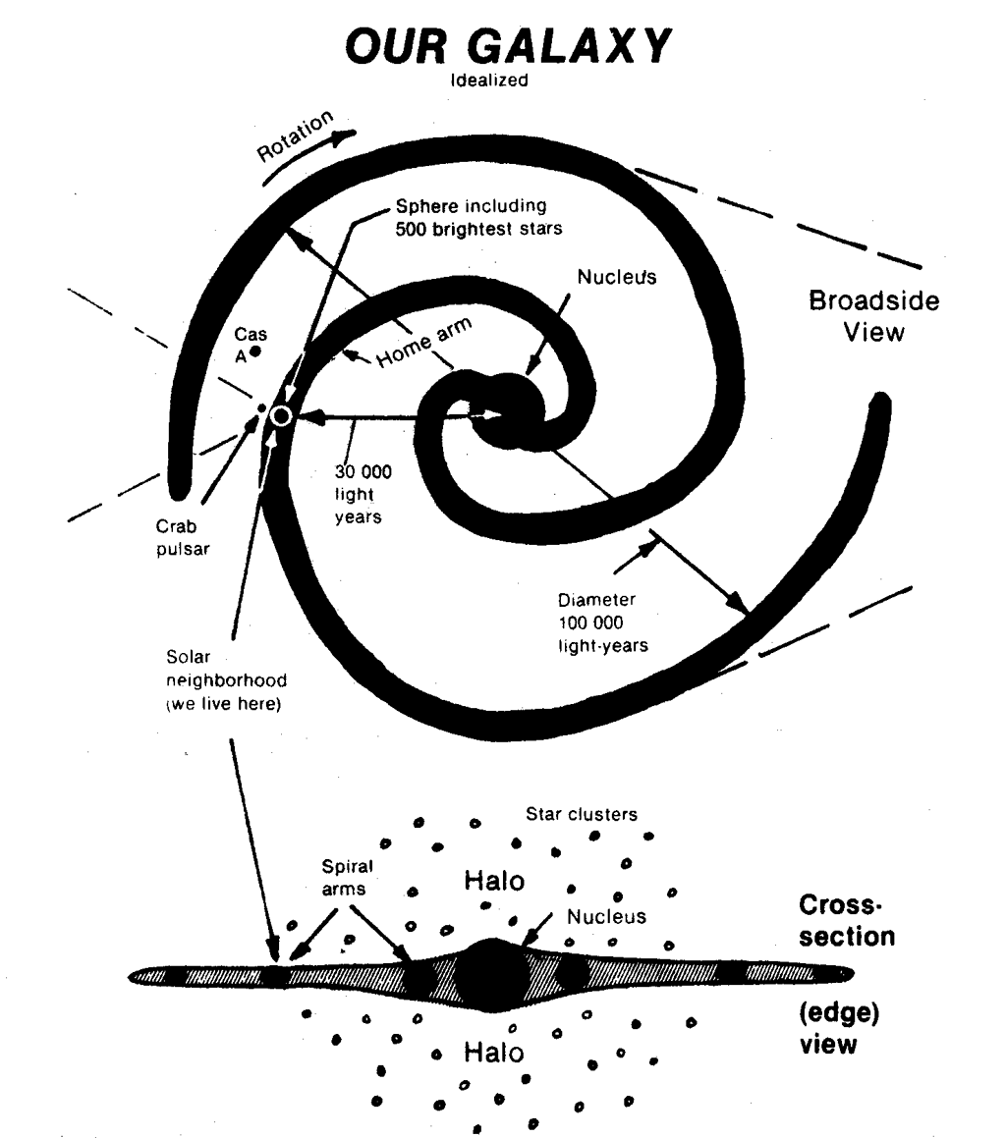
We don’t technically have any photos of the Milky Way since manmade objects have only recently ventured further than our solar system. In 2013, NASA confirmed that it believed the unstaffed Voyager I left our solar system and ventured into interstellar (inter: between, stellar: stars) space. Likewise, in 2018, it announced a similar fate for Voyager II. This still leaves the Voyager probes nowhere near the next nearest star, and is an insignificant distance on the scale of our galaxy. We’ve really not explored far at all. Even worse, the furthest a human has ever been from earth is when the crew of Apollo 13 were at their highest point on the far side of the moon, around 400,000km from the earth.
Questions
- What is the name of our galaxy?
- What is the shape of our galaxy?
- Where is our solar system within the galaxy?
- What does interstellar mean?
- Why don’t we have any direct photographs of our galaxy from the outside?
- What’s the furthest a human has been from earth?
- Have any human-made objects left our galaxy?
- Have any human-made objects left our solar system?
- How long would it take light to cover the distance the distance that the Apollo 13 staff got from earth (400,000km)? The speed of light is 3×10⁸m/s.
- Our galaxy is around 100,000 light years wide. Convert this to metres (in standard form). The speed of light is 3×10⁸m/s.

Artificial satellites and stable orbits
We would describe the moon as a natural satellite of the Earth. The moon was not put there by humans and its orbit occurs naturally. However, there are many other objects that orbit the Earth that have been put there by humans. We call these artificial satellites and they range from tiny communication satellites (such as the KalamSat, which was designed by an 18year old student in India) to the International Space Station (ISS) which can house up to 6 scientists.
The first artificial satellite was named Sputnik I and was launched by Russia in 1985. Since then, around 9000 artificial satellites have been launched to orbit the Earth. In 2018, it was estimated that around 5000 of these remain in orbit with almost 2000 being operational. Non-operational artificial satellites are categorised as space-debris and are a mounting issue.
Whilst artificial satellites are more commonly put into orbit around the Earth, they can be designed to orbit any astronomical object. There are currently around a hundred artificial satellites of the sun, with the Pioneer probes 6, 7, 8 and 9 being some of the more famous.
Questions
- What is a natural satellite?
- What is an artificial satellite?
- Do artificial satellites always orbit the Earth?
- What is space debris?
- Name three artificial satellites of the Earth.
- Name one natural satellite of the Earth.

How do objects stay in orbit?
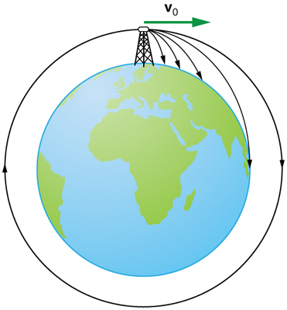
A good way to understand orbits is to imagine firing an object horizontally from a very tall building. We would expect our object to eventually fall to the Earth. Isaac Newton performed the same thought experiment, but imagined what would happen if we fired the object faster and faster. As we increase the speed of our object, we’d imagine it to always arc towards the ground, but get further and further away. What if we fired it so fast that as it curved downwards due to the force of gravity, the curve of the earth meant that the ‘floor’ curved away too?
This is how we put artificial satellites in orbit, we carefully put them at a certain distance from Earth, designing them to have a speed that allows them to be pulled by the gravitational force of the earth in such a way to drag them around it. How do we do this? We send them up on a rocket and release them at just the right time.
Clearly, within our atmosphere, our fired object would encounter air resistance and so we’d need to provide a constant thrust to counteract this. But in space, there is no air resistance, as there’s no air. So once we get our object at the correct speed and in the correct direction, the pull of the earth should do the rest.
Artificial satellite’s orbits are so close to being circular that we can consider them to be true circles. We therefore call the motion of an artificial satellite circular motion. The circular motion of satellites has some important properties:
- The force (from gravity), always acts towards the very centre of their circular orbit. This means that the force is at right angles to the satellite’s motion at every point.
- Every object that experiences a resultant force will accelerate – this is Newton’s second law. So objects in circular motion are constantly accelerating.
- An acceleration means that the velocity of the satellite is constantly changing.
- But, because the force is at right angles to the motion, it cannot change the speed of the orbiting object, it can only change its direction.

Questions
- Draw a diagram to explain how we could get a cannonball into an orbit of the Earth using just a cannon.
- Why is it possible to get a very low orbit on the moon (one that is just above the mountains), but no possible to do something similar on earth?
- How do we put satellites into orbit?
- Write down the formula for Newton’s second law.
- A satellite experiences a force from Earth of 0.005N. The satellite has a mass of 2.5kg. What is its acceleration?
- The two quantities speed and velocity: which is a vector and which is a scalar?
- What is the definition of velocity?
- How can the velocity of a satellite change but not its speed?
- Complete these sentences:
  - A satellite is accelerating because…
  - A satellite is accelerating but…
  - A satellite is accelerating so…
Stable orbits
There are three main categories for the different orbits that artificial satellites take around earth, depending on their distance away from the earth’s surface: low earth orbit (<2000km from the surface), medium earth orbit (between 2000km and 35786km from the surface) and high earth orbit (above 35786km from the surface).
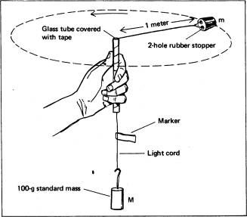
To be in a stable orbit requires a balance between the distance you are away from the object that you’re orbiting (called the radius of your orbit) and the speed that you are travelling at. As you get further from an object, on astronomical scales, the force of gravity becomes weaker (we don’t particularly notice this effect on the surface of earth and we consider the gravitational field strength to be roughly constant, g=9.8N/kg). Thinking back to our analogy of firing a cannonball out of a cannon on the earth, if gravity is weaker then we don’t need to travel quite as fast to end up in a stable orbit. This means that the greater the radius of our orbit, the slower it needs to be to be stable.
In the demo to the left, the force of gravity is simulated by the mass stack, and the orbiting object is the rubber stopper. A stable orbit is only achieved for specific combination of orbital speed and orbital radius. For a bigger radius, the orbital speed needs to be smaller.
At a very specific height (35786km from the surface of the earth), the speed for a stable orbit matches the rotational speed of the Earth perfectly. We call this a geostationary or geosynchronous orbit as it means our satellite will forever stay directly above one location on the Earth as the earth spins.
Questions
- What are the three main categories of orbits around the Earth?
- What is the relationship between the speed you need to orbit and the radius of your orbit for the orbit to be stable?
- Why is the rubber bung on a string demo not technically an orbit?
- What is a geostationary orbit?
- The formula for forces in circular motion is $F=\frac{mv^{2}}{r}$ (you do not need to know this). What resultant force is required to keep a 2kg mass orbiting with a speed of 250m/s if they are 7500km from the centre of the earth?
- The formula for forces in circular motion is $F=\frac{mv^{2}}{r}$ (you do not need to know this). At what speed do I need to be travelling at to be in a stable orbit if my mass is 90kg, and I am wanting to be in a geostationary orbit, around 42,000km from the centre of the earth where the force of gravity is 20N.

Complete the missing answers in the table. Numerical answers will need to be interpolated as a best guess.
Planet | Distance from sun (in millions of km) | Orbital speed (km/s)
Mercury | 60 | 50
 | 110 | 37
Earth | 150
Mars | 230 | 23
Jupiter | 780
 | 1400 | 9
Uranus | 2900
 | 4500 | 6

- What might the axes be for the following graph? Describe the relationship using your axes labels.

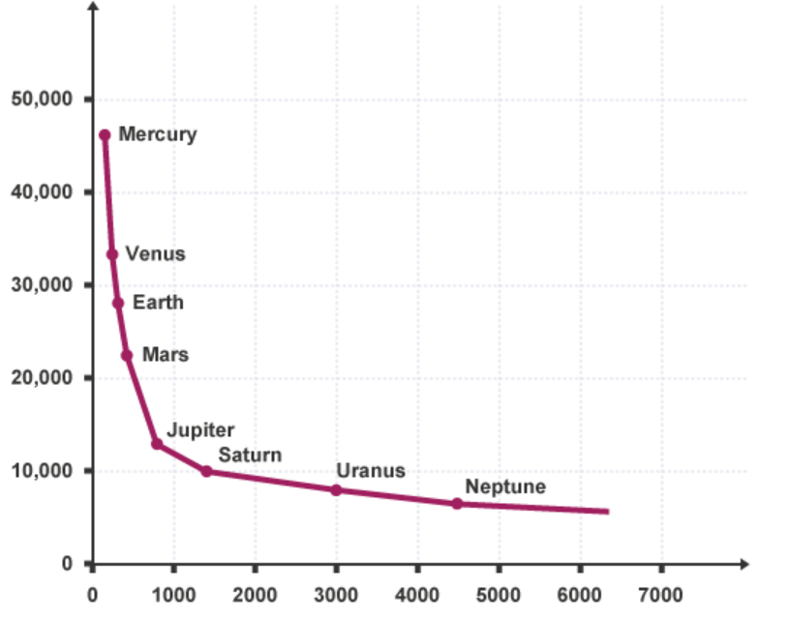

Lifecycle of a star
The birth of a star
A star begins its life as a nebula – a cloud of dust and gas. Over time, the force of gravity which acts between all objects that have mass starts to bring the dust and gas closer together. Larger clumps have a greater gravitational force which can bring in more of the surrounding dust and gas. This slow process creates a snowball effect with the more dense clumps getting larger and larger as they attract more material due to gravity.
As more dust and gas and drawn together, they are squashed into a smaller space. The collisions between particles become more frequent and more violent so the temperature of the system begins to increase. In this stage, we refer to the object as a protostar, the step before a star is formed when all of the ingredients are coming together.
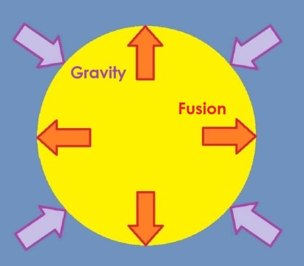
The key step to form a star is when the temperature is great enough (the particles have enough kinetic energy) that Hydrogen nuclei can fuse together (overcoming the electrostatic repulsion between them) and form Helium. This is the process of nuclear fusion, and it begins at around 15,000,000ºC. When this occurs a star can achieve a balance between the force of gravity that is attempting to squash the matter together further and nuclear fusion which is trying to expand the star. This balance can last for billions of years and we call the object a main sequence star during this time. Our sun is currently somewhere in the middle of its main sequence stage.
The process so far is the same for all stars regardless of size. But given that stars can form with a variety of masses, their eventual fates differ depending upon how big they are.
Questions
- What is a nebula?
- Why do the dust and gas begin to clump together?
- We say the dust and gas gets ‘squashed into a smaller space’, what physical property describes the amount of matter in a given amount of space? What is happening to this property when a star begins to form?
- How is temperature related to the movement of the particles in the cloud of dust and gas?
- What name is given to the object just before it becomes a main sequence star?
- What subatomic particles are there in a Hydrogen nucleus?
- Why do Hydrogen nuclei repel one another?
- What process needs to begin for a star to be considered a main sequence star?
- Why doesn’t a star collapse in on itself when there’s such a strong gravitational pull on all of the matter inside it?
- Why doesn’t the star expand due to the immense energy from nuclear fusion?
- What words could you use to compare the sizes of the expansion due to fusion and the contraction due to gravity?
- At what stage of life is our sun in?
The fate of stars
We consider the hydrogen within the star as nuclear fuel, a store of huge amounts of nuclear energy. As the process of nuclear fusion within the core of the star continues, more and more mass is converted into energy, which we most clearly see in the form of light (although stars emit across the entire electromagnetic spectrum). This means that, slowly but surely, the mass of the star is decreasing during its main sequence. This has an effect on the strength of the gravitational force that is preventing the star from expanding. With less mass, the strength of gravity weakens and towards the end of the main sequence, the outwards force (from nuclear fusion) now overcomes the inwards force (the ever decreasing force of gravity) so that the star expands.
Our star, the sun, is on the smaller side. Stars like our sun expand to become a red giant. In the case of our sun, we expect it to expand so that it subsumes the orbits of Mercury, Venus and Earth. Stars that are much larger than our sun go through a similar expansion, but on a larger scale, and become red supergiants.
Whether a red giant or a red supergiant, as the star expands, the particles have more space, so there are less collisions between particles and the kinetic energy of the particles begins to decrease. This means that the temperature of our star begins to decrease. At the same time, the fuel of our star (Hydrogen) is being completely used up. This now decreases the outwards force from the nuclear fusion. Gravity now takes over and causes the star to shrink. With no Hydrogen any more, the star shrinks until the next smallest elements, Helium and Lithium, can begin to fuse, making some of the larger elements in the periodic table. The larger the star to begin with, the heavier the elements that it will make during the end of its lifetime.
Questions
- Where does the star get the energy to radiate light?
- Why does the mass of the star decrease over the main sequence?
- Which force that has been keeping the star balanced begins to decrease as the mass decreases?
- When an object experiences two forces in opposite directions, but one is larger than the other, what do we call that situation?
- What happens to the star when the force from the nuclear fusion becomes larger than the force of gravity?
- What will our star turn into when it expands?
- What will a star much more massive than the sun turn into when it expands?
- What happens to the temperature of stars when they expand to red giants/supergiants?
- Why does a red giant or red supergiant eventually collapse?
- Why isn’t the process a cycle with a new star being born when the red giant/supergiant collapses?
- The diagram to the left shows the balanced forces acting on a star during its main sequence. Draw two similar diagrams to show how the forces change:
              - To create a red giant/supergiant
              - To make the star collapse after living as a red giant/supergiant.

The end of a star’s life
Once the nuclear fuel is all but spent, a small star like our sun will explode in a rather pathetic manner (compared to larger stars), releasing its outer layers (which now contain heavier elements), forming a planetary nebula. A planetary nebula is a cloud of ionised gas that has nothing at all to do with the formation of planets, and was most probably named this because they tend to be quite round in shape. Whilst the outer layers are emitted, within the cloud of the planetary nebula, the core of the star remains as a white dwarf. White dwarfs are incredibly dense, with a mass similar to that of the sun but squashed into a volume the size of the earth. They aren’t very bright as fusion can no longer occur, instead its light comes from the stored thermal energy within the material.
Scientists believe that once white dwarfs no longer have enough thermal energy to emit light, they’ll become black dwarfs: colder and non-luminous versions of white dwarfs. But calculations predict that the time it would take a white dwarf to reach this level of cooling is longer than the current age of the universe.
Larger stars end their lives in a more spectacular fashion. They explode after contracting a second time, releasing huge amounts of energy and scattering the elements that the star has managed to form (more on this later) all over the universe. This explosion is called a supernova.
In a similar way to small stars (like our sun) emitting a planetary nebula and leaving behind a white dwarf, larger stars explode as a supernova and leave behind one of two possible objects. The largest of all stars will leave behind a stellar black hole (it’s referred to as a stellar black hole as it’s been formed from a star). If not quite that large, but still large enough to have formed a supernova, then the star will form a neutron star. Neutron stars are even more dense than white dwarfs, squeezing the mass of the remnants of their star into a sphere with a radius of around 30km. Black holes are denser still and have such a strong gravitational attraction that they can pull light inside (hence their name).
Questions
- What is a planetary nebula?
- Why is ‘planetary nebula’ such a terrible name?
- The mass of the sun is 2×10³⁰kg. Its density is around 1400kg/m³. What is the volume of the sun?
- A white dwarf is incredily dense. If we squashed the mass of the sun (2×10³⁰kg) into the volume of the earth (1.1×10²¹m³), what would its density be?
- Why is a black dwarf named as such?
- Why do we think that no black dwarfs exist?
- What is a supernova?
- How is a supernova similar to a planetary nebula?
- How is a supernova different to a planetary nebula?
- What are the two possible end objects that a large star can turn into?
- What is the main difference between a neutron star and a black hole?
- What will our sun eventually turn into and why?
- Copy and complete this diagram to show the lifecycle of stars (the planetary nebula stage is not required):
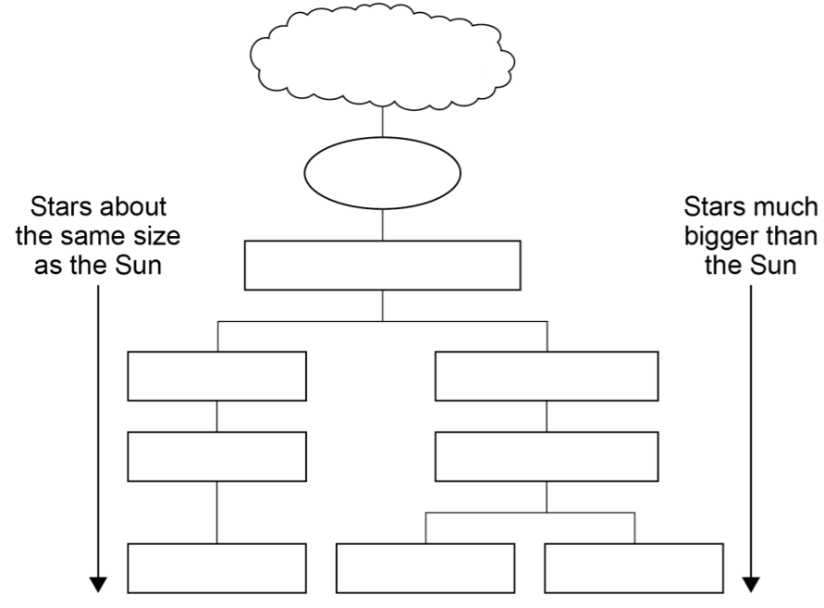

Creating New Elements
In the early universe, prior to the formation of any stars, Hydrogen was the main element in existence. It is the process of nuclear fusion that occurred when this initial Hydrogen was attracted (by gravity) together in the early universe that created all of the other elements.
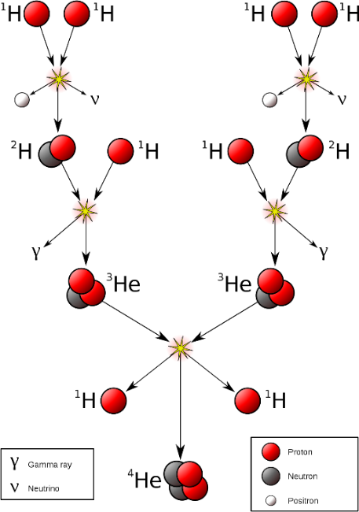
No matter what the size of the star, all of them will take Hydrogen and fuse them into Helium. This process of nuclear fusion is how stars shine. It’s not as straightforward as two Hydrogen atoms coming together to create Helium. Instead, a star has a chain reaction starting with two Hydrogen nuclei, ${}_{1}^{1}H$, going through nuclear processes to create Deuterium, ${}_{1}^{2}H$,(an isotope of Hydrogen that has a neutron, we also call this heavy Hydrogen). Deuterium can then combine with Hydrogen to form a light isotope of Helium, ${}_{2}^{3}{He}.$ Two of these light isotopes of Helium can combine to form the more familiar version of Helium, ${}_{2}^{4}{He}$, along with two further Hydrogen nuclei that can continue a chain reaction.
Elements beyond Helium can also be formed by fusion processes. The largest stars of all can go as far as fusing together elements to make Iron (${}_{26}^{56}{Fe}$).
Whilst it takes a lot of energy to bring the nuclei together to fuse the larger elements, it is more than paid back by the amount of energy released from nuclear fusion. Elements with an atomic number greater than 26 (larger than Iron) don’t release more energy when they are formed than was required to bring the smaller nuclei together, so stars can’t survive by making them. So where do elements larger than Iron come from?
It is the energy released during a supernova that allows elements more massive than Iron to be formed. In the explosion at the end of the life of the most massive stars, the nuclei get given enough kinetic energy to overcome the electrostatic repulsion between them and fuse together to make the largest elements, because it no longer matters that it’s not energy efficient to do so. The explosion also spreads these newly created elements out across the universe.
The periodic table below shows predictions of what fraction of each element on Earth came from where. There are even more exotic ways that elements can be created too.
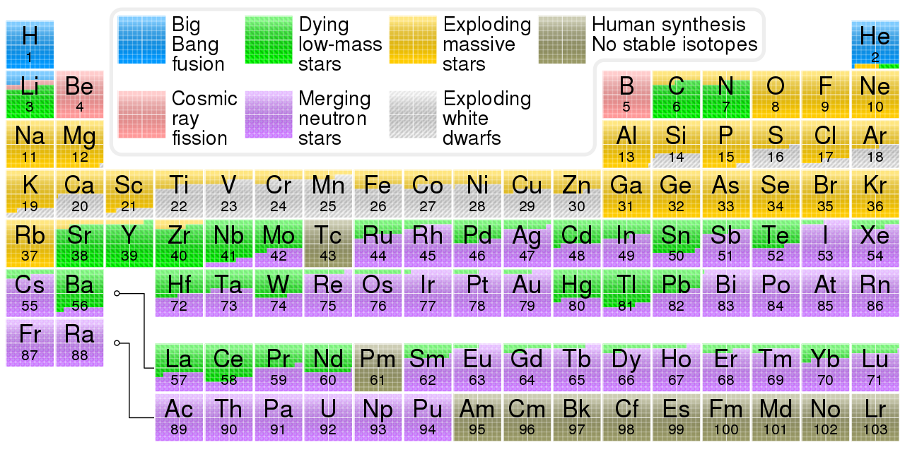
Questions
- Where are the majority of the elements created?
- What is an isotope?
- What is the nuclear equation for the fusing of Deuterium and Hydrogen to make a light isotope of Helium?
- What is the nuclear equation for the fusing of two light isotopes of Helium to form the more usual form of Helium and two Hydrogen nuclei?
- How are elements up to Iron in the periodic table formed?
- How are elements beyond Iron in the periodic table formed?
- Why is nuclear fusion only favourable up to the element Iron in the periodic table?
- Why does it take a lot of energy to bring two nuclei together to make them fuse?
- Why would the periodic table look like this if stars didn’t explode?
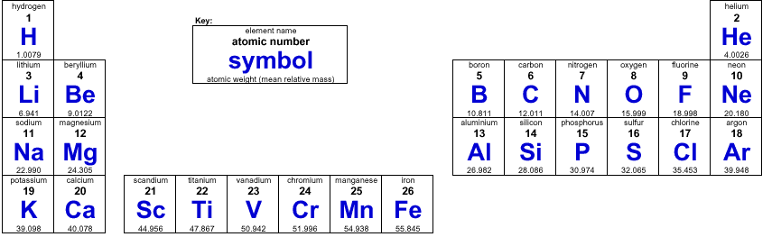
- How many protons and neutrons does Iron have?
- Other than creating elements higher than Iron, what other purpose does a supernova have?

Red Shift and the Doppler Effect
Red shift is one particular example of an effect that is more generally called the Doppler effect. You’ll have noticed the Doppler effect in your lives when you’ve heard the sound of a siren on an emergency vehicle change as it moves past you. The Doppler effect has three key components: a source of a wave, an observer of the wave and a motion between the source and the observer.
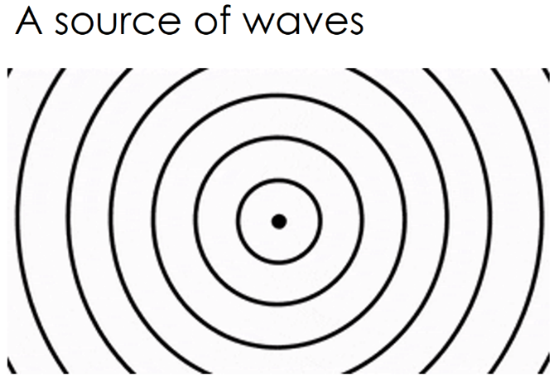
We should try to imagine the situation in slow motion. Let’s imagine that the source of a wave emits one complete wave every second (a frequency of 1Hz). If the source doesn’t move, and an observer is standing nearby, then the observer will pick up one complete wave every second (a frequency of 1Hz).

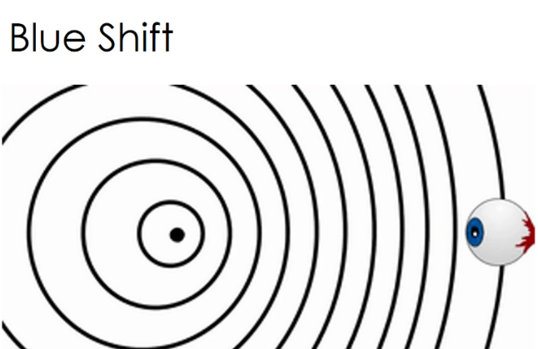
Now, instead, if the source begins to move towards the observer, then as it emits one wave, it also moves closer to the observer, effectively catching up the first wave by a small amount. The next wave is emitted closer to the initial wave than when the source was stationary. This has the effect of decreasing the wavelength as the observer sees it (the wave gets shorter), and increasing the frequency for the observer (the waves become more frequent). We call this blue shift as if our source of waves is emitting visible light then it shifts towards the blue end of the spectrum for the observer.
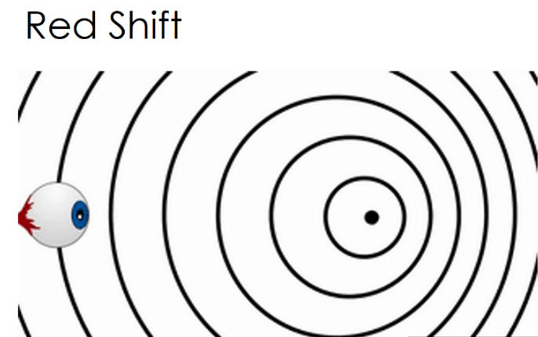
The opposite can happen if the source moves away from the observer. After emitting one wave (which begins to travel to the observer), the source has moved further away from the observer so that the next wave is even further behind than intended. This has the effect of increasing the wavelength as the observer sees it (the wave gets longer) and decreasing the frequency for the observer (the waves become less frequent). We call this red shift as if the source of waves is emitting visible light then it shifts towards the red end of the spectrum for the observer.
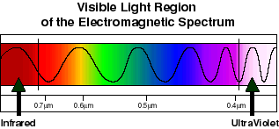
Questions
- What are the three things we need to achieve the Doppler effect?
- What happens to the frequency of light that is blue shifted?
- What happens to the frequency of light that is red shifted?
- What happens to the wavelength of light that is blue shifted?
- What happens to the wavelength of light that is red shifted?
- Thinking about the speed of a wave, why must frequency and wavelength change in the opposite manner (when one increases, the other decreases)?
- Why is red shift named the way it is?
- If sound is ‘red-shifted’ what do we notice about it?
- If sound is ‘blue-shifted’ what do we notice about it?
- As an ambulance moves towards you and then away, describe what you should notice about the sound. Include the terms ‘red-shift’ and ‘blue-shift’ when you refer to the pitch of the sound.
- Although we don’t notice it, the light from an ambulance siren is also Doppler shifted. Imagine that we see the light emitted from a stationary ambulance as green. What happens to the light as the ambulance moves towards and away from you? Include the terms ‘red-shift’ and ‘blue-shift’ when you refer to the colour of the light.
- Sound travels at 330m/s in air. The note middle-C on a piano has a frequency of around 260Hz. What is the wavelength of this sound?
- If I move the piano away from an observer as I play, the frequency ‘red-shifts’ to 250Hz. Does this sound higher or lower in pitch? What is the new wavelength of the sound?
- Light travels at 3×10⁸m/s. Blue light has a wavelength of 0.45μm. What is the wavelength of blue light?
- When an object emitting blue light is moving towards us, the wavelength decreases to 0.42μm. What is the new frequency?

Red Shift and the Big Bang Theory
When we observe the light coming from distant galaxies, we see that the light is red-shifted. If the light is red-shifted then that means that us, the observer, and the galaxy, the source, are moving away from one another.
Us moving apart from one other galaxy might not come as a surprise, after all, there are billions of them. What is surprising is that no matter which galaxy we observe, or in which direction from the Earth we look, the light from every galaxy is red-shifted. We are moving away from all galaxies simultaneously. The only way this can occur is if the entire universe is expanding.
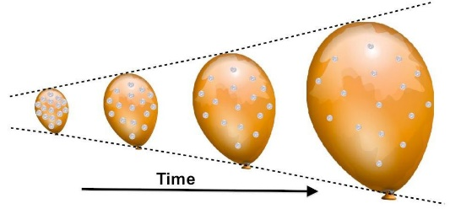
If we imagine that the universe is the surface of a balloon (ignoring completely the gas inside the balloon) and imagine sticking buttons (to represent the galaxies) onto the rubber surface, then as we inflate the balloon, they all start to simultaneously move apart. It is the space between us that is expanding. So, in truth, distant galaxies aren’t truly moving away from us, it is the space between us that is expanding. Space, isn’t expanding into anything, just the amount of space we have is getting larger (which is an incredibly odd thought).
This observation was a revelation. The first person to realise it was the American astronomer, Edwin Hubble, whose observations in 1929 changed the way we see the universe. The Hubble space telescope is named in his honour.
Not only is the light from every distant galaxy red-shifted, the further way a galaxy is from us, the more the light is red-shifted. That means that the most distant galaxies are moving away from us even faster than the closer ones. It was the 1998 observations of supernovae that made us realise that distant galaxies are receding ever faster.
This led scientists to hypothesise that if all of the galaxies are moving away from each other, then if we play time backwards, at some point the entirety of space was condensed into the smallest imaginable space. This is the Big Bang Theory: the universe was created from an unimaginably hot and unimaginably tiny point and expanded to create everything. What the universe is expanded into is unknown, because the Big Bang created space itself.
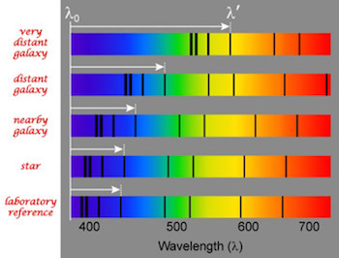
How do we know that the light from other galaxies is not simply different to begin with? How do scientists know that red shift has taken place? They use the emission spectra of stars. Emission lines (the dark lines in the spectrum) tell us what elements are present in distant object, as each elements has its own unique set of lines (due to the unique electron configurations of the elements). Given that all stars are undergoing the same fusion processes, using the same elements, they should all have the same emission spectra. If all of the galaxies were stationary, the emission spectra would be indentical as there’d be no motion between them (the source) and us (the observer). But that’s not what is seen. The emission lines of galaxies are all red-shufted and become more and more shifted as we look at galaxies further away. The shift is always towards the red end of the spectrum, showing that the wavelength that we see is longer than expected, as the galaxies are moving away from us.
Scientists continue to study the Universe because many questions still remain. Why does the rate of expansion seem to be increasing (this is the observation that led scientists to hypothesise about dark energy)? Why do galaxies behave as if they have more mass than we can see (this is the observation that led scientists to hypothesise about dark matter)? Are there any other habitable worlds? We do not know the answers to these questions yet, but research continues to make new discoveries every day to allow us to understand the Universe a little better.
Questions
- Why is light from distant galaxies red-shifted?
- Why do we think the Universe is expanding?
- How do we know that the light from other galaxies is red-shifted? How do we compare the light from different galaxies?
- How do we know that further away galaxies are receding faster?
- How did scientists come up with the Big Bang theory?
- If the Universe is expanding, what is happening to the overall density of the universe?
- If the Universe is expanding, what is happening to the overall mass of the universe?
- Why is a model of the Universe made of a balloon with attached buttons a good model?
- Why is a model of the Universe made of a balloon with attached buttons a bad model?
- What was the Universe like in the earliest moments?

