Finding exoplanets with the transit method

What we’ll learn today (points from the National Curriculum for Key Stage 2):
- recognise that they need light in order to see things and that dark is the absence of light
- recognise that shadows are formed when the light from a light source is blocked by an opaque object
- describe the movement of planets relative to their star
- identifying scientific evidence that has been used to support or refute ideas or arguments

Equipment you’ll need:
- A laptop with a webcam and the lightgrapher software installed from http://www.planetarium-activities.org/shows/sp/lightgrapher (additional instructions can be found here too)
- Some ‘planets’ – can be as simple as circular bits of card, or painted spheres of paper/playdough/blue-tac – attached to sticks
- A light source – you want a bulb with a roughly even brightness over its surface (for example, the one on the left below). Filament bulbs like the one on the right below don’t work as they don’t provide a sphere of similar brightness
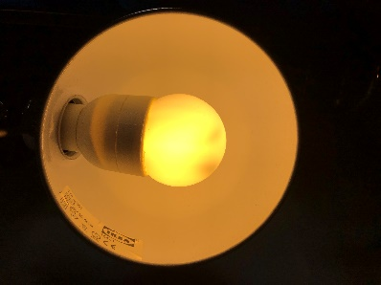 | 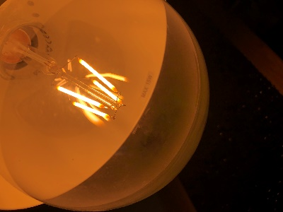

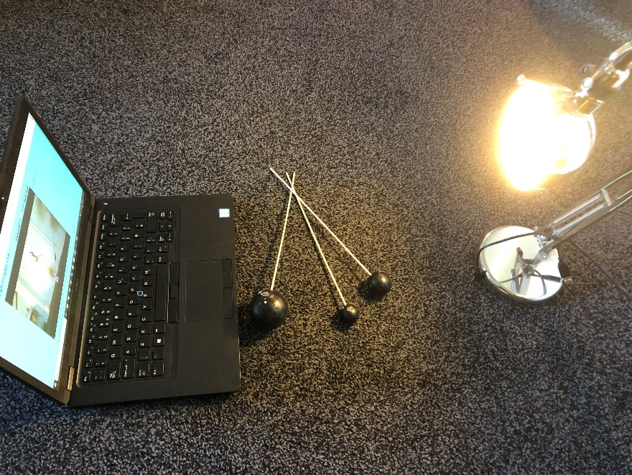

You can read and watch more about the hunt for exoplanets at:
https://www.planetary.org/explore/space-topics/exoplanets/transit-photometry.html
https://www.cfa.harvard.edu/~avanderb/tutorial/tutorial.html
https://sci.esa.int/web/gaia/-/58789-detecting-exoplanets-with-the-transit-method

We’ll be using the webcam as a telescope to measure the brightness (the amount of light) from our star (the lamp that we’re using). On installing and opening the software, select your chosen webcam on the first menu and you’ll see a feed from the webcam presented like below. Adjust the size of the black circle in the centre of the page so that it perfectly surrounds your ‘star’. This will allow the software to monitor the brightness in just this one area.
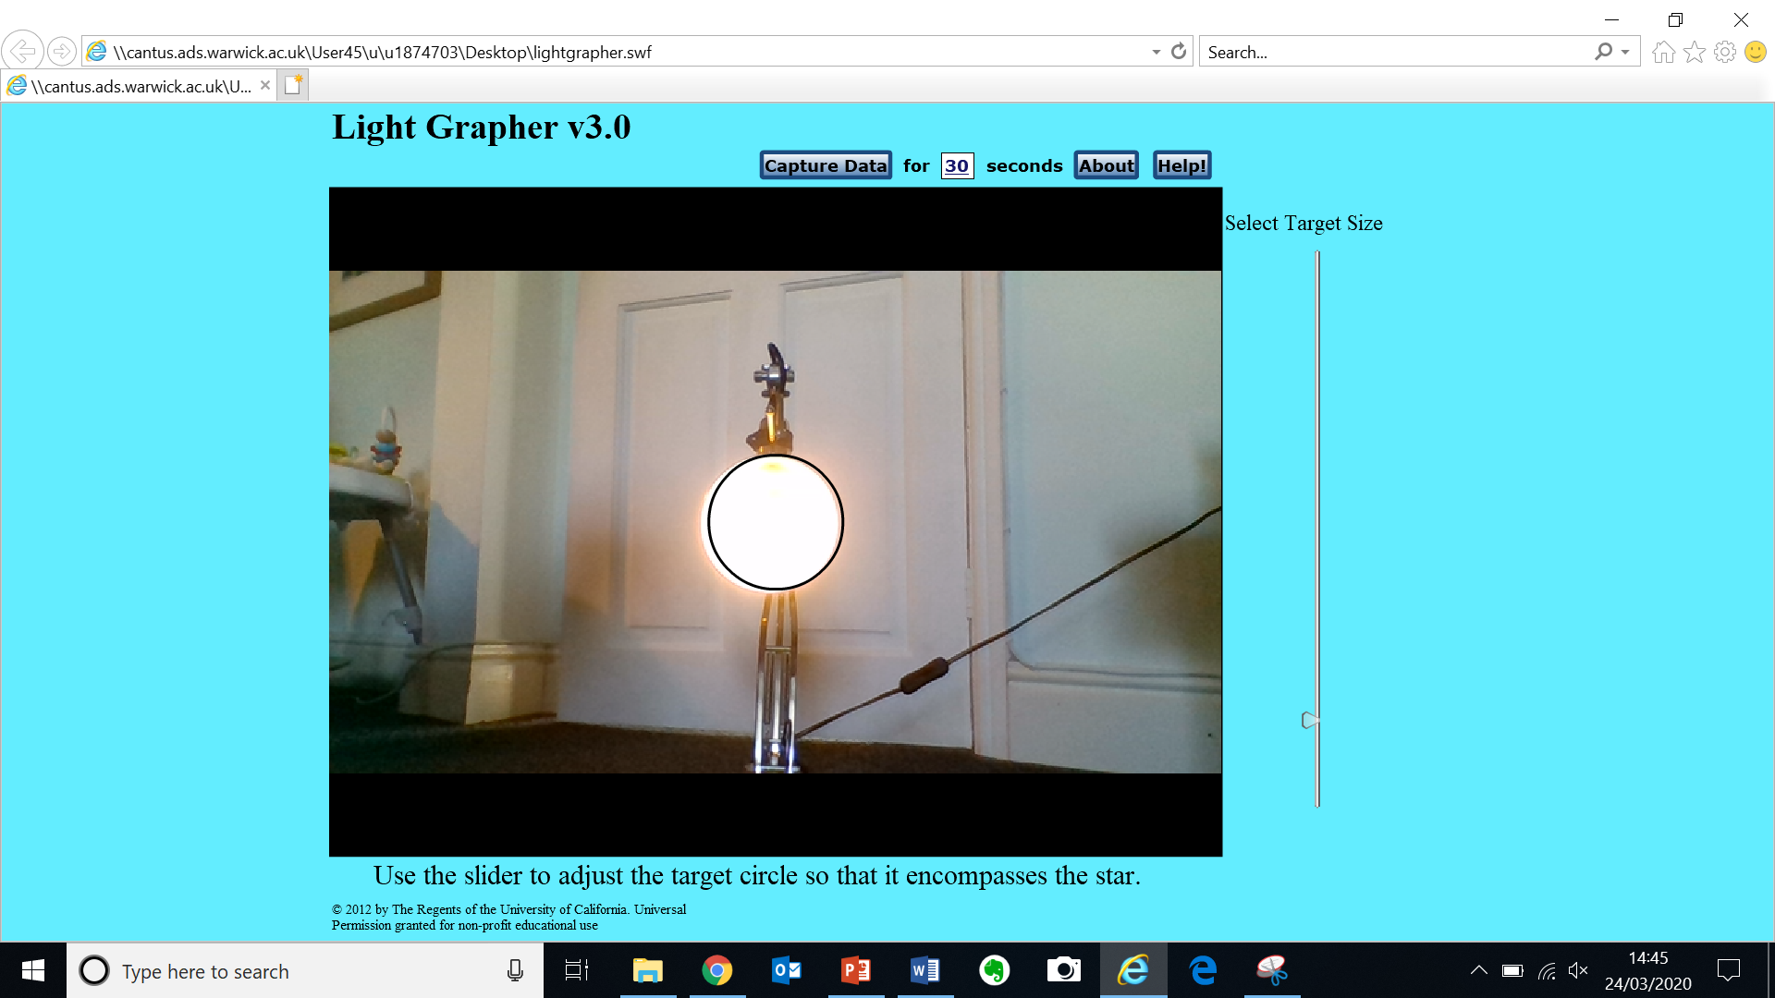

When you press ‘Capture Data’, the brightness will be plotted over time. We’ll move one ‘planet’ at a time between ‘the star’ and your ‘telescope’. The graph will show the effect on the brightness.
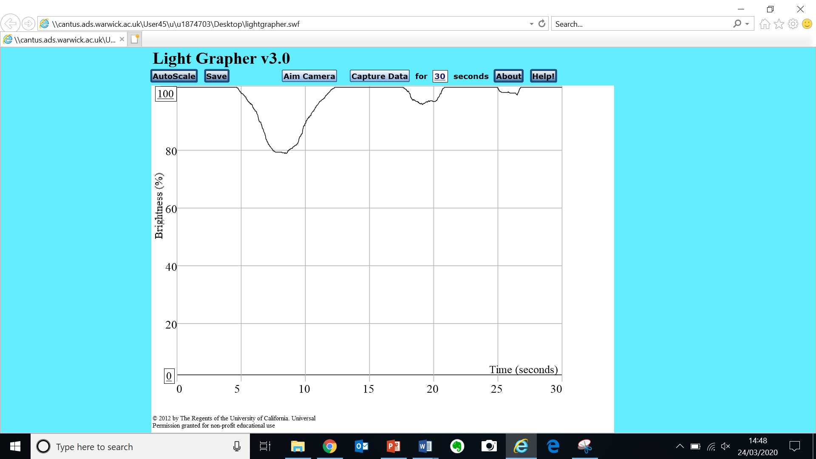
You should see the characteristic ‘dips’ in brightness from the planets. The bigger the planet, the bigger the dip, since it blocks more of the light.
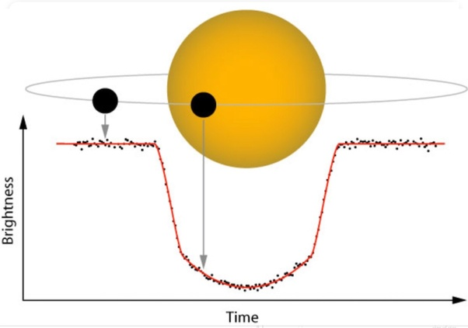

Questions
- Match the pictures with the different arrows – which part of the light curve is formed by which arrangement of planet and star?

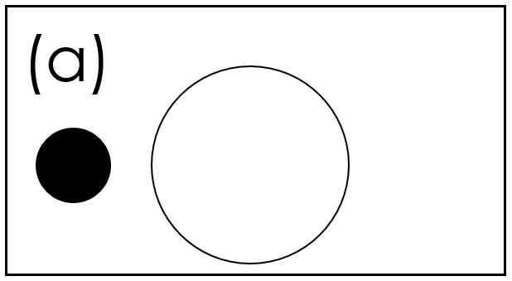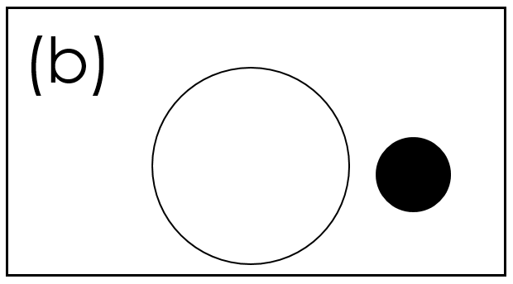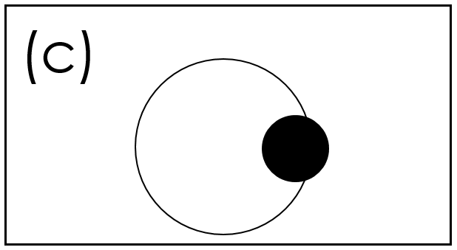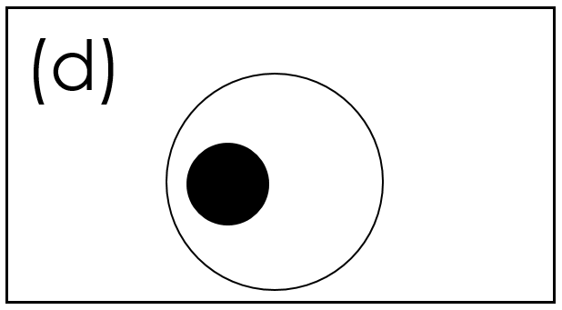
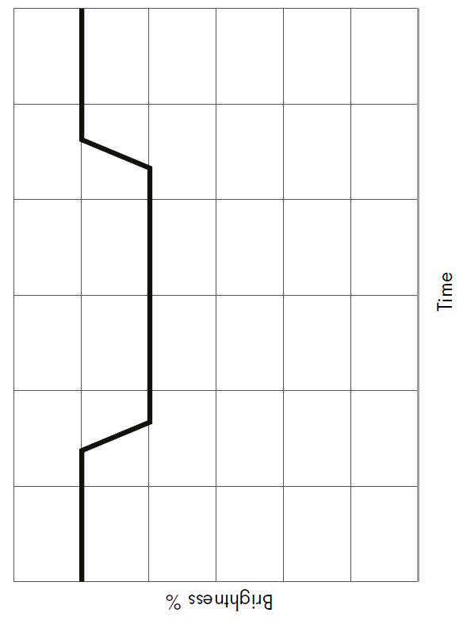
- Label what is happening in this light curve – the arrows are in different places now.

- Describe what happens to the amount of light we measure when an exoplanet orbits its star. Your answer should include the words orbit, brightness, increase, decrease.

…………………………………………………………………………………………………………………...

…………………………………………………………………………………………………………………...

…………………………………………………………………………………………………………………...

…………………………………………………………………………………………………………………...

…………………………………………………………………………………………………………………...

…………………………………………………………………………………………………………………...

…………………………………………………………………………………………………………………...

…………………………………………………………………………………………………………………...

- Add on a light curve to show an exoplanet that is bigger than this one
- Add on a light curve to show an exoplanet that is faster than this one
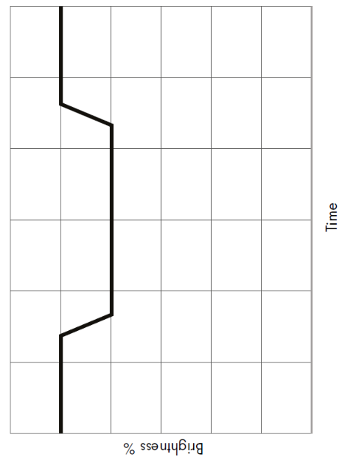
- When astronomers take their measurements, they are only sure that they have found an exoplanet when they see a dip in the brightness that happens are regularly spaced intervals like this:
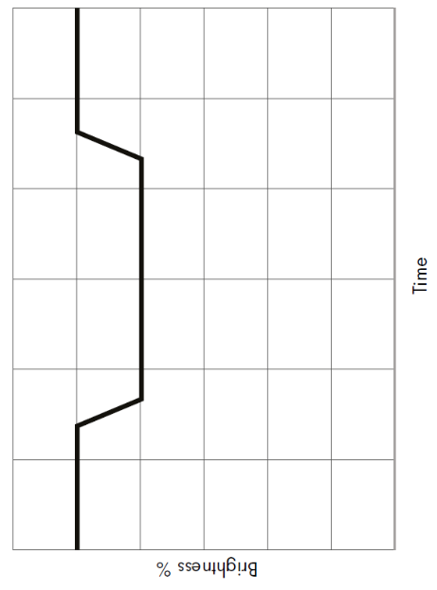
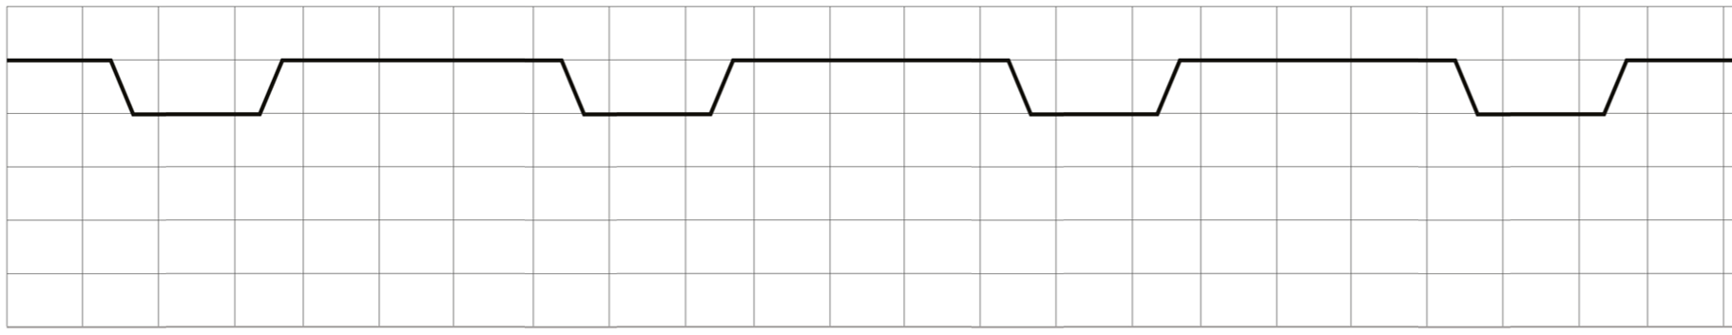

Why are astronomers looking for regularly spaced drops in brightness?

…………………………………………………………………………………………………………………...

…………………………………………………………………………………………………………………...

…………………………………………………………………………………………………………………...

…………………………………………………………………………………………………………………...

…………………………………………………………………………………………………………………...

…………………………………………………………………………………………………………………...

…………………………………………………………………………………………………………………...

…………………………………………………………………………………………………………………...

…………………………………………………………………………………………………………………...
Answers
- Match the pictures with the different arrows – which part of the light curve is formed by which arrangement of planet and star?

c
b
d
a
- Label what is happening in this light curve – the arrows are in different places now.
The planet is moving out of our line of sight of the star so the brightness increases back to its original level
The planet is in front of the star and is blocking as much light as it can.
A planet is moving in front of our view of the star so the brightness (amount of light) decreases.
No planet in between the star and the observer so the brightness is high.
c

- Describe what happens to the amount of light we measure when an exoplanet orbits its star. Your answer should include the words orbit, brightness, increase, decrease.
As a planet orbits a star it sometimes passes between the star and us, the observers. When this happens, the brightness that we measure from that area of the sky changes. As the planet begins to move across our view of the star, the brightness decreases steadily as the planet blocks more and more of the light from the star. Once the planet is completely in front of the star, it cannot block any more light, and so the brightness reaches a constant, lower level that depends on the size of the planet. As the planet continues through its orbit, it eventually moves out of our view of the star, so that the brightness steadily increases as it covers less and less of the star, eventually moving completely out of the way so that the brightness returns to its original level again.

- Add on a light curve to show an exoplanet that is bigger than this one
- Add on a light curve to show an exoplanet that is faster than this one
- When astronomers take their measurements, they are only sure that they have found an exoplanet when they see a dip in the brightness that happens are regularly spaced intervals like this:

Why are astronomers looking for regularly spaced drops in brightness?

Each new dip signifies that the planet has completed another orbit.
These dips should be regularly spaced in time as the time to complete an orbit (that planet’s year) is (roughly) constant.

If an object simply got in the way of the telescope (like a passing piece of debris) it would create a dip only once and wouldn’t be repeated.

Scientists look for repeated dips to confirm that the object that has blocked light is truly a planet that it orbiting a star and is hence repeatedly blocking the light.

