How do we find distant planets?

TEACHER BOOK

CREDITS:
Ben Rogers for some of the sections on orbits.
Bill Wilkinson for his #ScienceStories project

CURRICULUM POINTS:
- recognise that light appears to travel in straight lines
- use the idea that light travels in straight lines to explain that objects are seen because they give out or reflect light into the eye
- explain that we see things because light travels from light sources to our eyes or from light sources to objects and then to our eyes
- recognise that they need light in order to see things and that dark is the absence of light
- recognise that shadows are formed when the light from a light source is blocked by an opaque object
- find patterns in the way that the size of shadows change
- the idea that light travels in straight lines to explain why shadows have the same shape as the objects that cast them
- describe the movement of the Earth and other planets relative to the sun in the solar system
- use the idea that light travels in straight lines to explain why shadows have the same shape as the objects that cast them
- recording data and results of increasing complexity using scientific diagrams and labels, classification keys, tables, scatter graphs, bar and line graphs
- using test results to make predictions to set up further comparative and fair tests
- identifying scientific evidence that has been used to support or refute ideas or arguments

TO ADD
- describe the movement of the moon relative to the Earth
- describe the sun, Earth and moon as approximately spherical bodies
- use the idea of the Earth’s rotation to explain day and night and the apparent movement of the sun across the sky

Scale – Teacher Notes
Slides from Powerpoint
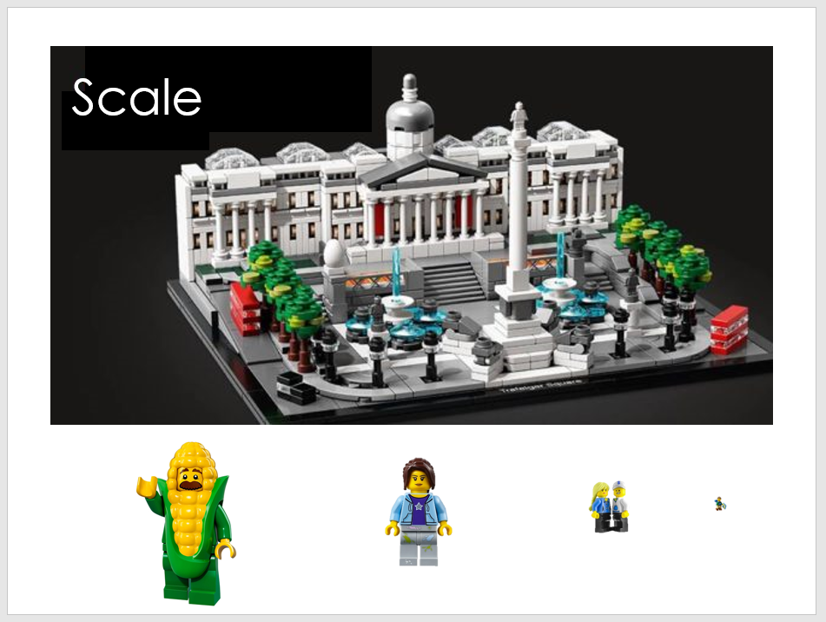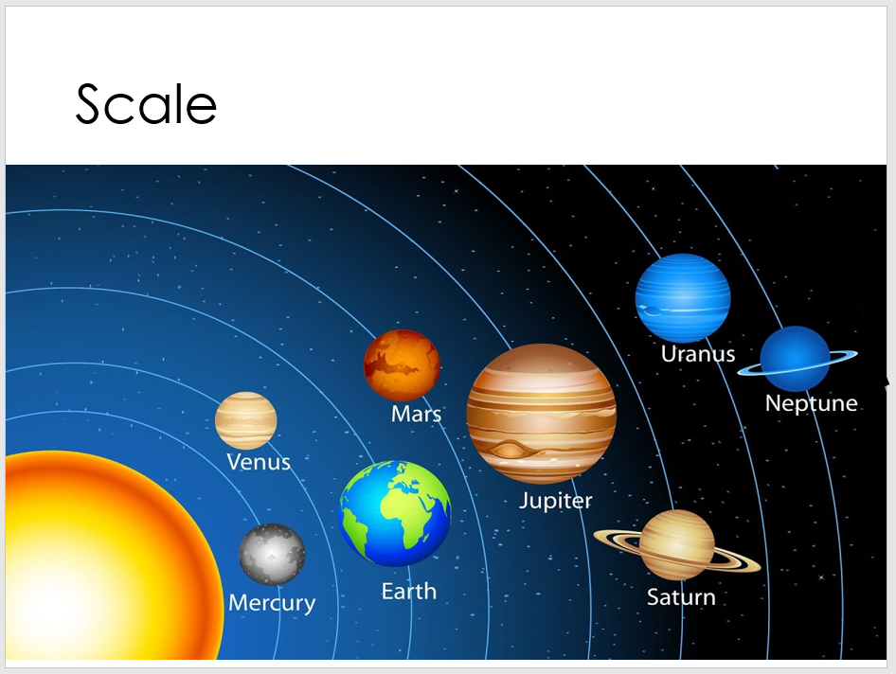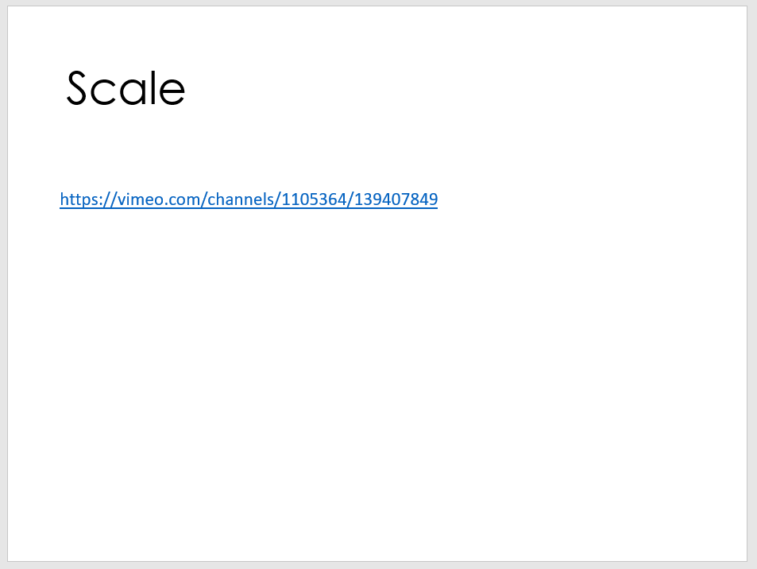
SLIDE 1
I discuss what a scale model is: a model in which each of the objects (and the gaps between them) have been shrunk (or enlarged) by the same amount. I would emphasise this by saying things like “To make Trafalgar square fit on my desk, I need to make it 1000 times smaller, so then for my model to look right, I need to make the buses 1000 times smaller and the trees 1000 times smaller… so that everything looks right relative to everything else”.
I’d then ask which of the minifigures along the bottom of the slide is ‘to scale’ and why. It’s the smallest one as ‘it’s been shrunk by the right amount/1000 times’ or because ‘it fits in a taxi/bus’.
SLIDE 2
Here we emphasise that most picture of our solar system are not to scale. Whilst the planets are in the correct order (we can take some time to learn these) there are many problems with diagrams like this:
- The planet’s sizes are not to scale – Jupiter is the largest and Mercury is the smallest but they’re not in the right proportions. Earth is far too big – it’s not bigger than Saturn etc.
- The spaces between the planets are not correct – they need to be much further apart.
- The planets are incredibly rarely found in a line like this
To get a true sense of scale, if the sun is 1m in diameter, then the earth is the size of a pea (around 1cm in diameter) and should be placed 110m away! Here is a calculator to find the relative sizes from the size of the sun.
https://www.exploratorium.edu/ronh/solar_system/
SLIDE 3
A scale model of the solar system can be built and this video (link in slide 3) shows an amazing example of this. Check their distances with the calculator. Particularly enjoy how they check by looking at the size of their model sun from the orbit of earth when the real sun rises – very clever https://vimeo.com/channels/1105364/139407849

Scale - Answers

A scale model is a model of an object or group of objects that has changed the size of absolutely everything by the same amount. If I wanted to make a half-size version of a human body, I’d make a model where the total height was half of the real amount, and the arm length was half of the real amount, and the width of their stomach was half of the real amount and the length of the hair was half of the real amount. I’d make everything the right size relative to the other parts.

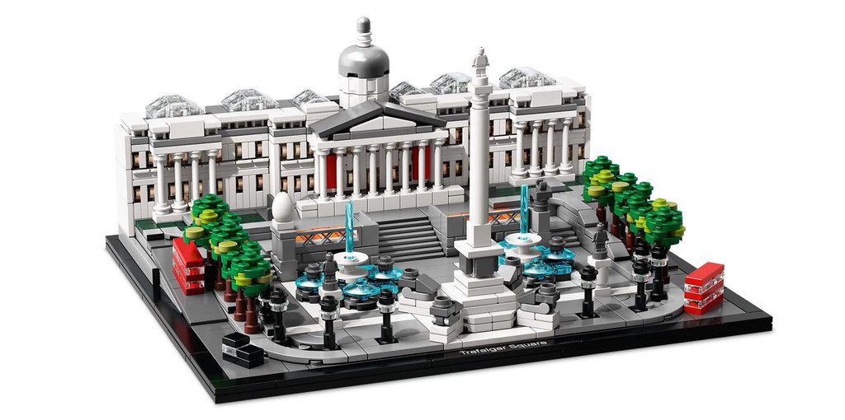
Questions
- Why is this LEGO model of Trafalgar square in London a good scale model?
- Because the sizes of the objects are correct relative to other objects.
- Because the objects are the ‘right size’
- Because the bus is smaller than the trees…

- Can you see anything that is not to scale?
- The water fountains are too tall
- To the left of the stairs, there’s a giant egg
- Nelson’s column should actually be even taller
- Discuss lampposts vs trees
- Why is the tiny LEGO minifigure at the end of this sentence the correct choice to add to this model of Trafalgar square? 
- Because this is the same scale as everything else
- He’s been shrunk by the same amount
- He’s been shrunk to the right size
- He can fit inside a bus, taxi etc.

Light in the universe – Teacher notes
Slides from Powerpoint
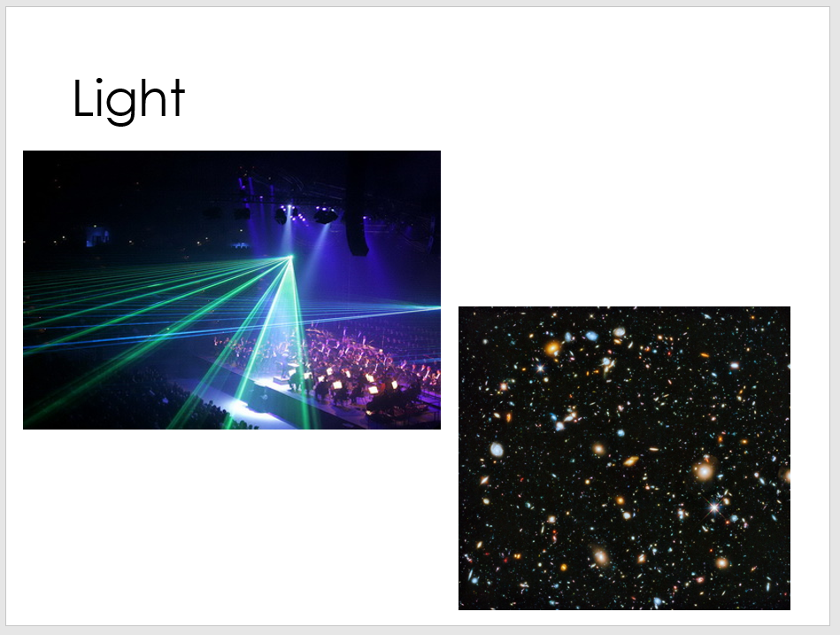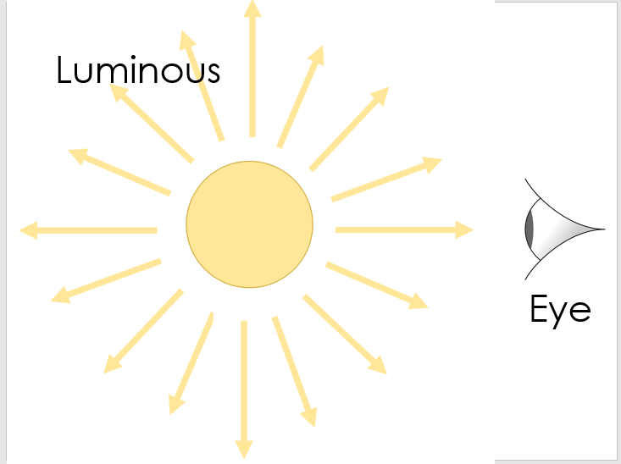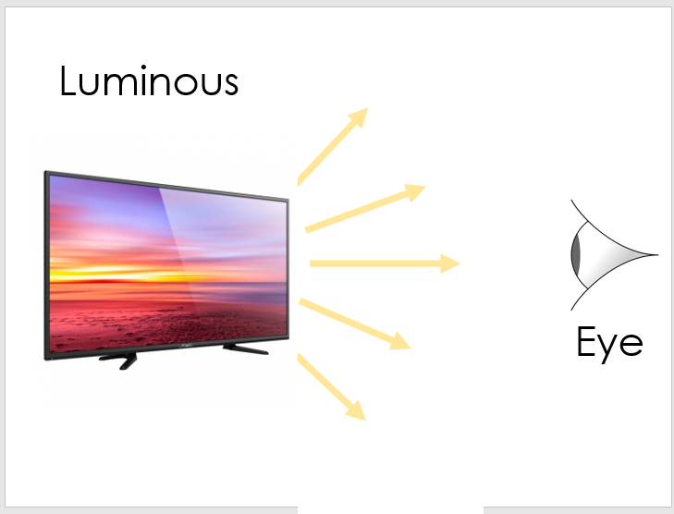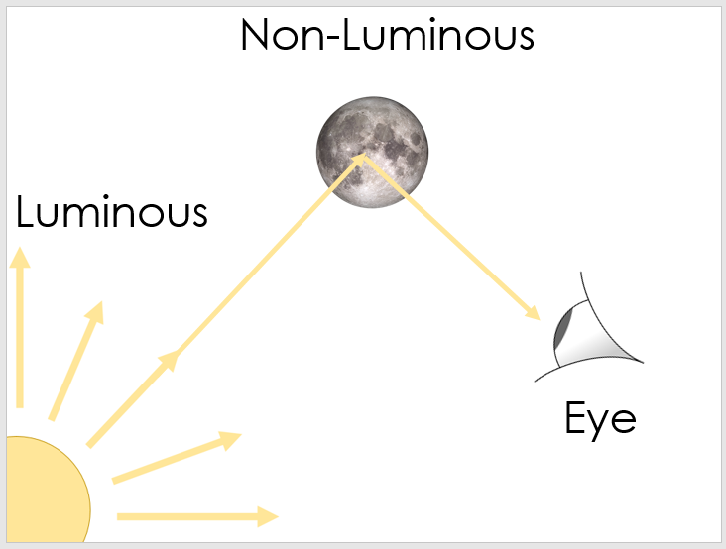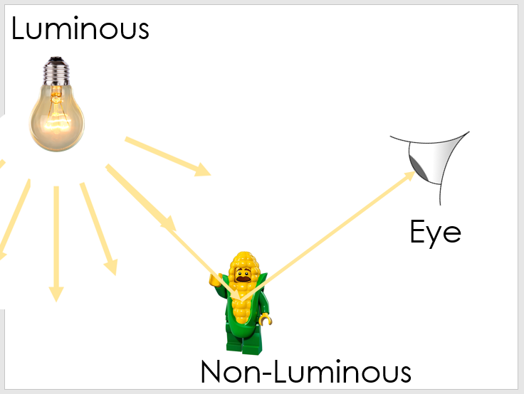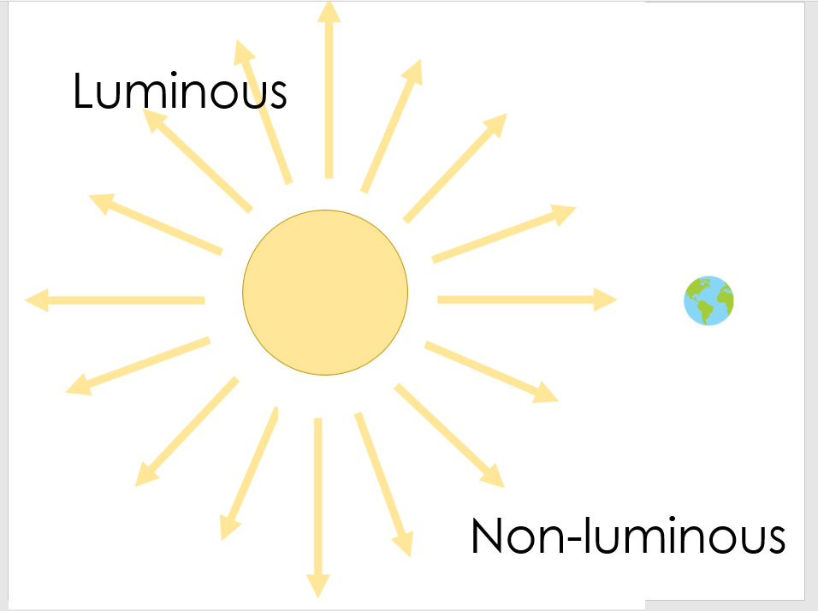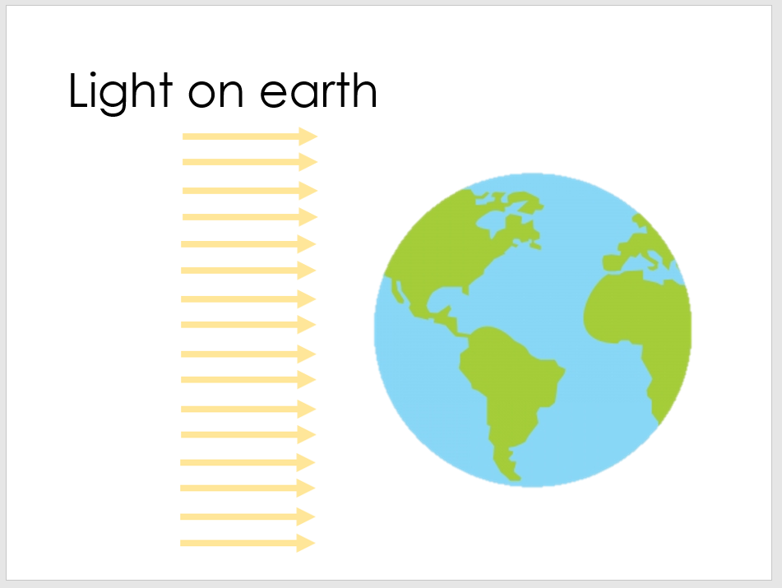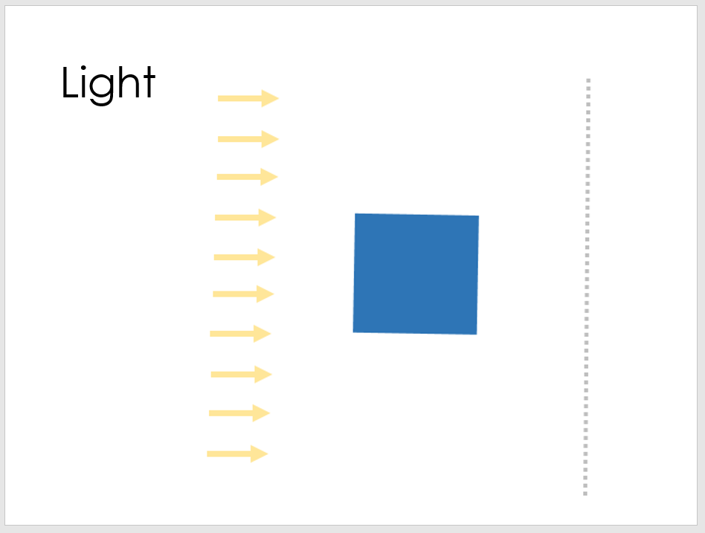
SLIDE 1
Here we emphasise that light travels in straight lines – it’s most obviously seen in a laser show but it happens from all light sources. The light from the lights in your room travel to your eyes in straight lines and from a TV etc. We go on to say that the light from distant stars also travels in straight lines to us and our telescopes (there is more to this in real life as due to Einstein’s General Relativity, we know that space curves around objects with mass and so light does ‘bend’ around massive objects, but this is because the space itself is bent, not truly the light).
SLIDE 2 & 3
Here we discuss the reason that we see an object is that light enters our eye. We start by looking at luminous objects (those which give out visible light) and realise that we see the sun and a TV because light from those objects is emitted and travels to our eyes in a straight line.
SLIDE 4 & 5
The reason we can see objects that are non-luminous (don’t give out visible light) is that they are illuminated by objects that are luminous (do give out visible light) and the light reflects off the non-luminous object into our eye. The only reason we see anything is that light must enter our eye, so if an object isn’t directly emitting light itself then it must be reflecting it from another light source.
SLIDE 6
Here we discuss how a luminous object gives out visible light whilst a non-luminous one doesn’t (technically, luminous can refer to any wavelength of light, so the earth is luminous in the infrared region of the electromagnetic spectrum – black body radiation). Why have the arrows been drawn the way they have from the sun?
- Because light travels in straight lines
- Because light is emitted in all directions
Ask if the picture is ‘to scale’? Earth need to be smaller and further away.
SLIDE 7
If we zoom in on the earth in the last slide then we see that the rays of light on earth from the sun (ignoring atmospheric effects) are parallel.
SLIDE 8
What happens when an object blocks light? (Light – yellow arrows; object – blue box; screen/wall – grey dotted line). We create a shadow. I use a visualiser and print out the slide and draw over the top of it to draw out ray diagrams to show students how big the shadows are following these principles:
- Continue the light in a straight line (straight doesn’t mean horizontal remember) until it hits an object or the screen. Shown in the answers by the thing grey arrows.
- As I’ve only drawn a few arrows, and this isn’t indicative of the true ‘amount’ of light, you can add more parallel lines in the gaps to truly find the ‘edges’ of the shadows – I’ve done this on the first of the answers.
- The shadow is the absence of light and so the gap between the light hitting the wall above the object and the light hitting the wall below the object is the shadow. Indicated by the thick black line on the answers.
Light in the universe - answers

Luminous objects are objects that emit (give out) light. In our solar system, the sun is the only luminous object. All of the planets and moons reflect light (the light from the sun bounces off them) and absorb light but they don’t emit light, so we say they are non-luminous.
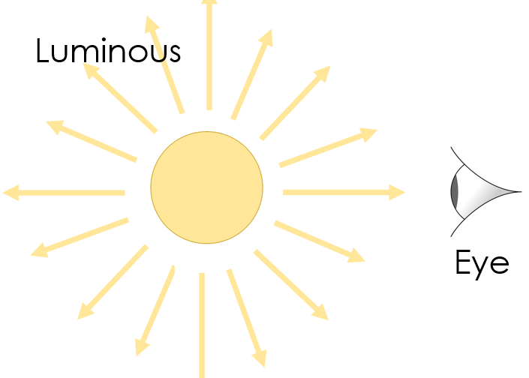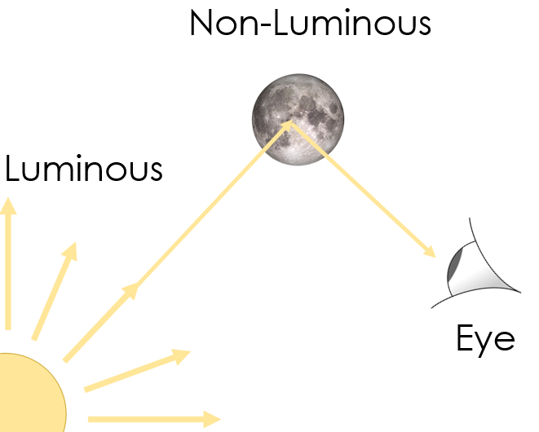

We see luminous objects because the light travels from the object to our eyes (in a straight line). We see non-luminous objects because they reflect light into our eyes (the light bounces off them).
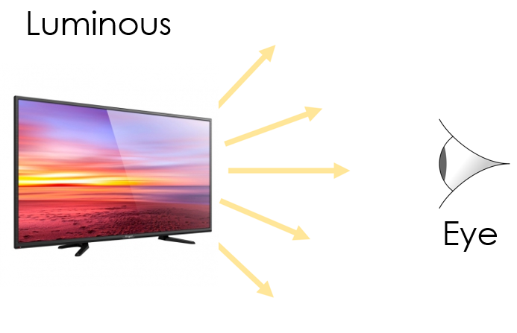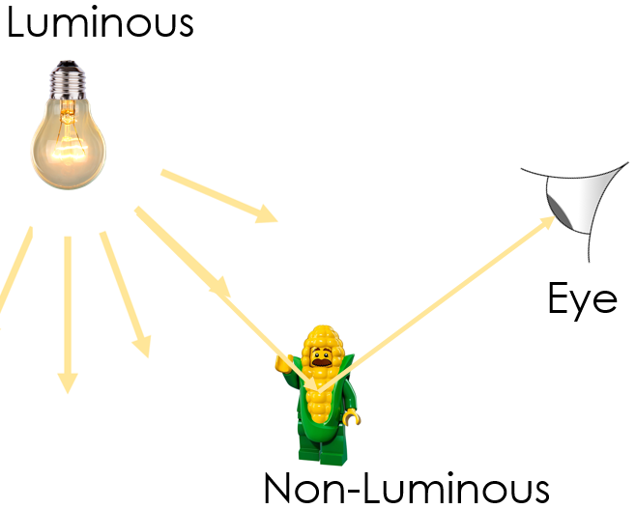
This doesn’t just apply to objects in space, but to all objects. In our classrooms and houses, we can see luminous objects directly but to see a non-luminous object, there must be a luminous object around to provide some light that the non-luminous object can reflect.

Questions:
- What does luminous mean? Give three examples of luminous objects.

Something that emits (gives out) light e.g. the sun, a lightbulb, a TV, car headlights, a torch.

- We see non-luminous objects because they reflect light into our eyes.

We see non-luminous objects but there must be a luminous object around to provide the light for the non-luminous object to reflect.

Light and shadow - answers

Luminous objects are objects that emit (give out) light. In our solar system, the sun is the only luminous object. All of the planets and moons reflect light (the light from the sun bounces off them) and absorb light but they don’t emit light, so we say they are non-luminous.

Light travels in straight lines and travels incredibly quickly (it could travel around the entire world 4 times in a second). If the path of light is blocked by an object, then behind the object a shadow forms. A shadow is an area that experiences less light and so appears darker than the surrounding areas.

Questions
- On the dotted line, draw the regions that would appear as shadows.

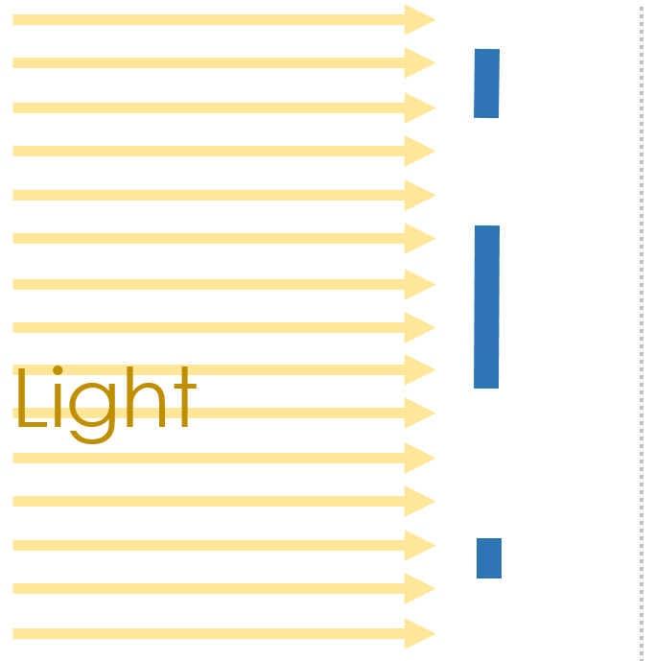
- On the dotted line, draw the regions that would appear as shadows when the sun is high in the sky (on the left) and when it is lower in the sky (on the right).

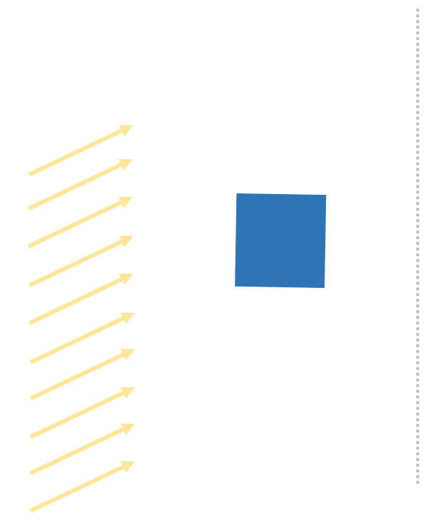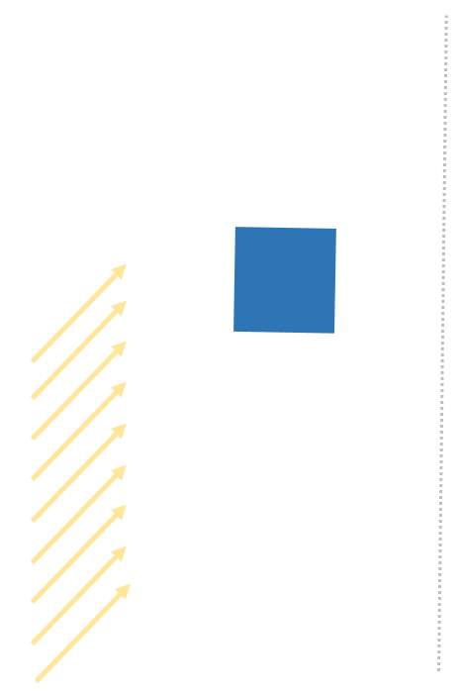

Shadows booster pack would fit in here

Slides:
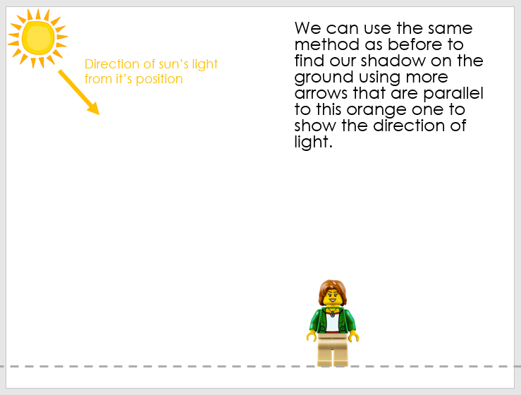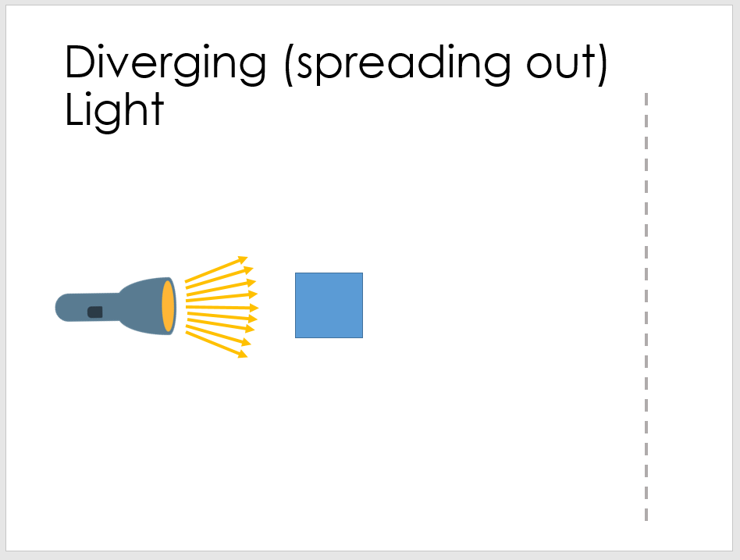
Slide 1 (and the similar versions)
I would tend to print out the first slide and use a visualiser to draw the ray diagrams. Here it’s tempting to talk about the sun moving across the sky but given that this is caused by the rotation of the earth (more on that later), I try to say ‘seems to move across the sky’.
You could ask how these shadows would be different if the person were taller/shorter.

Slide 2 (and the similar versions)
Again, I would tend to print out the first slide and use a visualiser to draw the ray diagrams. The students will also be doing these in their booklets.
I would do this before doing the practical so students have some knowledge to hang their observations on. If they do the practical first, there’s a greater chance of them misunderstanding what they’ve seen and then struggling to reconcile their observations with the explanation.

Practical
You can do the torch practical very easily, and this is a great opportunity to get students to think very carefully about measurements. How can they ensure they make the measurements of the width of the shadows accurately? Where are they measuring from and to and why? Should they use the mm side or the cm side of the ruler?
As a foreshadowing of secondary science, the following terms are used:

Accurate – close to the ‘true’ value.
Precise – how close together repeated measurements are.

You can be precise but not accurate, you can be accurate but not precise. If we imagine a target with the ‘true’ value we’re trying to measure in the centre then we can be:
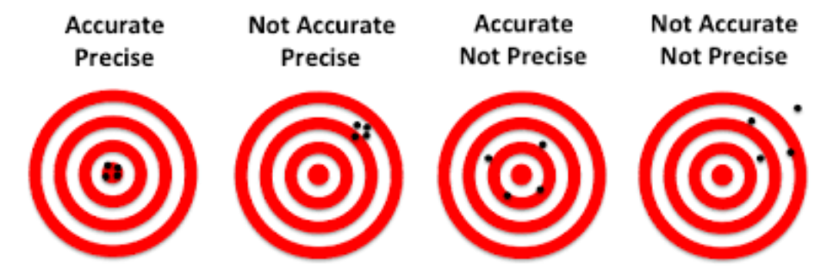

Shadows - answers

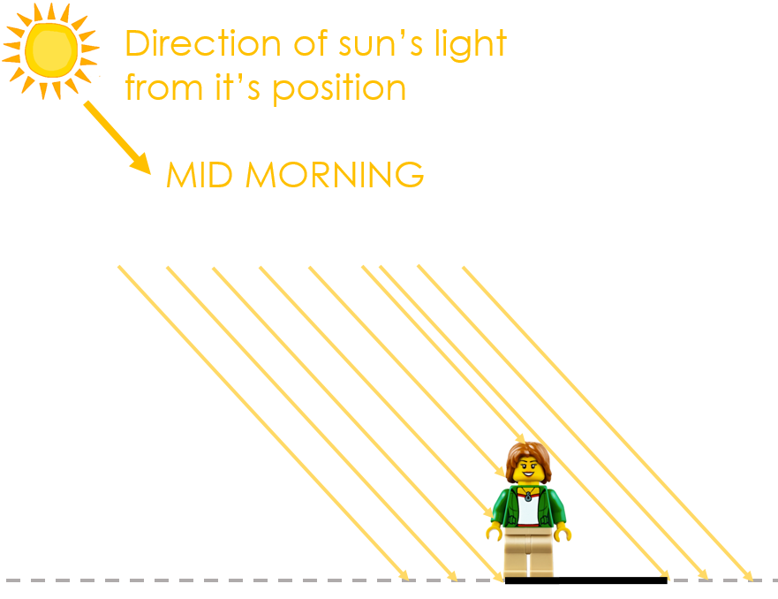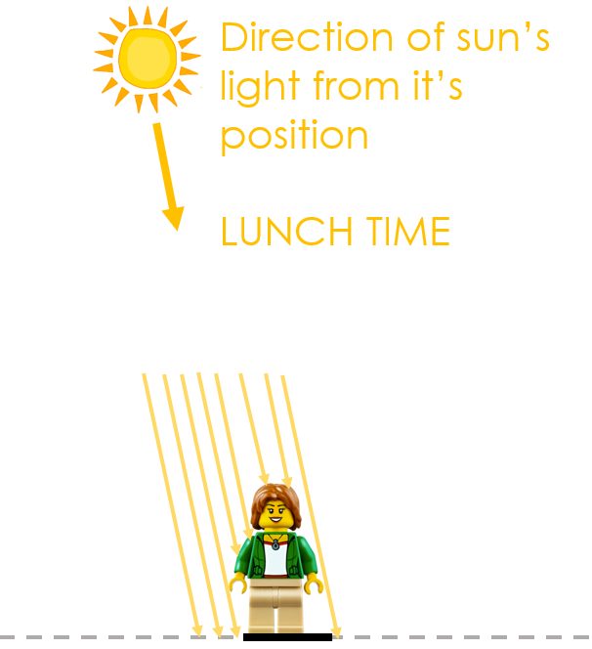
If light rays are parallel, shadows can change depending on the direction of the light. This is why our shadows change over the course of the day as the earth rotates the sun seems to move across the sky.

If the light is not parallel, but diverging (spreading out), then shadows can change depending on the direction of the light or the distance between the luminous object and the object that will cause the shadow.

Questions:
- At what time of day are our shadows shortest? Why?
Midday because that is when the sun is directly overhead so that our shadows are directly underneath us (technically the sun is only perfectly overhead on the equator, on the longest day, at midday).

- What happens to the length of our shadows as the sun sets?

Our shadows get longer.

- Complete these three ray diagrams to find the shadows caused by the diverging light of a torch shining on a cube as it gets further away.
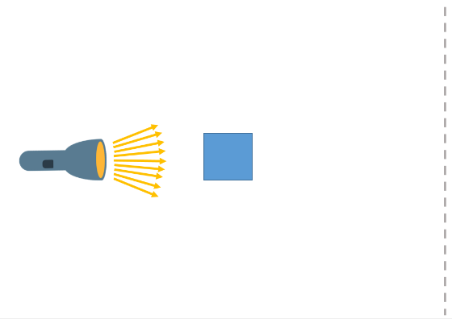
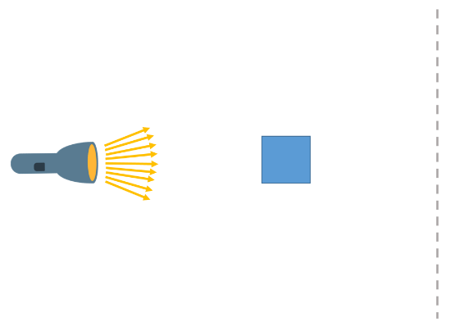
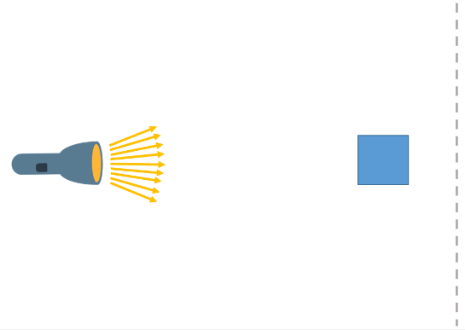

- Finish this sentence: As the cube gets further away from the torch, the shadow

Gets smaller

Shadows experiment
We’re going to test the prediction you made on the last page about how the distance between the luminous torch and the blocking object changes the size of the shadow.
Equipment
- Torch
- Object to block
- Ruler
- Screen (a piece of paper propped up)
Diagram
Below is the view from above your equipment. We’re going to change the distance between the torch and the blocking object and then measure the width of the shadow on the screen.
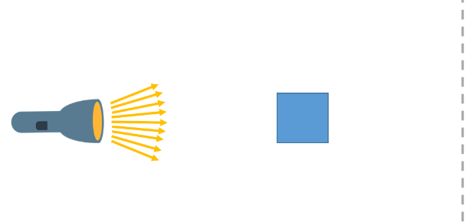
We need to keep the distance between the torch and the screen constant.

Steps
- Set up the equipment like in the diagram
- Set the distance from the end of the torch to the start of the blocking object and check it with a ruler. Write this in your table.
- Turn on your torch and measure the width of the shadow with a ruler. Write this in your table.
- Go back to step 2 and change the distance again.
Results
Distance between torch and blocking object (cm) | Width of shadow (cm)
Conclusion
My prediction was correct/incorrect. When the distance between the torch and the blocking object increased, the width of the shadow

…………………………………………………………………………………………………..

…………………………………………………………………………………………………..

The size of the earth – teacher notes
Slides
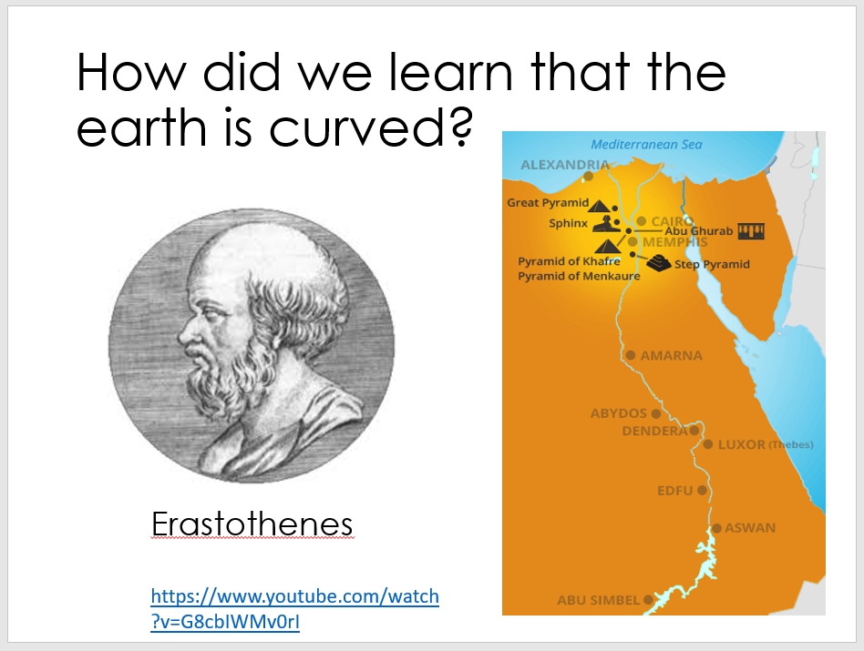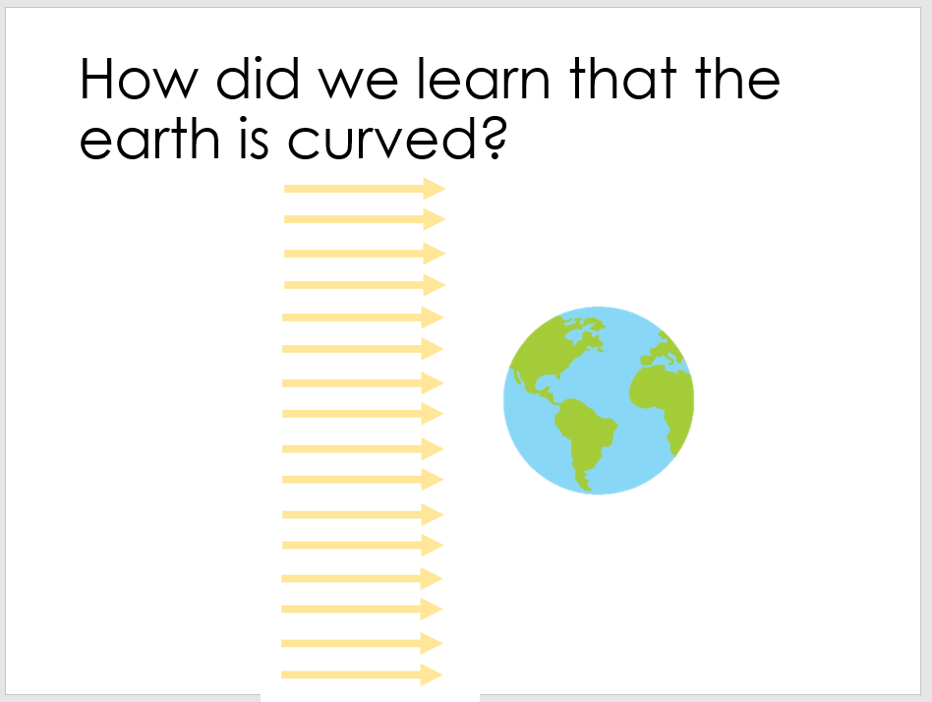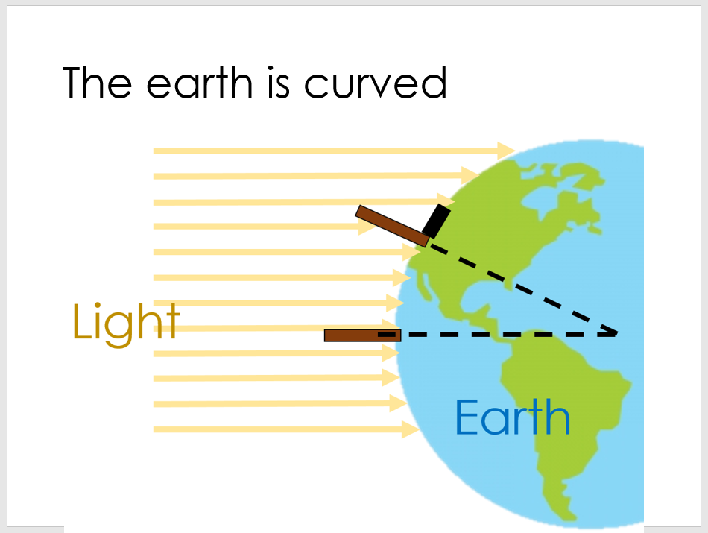
SLIDE 1
We can use the idea of light and shade to explore how Eratosthenes calculated that the earth was curved and found it’s radius. Watch the video by Carl Sagan https://www.youtube.com/watch?v=G8cbIWMv0rI – you could make a model yourself with two lego brick towers stuck on a flexible base or two pencils punched through a piece of card – you need to do this outside to take advantage of the parallel rays of light (inside, your light source will be too close and the light will be diverging).
SLIDE 2 and 3
These slides draw out how it looks from the side. The posts (brown boxes) are perpendicular to the earth where they are (so if you continue the post down, they hit the centre of the earth – dashed lines). The parallel rays of light (yellow arrows) form different shadows (black lines along earth) dependent upon our latitude.
You can read the story written out by the excellent Bill Wilkinson (@DrWilkinsonSci on twitter) who has an amazing project of similar science stories (https://drwilkinsonscience.wordpress.com/2018/07/05/sciencestories/ and https://drive.google.com/drive/folders/13fjEqijR2gGKhu96IvCN4DOOT4NjPShD)

The size of the earth
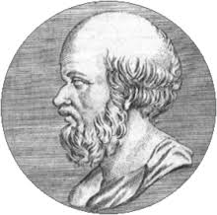
The true size of the earth was first worked out in a simple and ingenious way by a man named Eratosthenes, who lived in the city of Alexandria in Egypt in the third century B.C. He was an astronomer, historian, geographer, philosopher, poet, theatre critic and mathematician. He was also the chief librarian at the great library of Alexandria and one day while reading a papyrus book in the library he came across a curious account.

He read that at precisely noon on the longest day of the year, the shadows from temple columns or vertical sticks in the city of Syene would grow so short that they could not be seen. At that moment the sun was exactly overhead. It was an observation that someone else might easily have ignored - sticks, shadows, the position of the sun – what possible importance might they have? But Eratosthenes was a scientist and his contemplation of these homely matters changed the world. Because Eratosthenes has the idea to experiment, to actually ask whether a stick in his city of Alexandria, 800km north of Syene, would cast a shadow near noon on June 21st. And it turns out, they did.

Eratosthenes asked himself how it could be that at the same moment a stick in Syene would cast no shadow and a stick in Alexandria, 800km to the north, would cast a very definite shadow? The answer was that the surface of the earth is curved because it is a globe.

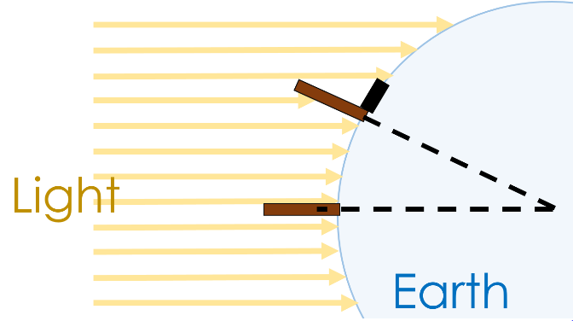
The sun is so far away that the rays are parallel when they reach the Earth. Sticks at different angles to the sun’s rays will cast shadows of different lengths. Not only did Eratosthenes prove that the earth was curved, he went on to deduce the circumference of the earth (the distance around its centre) from what he had seen. Eratosthenes knew the distance between Alexandria and Syene: 800km. How did he know this? Because he hired someone to pace out the entire distance so that he could perform his calculation. He used geometry to calculate the angle between Alexandria, the centre of the earth and Syene and used this to estimate that the circumference of the earth must be 40,000km. Amazingly, that’s the right answer – we now know that the circumference of the earth is 40,075km! Eratosthenes’ only tools were sticks, eyes, feet and brains plus a zest for experiment. With those tools he correctly deduced the circumference of the earth. That’s pretty good figuring for 2200 years ago!

The size of the earth - answers

- Why do you think that Eratosthenes, one of greatest minds of his generation, was working at a library?
- There were no universities at the time so this was the equivalent.
- This is where all of the scrolls/books were kept so you could learn new things

- What does the word geometry mean?

geo metry

earth measure

Bringing the parts together, geometry means measuring the earth

- Draw how long the shadows would be along the dotted line (just like in the example on the left hand page) of the surface of the earth for these sticks in three different locations.

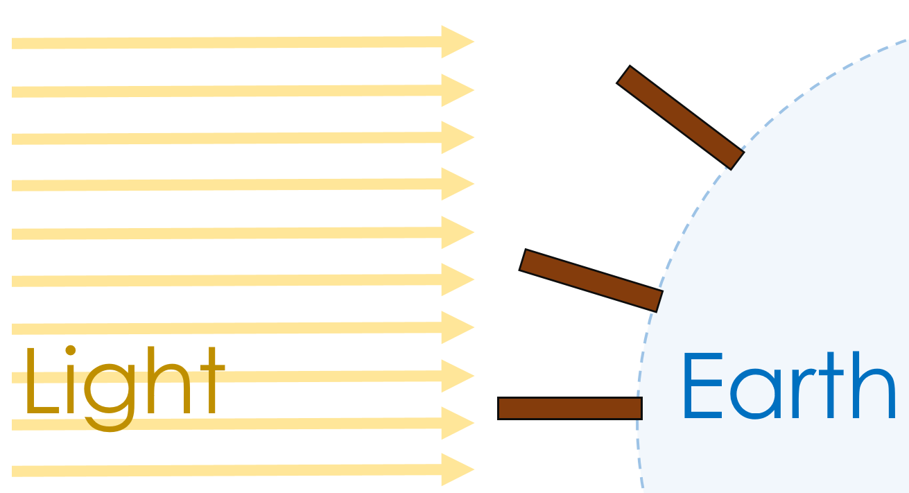

Objects in the universe – teacher notes
This is a few slides of awe and wonder. The table on the next page lists objects in the universe from largest to smallest (very roughly).
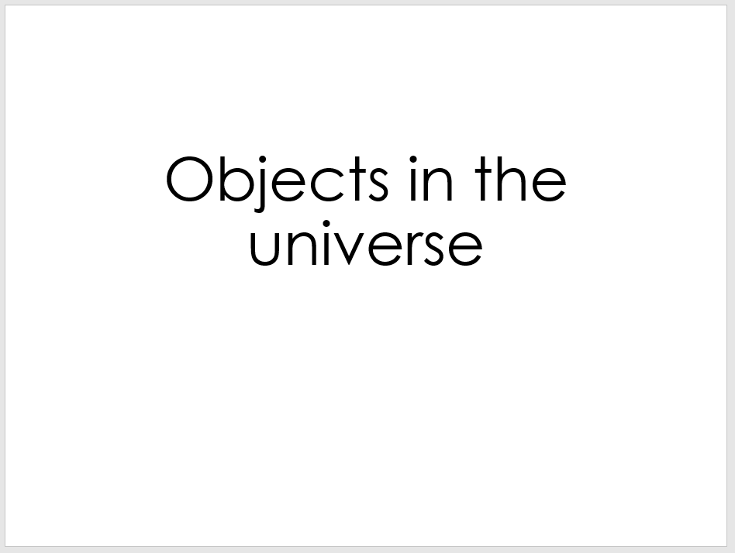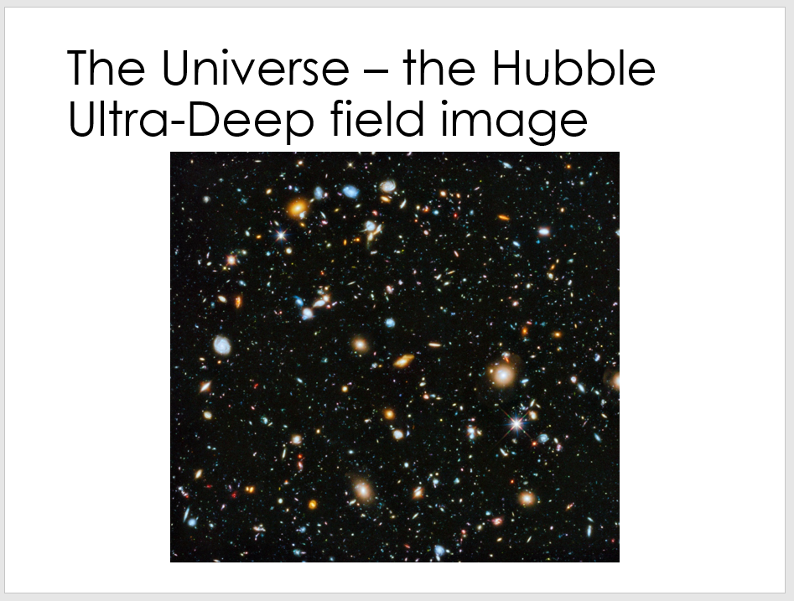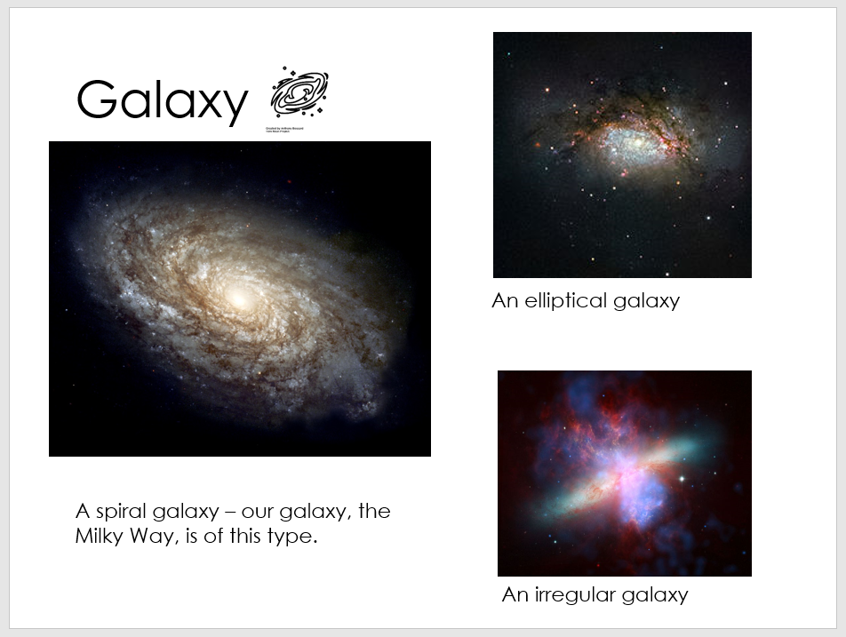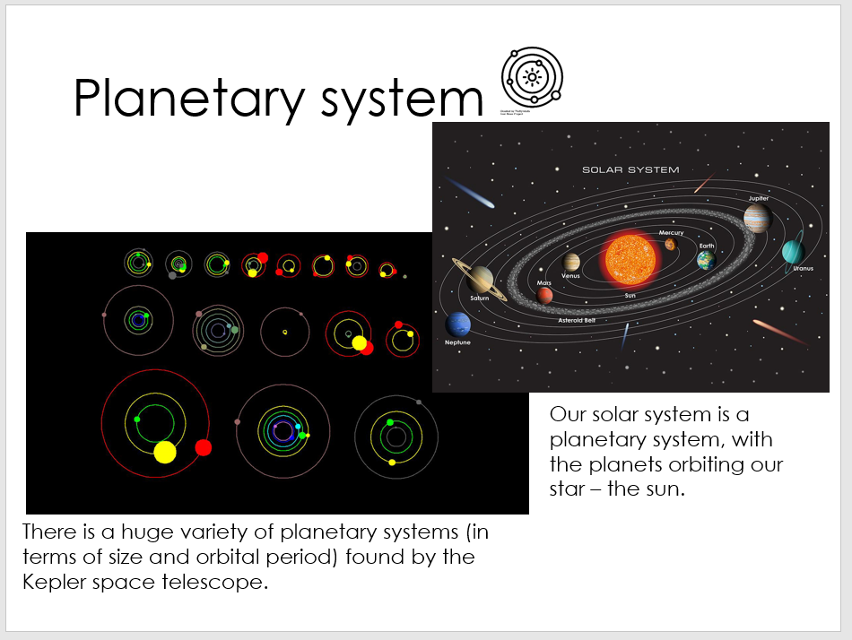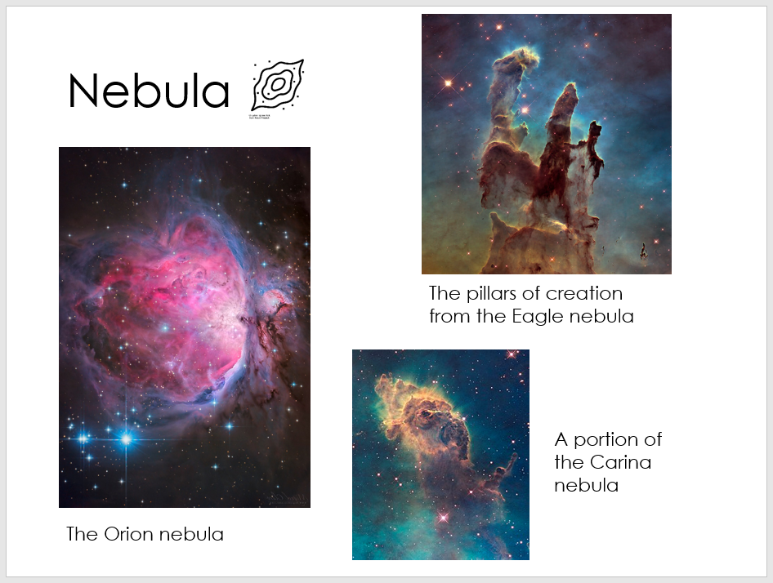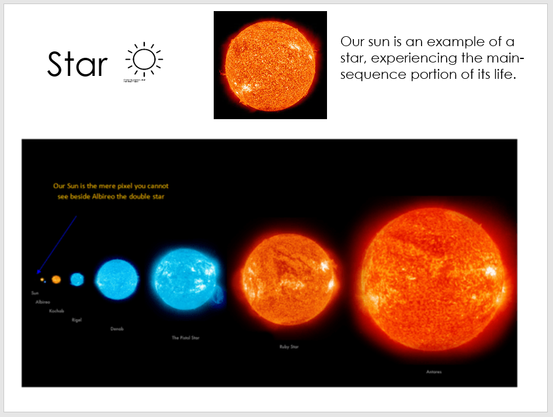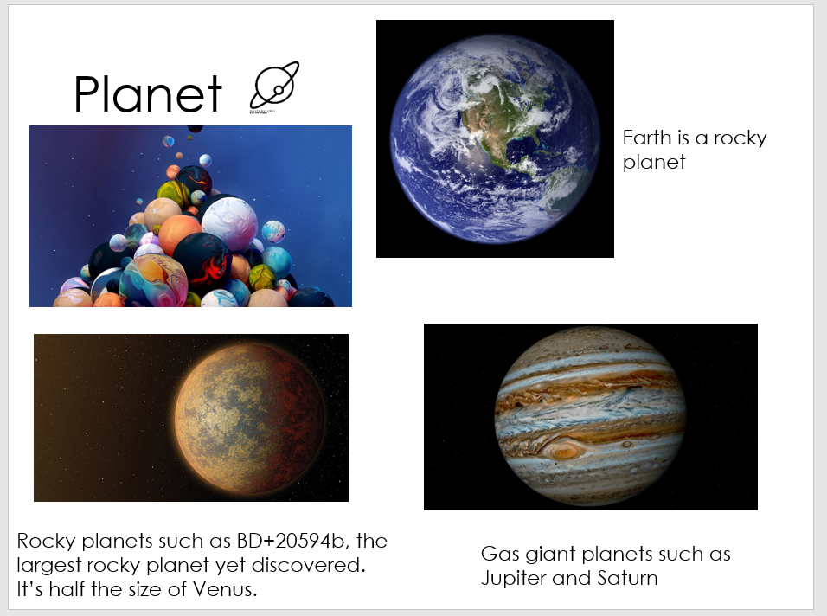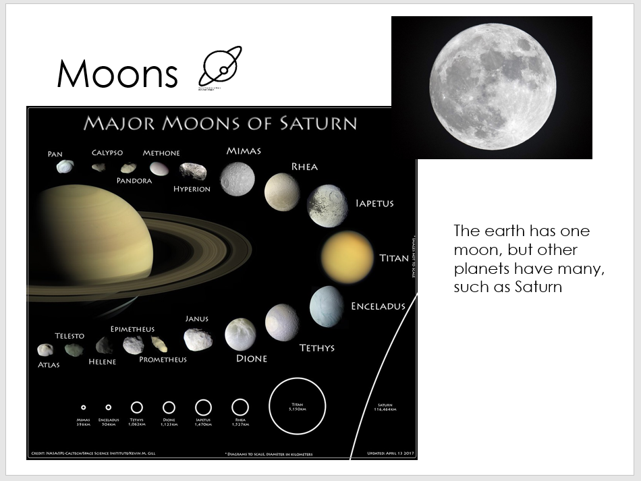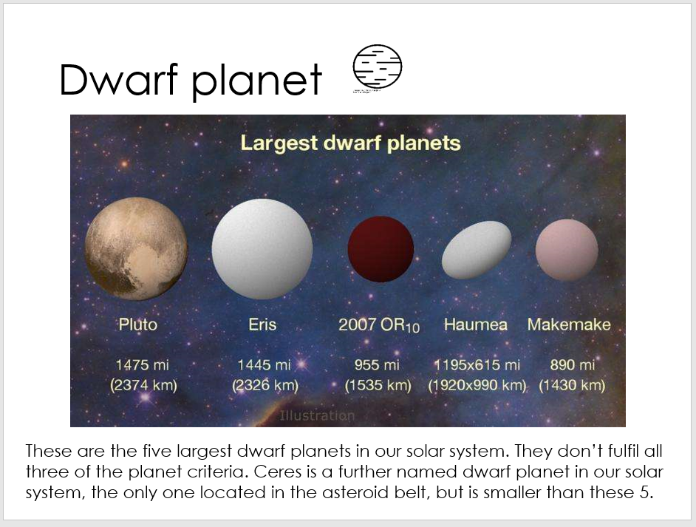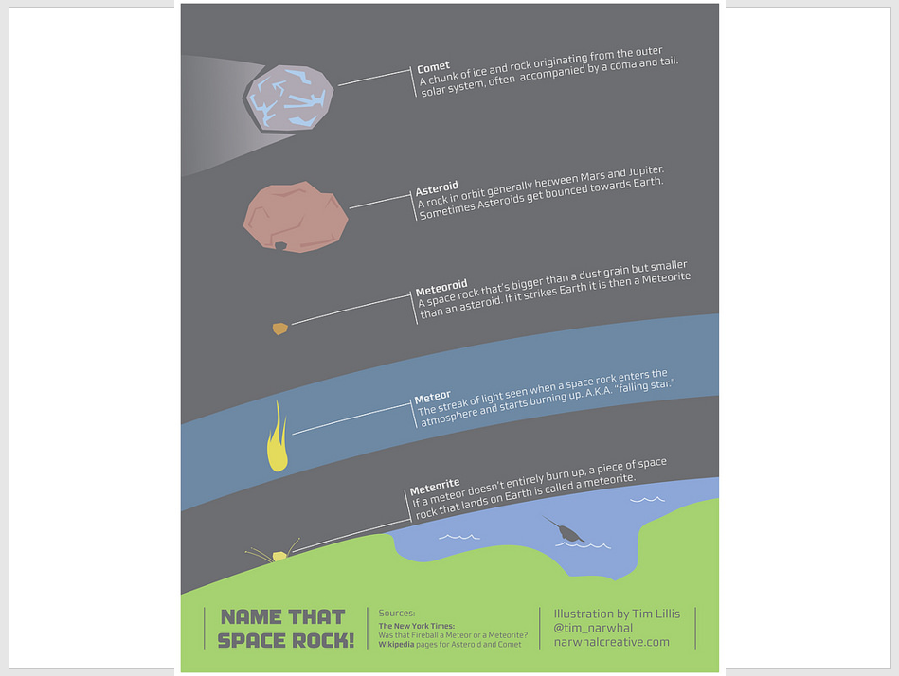
Some important distinctions:
- Galaxies are collections of stars (and their orbiting planets), dust and gas (as well as dark matter) that are bound into a single entity by gravity. Galaxies come in three families of shapes and many are thought to have supermassive black holes at their centre. The universe contains an estimated 200billion galaxies.
- Galaxies are filled with planetary systems: planets, dwarf planets, asteroids and all other objects that are gravitationally bound to orbit their star. Current research looks into the wide variety of planetary systems out in the Universe, noting the massive variation there is between one system and the next. Our planetary system consists of eight planets, five dwarf planets and two belts of debris – the asteroid belt and the Kuiper belt – we call it the solar system. Each galaxy contains billions of stars (and hence billions of planetary systems). Nebulae are clouds of dust and gas that are bound by gravity. They are truly vast, being light years across. They host star-forming regions such as the pillars of creation in the Eagle nebula where the dust and gas becomes denser, attracting more dust and gas due to the additional gravitational field until a star is formed.
- A star is a hot sphere of plasma – ionised gas – that is emitting electromagnetic radiation due to a process of nuclear fusion at its core. This is what makes stars luminous (they emit light). Not all stars are the same. Whilst in the night sky, we see them as tiny specks of light, there is a huge variation in the size, mass and colour of stars as they form, grow and die. The star in our planetary system is called the sun.
- Just like there is a huge variety of galaxies and stars, there is a huge variety of planets. These are non-luminous objects (they don’t emit visible light) that orbit a star. There are conditions that must be fulfilled to be considered a planet – you need to independently orbit your star, you need to have a large enough mass to be roughly spherical, you need to be the dominant object on your orbital path.
- A moon is any natural object that orbits a planet due to gravitational pull of the planet. They come in a wide range of shapes and sizes – whilst lots of moons are spheres, they don’t have to be. Some planets have a huge number of moons, some have none. A moon is always smaller than the planet that it orbits, but a planet’s moon may be significantly larger than other planets e.g. Jupiter’s largest moon Ganymede is bigger than the planet mercury.
- The dwarf planets don’t fulfil all three planetary criteria (1 – orbit a star; 2 – be so big as to be roughly spherical; 3 – dominate your orbit/have a clear neighbourhood which means any objects your encounter on your orbit must be much, much smaller than you). For instance, Pluto is no longer considered a planet as it isn’t the dominant object on its orbital path.
- The last slide in this section outlines the differences between asteroids, comets, meteoroids, meteors and meteorites.

Objects in the universe
The universe as we see it comprises of billions upon billions of galaxies, each containing millions of stars and planets, as well as dwarf planets, asteroids, comets and nebulae. What are all of these objects? And which are bigger?
Biggest  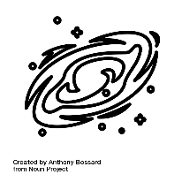  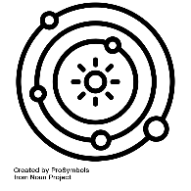  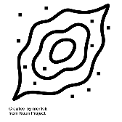  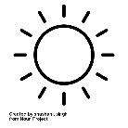  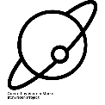  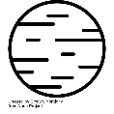  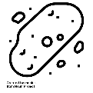  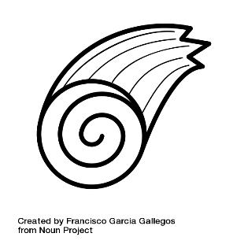  Smallest | Universe | The entirety of everything. The universe contains every object we know of.
 | Galaxy | A large collection of stars (each a possible planetary system of its own) that travel together through the universe. Our galaxy is the Milky Way.
 | Planetary system | The collection of objects that are attracted by gravity to the central star. We call our star system the solar system and it includes our star – the sun, the eight planets, five named dwarf planets, the asteroid and Kuiper belts.
 | Nebula | A collection of gas and dust that will eventually form a star.
 | Star | The luminous object at the centre of each star system. We call our star the sun.
 | Planet | The non-luminous objects that orbit a star.
 | Moons | The non-luminous objects that orbit planets.
 | Dwarf Planet | The non-luminous objects that orbit a star that don’t fulfil all of the planet criteria.
 | Asteroid | Generally lumps of rock and metal.
 | Comet | Generally lumps of ice and rock.

The order of the above table isn’t perfect. A moon will always be smaller than the planet that it orbits, but it might be bigger than some of the other planets in the same star system. Equally, some asteroids might be bigger than some moons.

What shape are planets and stars?
Slide
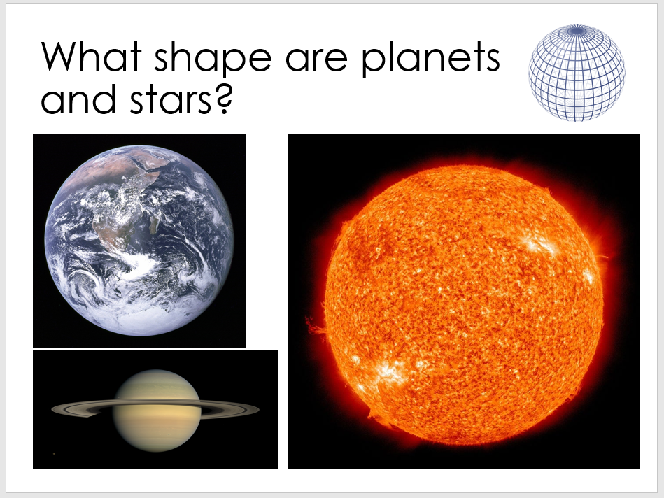
By definition, a planet must be close to being spherical. Technically, they are oblate spheroids if they spin. The earth bulges around its center so has a slightly larger circumference when measured around its waist compared to being measured vertically through the poles.
The earth is, though, incredibly round. By comparison, the earth is closer to a sphere than a snooker ball which is quite amazing. People often say that it’s ‘smoother’ than a snooker ball but this isn’t quite true: https://ourplnt.com/earth-smooth-billiard-ball/#axzz6Ip7RQB9p

What shape are dwarf planets and moons

Slides
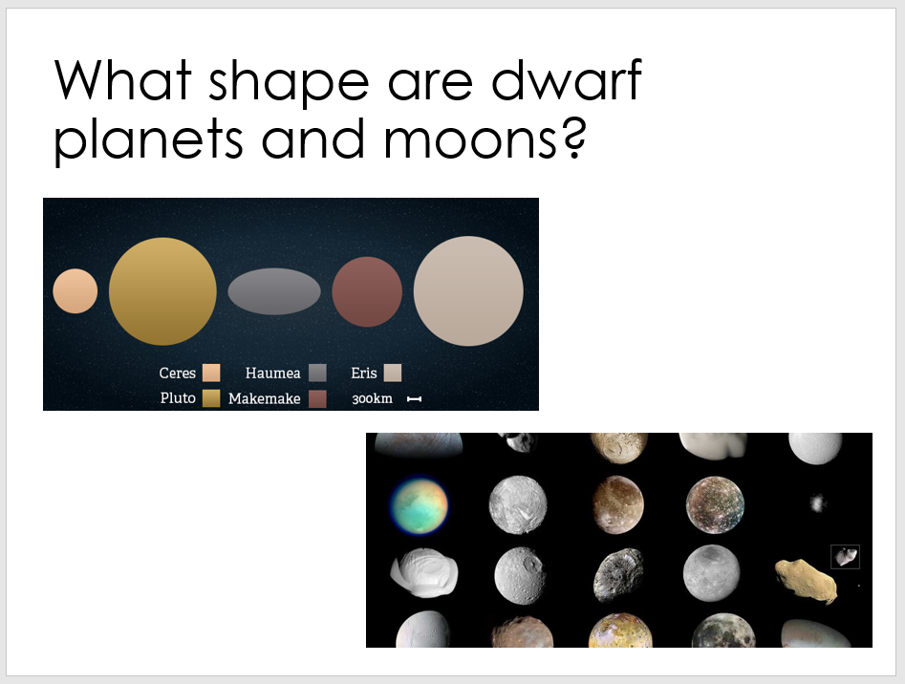
Whilst dwarf planets and moons may be spherical (e.g. Pluto and the earth’s moon), they don’t have to be spherical to be considered a dwarf planet/moon.

A moon really can be any shape, even very small, provided it orbits a planet.

A dwarf planet is a little more limited, as if it is too small then it gets reclassified as an asteroid/comet.

Objects in the universe - answers

Questions
- Name three objects in the universe that are always smaller than a galaxy

A planetary system, a star, a planet, a moon, a dwarf planet, an asteroid, a comet, a meteoroid

- What shape are planets and stars?

Spherical, a sphere

- What is the difference between a comet and an asteroid?

Comets have ice in them whereas asteroids don’t.

- What’s larger: a moon or a planet?

A moon is always smaller than the planet that it orbits. BUT one planet’s moon may be larger than another planet. For instance, Jupiter’s largest moon Ganymede has a radius of around 2600km whereas the planet Mercury has a radius of just 2450km.

- In as much detail as you can, describe where humans live within the universe

We live on earth, a rocky planet that orbits a star that we call the sun. We call this planetary system the solar system and it lives on one arm of a spiral galaxy called the Milky Way. The Milky Way contains billions of other stars. The Milky Way is just one of billions of galaxies that make up our universe.

- Draw three diagrams to illustrate the three criteria (rules) that must be ticked for an object to be classified (labelled) as a planet:
Criteria 1  Diagram to show orbiting a star | Criteria 2  Diagram to show being roughly spherical | Criteria 3  Diagram to show dominating your orbit

The motion of the earth – teacher notes

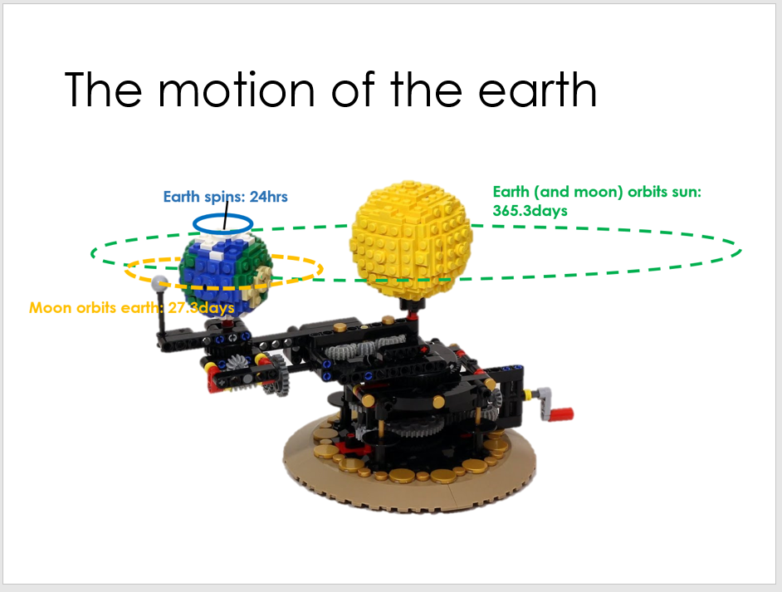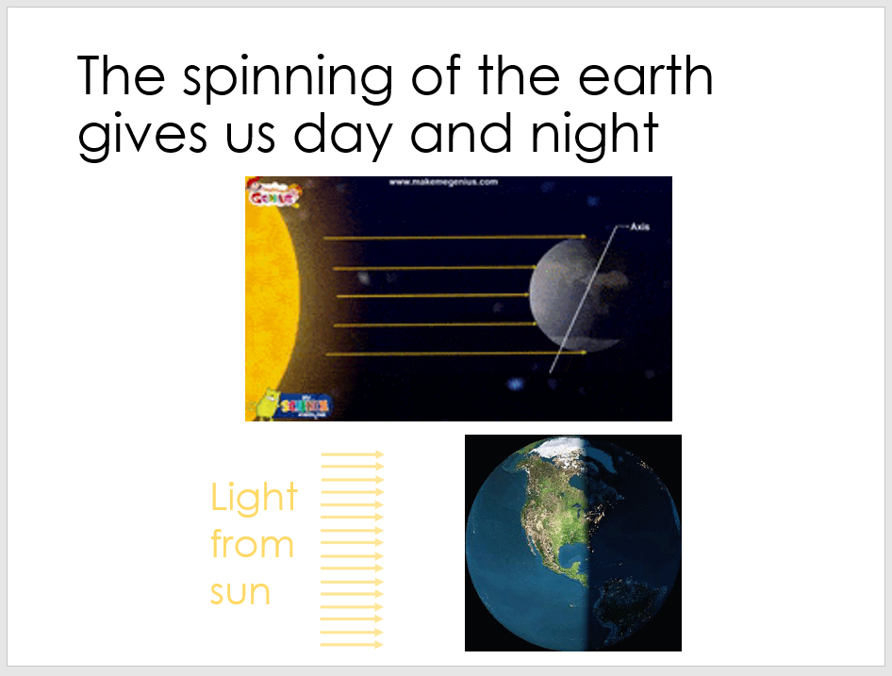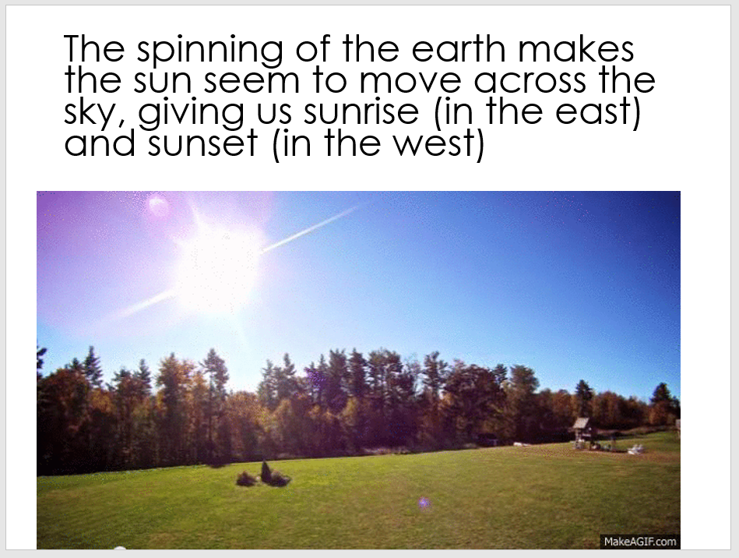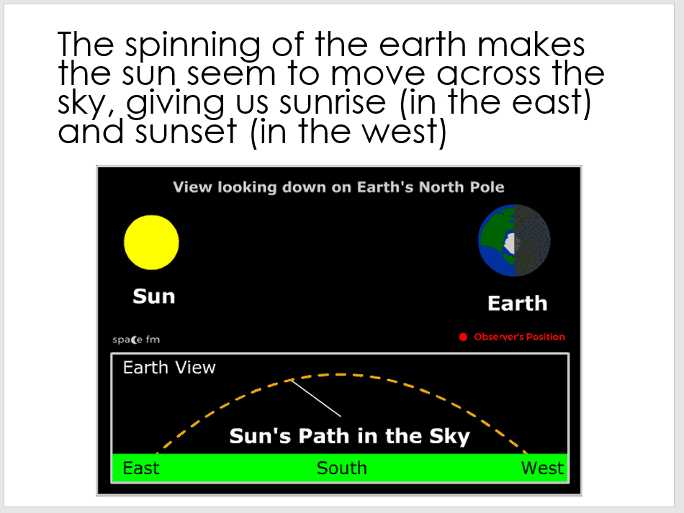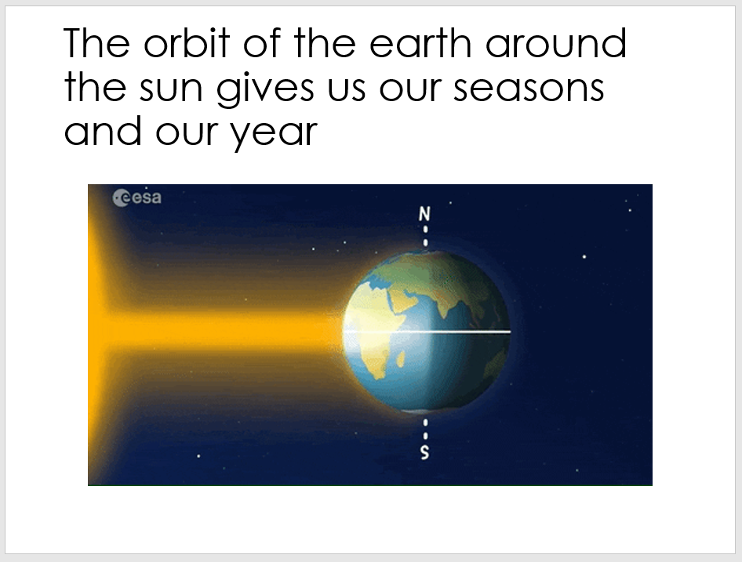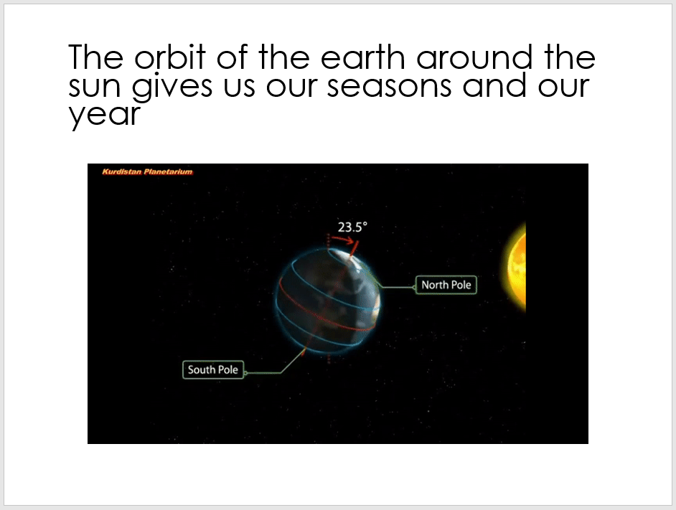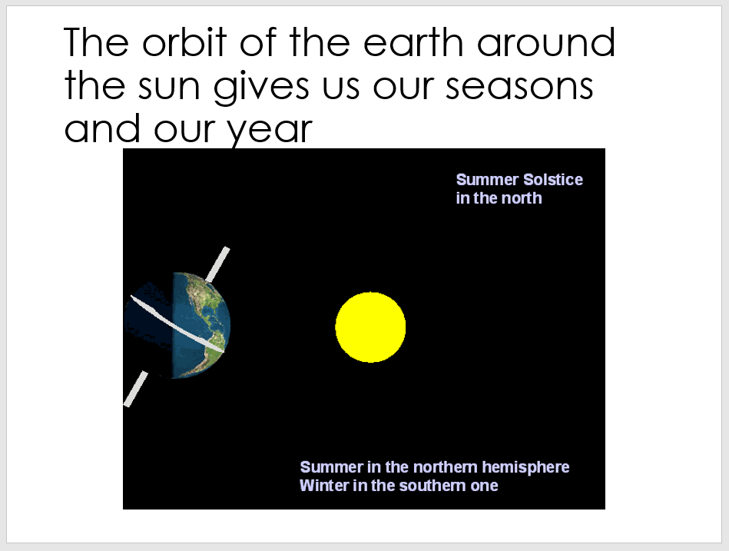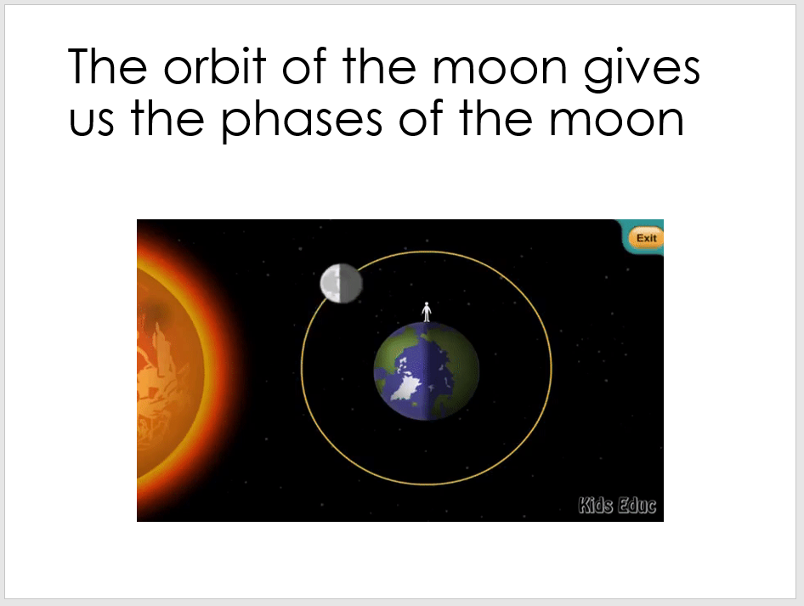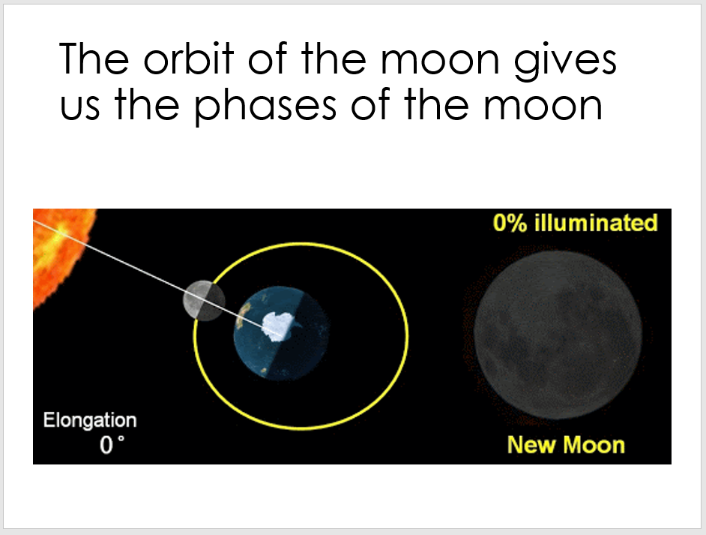
SLIDE 1
A video of the LEGO orrery model and the instructions can be found at: https://jkbrickworks.com/earth-moon-and-sun-orrery/
Here’s a good chance to ask again about whether or not a model is to scale. To make this model to scale we need to make the earth smaller (or sun bigger) and much further away. We also need to make the moon larger compared to the earth (the moon is about a quarter the diameter of the earth) and it needs to be further away.
The earth, our moon and the sun are all spherical in shape. All planets and stars are spherical in shape but not all moons.
Here we’re making the distinction between when an object is spinning and when an object is orbiting.
- The earth is spinning on its axis (technically its axis is tilted by just over 20˚), taking 24hrs to do so. This gives us day and night since light travels in straight lines and can only ‘light up’ one side of the earth.
- The sun is spinning on its axis (slower than the earth).
- The moon is orbiting the earth, taking 27 earth days to do so. This gives us the phases of the moon as only the side of the moon that is facing the sun is lit, and we see different portions of this during its orbit.
- You might notice that we always see the same face of the moon. This is because the moon is spinning at almost exactly the same rate that it’s orbiting. This is called synchronous rotation.
- The earth is orbiting the sun and takes 365.25 earth days to do so. Our calendar is 365 days, so every 4 years, we collect the ignored 0.25days from each together and create a leap year of 366 days by putting an additional day in February.
You could get three students to try and model this system with each of them playing the role of sun, earth and moon (possibly holding balls/fruits). Get the rest of the class to discuss what each of them should be doing. Earth: spinning and orbiting sun. Moon: orbiting earth (and spinning so as to keep same side facing earth).
SLIDE 2
These two animations emphasise that day and night come about due to the spinning of the earth and the fact that light travels in straight lines. As the light from the sun must travel in straight lines, it can only light up the side of the earth that is facing the sun. This changes as the earth spins giving us a period of time facing the sun – daytime. And a period of time where the sun cannot reach us – night time (the absence of direct light from the sun).
SLIDE 3
This is a concrete example to show students the sun moving across the sky. Get them to make a note of the position of the sun in the sky over the course of the day.
SLIDE 4
This animation is worth spending some time on, and might be worth acting out too. You’d need a large light and a student to spin on the spot (anticlockwise) looking straight at all times (not turning their head). They’d see the sun spear in the left peripheral vision (the ‘east’) and move across their vision (the sky) before disappearing in their right peripheral vision (the ‘west’).
In the animation, the observer is the red dot and their view of the sky is plotted as the earth spins.
SLIDE 5
This animation sets up our understanding of the origin of the seasons. The seasons are actually causes by the tilt of the earth. This animation shows that because of the tilt, one hemisphere is tilted towards the sun with the other tilted away from the sun. The hemisphere that is tilted towards the sun experiences sunlight that is more direct (closer to perpendicular to the surface of the earth) and hence more intense – they experience summer. At the same time, the other hemisphere is tilted away from the sun, experiencing less direct sunlight, and hence winter.
THE SEASONS ARE NOT DUE TO THE EARTH BEING CLOSER TO/FURTHER FROM THE SUN.
https://spaceplace.nasa.gov/seasons/en/
SLIDE 6
This animation shows how the tilt of the earth stays fixed throughout space and so:
- the northern hemisphere is tilted towards the sun to begin with (Northern hemisphere summer, southern hemisphere winter)
- then as the earth orbits 90degrees the tilt of the earth isn’t tilted either hemisphere towards the sun (Northern hemisphere autumn, southern hemisphere spring)
- a further 90degrees of orbit and the northern hemisphere is now tilted away from the sun (Northern hemisphere winter, southern hemisphere summer)
- a further 90degrees of orbit and the tilt of the earth, again, isn’t tilting either hemisphere towards/away from the sun (Northern hemisphere spring, southern hemisphere autumn).
SLIDE 7

This animation gives the freeze frame main points of the last animation with labels.

SLIDE 8

NOTE: THE PHASES OF THE MOON IS NO LONGER ON THE PRIMARY SPEC, THEY SIMPLY NEED TO KNOW THAT THE MOON ORBITS THE EARTH.

This slide sets up an understanding of the orbit of the moon by showing that the same side of the moon is illuminated by the sun at all times as it orbits the earth. Only the side of the moon that is facing the sun is lit. The ‘dark side’ of the moon never gets any light.

SLIDE 9

Optional. This shows how the moon appears from earth as it orbits. Because only one side is lit, and that side is not always facing us, as the moon orbits around the earth, we see different amounts of the lit surface.

The white line that joins the earth and moon in the animation helps us to understand which part of the moon is visible to us and this is then shown in the bottom right as the earth’s point of view of the moon.

Note that moon isn’t only visible at night, much of the time it is visible is during the day on earth. New moons and crescent moons tend to be daytime events.

The motion of the earth - answers
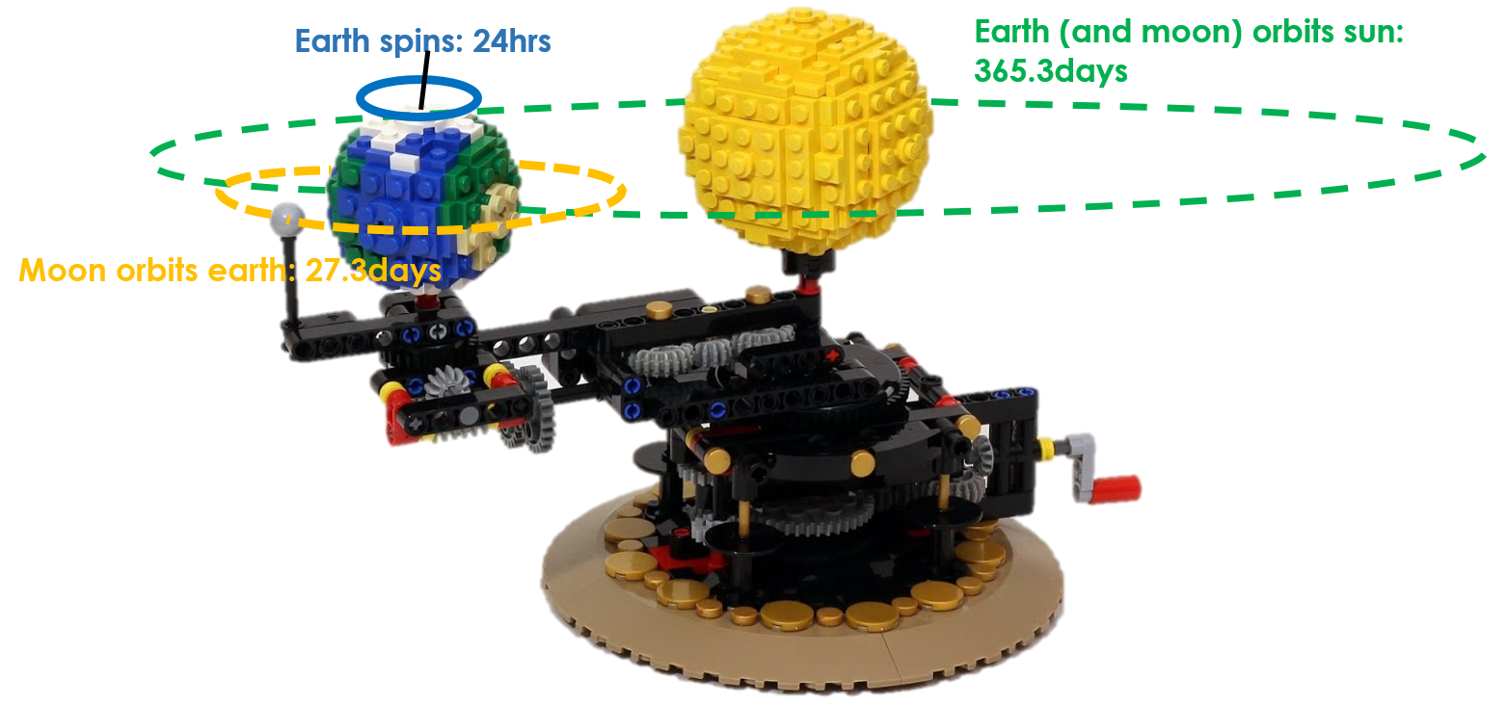

There is lots of motion happening at once in the solar system. The earth spins on its axis, taking 24hours to do so (this is not an orbit) – this gives us the length of the day. It’s daytime when the part of the earth that you’re on is facing the sun and it’s night time when it faces away. The moon orbits around the earth, taking 27.3 days to go the whole way around. This gives us the different phases of the moon: full moon, half moon, new moon etc. Finally, the earth orbits the sun, taking 365.3 days to go the whole way around. This gives us our year and the changing of the seasons.

Questions
- What motion of the earth gives us day and night?

The spinning of the earth on its axis.
It takes 24hours.

- What motion of the earth gives us our year?

The orbit of the earth around the sun.
This takes 365.25 days.

- Why might we say that the moon orbits two objects?

The moon orbits the earth whilst the earth orbits the sun.

- What would I have to change to make the sizes a scale model of the sun, earth and moon?

The earth would need to be smaller (or the sun larger).
The earth needs to be further from the sun.
The moon needs to be about ¼ the size of the earth and further from it.

What is an orbit? – teacher notes
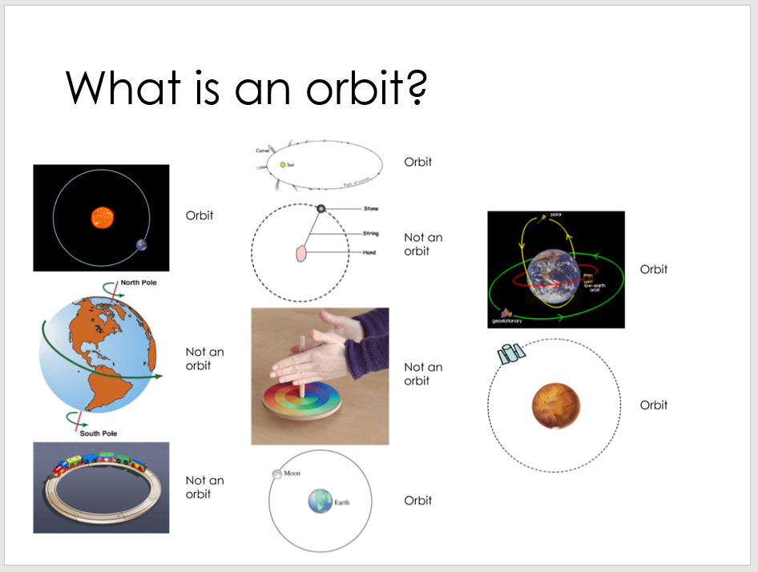
An orbit is when
- One object moves around another object…
- …because of the force of gravity
Go through each of the images on the slide and discuss why they have been classified as ‘orbit’ or ‘not an orbit’.Examples:
- The earth spinning is not an orbit because it is not going around another object.
- The stone being swung around by a hand is not an object, because even though the stone goes around the hand, it is not caused by the gravitational pull of the hand (it’s causes by tension in the string).
Possible demo: One person stands still and is the sun. Another person stands nearby and is the earth. The ‘sun’ holds one end of a piece of string whilst the ‘earth’ holds the other. This string represents the gravitational pull of the sun on the earth.
- If the earth were stationary, then as the string is pulled by the sun, the earth is pulled inwards and burns up.
- But if the earth tries to walk in a straight line (as the earth is actually moving), then the string should pull the earth so it doesn’t move in a straight line but instead moves around the sun, keeping a constant distance from it (the length of the string).

Orbits are not circles

Until 1609, astronomers believed that the planets travelled in circular orbits. It took a genius to calculate their actual paths - Kepler discovered that planets travel in ellipses. This was a problem for astronomers. No one understood what force could make the planets travel in elliptical orbits. At first, Kepler thought it might be magnetism, but this is not correct.
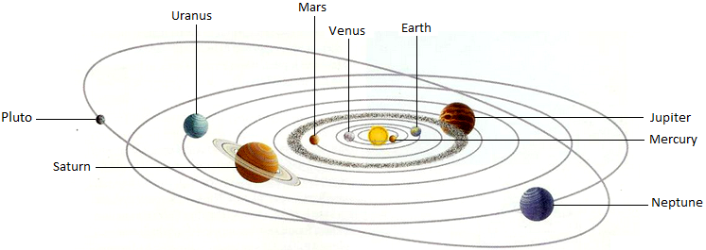

Note: this image is not to scale. In the real solar system:
- The orbits would need to be much larger.
- The planets would need to be much smaller.
- The ellipses would not be as stretched as this (that’s why it took a long time to realise the orbits were not circles.

Orbits - answers

- Write your own definition of what an orbit is.

An orbit is when one object moves around another due to the force of gravity.

- Draw a line to show the path that the earth takes around the sun:

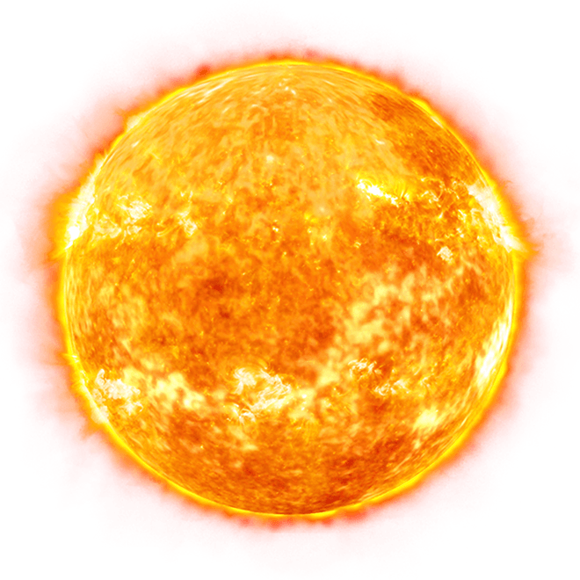



- In terms of scale, why is the diagram above not realistic?

The earth is too large compared to the sun.
The earth is too close to the sun.

Exoplanets Intro – teacher notes

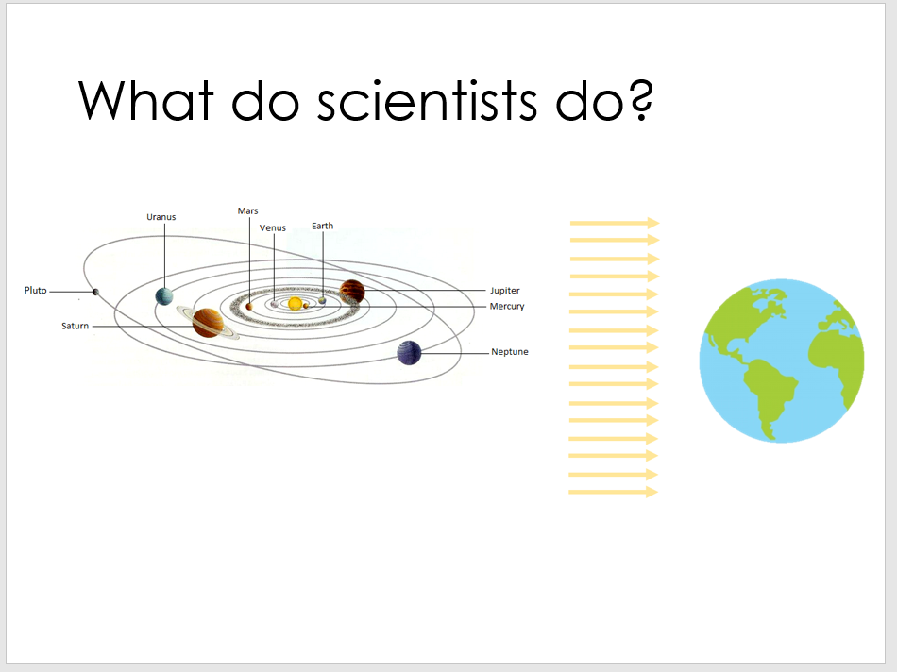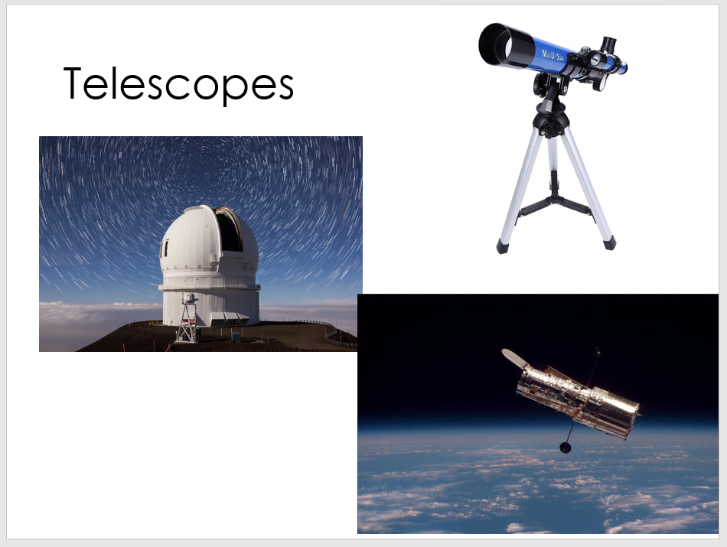

Scientists research new ideas, often starting with very basic ones. If we know that planets orbit stars, and we know that light travels in straight lines, and we know that shadows are caused when an object blocks the path of light, then what might we be able to notice from earth if there’s a planet around a distant star?

Exoplanets are the name given to planets that orbit stars that are not our sun.

Astronomers use telescopes to make their measurements. But exoplanets are so far away from us that we can’t see them directly – no matter how good our telescope is. So instead of looking to take a direct picture of them, we look at how a planet influences the light we see from the star that it is orbiting.

Exoplanets – teacher notes

We discuss the videos of transit curves being produced by thinking about how we block the light from the sun (or the light from a bulb in the classroom) and make it more bearable for our eyes by moving our hand in front of it. We don’t block all of the light, but we make it less bright. Exoplanets do the same thing to the light from distant stars and we use this idea (that the planet blocks the light) to find them.
Some lovely graphics can be seen here:
https://www.cfa.harvard.edu/~avanderb/tutorial/tutorial.html
https://www.planetary.org/explore/space-topics/exoplanets/transit-photometry.html

Equipment you’ll need for the demo:
- A laptop with a webcam and the lightgrapher software installed from http://www.planetarium-activities.org/shows/sp/lightgrapher (additional instructions can be found here too)
- Some ‘planets’ – can be as simple as circular bits of card, or painted spheres of paper/playdough/blue-tac – attached to sticks
- A light source – you want a bulb with a roughly even brightness over its surface (for example, the one on the left below). Filament bulbs like the one on the right below don’t work as they don’t provide a sphere of similar brightness
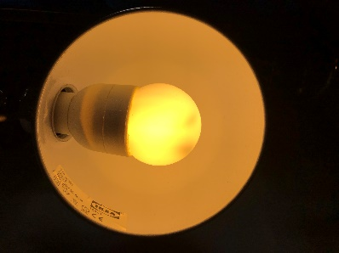 | 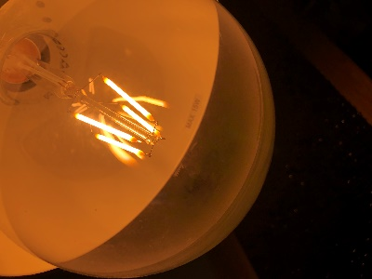

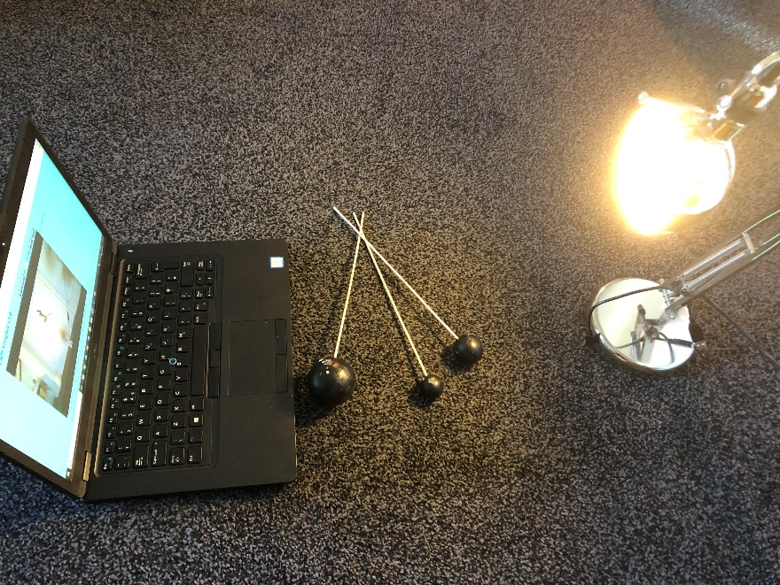
You can read and watch more about the hunt for exoplanets at:
https://www.planetary.org/explore/space-topics/exoplanets/transit-photometry.html
https://www.cfa.harvard.edu/~avanderb/tutorial/tutorial.html
https://sci.esa.int/web/gaia/-/58789-detecting-exoplanets-with-the-transit-method

We’ll be using the webcam as a telescope to measure the brightness (the amount of light) from our star (the lamp that we’re using). On installing and opening the software, select your chosen webcam on the first menu and you’ll see a feed from the webcam presented like below. Adjust the size of the black circle in the centre of the page so that it perfectly surrounds your ‘star’. This will allow the software to monitor the brightness in just this one area.
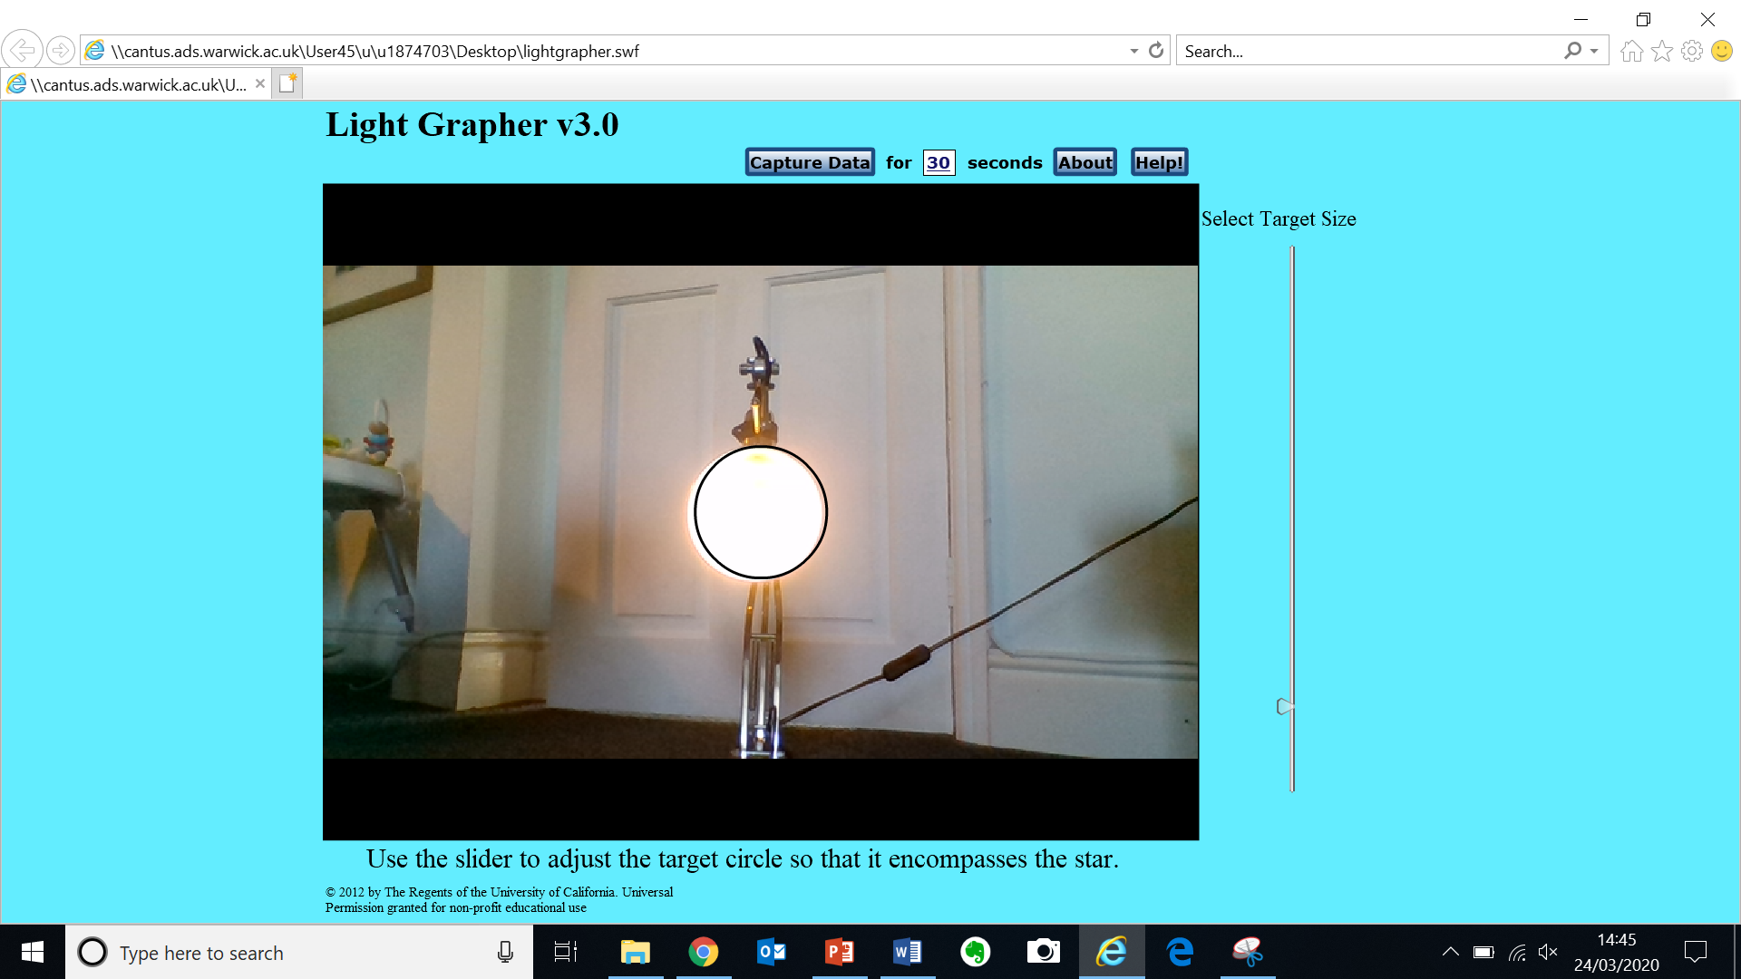

When you press ‘Capture Data’, the brightness will be plotted over time. We’ll move one ‘planet’ at a time between ‘the star’ and your ‘telescope’. The graph will show the effect on the brightness.
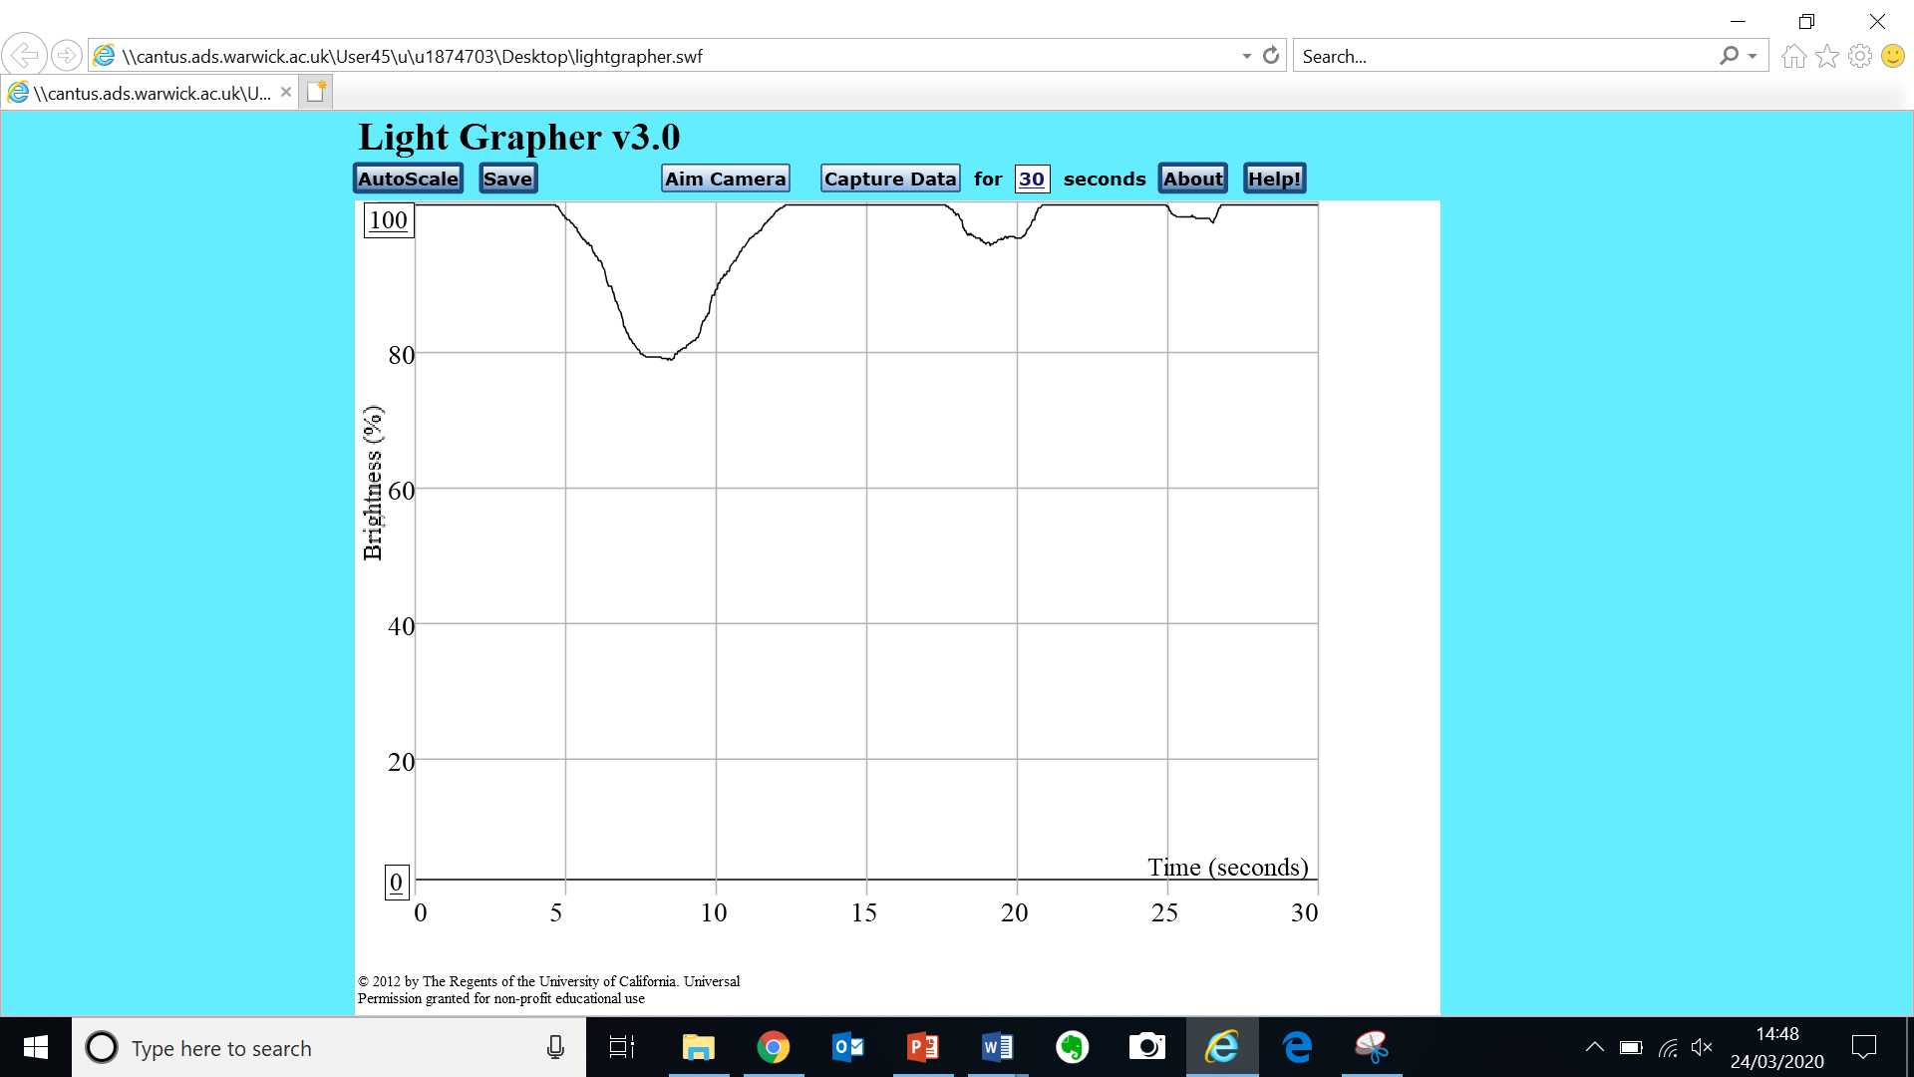
You should see the characteristic ‘dips’ in brightness from the planets. The bigger the planet, the bigger the dip, since it blocks more of the light.

Exoplanets

When we look out at the night sky with our eyes, we see lots of stars. When we use telescopes, we can even see entire galaxies that each contain millions of stars. An exoplanet is a planet that orbits a distant star, just like the planets in our solar system orbit our star, the sun. One of the easiest ways to spot them is the effect they have on the light from the star when they move between the star and our (or our telescope’s) point of view.

As a planet moves in between us and a distant star, the light that hits the planet can no longer get to us – we are in its shadow. This means that if we measure the brightness of that star, it decreases (goes down) if a planet moves across it. This method of finding exoplanets is called the transit method.

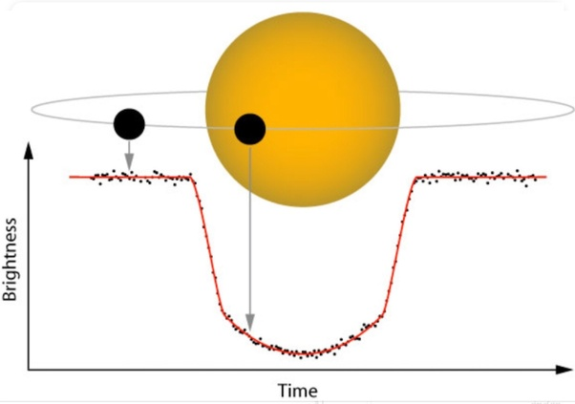

As a planet orbits its star, we see this same decrease in brightness happen over and over again at regular intervals.

From the size of the dip in brightness and the length of time for which it is dimmer, we can learn about the size and speed of the planet.

Questions
- Match the pictures with the different arrows – which part of the light curve is formed by which arrangement of planet and star?

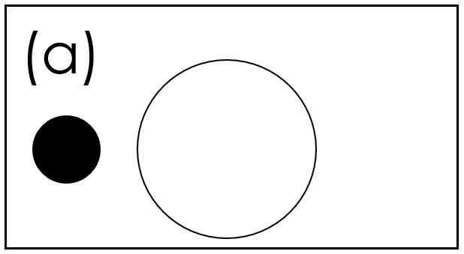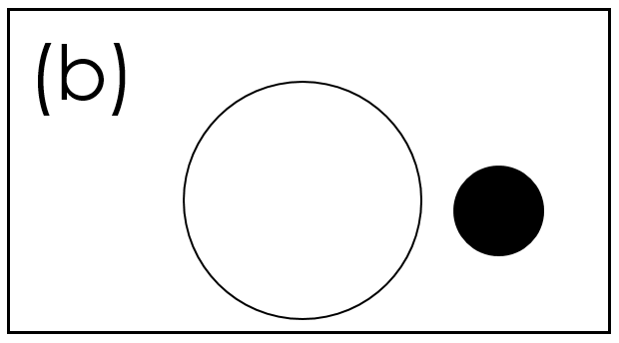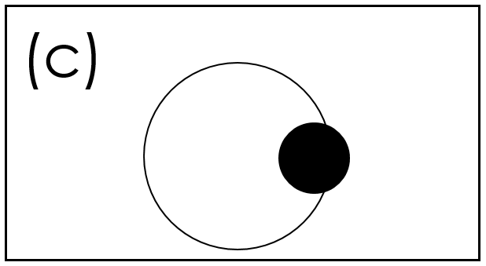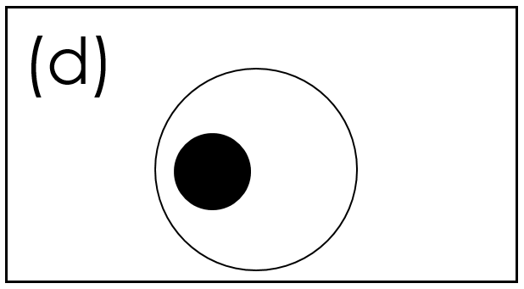
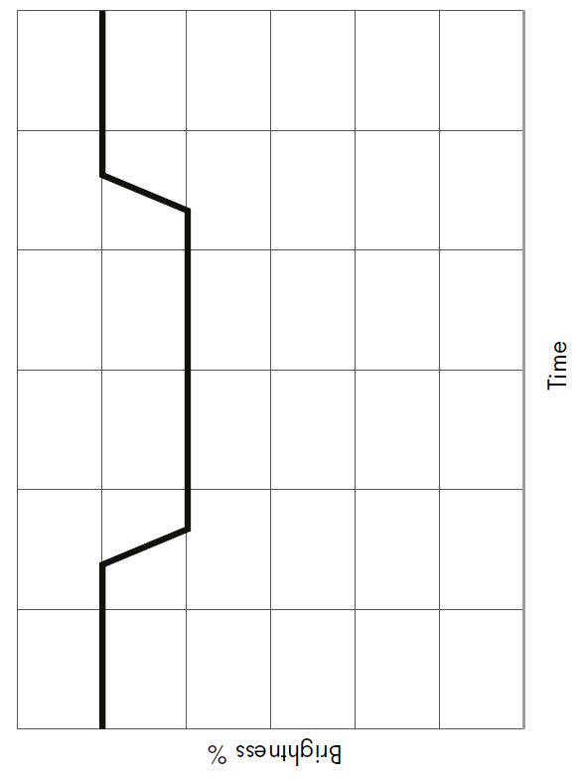
c
b
d
a
- Label what is happening in this light curve – the arrows are in different places now.
The planet is moving out of our line of sight of the star so the brightness increases back to its original level
The planet is in front of the star and is blocking as much light as it can.
A planet is moving in front of our view of the star so the brightness (amount of light) decreases.
No planet in between the star and the observer so the brightness is high.
c

- Describe what happens to the amount of light we measure when an exoplanet orbits its star. Your answer should include the words orbit, brightness, increase, decrease.
As a planet orbits a star it sometimes passes between the star and us, the observers. When this happens, the brightness that we measure from that area of the sky changes. As the planet begins to move across our view of the star, the brightness decreases steadily as the planet blocks more and more of the light from the star. Once the planet is completely in front of the star, it cannot block any more light, and so the brightness reaches a constant, lower level that depends on the size of the planet. As the planet continues through its orbit, it eventually moves out of our view of the star, so that the brightness steadily increases as it covers less and less of the star, eventually moving completely out of the way so that the brightness returns to its original level again.

- Add on a light curve to show an exoplanet that is bigger than this one
- Add on a light curve to show an exoplanet that is faster than this one
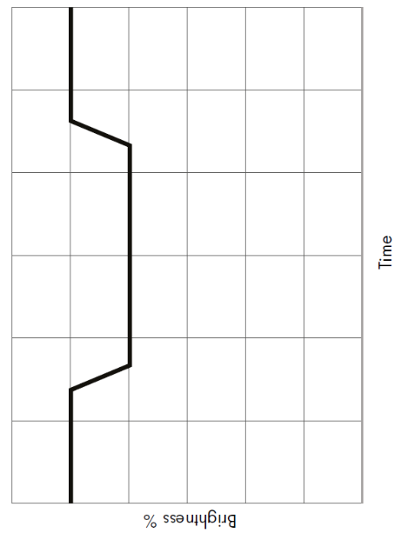
- When astronomers take their measurements, they are only sure that they have found an exoplanet when they see a dip in the brightness that happens are regularly spaced intervals like this:
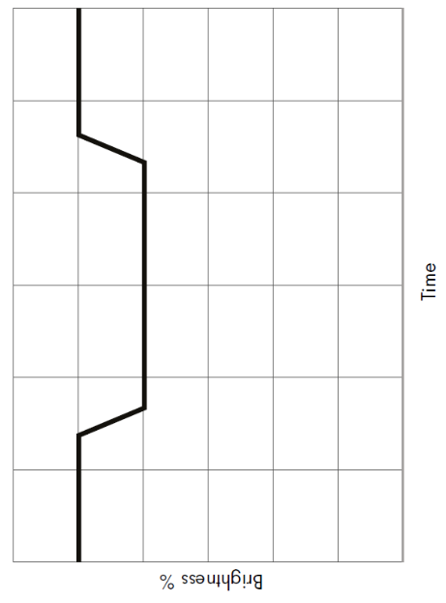
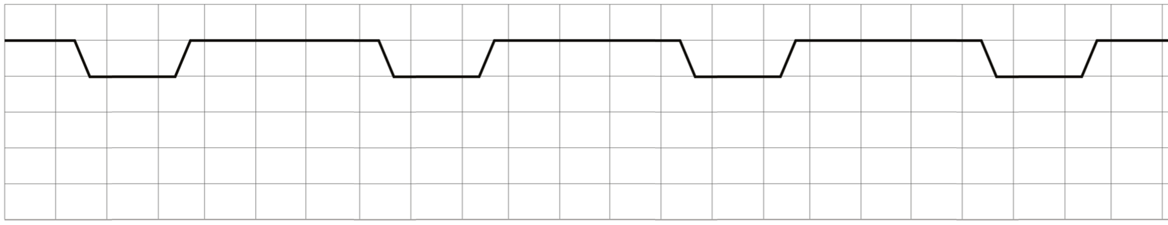

Why are astronomers looking for regularly spaced drops in brightness?

Each new dip signifies that the planet has completed another orbit.
These dips should be regularly spaced in time as the time to complete an orbit (that planet’s year) is (roughly) constant.

If an object simply got in the way of the telescope (like a passing piece of debris) it would create a dip only once and wouldn’t be repeated.

Scientists look for repeated dips to confirm that the object that has blocked light is truly a planet that it orbiting a star and is hence repeatedly blocking the light.

- Each square on the graph above represents 30days. Estimate how long the planet is in front of its star for:

Each orbit has a dip that lasts for roughly two squares, so 2x30=60days per orbit.
The graph shows four orbits so 4x60=240days.

- How long does it take the planet that created the transit graph above to orbit its star?

6 squares from one orbit to the next.
6 x 30 = 180
180days

Quiz

How does light travel? | In straight lines (and very fast)
What do we call an object which emits (gives out) light? | Luminous
What is the dark region called behind an object where there is no light? | A shadow
Why do we call space ‘space’? | Because it is so empty. There’s lots of space between objects.
What is the shape of the earth? | A sphere/a globe
What movement of the earth gives us day and night? | It’s spinning on its axis
What is an orbit? | The elliptical path that an object takes around another due to gravity acting between the two.
Why is it hard to make a scale model of our solar system? | Because there is so much space between objects/objects are tiny compared to the distances from our star, the sun.
What movement of the earth gives us our year and the seasons? | Its orbit around the sun.
What shape are orbits? | Ellipses (an ellipse)/elliptical
What does a moon orbit? | A planet
What is an exoplanet? | A planet that orbits a star that isn’t our sun.
Exoplanet A is twice as big as exoplanet B. Which exoplanet will be easier to notice by the transit method? | Exoplanet A as it’ll block more light.
What do astronomers use to look at the light from distant stars? | Telescopes

