How do we find distant planets?

LAB BOOK

Name: ………………………………………………………………..

Class: …………………………………………………………………



Scale

A scale model is a model of an object or group of objects that has changed the size of absolutely everything by the same amount. If I wanted to make a half-size version of a human body, I’d make a model where the total height was half of the real amount, and the arm length was half of the real amount, and the width of their stomach was half of the real amount and the length of the hair was half of the real amount. I’d make everything the right size relative to the other parts.


Questions
- Why is this LEGO model of Trafalgar square in London a good scale model?

…………………………………………………………………………………………………..

…………………………………………………………………………………………………..

- Can you see anything that is not to scale?

…………………………………………………………………………………………………..

…………………………………………………………………………………………………..

- Why is the tiny LEGO minifigure at the end of this sentence the correct choice to add to this model of Trafalgar square? 

…………………………………………………………………………………………………..

…………………………………………………………………………………………………..

…………………………………………………………………………………………………..

Light in the universe

Luminous objects are objects that emit (give out) light. In our solar system, the sun is the only luminous object. All of the planets and moons reflect light (the light from the sun bounces off them) and absorb light but they don’t emit light, so we say they are non-luminous.

Light travels in straight lines and travels incredibly quickly (it could travel around the entire world 4 times in a second). If the path of light is blocked by an object, then behind the object a shadow forms. A shadow is an area that experiences less light and so appears darker than the surrounding areas.

Questions
- On the dotted line, draw the regions that would appear as shadows.

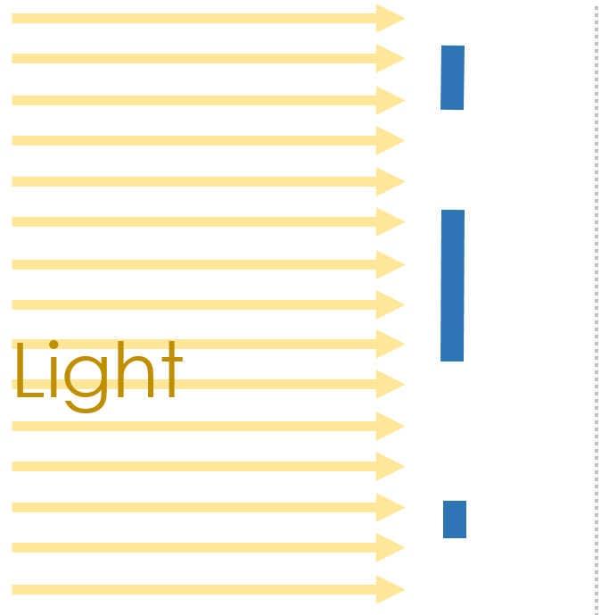
- On the dotted line, draw the regions that would appear as shadows when the sun is high in the sky (on the left) and when it is lower in the sky (on the right).

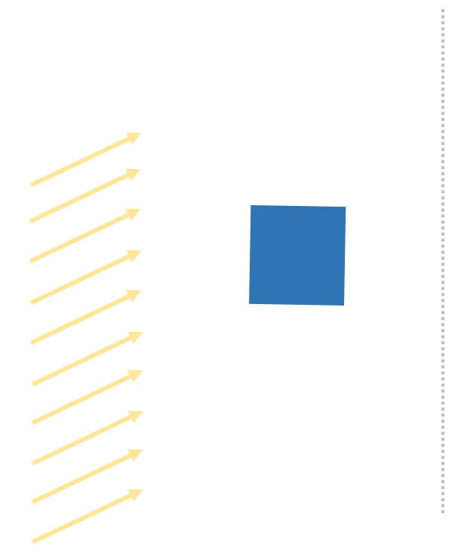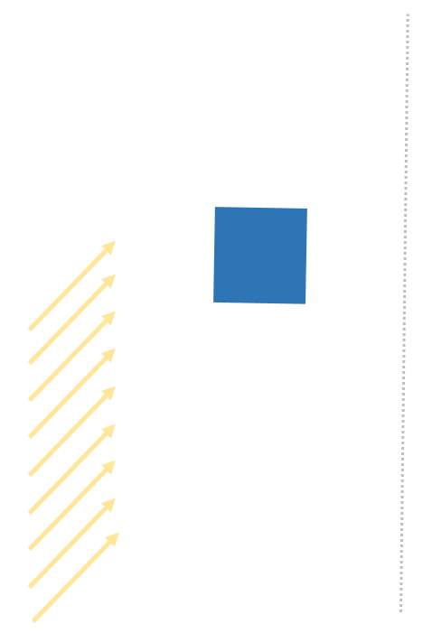

The size of the earth
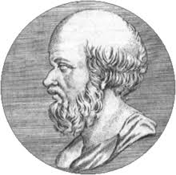
The true size of the earth was first worked out in a simple and ingenious way by a man named Eratosthenes, who lived in the city of Alexandria in Egypt in the third century B.C. He was an astronomer, historian, geographer, philosopher, poet, theatre critic and mathematician. He was also the chief librarian at the great library of Alexandria and one day while reading a papyrus book in the library he came across a curious account.

He read that at precisely noon on the longest day of the year, the shadows from temple columns or vertical sticks in the city of Syene would grow so short that they could not be seen. At that moment the sun was exactly overhead. It was an observation that someone else might easily have ignored - sticks, shadows, the position of the sun – what possible importance might they have? But Eratosthenes was a scientist and his contemplation of these homely matters changed the world. Because Eratosthenes has the idea to experiment, to actually ask whether a stick in his city of Alexandria, 800km north of Syene, would cast a shadow near noon on June 21st. And it turns out, they did.

Eratosthenes asked himself how it could be that at the same moment a stick in Syene would cast no shadow and a stick in Alexandria, 800km to the north, would cast a very definite shadow? The answer was that the surface of the earth is curved because it is a globe.

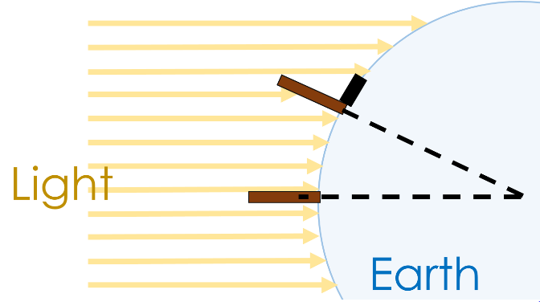
The sun is so far away that the rays are parallel when they reach the Earth. Sticks at different angles to the sun’s rays will cast shadows of different lengths. Not only did Eratosthenes prove that the earth was curved, he went on to deduce the circumference of the earth (the distance around its centre) from what he had seen. Eratosthenes knew the distance between Alexandria and Syene: 800km. How did he know this? Because he hired someone to pace out the entire distance so that he could perform his calculation. He used geometry to calculate the angle between Alexandria, the centre of the earth and Syene and used this to estimate that the circumference of the earth must be 40,000km. Amazingly, that’s the right answer – we now know that the circumference of the earth is 40,075km! Eratosthenes’ only tools were sticks, eyes, feet and brains plus a zest for experiment. With those tools he correctly deduced the circumference of the earth. That’s pretty good figuring for 2200 years ago!

Questions

- Why do you think that Eratosthenes, one of greatest minds of his generation, was working at a library?

…………………………………………………………………………………………………..

…………………………………………………………………………………………………..

…………………………………………………………………………………………………..
- What does the word geometry mean?

geo metry

……………………… ………………………………

Bringing the parts together, geometry means ………………………………………

…………………………………………………………………………………………………

- Draw how long the shadows would be along the dotted line (just like in the example on the left hand page) of the surface of the earth for these sticks in three different locations.

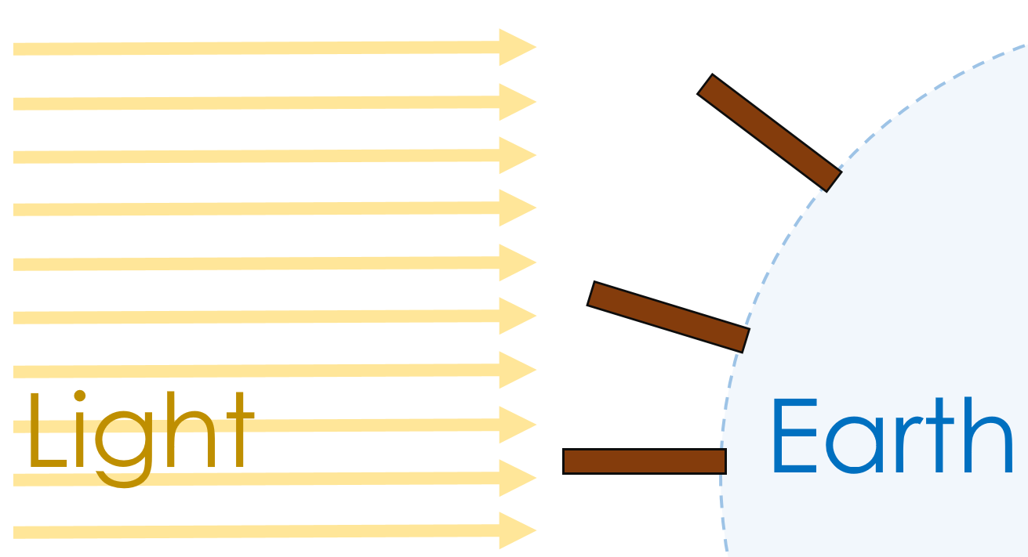

Objects in the universe

The universe as we see it comprises of billions upon billions of galaxies, each containing millions of stars and planets, as well as dwarf planets, asteroids, comets and nebulae. What are all of these objects? And which are bigger?
Biggest  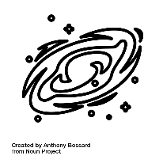  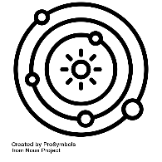  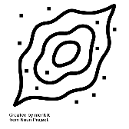  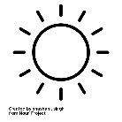  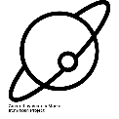  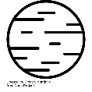  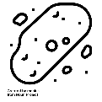    Smallest | Universe | The entirety of everything. The universe contains every object we know of.
 | Galaxy | A large collection of stars (each a possible planetary system of its own) that travel together through the universe. Our galaxy is the Milky Way.
 | Planetary system | The collection of objects that are attracted by gravity to the central star. We call our star system the solar system and it includes our star – the sun, the eight planets, five named dwarf planets, the asteroid and Kuiper belts.
 | Nebula | A collection of gas and dust that will eventually form a star.
 | Star | The luminous object at the centre of each star system. We call our star the sun.
 | Planet | The non-luminous objects that orbit a star.
 | Moons | The non-luminous objects that orbit planets.
 | Dwarf Planet | The non-luminous objects that orbit a star that don’t fulfil all of the planet criteria.
 | Asteroid | Generally lumps of rock and metal.
 | Comet | Generally lumps of ice and rock.

The order of the above table isn’t perfect. A moon will always be smaller than the planet that it orbits, but it might be bigger than some of the other planets in the same star system. Equally, some asteroids might be bigger than some moons.

The motion of the earth
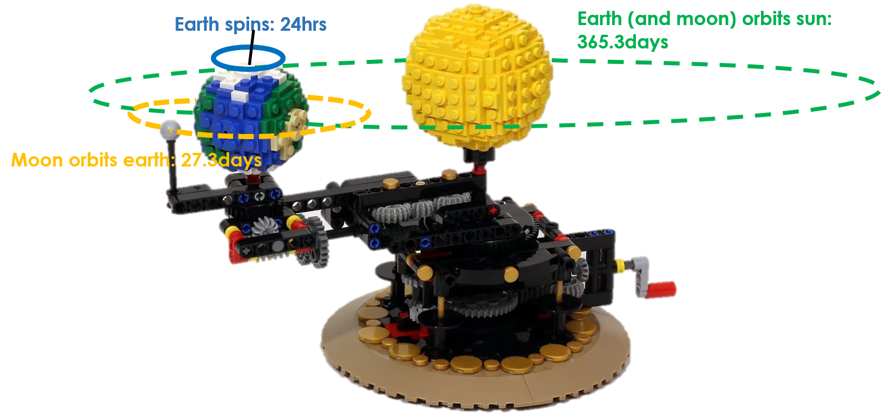

There is lots of motion happening at once in the solar system. The earth spins on its axis, taking 24hours to do so (this is not an orbit) – this gives us the length of the day. It’s daytime when the part of the earth that you’re on is facing the sun and it’s night time when it faces away. The moon orbits around the earth, taking 27.3 days to go the whole way around. This gives us the different phases of the moon: full moon, half moon, new moon etc. Finally, the earth orbits the sun, taking 365.3 days to go the whole way around. This gives us our year and the changing of the seasons.

Questions
- What motion of the earth gives us day and night?

…………………………………………………………………………………………………..

…………………………………………………………………………………………………..

- What motion of the earth gives us our year?

…………………………………………………………………………………………………..

…………………………………………………………………………………………………..

- Why might we say that the moon orbits two objects?

…………………………………………………………………………………………………..

…………………………………………………………………………………………………..

- What would I have to change to make the sizes a scale model of the sun, earth and moon?

…………………………………………………………………………………………………..

…………………………………………………………………………………………………..

…………………………………………………………………………………………………..

What is an orbit?
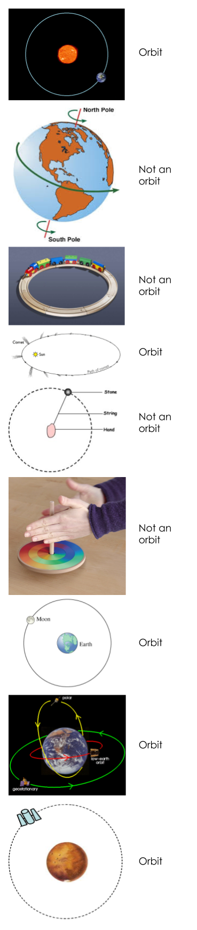

Orbits are not circles

Until 1609, astronomers believed that the planets travelled in circular orbits. It took a genius to calculate their actual paths - Kepler discovered that planets travel in ellipses. This was a problem for astronomers. No one understood what force could make the planets travel in elliptical orbits. At first, Kepler thought it might be magnetism, but this is not correct.
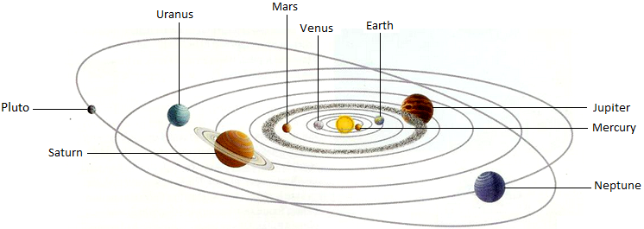

Note: this image is not to scale. In the real solar system:
- The orbits would need to be much larger.
- The planets would need to be much smaller.
- The ellipses would not be as stretched as this (that’s why it took a long time to realise the orbits were not circles.

Questions

- Write your own definition of what an orbit is.

…………………………………………………………………………………………………..

…………………………………………………………………………………………………..

…………………………………………………………………………………………………..

- Draw a line to show the path that the earth takes around the sun:

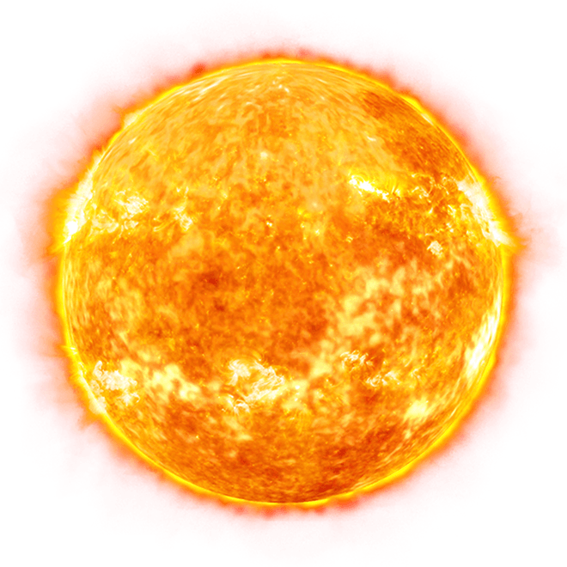



- In terms of scale, why is the diagram above not realistic?

…………………………………………………………………………………………………..

…………………………………………………………………………………………………..

…………………………………………………………………………………………………..

…………………………………………………………………………………………………..

…………………………………………………………………………………………………..

Exoplanets

When we look out at the night sky with our eyes, we see lots of stars. When we use telescopes, we can even see entire galaxies that each contain millions of stars. An exoplanet is a planet that orbits a distant star, just like the planets in our solar system orbit our star, the sun. One of the easiest ways to spot them is the effect they have on the light from the star when they move between the star and our (or our telescope’s) point of view.

As a planet moves in between us and a distant star, the light that hits the planet can no longer get to us – we are in its shadow. This means that if we measure the brightness of that star, it decreases (goes down) if a planet moves across it. This method of finding exoplanets is called the transit method.

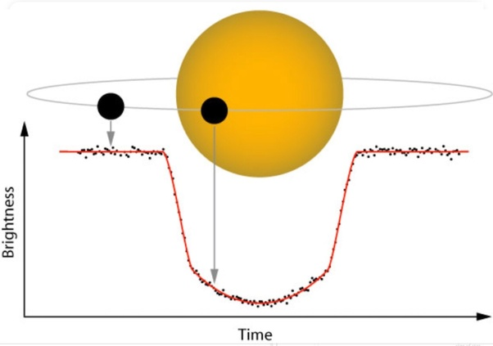

As a planet orbits its star, we see this same decrease in brightness happen over and over again at regular intervals.

From the size of the dip in brightness and the length of time for which it is dimmer, we can learn about the size and speed of the planet.

Questions
- Match the pictures with the different arrows – which part of the light curve is formed by which arrangement of planet and star?

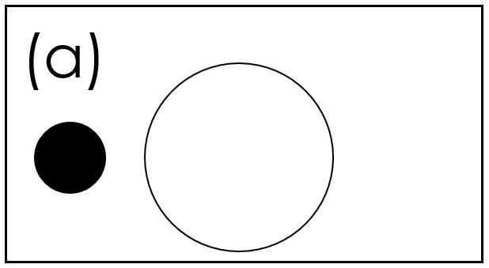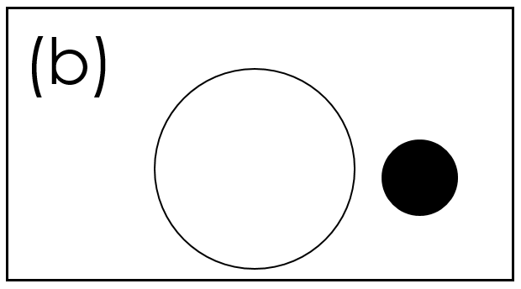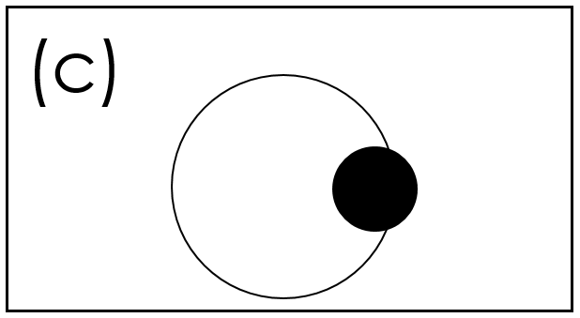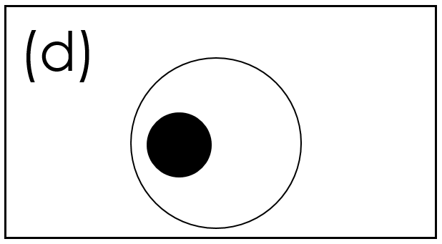
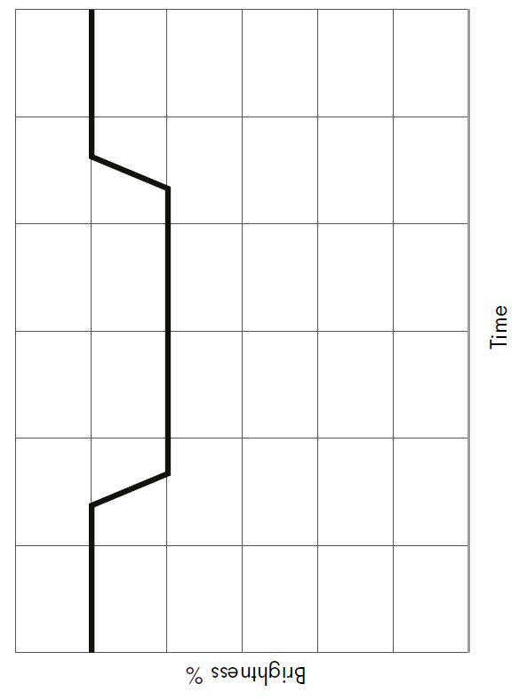
- Label what is happening in this light curve – the arrows are in different places now.

- Describe what happens to the amount of light we measure when an exoplanet orbits its star. Your answer should include the words orbit, brightness, increase, decrease.

…………………………………………………………………………………………………..

…………………………………………………………………………………………………..

…………………………………………………………………………………………………..

…………………………………………………………………………………………………..

…………………………………………………………………………………………………..

…………………………………………………………………………………………………..

…………………………………………………………………………………………………..

- Add on a light curve to show an exoplanet that is bigger than this one
- Add on a light curve to show an exoplanet that is faster than this one
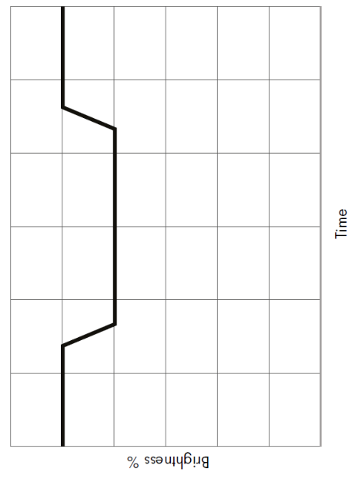
- When astronomers take their measurements, they are only sure that they have found an exoplanet when they see a dip in the brightness that happens are regularly spaced intervals like this:
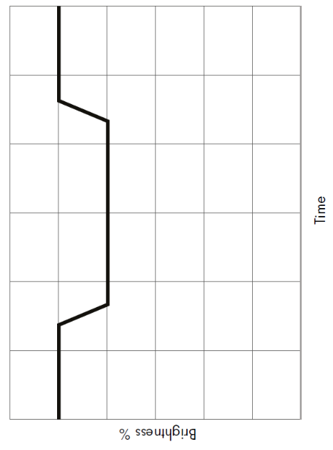
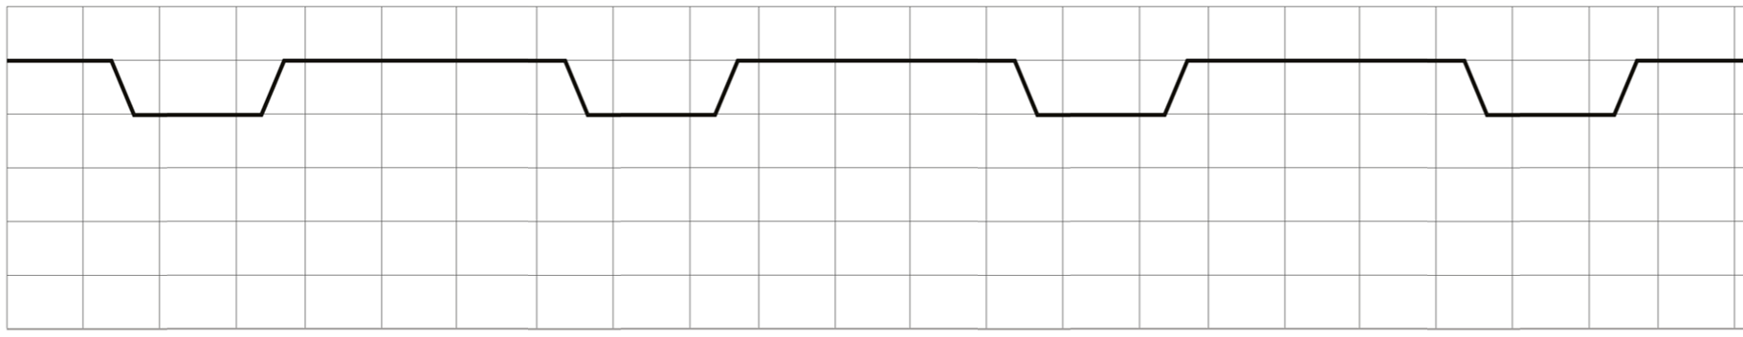

Why are astronomers looking for regularly spaced drops in brightness?

…………………………………………………………………………………………………..

…………………………………………………………………………………………………..

…………………………………………………………………………………………………..

…………………………………………………………………………………………………..

…………………………………………………………………………………………………..

- Each square on the graph above represents 30days. Estimate how long the planet is in front of its star for:

…………………………………………………………………………………………………..

…………………………………………………………………………………………………..

…………………………………………………………………………………………………..

…………………………………………………………………………………………………..

- How long does it take the planet that created the transit graph above to orbit its star?

…………………………………………………………………………………………………..

…………………………………………………………………………………………………..

…………………………………………………………………………………………………..

…………………………………………………………………………………………………..

Quiz

How does light travel?
What do we call an object which emits (gives out) light?
What is the dark region called behind an object where there is no light?
Why do we call space ‘space’?
What is the shape of the earth?
What movement of the earth gives us day and night?
What is an orbit?
Why is it hard to make a scale model of our solar system?
What movement of the earth gives us our year and the seasons?
What shape are orbits?
What does a moon orbit?
What is an exoplanet?
Exoplanet A is twice as big as exoplanet B. Which exoplanet will be easier to notice by the transit method?
What do astronomers use to look at the light from distant stars?

