John Johnson (2014), Warm planets orbiting cool stars, Physics Today, Vol. 67, Issue 3, p. 31
The article can be accessed at https://physicstoday.scitation.org/doi/10.1063/PT.3.2309 During the COVID-19 pandemic, you can access the entire Physics Today back catalogue for free just by registering. You’ll need to register (just requires an email address) to get the PDF of this paper.
You can also download the Cornell notes template for this paper (which includes the same questions) as a Word Document or PDF. Teachers, feel free to download this and forward it on to your students.
This week we’re looking at another, different style of article. This is a popular science article but for a specialist physics magazine: Physics Today. The magazine is published by the American Institute of Physics and is aimed at physics specialists but to broaden their picture of the research that is taking place in different fields, so each article allows for a broad audience but gives enough detail to keep specialists interested. This makes it the perfect magazine for us, as keen physicists in training.
We’re going to move forward with our Harvard notetaking too, by making the notetaking more in keeping with how you might use it in a lecture. Rather than questions down the left-hand column, I’m just going to give you some shorter prompts. These will often be definitions. For each section, I’ll then write one or two summary questions.
As a little bit of extra help, this link gives a nice guide to the basic techniques used for exoplanet detection: https://www.planetary.org/explore/space-topics/exoplanets/how-to-search-for-exoplanets.html
INTRODUCTION
M⊙ is the symbol use for a solar mass (the mass of the Sun).
(P1, C1&C2) Red dwarf
(P1, C1) Radiative diffusion
(P1, C1) Hydrostatic equilibrium
(P1, C1) Luminosity
(P1, C1) Luminosity scaling with mass.
(P1, C2) Black body
(P1, C2) Exoplanet

INTRODUCTION SUMMARY QUESTIONS
Why are red dwarfs significantly fainter than the Sun?
Why have astronomers focussed their attention on sun-like stars when looking for exoplanets rather than red dwarfs?
What information can you extract from the graph shown in Figure 1 (take note of the unusual x-scale).

EARLY DISCOVERIES
(P2, C1) Barnard’s star
(P2, C1) Light year
(P2, C1) Proper motion (HINT: really think about the diagram at this link)
(P2, C1) Van de Kamp’s wobbles
This image may be useful for some of the ideas in P2, C2
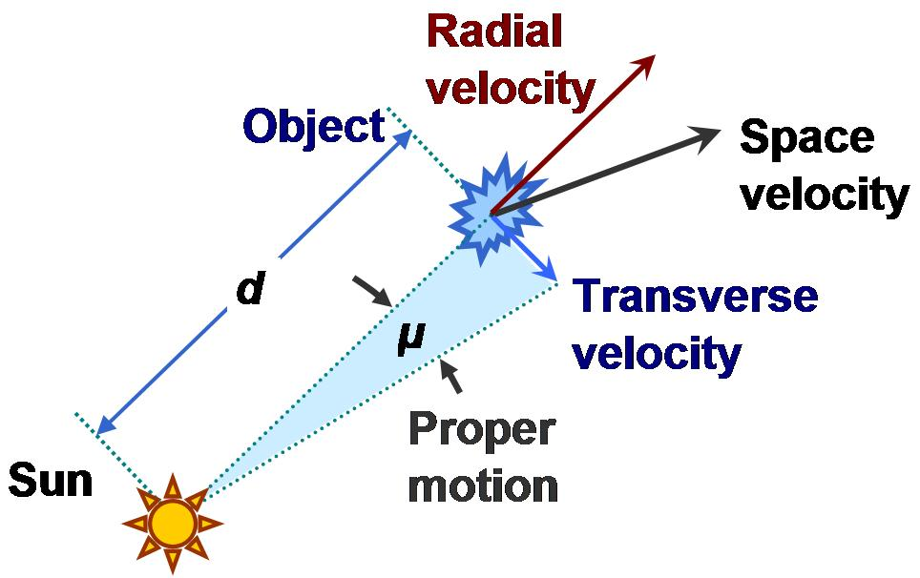
Taken from Wikipedia https://en.wikipedia.org/wiki/Proper_motion
(P2, C2) Plane of the sky
(P2, C2) Doppler shift
(P2, C2) Spectral lines
(P2, C2) Does Barnard’s star have planets orbiting?
(P2, C2) Gl 876
(P2, C2) Astronomical unit
(P2, C2) Gl 876b and Gl 876c
(P3, C1) Protoplanetary disc
(P3, C1) Super earth
(P3, C1) Observational bias

EARLY DISCOVERIES SUMMARY QUESTIONS
Why do astronomers need to use two different techniques to measure the velocity of an astronomical object through the universe?
How do astronomers use spectral lines?
How are planets detected around red dwarfs?
Why are gas giants rare to find orbiting red dwarfs?

MICROLENSING
(P3, C1) Curving of spacetime
(P3, C2) Microlensing (this GIF might help. It’s also helpful to think of it in terms of brightness, I find).
(P3, C2) Einstein ring

MICROLENSING SUMMARY QUESTIONS
What happens to the brightness of a source star as a lens star moves across our line of sight?
How might a planet, if placed in a fortuitous position, alter this lensing by the lens star?
Why is the microlensing technique biased towards finding heavier planets?

TRANSITING EXOPLANETS
(P4, C1) M Dwarf
(P4, C1 & C2) Transit method
(P4, C1) GJ 1214 and GJ 1214b
(P4, C2) Habitable zone

TRANSITING EXOPLANETS SUMMARY QUESTIONS
Why is an earth sized planet easier to detect if orbiting a red dwarf?
Why is it easier to detect planets in the habitable zone around red dwarfs than sun-like stars?

(You’ll need to read part of the next section to answer this). What are the downsides of using ground-based telescopes to find exoplanets with the transit method?

KEPLER’S RED DWARF CENSUS
(P4, C2) Kepler space telescope
(P4, C2) CCD

KEPLER’S RED DWARF CENSUS SUMMARY QUESTIONS
What advantages does Kepler have over ground-based methods?
Why can Kepler make more accurate measurements of the transits of planets around brighter stars?
What difficulty do red dwarfs present when hunting for planets?

STELLAR SPECTRA
(P5, C1) Absorption lines
(P5, C2) Parallax measurements
(P5, C2) Metallicity

STELLAR SPECTRA SUMMARY QUESTIONS
Why are the properties of red dwarfs not as well understood as sun-like stars?
How do astronomers deduce the mass of a red-dwarf?

A MINIATURE
(P6, C1) Kepler 42

A MINIATURE SUMMARY QUESTIONS
What does Figure 5 show?
What do studies of red dwarf systems suggest about Earth-like planets?

FROM HUNTERS TO GATHERERS SUMMARY QUESTIONS
Why will the next generation of planet hunting instrumentation likely be tailored towards the infrared portion of the electromagnetic spectrum?
How will astronomers look for life on planets they think have potential?

SUMMARY QUESTIONS (submit these, along with your SKIM-READ answers to thomas.millichamp@warwick.ac.uk)
Why do you think red dwarfs are such an interesting area of research?
Discuss the different ways in which astronomers use spectral lines.

Compare the techniques of microlensing and transit photometry for finding exoplanets.

FURTHER READING
NASA have an entire website devoted to exoplanets at https://exoplanets.nasa.gov/
Our very own Dr. David Brown has created a workshop that includes loads of links to tools to enhance what we’ve looked at here https://warwick.ac.uk/fac/sci/physics/research/astro/people/dbrown/transitworkshop/
The article mentions the TESS experiment towards the end, you can learn more about that here https://tess.mit.edu/
If you are interested in learning more about exoplanets, there are some great popular books on exoplanets (e.g. The Planet Factory: Exoplanets and the Search for a Second Earth by Elizabeth Tasker) and I’ve been given a list of textbooks by Professor Dan Bayliss if you would like something that is at a truly advanced level:
- How Do You Find an Exoplanet? (Princeton Frontiers in Physics) by John Johnson (the author of the paper this week)
- Transiting Exoplanets by Carole Haswell
- Exoplanets (Space Science Series) by Sara Seager

