G. Binnig and H. Rohrer (1999), In touch with atoms, Reviews of Modern Physics, Vol. 71, No. 2
The article can be accessed at https://www.researchgate.net/publication/238552666_In_Touch_with_Atoms (Click the ‘Download full-text PDF’ button and a download should start without having to sign up).
You can also download the Cornell notes template for this paper (which includes the same questions) as a Word Document or PDF. Teachers, feel free to download this and forward it on to your students.
This week’s article focusses on local-probe microscopy. The authors, Binnig and Rohrer, are two of the key figures in the development of the popular nanoscale probes the scanning tunnelling microscope (STM) and the atomic force microscope (AFM). They won the 1986 Nobel Prize and what we’re reading here is the Nobel acceptance paper (much like the graphene one we previously read). These techniques began life as imaging techniques and there’s a beauty in their simplicity. As the techniques have evolved (particularly the STM) they have been able to do more than simply scan a surface, but can now manipulate nanoscale objects. The methods have become easier to use over time so that now, undergraduate students have access to them and can achieve atomic scale resolution in an afternoon of using them!
We’re going to start with a skim read. Don’t worry if it doesn’t make complete sense, or if you skim some sections quicker than others as you’re feeling uncomfortable with them, that’s fine.
This week we’d like you to come up with about three SKIM-READ QUESTIONS that you felt you needed to answer to allow you to understand as much as possible on a second read through.
Why do physicists often argue that two objects never really ‘touch’?
What is a wavefunction?
What is quantum mechanical tunnelling?
What are piezoelectric tubes?
Acronyms and initialisms in this paper:
AFM | Atomic Force Microscope
SNOM | Scanning Near-field Optical Microscope
STM | Scanning Tunnelling Microscope

ABSTRACT
What is the rough size of an atom?
What is the rough size of a water molecule?
What do they mean by the term ‘local probe’?
At the scale of atomic structures, what will local probes be able to sense?

BACK TO THE FUTURE OF MECHANICS
(P1, C1) What do the authors mean by the term ’electronics’?
(P1, C1) What do the authors mean by the term ‘mechanics’?
(P1, C1) Why do the authors consider the atomic cores to be, at best, the ‘guardian of the electron’?
(P1, C1) Why might you argue that atomic cores are much more than the ‘guardian of the electron’?
(P1, C1) What can a Scanning Tunnelling Microscope (STM) do?
(P1, C1) Analyse the individual words of the phrase ‘The STM is a mechanically positioned, electrically sensitive kind of nanofinger’ to understand what an STM is.
(P1, C1) Looking at Figure 1, how might you improve your earlier definition of ‘local probe’?
(P1, C1) What does ‘inhomogeneity’ mean?
(P1, C1) What had been the focus of condensed matter physics?
(P1, C1) Why do we consider an inhomogeneity to be a local phenomenon?
(P2, C1) Why would such a small local probe (atomically thin) need a ‘high precision nanodrive’ when scanning a material?
(P2, C1) What are ‘continuous and reproducible displacements’?
(P2, C1) Why is good vibration isolation necessary?
(P2, C1) Why does the concept of contact blur when we get to the nanometre level?
(P2, C1) What does resolution mean in the context of creating an image?

Before you read the paragraph that begins ‘In STM, the interaction can be described…’, we need to get a more basic understanding of how an STM works. Read this brief article from ‘How an STM Works’ now. The diagram below may also be useful. ‘Describe how an STM works’ will be one of our summary questions this week, so draft out an initial answer now.
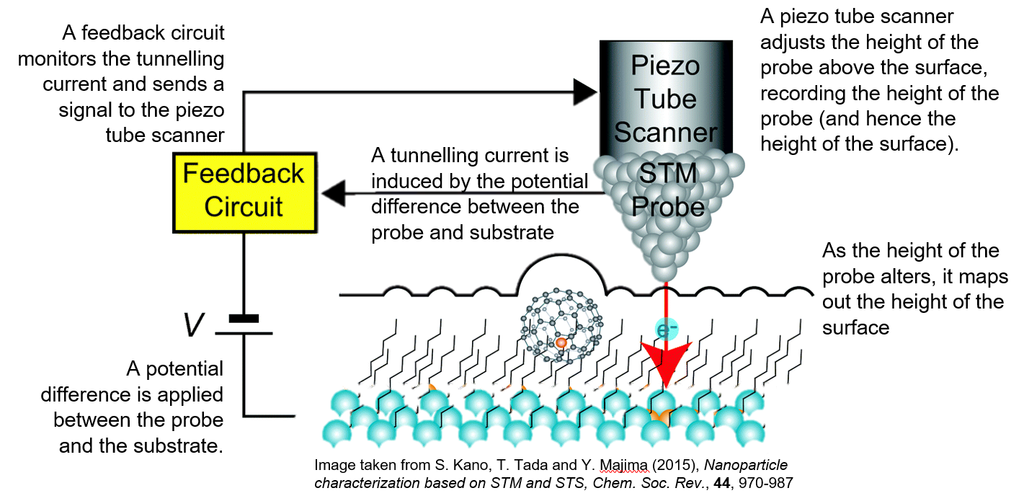
(P2, C1) As the scanning tip (or probe) gets further from the surface of a material, what happens to the tunnelling current?
(P2, C1) What is the rough estimate of the decay length for most tip/sample combinations?
(P2, C1) Why would the STM be less effective if the decay length was longer?
(P2, C1) Why do the authors state that ‘atomic resolution was inevitable’?
(P2, C1) Why do you think that thermal fluctuations (think of these for now as random fluctuations in the movements of atoms in the material) of atoms in a lattice can be ‘averaged out’?
(P2, C2) What is meant by describing an STM as ‘an electronic-mechanical hybrid’?
(P2, C2) What is the constant interaction/mechanical mode of an STM?
(P2, C2) How else can an STM be operated? What are the limitations?
The article discusses a ‘magical Si(111) 7x7 reconstruction’ which was used to persuade the community that the STM was a powerful tool. This image can be seen here.

II. COLOURFUL TOUCH
(P2, C2) What do the authors mean by the term ‘colourful touch’?
(P3, C1) What are the two main reasons for using an STM?

Due to the STM using a tunnelling current to ascertain where the surface is, an accurate topography of a surface relies on the electronic structure of the surface remaining constant. In the simplest case, if we imagine a hypothetical smooth surface that is in one location metallic whilst insulating in another then an STM not going to register this surface as smooth and continuous (in fact, it won’t register the insulating surface at all). This property of tunnelling current – that it samples the local electronic properties of a surface – can actually be useful, though, as the authors take note of in (P3, C1)
(P3, C1) What is the downside of the slightly more recent Scanning Near-field Optical Microscope (SNOM) compared to the STM?
(P3, C1&2) What is an advantage of the atomic force microscope (AFM) over the STM?
(P3, C2) What are van der Waals forces? We looked at this very briefly in a previous week whilst discussing Gecko tape.
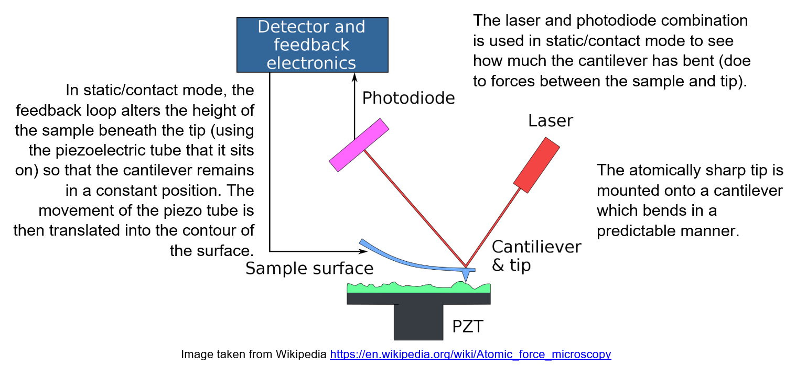

(P3, C2) What are the two operating modes of an atomic force microscope (AFM)? Describe them briefly.
(P3, C2) Why is the AFM ‘more mechanical in nature’ than the STM?
(P3, C2) Given that the usage of the cantilever is based upon Hooke’s law, discuss some of the practicalities that might be involved in choosing a cantilever.
(P3, C2) We have met this idea before, but what is microfabrication?
(P3, C2) Why is it difficult to achieve atomic resolution with an AFM?
(P3, C2) Why are AFMs not typically operated in air?
(P4, C1&2 and Figure 2) What does Figure 2 show? Why is it remarkable? (This will be one of our summary questions this week)

III. CHANGE AND CHALLENGE
“They are fragile individuals, whose properties and functions depend strongly on their context and which are usually quite different from those in the isolated state.” This quote will be used in one of our summary questions this week. For now, just take a few moments to really think about what the authors might mean by this.
(P4, C2 and P5, C1) Why isn’t the STM strictly non-invasive?
(P5, C1) How has the invasive nature of STM been used to advance the technique?
(P5, C1) How can working in a liquid environment be beneficial (or why is the liquid-solid interface thought by the authors to be the interface of the future)?

Around now the authors begin to dig into some of the more advanced applications of local-probe microscopy. We won’t have any questions on this part, but it would be very beneficial to carry on reading this section to see how the STM and AFM develops from a tool to look and manipulate atoms to more exotic ventures.
IV. NATURE’S WAY
(P6, C2) Why do the authors draw links between the local probe microscopy techniques and nature itself?

SUMMARY QUESTIONS (submit these, along with your SKIM-READ answers to thomas.millichamp@warwick.ac.uk)
How does a Scanning Tunnelling Microscope (STM) work?
What does Figure 2 show? Why is it remarkable?
“They are fragile individuals, whose properties and functions depend strongly on their context and which are usually quite different from those in the isolated state.” This is the description of atoms, molecules and nanometer-sized objects given in III. Change and Challenge. What does this quote bring to your mind about the atomic world?

FURTHER READING
This page at IBM gives a great background on the STM and the impact it has had and continues to have on modern technology
https://www.ibm.com/ibm/history/ibm100/us/en/icons/microscope/
This page gives a good background on the AFM
https://www.nanoscience.com/techniques/atomic-force-microscopy/

