I. Timokhin & A. Mischenko (2016). Novel approach to Room Temperature Superconductivity problem.
https://arxiv.org/abs/2003.14321
This paper is not printed in a peer-reviewed journal but is instead on the Physics arXiv (pronounced archive). The arXiv is an open-access repository of papers that have been moderated but haven’t gone through the peer-review process of a journal. Many papers on the arXiv are first drafts of papers to show the scientific community that the work has been done whilst the manuscript goes through the (sometimes lengthy) process of peer review.
The arXiv is full of amazing papers, but we must be even more cautious about information found here as it has not been thoroughly checked and may, therefore, be wrong. This paper is on the arXiv, though, as it is a more light-hearted paper and will almost certainly not be acceptable to a scientific journal.
Last week, we discussed how the author list works, with the superscript number next to each author corresponding to the institution that they work for. This week, you’ll see that the authors are working from home during the COVID-19 pandemic, and as we shall see, are clearly working in their kitchen.
ABSTRACT
Remember, the abstract is a short summary of the main findings of the paper. Scientists use them to work out whether or not they need to read the rest of the paper.
What is T_{C}?

What novel approach have the authors taken?

Why should we be wary of papers on the arXiv that propose a ‘novel approach’?
One of the things we often have to do when reading papers is to follow a reference or look up a concept you don’t already know about so that you can fully understand a piece of work. As you do this, more and more tabs open on your computer and you might start to feel a bit lost in the web of references, and ultimately forget what you’re looking for in the first place.
If, after a bit of reading, if you notice that you’re feeling the urge to start tracking down more than just the odd fact, then stop and write down exactly what you’re hoping to find out. If you’re going to start trawling through literature and the rest of the internet, then you need a bit of direction. This is where Cornell notes are so useful. This is what to do:
- Skim read the entire article and highlight or list bits that you don’t know about. It’s absolutely fine to not understand things – it may even be the authors fault for not being clear.
- Phrase these ideas into a few prompt questions in Cornell notes. The questions should be written to maximise the amount of the article that you’ll be able to understand afterwards.
- Google or use the references in the text to find answers to your questions and write them in your own words in as succinct a form as possible.
- Your answers might not be completely perfect, but they will hopefully get you to a better understanding of the paper. The next time the same concepts appear in your reading, you’ll learn a little more and a little more.
The key thing is that you can’t become an expert in a field overnight. It takes prolonged exposure to ideas in multiple different circumstances. It could take a lot of time, particularly at this stage in your education, trying to gain a complete understanding of just one idea within this article. But you’re not expected to have a complete understanding yet – we need to learn enough to get by to gain further exposure.
At this point, skim read the entire article, thinking about what questions you have.
Our suggested questions would look something like this
- Why do superconductors have a superconducting transition temperature?
- What are the behaviours that indicate an object is in a superconducting state?
- What is the Meissner effect?
- What is flux locking (also known as quantum locking)?
Here, we’ve done the next bit for you which is to proceed to answer the questions you’ve written by doing a bit of research. Below is just an example of what you might write. Added in brackets after each answer are the places we found the information – note that we didn’t just use Wikipedia, we always verified any information we found there by checking a non-editable source of information. But Wikipedia is an excellent resource if used carefully, just like the arXiv.
Under each example answer that’s been written for you, write down an answer in your own words to the same question, using the references that we’ve found. Here we’re trying to break the process down for you so you don’t waste time doing your own Googling right now – we just want you to concentrate on reading the information and synthesising a simple answer.
1. Why do superconductors have a superconducting transition temperature?  2. What are the behaviours that indicate an object is in a superconducting state?  3. What is the Meissner effect?  4. What is quantum locking (also known as flux pinning)? | Much like cooling water so that it forms ice (a transition that occurs at a specific temperature, the melting point: 0ºC), superconductivity is a phase of matter that occurs below a specific temperature (the superconducting transition temperature). In water and ice, the transition alters the intermolecular bonds between water molecules. In the superconducting transition, it’s a transition in the way that the electronic structure (the electrons) behave. Once cooled, the electrons behave as if there’s no electrical resistance within the material (from the lattice). For conventional superconductors, the reasons for this are understood (the electrons form Cooper pairs), but there are a group of superconductors – the high temperature superconductors – where the mechanism for the electrons’ pairing remains unknown.  To form this answer we read the first couple of paragraphs of this:  https://en.wikipedia.org/wiki/Superconductivity#Phase_transition  And we read about half of the superconductivity section (Section 21-5) of this  https://www.feynmanlectures.caltech.edu/III_21.html  (The online Feynman lectures are a great resource by the way).  Your own answer:  The superconducting transition is highlighted by abrupt changes in the materials resistivity and its specific heat capacity (a so-called phase transition). In its superconducting state, a superconductor has zero electrical resistance (which makes it useful for lossless transmission of electrical currents). A ‘perfect conductor’ would also display zero resistance but what sets a superconductor apart from a perfect conductor (as well as the abrupt phase transition) is the Meissner effect.  We read this  http://www.chm.bris.ac.uk/webprojects2006/Truscott/paged_r.html  And this  https://en.wikipedia.org/wiki/Superconductivity#Elementary_properties_of_superconductors  Your own answer:  The sudden expulsion of a magnetic field from within the bulk of a superconductor when cooled below its superconducting transition temperature. As soon as the temperature is below T_{C}, a superconductor instantly ejects a magnetic field from within its bulk (the magnetic field does penetrate a small distance into the material – the London penetration depth).  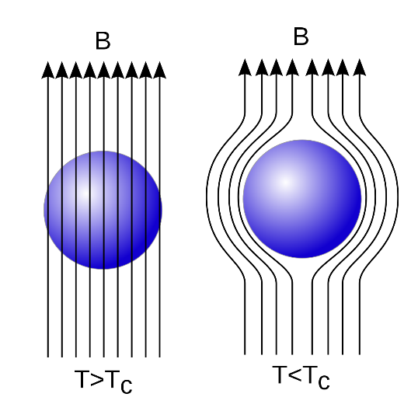  Taken from  https://en.wikipedia.org/wiki/Superconductivity#Meissner_effect  And  https://www.open.edu/openlearn/science-maths-technology/engineering-technology/superconductivity/content-section-2.3  Your own answer:  Imagine we have a superconductor that is held below its superconducting transition temperature so that it is in its superconducting state. The superconductor is placed within a magnetic field and the strength of the magnetic field can be altered. Above a certain field strength a ‘type-I’ superconductor will stop being superconducting – it will go through a phase transition (just like it did with temperature) to a non-superconducting state. A ‘type-II superconductor’ behaves differently and above a certain field, it no longer expels all of the magnetic field, but allows the magnetic field to enter the bulk and penetrate the material in the form of ‘flux tubes’ (simply cylindrical regions of the superconductor that now allow a magnetic field to pass through). These regions are fixed in place within the superconducting material (but change in number if we alter the field). These tubes act to literally pin the superconductor where it is relative to the applied magnetic field – allowing you to turn the magnet upside down and have the superconductor stay in place now ‘hovering below’ the magnet.  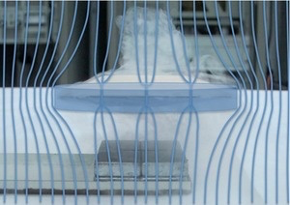  We got this from  https://en.wikipedia.org/wiki/Flux_pinning  And definitely watch the following video (and ignore the manic laughing)  https://www.youtube.com/watch?v=Z52_2WGCJak  Your own answer:

Now that we've researched the few concepts that underpin the majority of this paper, you should now be in a much better position to understand most of the article. You might still not appreciate the entirety of the experimental setup, but you should understand the general idea of what they’re doing (and begin to understand the joke behind the paper).

We now want you to read the article in more detail now, and just as we’ve done in previous weeks, answer the comprehension questions for each section as we go along.

INTRODUCTION
You’ll see scientists use their own abbreviations quite frequently, and let you know what they are by including them in brackets after the first use of the term. What does RTS stand for here?

What is the Kelvin scale of temperature? If room temperature is generally considered to be 295K, what is this in degrees Celsius?

Looking at the chemical compostion of the rare-earth superhydride LaH₁₀, why are they called rare-earth superhydrides?

Superhydrides have some of the highest T_{C} values found so far. What is their disadvantage?

The formula for pressure is P=F/A where F is the applied force and A is the surface area over which it’s applied. To achieve high pressures, what are the two things we could do?

What is one of the reasons LaH₁₀ needs to be under high pressure?

Why might it be difficult to measure the Meissner effect within a diamond anvil?

What does the abbreviation YBCO stand for?

Convert the superconducting transition temperature of YBCO (92 K) to ºC.

Liquid nitrogen has a boiling point of –196 ºC (77 K), why is this a useful fact for their experiment?

MATERIALS AND METHODS
What are the scientists actually cooling? (Figure 1C)

Why do they use thermal grease to attach the YBCO to the room initially?

What is a ‘field cooling’?

Why might the base temperature (80 K) be higher than the boiling point of liquid nitrogen (77 K)?

Why do they evacuate the room down to a pressure of 10⁻³ mbar?

RESULTS AND DISCUSSION
In Figure 2 A and B we see an abrupt change in behaviour (when the temperature changes from below to above T_{C}) - why is this important?

Why is the term equilibrium important to this scenario of an object freely ‘floating’?

What are differences in the forces that the superconductor experiences in Figure 2A and the magnet experiences in Figure 2C that allow them to ‘float’?

Why do they also need to perform the experiment upside down (note that the magnet is now suspended in Figure 2 C-F)?

In Figure 2 D and E, why has the magnet moved slightly?

Why does the magnet move back to its original position in Figure 2 F?

SUMMARY (send your answers to thomas.millichamp@warwick.ac.uk)
This week, rather than summarising the paper (as hopefully you can see that the paper is really only humorous), you’re going to follow the approach that we took during this paper of finding and answering the key questions needed to understand the majority of a scientific work.
For this paper, we skim read the whole piece and decided that we needed to know answers to the following questions to get a good comprehension of the article:
- Why do superconductors have a superconducting transition temperature?
- What are the behaviours that indicate an object is in a superconducting state?
- What is the Meissner effect?
- What is flux locking (also known as quantum locking)?
We then researched answers to these questions and wrote them in our own words.
You’re going to do the exact same thing for a different article this week to show that you can find the key relevant background knowledge. We want you to do the following:
- Skim read this article (J. M. A. Chawner et al. (2019), LEGO® Block Structures as a Sub-Kelvin Thermal Insulator, Scientific Reports, 9, 19642)
- List between three and five key questions on the background information that the reader (you) needs to know to attempt to understand the piece.
- Find answers to these questions, writing them in your own words but also giving your sources (simply as links, not using full referencing technique for now)

Submit these to thomas.millichamp@warwick.ac.uk and the best questions and answers will be published on the website next week (along with the answers to all of the comprehension questions above).

Further reading
This article outlines some of the current research towards finding a truly ‘room temperature’ superconductor (that is one where the superconducting state occurs at a normal room temperature, not where we cheat and cool the entire room instead!)
https://www.nature.com/articles/d41586-019-01583-y

