Physics Building
P124
Emergency Response Plan
- Emergencies
- Emergency Responses
2.1 Emergency Response Maps
3. Emergency contacts
- Revisions and Changes
Last revised: 20/09/2023

Table of Contents
1. Emergencies 3
2. Emergency Response – Fire 4
2.1 Emergency Response – Fire Map 5
2. Emergency Response – Gas 6
2.1 Emergency Response – Gas Map 7, 8
2. Emergency Response – Electrocution 9
2.1 Emergency Response – Electrocution Map 10
2. Emergency Response – Chemical Spill 11
2.1 Emergency Response – Chemical Spill Map 12
2. Emergency Response – Flooding …………………………………………………………………………………………………………………………………………………………………………………………………………………… 12
2. Emergency Response – LEV failure …………………………………………………………………………………………………………………………………………………………………………………………………………… 13
3. Emergency Contacts 14
4. Revisions and Changes 15

1. Emergencies

The following situations are emergencies:
- Fire in the laboratory, or elsewhere in the building.
- Gas leak/gas alarm in the laboratory or elsewhere in the building.
- Electrocution of a person in the laboratory.
- Chemical spillage or toxic hazard occurring within the laboratory or elsewhere in the building.
- Flooding in the laboratory, or elsewhere in the building.
- LEV Failure in the laboratory (P128 only).
The following situation requires action:
- Magnet Quench in the lab, or elsewhere in the building.

2. Emergency Response
Initial Response to ALL Emergencies:

Assess the situation
- Assess the emergency, be prepared to evacuate the laboratory.
- If the nature of the emergency puts anyone in the lab at risk of harm, evacuate the lab immediately and call the campus security.
- If the emergency can be controlled without personal risk, deal with the incident following guidance below (“Incident Emergency Response”)

Emergency | Assessment | Emergency Response
Fire in the lab | - If the fire can be controlled without personal risk. | Immediate response if the fire cannot be extinguished by a trained competent person on site or anyone is at risk of harm:  - Evacuate the laboratory.  - Sound the fire alarm.  - Activate any emergency stops.  - Evacuate the building.  Call the campus security gatehouse on ext. 22222  (024 765 22222)*  IF the fire can be extinguished then for an equipment or material fire:  - Use the correct fire extinguisher or fire blanket to attempt to extinguish the fire.  DO NOT ATTEMPT TO TACKLE A FIRE IF UNCONFIDENT
2.1 Emergency Response Map for Fire


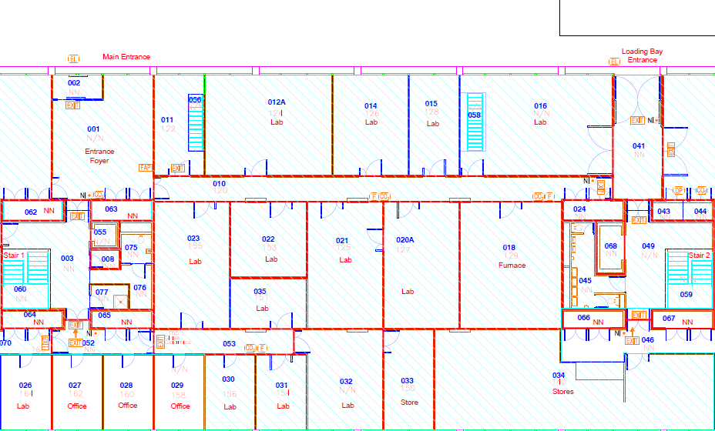
Fire Extinguisher or Fire Blanket Locations
Ground Floor
Emergency Door Release
Fire Alarm Sounder
Route to nearest fire exit
Emergency | Assessment | Emergency Response
Gas leak and general alarm  within the building | Listen for the building alarm and take immediate action.  This will be most audible in the laboratories where the O2 depletion sensors are located.  Enter location: P125, P126, P127, P128, P130  An independent portable O2 depletion sensor should be used when checking a room’s O2% if the room could not be ventilated upon exit.  The person checking should be wear self-contained breathing apparatus (SCBA) and any other PPE relevant to the hazards of the space. | On hearing a continuous alarm in the building:  - Evacuate the laboratory and try to increase ventilation where possible (including opening doors between the affected room and the outside, e.g. the Loading Bay).  - Check the O2 depletion sensor control panel if it is safe to do so, to see if there are any faults or false alarms.  - Contact the Space Owner who will escalate as needed and communicate with relevant competent personnel to establish the next steps.  DO NOT ENTER A ROOM IF YOU SEE A PERSON LAYING UNCONSCIOUS, YOU COULD BE NEXT!
2.1 Emergency Response Map for Gas Leak
Ground Floor
N2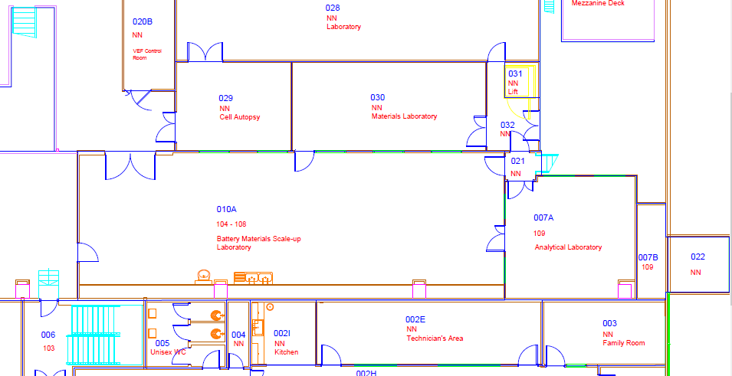

N2

Nitrogen line outlet
CA
R

R

R

R

CA
R

R

O2

O2

O2

O2

O2

CP

Control Panel for O2 depletion sensors/alarms
O2 depletion sensors/alarms (3 per location at different heights)
O2

R

CA
Gas regulator locations
Compressed air regulator locations
Route to gas cages
Key
Emergency | Assessment | Emergency Response
Electrocution in the lab | Recognise the signs of electrocution, any or all of:  - Collapse.  - Possible convulsion.  - Possible burning smells.  - Possible associated equipment power cut, sparks, smoke. | If safe to do so without touching the victim or equipment in contact with the victim:  - Switch off the power to any appliance that the person is in contact with at the wall or socket.  - Use safety hook to disengage the person from the live equipment.  FIRST AID:  - Call the campus security gatehouse on ext. 22222  (024 765 22222)*  - DEFIBRILLATOR ON SCIENCE CONCOURSE.  DO NOT APPROACH OR TOUCH THE VICTIM! YOU WILL ALSO BE ELECTROCUTED IF YOU TOUCH THE PERSON OR EQUIPMENT
2.1 Emergency Response Map for Electrocution

Ground Floor
Key


Defibrillator locations:
Physics Concourse
D
Electrical Safety Hook
S
Defibrillator
D
Route to Defibrillator
Emergency | Assessment |  | Emergency Response
Chemical Spillage/toxic hazard | A chemical spill would most likely occur when handling containers of liquid or large jars of powders.  ** Check the COSHH and SDS for powders on the suitable clean up protocol (brushes are usually not recommended for powder spills for the chance of making airborne particles). |  | Chemical fumes or extensive spillage or hazard  If the chemical spill has not contacted a person:  - Evacuate the laboratory (or building as appropriate) and place barriers to prevent re-entry.  - Inform the Principal Investigator, Space Owner and Technical Services Manager of the incident.  - Check the COSHH assessment and the SDS for the chemical that has been spilt. Follow the clean-up procedure wearing the appropriate PPE*.  - Use the chemical spill kits available in P128 or P162 (Robb Johnston to contain and clean up the spills if a liquid chemical is spilt, use the Numatic vacuum cleaner for powder spills.  If the chemical spill has contacted a person:  - Call the campus security gatehouse on ext. 22222 (024 765 22222)  - Assess the spill - where has it landed (clothes, skin, eyes), check the COSHH and SDS for first aid and perform as necessary, see map for key item locations (eye wash, emergency showers, first aid box).  - Inform the Principal Investigator, Space Owner, and Technical Services Manager of the incident.  - Check the COSHH assessment and the SDS for the chemical that has been spilt.  - Follow the chemical spill clean-up procedure documented in the respective COSHH assessment, ensure correct PPE is worn.
2.1 Emergency Response Map Chemical Spill
Ground Floor




Emergency Chemical Shower and Eye Wash Basin
First Aid
Eyewash bottles
Emergency Shower is outside the laboratories in the loading bay on the ground floor.
SK
SK
Key
SK
Chemical Spill Kit Locations
Emergency |  | Assessment |  | Emergency Response
Flooding in the laboratory or elsewhere within the building |  | - If the cause of the flood is accessible and safe to reach, please isolate the source of the flood. |  | - In the event of a flood, evacuate the laboratory safely.  - Notify the following people/departments:  University Estates (via Community Safety team on ext. 22222 (02476 522222).  The PI of the lab: as contained in the emergency contact list.
Emergency |  | Assessment |  | Emergency Response
LEV failure/Fumehood extraction failure |  | - P128 only.  - Acids and bases are stored in separate metal storage cupboards underneath the LEV.  - Recognise the signs that the LEV is not extracting properly. LEV training module should have been completed.  Alarm on LEV will trigger when they have failed. |  | - In the event of a failure, evacuate the laboratory safely. Do not re-enter for any reason.  - If concerned about possible exposure check COSHH assessment and seek medical treatment.  - If laboratory access is required during failure the person checking should wear self-contained breathing apparatus (SCBA) and any other PPE relevant to the hazards of the space.  - Notify the following people/departments:  University Estates (via Community Safety team on ext. 22222 (02476 522222)  The PI and space owner of the lab: as contained in the emergency contact list.
Situation |  | Assessment |  | Response
Magnet Quench |  | - If the superconducting magnet undergoes an unexpected transition into the normal state while under power, known as a quench, liquid cryogens will boil quickly releasing significant quantities of gas.  - Warning signs include an unexpected noise from the magnet, sudden loss of field/current, gas rapidly emerging from safety valves.  Location of superconducting magnets: P125, P126, P127, P130. |  | - Open doors and windows to better ventilate the area if safe to do so.  - Vacate room, until gas no longer emerging from safety valves.  - If O2 alarms sound, follow procedure for GAS LEAK above.  When safe to return to room, arrange to fill magnet cryostat with cryogens as soon as possible

3. Emergency contacts

The following is correct as of 15/09/2023:
Name | Role | Contact details | Laboratories
First Aiders | First Aid | As per QR Poster | All
Campus Security | Security | 02476 522222 | All
Martin Lees | Principal Investigator | (0)24761 523375 | P125, P126, P130
Geetha Balakrishnan | Principal Investigator | (0)2476 573879 | P122, P124, P128
Robb Johnston | Technical Services Manager | (0)2476 523988  R.I.Johnston@warwick.ac.uk | All

4. Revisions and Changes
Name(s) | Revisions | Date Revised

