Physics Building
P1.22, P1.24, P1.25, P1.26, P127, P1.28 P1.29, P1.30, P1.55
Superconductivity & Magnetism Group
Emergency Response Plan
- Emergencies
- Emergency Responses
2.1 Emergency Response Maps
3. Emergency contacts
- Revisions and Changes
Last revised:16/07/2024

Table of Contents
1. Emergencies 3
2. Emergency Response – Fire 4
2.1 Emergency Response – Fire Map 5
2.2 Emergency Response – Gas 6
2.2 Emergency Response – Gas Map 7, 8
2.3 Emergency Response – Chemical Spill 11
2.3 Emergency Response – Chemical Spill Map 12
2.4 Emergency Response – Flooding ………………………………………………………………………………………………………………………………………………………………………………………………….……………… 13
3. Emergency Contacts 15
4. Revisions and Changes 16

1. Emergencies

The following situations are emergencies:
- Fire in the lab, or elsewhere in the building
- Gas leak, Magnet Quench and gas alarm in the lab, or elsewhere in the building
- Chemical spillage or toxic hazard occurring within the lab
- Flooding in the lab, or elsewhere in the building

2. Emergency Response
Initial Response to ALL Emergencies:

Assess the situation
- Assess the emergency, be prepared to evacuate the laboratory.
- If the nature of the emergency puts anyone in the lab at risk of harm, evacuate the lab immediately and call the campus security.
- If the emergency can be controlled without personal risk, deal with the incident following guidance below (“Incident Emergency Response”)

Incident Emergency Response:
Emergency | Assessment | Emergency Response
2.1 Fire in the lab | - If the fire can be controlled without personal risk  - Next appropriate response | Immediate response if the fire cannot be extinguished by a trained competent person on site or anyone is at risk of harm:  - Evacuate the lab  - Sound the fire alarm  - If safe to do so, set magnet sweeping to zero field  - Evacuate the building  Call the campus security gatehouse on ext. 22222  (024 765 22222)*  IF the fire can be extinguished then:  Equipment or material fire:  - Use the correct fire extinguisher, or fire blanket, or sand to attempt to extinguish fire.  DO NOT ATTEMPT TO TACKLE A FIRE IF UNCONFIDENT
2.1 Emergency Response Map for Fire
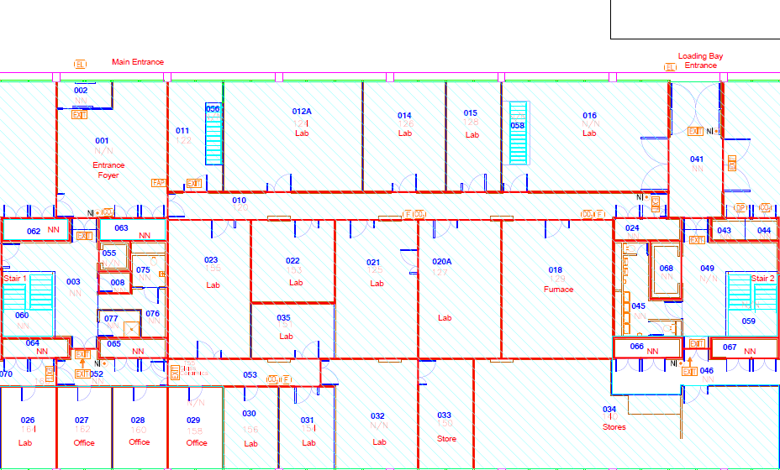



P127

Fire Extinguisher and sand bucket Locations
Ground Floor
Emergency Door Release
Sound Fire Alarm
Route to nearest fire exit
Key
2.2 Gas leak. magnet quench and general alarm  Within the building | Listen for the room or building alarm and take immediate action.  This will be most audible in the labs where the O2 depletion sensors are located.  Oxygen depletion alarm location in P125, P126, P127, P128, P130  These alarms are Analox O2NE+ TM which are fitted to lab spaces where activities with asphyxiating gases pose a risk.  If the superconducting magnet undergoes an unexpected transition into the normal state while under power, known as a quench, liquid cryogens will boil quickly releasing significant quantities of gas.  Warning signs include an unexpected noise from the magnet, sudden loss of field/current, gas rapidly emerging from safety valves. | On hearing a continuous alarm in the room/building:  - If the oxygen depletion alarm detects O2 concentrations below 19.5% Alarm 1 indicator will begin to flash, and the buzzer will sound at a slow speed. Ventilate the area until alarm light goes out. If competent to do so, source the leak and shut off. Otherwise contact the Space Owner and Technical Services Manager for assistance.  - If the oxygen depletion alarm detects O2 concentrations below 18% Alarm 1 & 2 will flash and a horn will sound quickly. It is vital that the room is evacuated IMMEDIATELY and that NO ONE ENTERS the room.  - Whilst evacuating try to increase ventilation where possible (including opening doors between the affected room and the outside, e.g. the Loading Bay)  - Alarms are self-cancelling when O2 level rises above the alarm limits (above 19.5%). ONLY allow access to the room once this has been confirmed.  - Only upon confirming point 4 can the O2 depletion sensor panel be checked to see if there are any faults or false alarms.  - A yellow flashing light means there is an internal fault with the system. Contact the Space Owner who will escalate as needed and communicate with relevant competent personnel to establish the next steps.  - If a magnet has quenched and it is safe to enter the lab space (following point 4) then arrange to fill magnet cryostat with cryogens as soon as possible.  DO NOT ENTER A ROOM IF THE OXYGEN % IS BELOW 18%  OR IF YOU SEE A PERSON LAYING UNCONSCIOUS!
2.2 Emergency Response Map for Gas Leak
CP

Control Panel for O2 depletion sensors/alarms
O2 depletion sensors/alarms (3 per location at different heights)
O2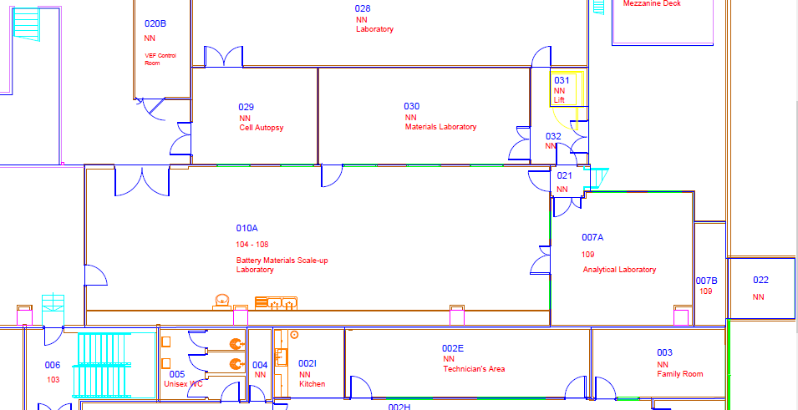

R

CA
Gas regulator locations
Compressed air regulator locations
Route to gas cages
Key

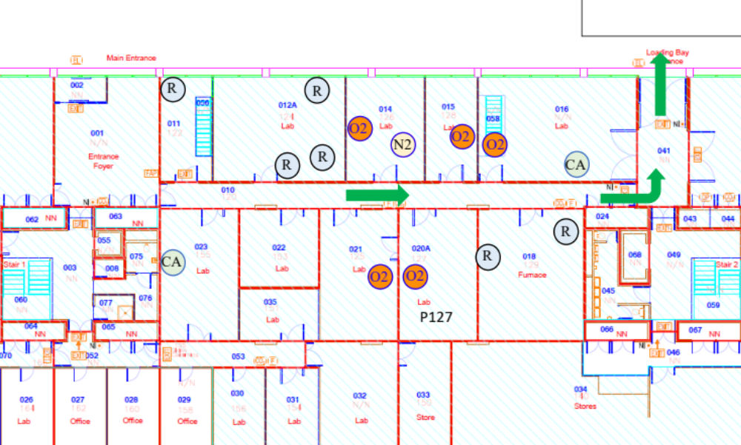

Emergency | Assessment |  | Emergency Response
2.3 Chemical Spillage/toxic hazard | A significant chemical spill is unlikely to occur in P127 P125, P126, P127, P128, P130 as only small amounts of chemicals are used. |  | Do not deal with a spill unless trained and you are confident in what you and doing.  For small chemical spills clean them up as quickly as possible.  Spill kits are available in Technical Services Managers Office (P1.62) and P1.28. However, if you do not know how to clean up a hazardous chemical you may make it worse and should contact the Principal Investigator, Space Owner and Technical Services Manager of the incident.  Always wear the correct PPE. This needs to suitable for the type of substance you are dealing with and to fit you, so not to add the risk from slips / trips or manual handling while cleaning up the spill.​  If the chemical spill has contacted a person:  - Call for a first aider or campus safety on ext. 22222 (024 765 22222)  - Assess the spill - where has it landed (clothes, skin, eyes), check the COSHH and SDS for first aid and perform as necessary, see map for key item locations (eye wash, emergency showers, first aid box)  - Inform the Principal Investigator, Space Owner, and Technical Services Manager of the incident.  - Check the COSHH assessment and the SDS for the chemical that has been spilt.  - Follow the chemical spill clean-up procedure documented in the respective COSHH assessment, ensure correct PPE is worn.
2.3 Emergency Response Map Chemical Spill
Ground Floor









Emergency Shower is outside the laboratories in the loading bay on the ground floor.
SK
SK
P127

Emergency Chemical Shower and Eye Wash Basin
First Aid
Eyewash bottles
Key
SK
Chemical Spill Kit Locations
2.4 Flooding in lab or elsewhere within the building |  | If the cause of the flood is accessible and safe to reach, please isolate. |  | In the event of a flood, evacuate the lab safely.  Notify the Space Owner, PI, Technical Services Manager and Estates.  University Estates (via Community Safety team on ext. 22222 (02476 522222)

3. Emergency contacts

The following is correct as of 16th July 2024:
Name | Role | Contact details | Laboratories
First Aiders | First Aid | As per QR Poster | All
Campus Safety | Security and First Aid | 02476 522222 | All
Paul Goddard | Principal Investigator / Space Owner | 02476 151775  P.Goddard@warwick.ac.uk | P1.27
Martin Lees | Principal Investigator / Space Owner | 024 765 23375  M.R.Lees@warwick.ac.uk | P1.25, P1.26, P.128, P1.29, P1.30
Geetha Balakrishnan | Principal Investigator / Space Owner | 024 765 73879  G.Balakrishnan@warwick.ac.uk | P1.22, P1.24
Daniel Mayoh | Principal Investigator / Space Owner | 024 765 22329  D.Mayoh.1@warwick.ac.uk | P1.55
Robb Johnston | Technical Services Manager | (0) 2476 523988  R.I.Johnston@warwick.ac.uk | All

4. Revisions and Changes
Name(s) | Revisions | Date Revised
Paul Goddard, Martin Lees, Geetha Balakrishnan, Daniel Mayoh, Stephanie Andrews-Brown | Changes made to oxygen depletion alarm response (addition of Analox device specific’s) and spill kit information. | 15th July 2024

