Experimental based Student Project – Risk Assessment
Title of Project Risk Assessment | Crystals of Frustrated Magnets |  |  | Date of assessment | 12/10/2023
Location of work areas | 122, 124, 130, 164 |  |  | End date of project | 15/03/2023
Description of project | Producing polycrystalline samples of Ho₂PdSi₃ and Dy₂PdSi₃ in bulk using the Argon arc furnace. Single crystal growth will then be performed using an optical floating-zone furnace. We will then examine the structural properties and crystal quality using X-ray diffraction and the low-temperature magnetic properties using the SQUID magnetometer.
Assessment carried out by | Gwon Yueng Chiu – Project partner  Daniel Mayoh – Supervisor  Geetha Balakrishnan – Co-Supervisor
Additional information | This project will include:  - Experimental including hazardous chemicals.  - Experimental including ionising radiation. E.g., radioactive sources, electron microscopes (scanning microscopes).

Display Screen Equipment (Laptops, Computers, Tablets)
Although you are undertaking an experimental project you will be working from a computer or other display screen equipment (laptop, tablet) whilst writing up your project. DSE (display screen equipment) training will apply to you as you will be working with DSE equipment continuously for more than 60 minutes a day during the write-up phases of your project.
The following checklist is intended to enable you to self-assess your workstation area and make suitable adjustments to minimize stress and strain on your body.
If you have responded "No" to any of the questions, please follow the workstation guidance and adjust your set up. You can also speak with your supervisor. Alternatively speak with the Health and Safety Officer (Stephanie Brown) who will be able to offer guidance.
No matter how well the workstation is designed or set up, problems can arise if you are working at a computer for long periods as lack of movement can lead to muscular aches and pains. Follow the link here for some stretch to follow
For more information on computer work follow the link here.
- Desk Set-Up
Are all items on your desk necessary, can they be removed to off-desk storage such as filing cabinets, cupboards, and shelves to make more space? Position frequently used items close to hand to avoid having to reach or twist but make sure the keyboard and mouse do not get moved out of position.
Is there enough space on your desk for the flow of work? | Yes
Is there adequate leg room (height, width and depth)? | Yes

- Chair
Adjust the chair height so your elbows are roughly the same height as the desk edge. If, after adjusting your chair you have noticeable pressure under your thighs at the front of the chair cushion you probably need a footrest.
Is your chair at a height that puts your elbows at approximately desk height when you are using the keyboard. | Yes
Is the seat cushion a suitable length for your upper leg length, so you are able to sit fully upright and back in the seat without your knees hooking the front of the cushion. | Yes
If fitted, are the armrests at a suitable supportive height when you are sitting upright? | No
Can you get the chair close enough to the desk to type with your elbows vertically under your shoulders? | Yes
Is the chair stable and undamaged? | Yes

- Monitor
Adjust the monitor so that the top of the screen is level with your eyes. If your monitor is too low, a screen riser can be used. If you are getting a lot of problems with dry sore eyes you can set it a little lower but be careful not to place it too low as this will affect your head position and can trigger neck pain.
Is the top of the visible area of the monitor at eye height when you are sitting upright? | Yes
Is the monitor at a suitable distance from your eyes? | Yes

Is the monitor positioned directly in front of you so you do not sit at an angle or twisted? | Yes
Is the screen tilted to the best angle? | Yes
Is your screen free from glare and reflections? | Yes
Is the information on the screen well defined and easy to read? | Yes
Are you free from eye discomfort when using the screen? | Yes

- Keyboard
Check the keyboard; if the feet on the back are raised tuck them in so the keyboard is flat on the desk. If your elbows are quite a bit lower than your wrists, check the height of your chair. Make sure you are sitting close enough to the desk. If you are right-handed and the width of the keyboard is pushing the mouse over to the right, try using the mouse in your Left hand. For mouse intensive tasks move the keyboard to one side so you can use the mouse in front of you.
Are your wrists and hands levels when using the keyboard? | Yes
Are your elbows directly under your shoulders when using the keyboard? | Yes
Are you elbows directly under your shoulders when using the keyboard? | Yes
Is the mouse close enough to be used without extending the arm at the elbow? | N/A

- Work environment
Review the layout of your workstation and work area and clear away any unnecessary clutter. You should be able to move your chair freely in order to avoid twisting and reaching.
Do you have adequate space to access your desk and manoeuvre the chair? | Yes
Is the work area free from obstructions and hazards such as tripping? | Yes
Can you organise your time to have adequate breaks from the screen? | Yes
Is there adequate lighting for all tasks?

DSE Remedial Actions
Please insert any remedial actions if ‘No’ was answered to any of the questions | Try not to depend on the arm rests for better posture

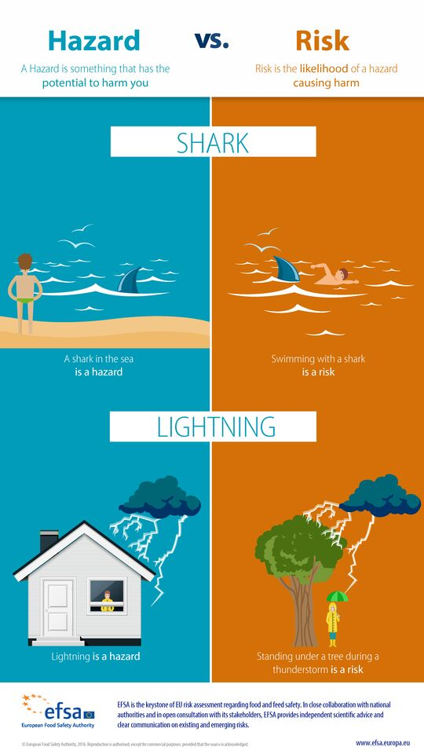
What is a risk assessment?
A risk assessment is the process of identifying what hazards exist or may appear and how they may cause harm and to take steps to minimise harm.
There are 5 steps to a risk assessment:
- Identify hazards.
  - a potential source of harm
- Decide who might be harmed and how.
  - users, contractors, others in the vicinity, members of the public etc
- Asses the risk and evaluate the control measures.
  - Risk is the likelihood of the hazard causing harm.
  - Control measures are actions taken to reduce the potential harm.
  - likelihood x severity = risk level
  - More information on this can be found in the risk matrix at the bottom of the risk assessment.
- Record your findings (in the form of a risk assessment)
- Review periodically.
  - Whenever there has been a change to activities e.g. processes, procedures or equipment. When an incident has occurred.
Chemical Risk Assessments (COSHH – Control of Substances Hazardous to Health)
Are you going to be working with any hazardous chemicals or substances as part of your project? You may need to complete an additional chemical risk assessment.
Discuss with your Supervisor what substances you would like to use. Supervisors should already have in place COSHH assessments covering any chemicals actively being used in their laboratory spaces, which could already control the risks of chemical/s you might be using. For example, IPA and Acetone. In these circumstances you do not need to duplicate the COSHH assessment, but please ensure that you read, understand, and follow the control measures.
The Risk Assessment Guidance introduces you to the general principles that should be applied, and which type of risk assessment form should be completed under different circumstances. The general principles are outlined below:
'Very low' hazard materials, even at high volumes – incorporate into your project risk assessment.
If 'Low' hazard material, using low volumes – again, if the precautions are straightforward, incorporate these into your project risk assessment.
Medium or even some High hazard materials, where you have regular use or which involves moderate volumes - Standard COSHH assessment form, although regular or routine tasks.
When the hazard is unknown or uncertain, or there is the potential for hazardous bi-products, or intermediary substances to be generated, then assume an Advanced COSHH assessment is required.
Very High involving higher toxicity/flammability and higher quantities of materials than those specified STOP, seek advice.
For links to COSHH assessment templates please follow the link here.
Training for use of Equipment and Laboratory Space
Before entering a laboratory space, you should read through any relevant risk assessments to the space and equipment that will be applicable to you. You will be able to get risk assessments from your Supervisor, Space Owner, or Principal Investigator of the laboratory space. You will then have a formal induction into the laboratory space and explained the health and safety requirements which you must always adhere to.
If you are to use any equipment within a laboratory space, you must be trained by a competent person before you do so. Do not touch or use any equipment that you have not been given training and permission to use! Equipment training requirements will be explained to you by your Supervisor, Space Owner, or Principal Investigator of the space.
Some training courses are available through Health and Safety Services here. Your supervisor will inform you of the training requirements for the laboratory space.

Ionising Radiation
This section is only applicable if you are working with ionising radiation.
As stated previously, when working with a piece of equipment you need to undertake training with a competent person. For use of ionising radiation in the department such as electron microscopes (scanning microscopes) or radioactive sources you need to organise training with the person who is responsible for the equipment/sources you require use.
Please list the equipment/sources to be used here and sign the declaration below:
Powder X-ray diffraction (Anton Paar XRDynamic 500 diffractometer)
Laue X-ray diffraction (Photonic-Science)

I understand the rules for the use of sources of ionising radiation and I agree to abide by them. I will only use the equipment specified above, and understand that to use any further equipment, even of the same type, requires specific approval from the Departmental Radiation Protection Supervisor. I further acknowledge that I am aware that any breach of these Regulations may result in permission to use sources of ionising radiation being withdrawn.
Signed: Andra Lye Date: 16/10/2023
Please take your risk assessment to Dr Johnathan Duffy (P4.39) who will arrange and check your training. Only once this form is complete and signed by the Group Radiation Protection Supervisor can you commence working with radiation.
I certify that the above name person will work only in an open or supervised area on the equipment detailed above.
Signed: Date:
Departmental Radiation Protection Supervisor
I hereby state that in my opinion that the above-named person can handle the sources of radiation named above in a responsible manner and that the student has been trained in their proper use.
Signed: Date:
Departmental Radiation Protection Supervisor
Artificial Optical Radiation (Non-ionising Radiation)
This section is only applicable if you are working with non-ionising radiation.
Lasers:
All users of class 3B or 4 lasers, and others that may be affected using these lasers, must undertake appropriate training.
The training required for laser users is given below:
- University laser safety awareness training - required for all users of Class 3B and 4 lasers, and lower-Class lasers that contain Class 3B or 4 lasers and may be accessible under certain conditions (e.g. servicing).) Your supervisor will check you have completed this before local training.
- Local training on the use of the specific system must be provided. This is particularly important for those who carry out open beam work (e.g. laser beam alignment), and robust and comprehensive training will be provided by whoever is responsible for the laser.

In addition to this all users of lasers in classes 3B and 4 must be registered with the University RPO (Radiation Protection Officer). The laser registration user form must be filled in and submitted.
Broadband Sources:
If you are working with non-laser (broadband) sources, you need to ensure that you have undertaken appropriate training. Common type of hazardous AOR source is the ultraviolet (UV) source e.g. UV transilluminators, UV curing and UV sterilisation. For additional guidance on UV sources, click here.
University AOR safety awareness training is required for all users of hazardous AOR sources, in addition to local training. (Awareness training is under development. Contact the University RPO (Steven Leemoon for further information).

Hazard Identification
The below information can be used to help with the identification and classification of hazards involved your in project. The below is not an exhaustive list but it may help you prioritise the main hazards associated with an activity.
Mechanical Hazards | Electrical Hazards
Abrasion | Arcing from hot works
Crushing | Electrical skin burns
Cutting/shearing | Electrocution
Entanglement | Sources of ignition (explosion)
Impact/ejection | Portable equipment not PAT tested
Entrapment | Fire
Hand tools including power tools and knives. | Poor isolation of equipment

Chemical Hazards | Radiation
Allergies, dermatitis | Ionising radiation
Asphyxiation | Non ionising radiation - Lasers
Carcinogens or substances that can harm reproduction | Electrocution
Fire and explosions | Sources of ignition (explosion)
Toxicity and burns | Portable equipment not PAT tested
Routes of entry into the body – inhalation, ingestion, injection, absorption | Fire
Spillages, emergency actions and waste disposal

Location and Physical Hazards | Continued…
Remote working | Pressure systems: autoclaves (steam steriliser for lab instruments and instruments), gas regulators, air compressors,  (A pressure system is one that contains or is likely to contain a relevant fluid over 0.5 bar)
Lighting conditions | Needle sticks
Cryogenic gases – burns, asphyxiation | Uneven surfaces
Experimental rigs
Extreme temperatures hot or cold
Fieldwork
Vacuum System (including vacuum pump systems – this is a device for moving fluids or slurries from one place to another)
Sharp objects – broken glassware, needle sticks

Hazards and how they may cause harm | Who may be at Risk? | Existing Control Measures | Current  Risk Level  (VL,L,M,H,VH) | Where current risk is M, H or VH, what additional Control Measures are required? | Action required by whom & by when? | Final  Risk Level
Argon Arc Furnace – Intense source of UV radiation may cause burns or blindness | Student and Staff in lab during operation | Use a UV protection shield and wear protective gloves | L |  | - | L
Optical Floating-Zone Furnace – High pressure and irradiation | Student and Staff in lab during operation | Door/barrier as a shield – do not break the interlock when in operation | L |  |  | L
Cryogenics in Squid Magnetometer (Liquid Nitrogen) –  Cold-burns, asphyxiation from cryogens displacing oxygen in the air | Student and Staff in lab during operation | Well-shielded, move outside if the oxygen gas alarm sounds when the oxygen in the room is dangerously low, do not touch cold surfaces (burns)  Liquid Nitrogen training by Martin Lees (Oct. 23, 2023) | L |  |  | L
Magnetic fields in Squid Magnetometer –  Can interfere with objects with magnets (e.g. heart pacemakers, medical implants, magnetic cards, watches) | Student and Staff in lab during operation | Keep magnetisable objects far away from the cryomagnet while it is energised.  Do not enter room if one has a heart pacemaker fitted. | L |  |  | L
Pressurised gas system –  Can cause the quartz glass to shatter, releasing argon gas to the atmosphere | Student and Staff in lab during operation | Valves and regulators should be working correctly.  Check that the quartz glass of the arc furnace is not cracked before use | L |  |  | L
Powder/Laue X-ray diffraction –  Ionising radiation severe burns | Student and Staff in lab during operation | Moving parts, X-ray source – system is interlocked as a safety measure | L |  |  | L
Electrical generator –  Electric shock, fire, overheating electrocution, burns | Student and Staff | Insulated, don’t tamper with the generator box.  Gloves to prevent direct contact.  Emergency stop switch. | L |  |  | L
Chemicals –  Asphyxiation (argon gas), explosion (if argon gas is exposed to extreme heat) | Student and Staff | Appropriate PPE will be worn when working with chemicals.  Have read the relevant SDS and wrote the COSHH assessment in a separate file. | L |  |  | L

Work should not be carried out until the assessment is completed and all required control measures are in place.
Overall Final Risk Rating (Highest level in final column above) | L

Additional Comments from Project Supervisor
Students will be trained how to work in our lab environment competently and safely.
Approved By  (Project Supervisor) | 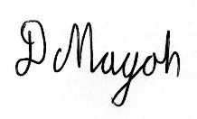  Daniel Mayoh
Date | 16/10/23
Please print a copy, sign it and keep for your records

 | Severity |  |  |  |  |  |  | Risk Level
Likelihood | Superficial | Minor | Serious | Major | Extreme |  | Very low | Acceptable risk - no action required
Unlikely | Very low | Very low | Low | Low | Moderate |  | Low | Tolerable risk - further control measures not required, but status must be monitored
Possible | Very low | Low | Low | Moderate | High |  | Moderate | Further control measures required to reduce risk as far as is reasonably practical
Likely | Low | Low | Moderate | High | Very high |  | High | Urgent action required to allow activity to continue
Very likely | Low | Moderate | High | Very high | Very high |  | Very high | Risk intolerable - activity must cease until the risk has been reduced
Extremely likely | Moderate | High | Very high | Very high | Very high
See ‘Matrix for risk evaluation’ for further guidance.

