Project Title: Optimising robotic platforms for terahertz detection of cancer
Supervisor: Prof Emma MacPherson
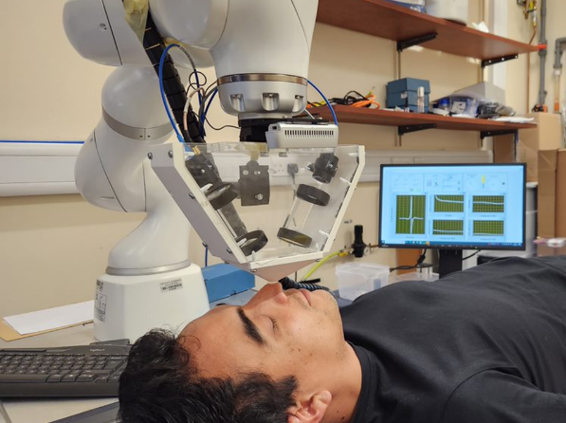
Are you interested in applying physics to situations that could benefit medical diagnosis? Terahertz (10¹² Hz, THz) pulsed imaging is a new technique with high resolution (about 20 μm) and has only emerged recently as a potential new clinical tool for medical imaging. It is a totally non-destructive and non-ionising imaging modality as the average power of the pulse for producing the radiation is as small as 100 nW. The radiation produced is focused onto the sample of interest and then detected coherently. A point measurement is analogous to an ultrasound A-scan. Reflections off different layers are used to determine the structure at various depths. THz light is very sensitive to hydrogen bonds. By Fourier transforming the time-domain data, useful spectroscopic information can also be revealed. Potential applications range from security imaging to medical diagnosis, but the analysis and instrumentation needs to be tailored for each application investigated. THz light can be generated and detected using photoconductive antennas. The useable frequency range of a THz system depends on the photoconductive devices as well as other factors such as optical alignment.
The aim of this project is to take accurate and repeatable robotically controlled non-contact THz measurements of skin with a view to developing classification algorithms for skin cancer and potentially other skin conditions. For example, it may be possible to use THz imaging to detect early stages of skin cancer, or the lateral extent of tumours that are beneath the skin’s surface, and not yet visible. Applicants do not need a medical background, more importantly, they need an interest in robotics, programming, optics and data analysis.
Prof MacPherson joined Warwick University in 2017 and received a Wolfson Merit award to support her research in the UK. For more background information regarding the Ultrafast THz Photonics group and Prof MacPherson’s research interests, please see https://warwick.ac.uk/fac/sci/physics/research/condensedmatt/ultrafastphotonics and https://warwick.ac.uk/fac/sci/physics/research/condensedmatt/ultrafastphotonics/emmasthzgroup/. The PhD project will be linked with the £8M Terabotics Programme grant Terabotics Programme Grant (warwick.ac.uk) and will have links with the University of Leeds and The university of Exeter.
For further information do not hesitate to contact Prof MacPherson directly on e.macpherson@warwick.ac.uk This is a fully funded-PhD studentship at standard UK Research Council rates, available with a flexible start date from October 2024 onwards for a 3.5 year period. The Studentship covers university fees and a living stipend, and is available to UK and EU students.
For more information please see http://go.warwick.ac.uk/PhysicsPG .

