EMERGENCY PROCEDURES – P424 VACUUM SYSTEMS

Unless you are an Expert User
DO NOTHING
to the vacuum systems.

If there is a MAJOR WATER LEAK shut off the water supply behind the blue electronics racks here:

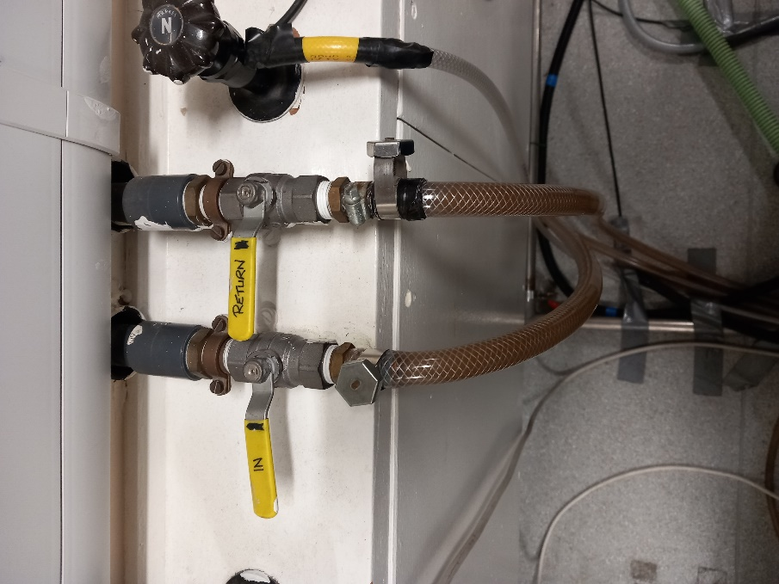
CLOSE both the “In” and “Return” levers.
They are shown CLOSED in this photo.
EMERGENCY PROCEDURES – P422 VACUUM SYSTEMS

Unless you are an Expert User
DO NOTHING
to the vacuum systems.

If there is a MAJOR WATER LEAK shut off the water supply on the right side wall here:

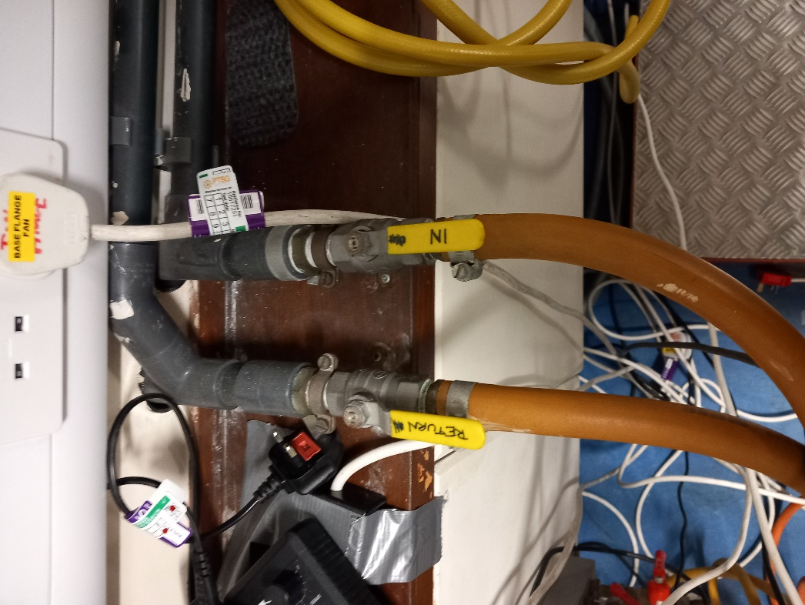
CLOSE both the “In” and “Return” levers.
They are shown OPEN in this photo.
EMERGENCY PROCEDURES – P422 VACUUM SYSTEMS

Unless you are an Expert User
DO NOTHING
to the vacuum systems.

If there is a MAJOR WATER LEAK shut off the water supply on the left side wall here:

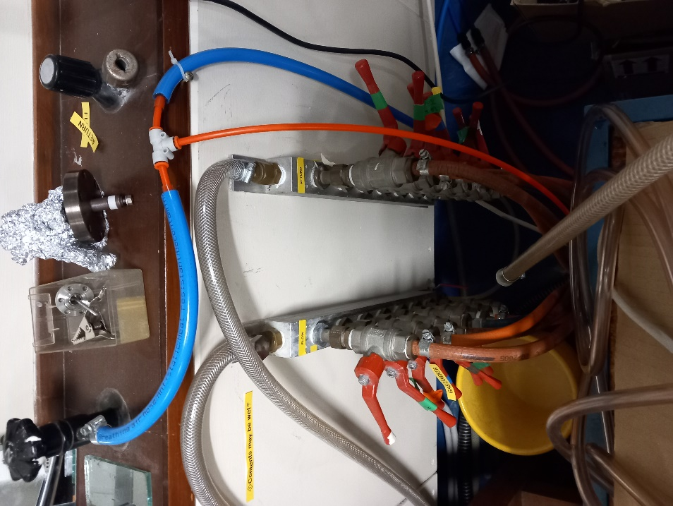
CLOSE all levers.
Parallel to wall = closed. Parallel to outlet pipes = open.

