High-Resolution Probing Ferroic-ordering by Electron Ptychography

The emergence of ferroic orderings in materials at the atomically thin limit, including ferromagnetism and ferroelectricity, has attracted tremendous attention due to their novel physics and promising applications for future flexible nanoelectronics including artificial e-skin, flexible touch sensors and health monitors. Understanding the underlying physics behind the ferroic phenomena requires a high-resolution image technique that can directly visualize magnetic or electric fields in the materials at the nanometer, even down to atomic resolution.
The aim of this project is to develop a new pioneering algorithm-driven imaging technique called ptychography in conjunction with machine learning and ultrafast detectors. Much of the work will involve using scientific Python or Matlab to develop new ways of quantitatively analysing ferroic properties and structure in 2D ferroic thin films at the atomic scale. Combined with tomographic methods, we will further extend 2D field projections into 3D vector field reconstruction. Furthermore, we will look at dynamic behaviours of materials in situ and study how they respond to a changing external stimulus (electric, magnetic field, temperature).

The experimental part of the project will be based in the Warwick Analytical Science Centre, which hosts a state-of-the-art JEOL ARM microscope where a new cutting-edge ultrafast detector allowing the image to be recorded at 1000 frames per second can be applied in a very wide range of 4D STEM image techniques such as virtual STEM, DPC etc..

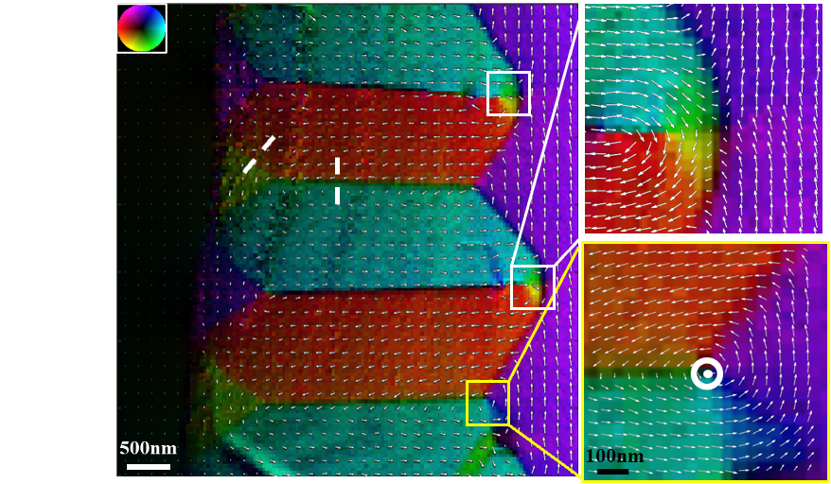
Figure: Magentic field mapping in materials.

This PhD studentship is available for an immediate start. To discuss this project further contact: peng.wang.3@warwick.ac.uk

More Details of the project:
https://warwick.ac.uk/fac/sci/physics/staff/academic/pwang/openpositions/

