“Physics Day” Workshop: Frontiers in Electron Microscopy for Physical Sciences

Friday 28th October
Room 2.41, Ramphal Building
University of Warwick

Thank you for registering to attend “Physics Day” Workshop at the University of Warwick.
We look forward to welcoming you in the atrium of the Ramphal Building from 09:30.

Program:
Time | Agenda
09:30-10:00 | Arrival and Registration
 | Departmental Lecture chaired by Peng Wang
10:00-11:00 | Prof. Xiaoqing Pan （University of California, Irvine）  Probing Properties and Dynamic Behaviors of Topological Polar States by Electron Microscopy and Emergent Phonon Phenomena at Interfaces Probed by Vibrational Electron Microscopy
11:00-11:30 | Coffee Break
 | Morning Section Chaired By Geoff West
11:30-11:50 | Prof. Richard Beanland (University of Warwick)  The Electron Microscopy RTP at Warwick and the Science it Enables
11:50-12:10 | Dr. Matthew Piggott (University of Nottingham)  EM at the Nanoscale & Microscale Research Centre
12:10-12:30 | Prof. Bo Chen (University of Leicester)  EM Facilities And Research at University of Leicester
12:30-12:50 | Dr. Peng Wang (University of Warwick)  Electron Ptychography: An Emerging Computational Microscopy For Physical Sciences
12:50-14:00 | Lunch
 | Afternoon Section Chaired By Richard Beanland
14:00-14:20 | Prof. Yu-Lung Chiu (University of Birmingham)  Microscopy And Metallurgy
14:20-14:40 | Dr. Zhaoxia Zhou; Dr. Stuart Robertson (University of Loughborough)  From Icroplastics To Solar Cells, Materials Characterisation In Complex Systems
14:40-15:00 | Dr. Shengfu Yang (University of Leicester)  The Growth Of Novel Nanomaterials In Superfluid Helium
15:00-15:20 | Dr. Mingwen Bai (Coventry University)  In Situ Scanning Electron Microscopy For Materials Science And Engineering
15:20-15:40 | Dr. Geoff West (University of Warwick)  EM facilities at WMG – The Analysis of Batteries and Steel
15:40 | Closing Remark

Directions to the event
Any question regarding directions, please contact: Aidan Horne (Aidan.Horne@warwick.ac.uk)

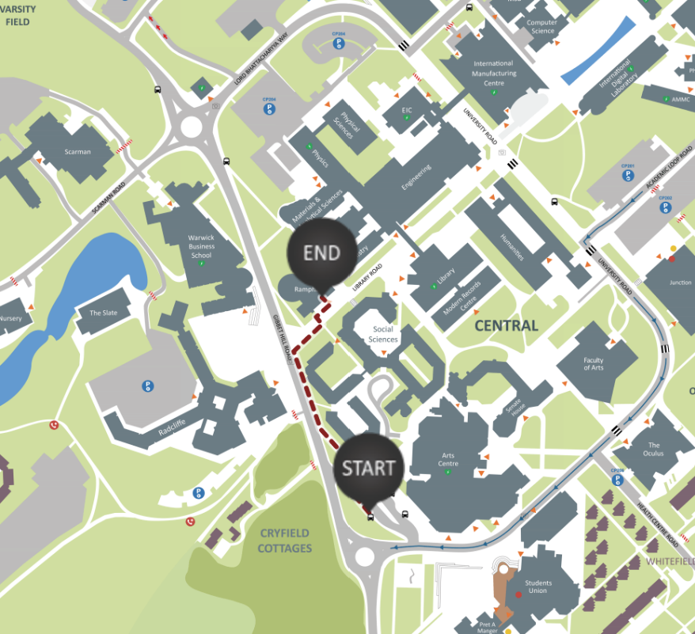
If travelling to the event via public transport, all buses to campus stop at the University interchange. Leave the bus here and follow the route shown. The walk to Ramphal building takes around 3 minutes.

If arriving by car, arrive at car park 8 which appears on Google maps. Then follow the short walk shown below to arrive at Ramphal building. Please note parking charges will apply.
